CONTEXT
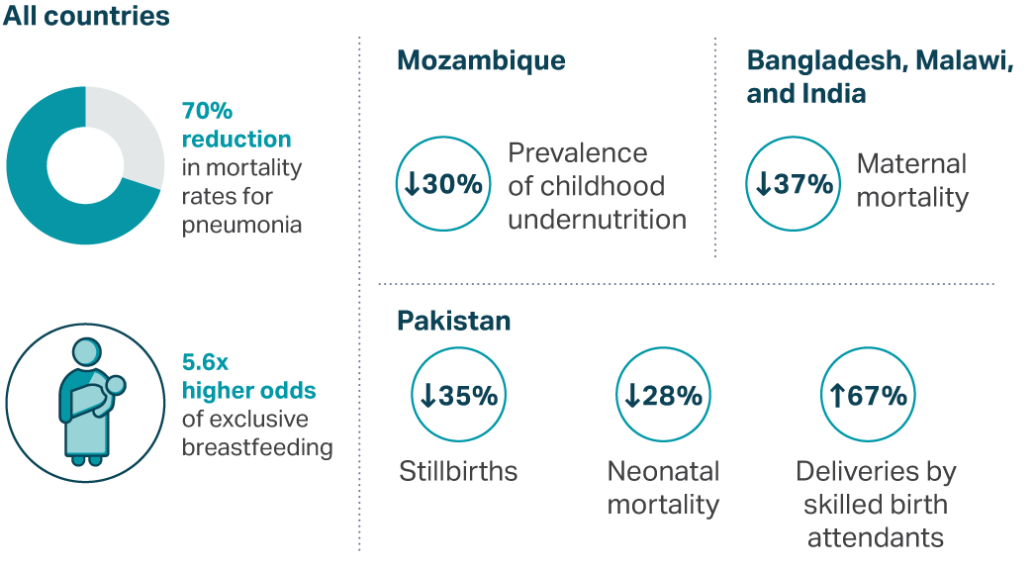
Community Health Workers (CHW) are essential for achieving Universal Health Coverage (UHC) and improving primary healthcare delivery. They serve as the critical link between healthcare systems and communities, delivering essential health services to underserved populations. For instance, evidence shows that countries that invest in effective CHW programs can significantly increase immunization rates, enhance nutrition outcomes, and reduce under-five and maternal mortality. As 2030 nears, strengthening CHW programs is a key step countries can take to bring themselves closer to achieving the Sustainable Development Goals (SDGs).

Despite their important role, CHW programs often face challenges in scaling and sustaining their impact. One key challenge they face is a lack of data they can use to assess their performance and guide improvements. However, Exemplars research shows that low-cost performance monitoring systems can help CHW programs track their progress, improve service delivery, and adapt their programs over time to ensure long-term sustainability.
Insights from Sierra Leone
Leaders of health systems around the world can learn from Sierra Leone’s experience, which is an example of this intentional shift towards a data-driven approach.
When Sierra Leone launched its CHW program in 2012, it was mostly composed of fragmented, disease-specific initiatives where donors deployed their own community-based service providers. In 2021, it began to integrate all existing cadres under a single national policy to improve the efficiency and effectiveness of community-based healthcare delivery. The 2021 policy also aimed to extend coverage to hard-to-reach communities, improve gender equity in the workforce, and integrate service delivery across the full package of services that CHWs provide.
To support this transition, the Sierra Leone Ministry of Health, in collaboration with Last Mile Health and with support from Exemplars in Global Health, introduced an effort in 2022 to assess and improve the rollout of the country’s new revised CHW policy. In this initiative, the government collected evidence of CHW program functionality using tools such as recruitment records, pre- and post-training tests, and phone surveys designed to elevate input from CHWs themselves. The goal was to use the findings to develop evidence-based recommendations to support system-level adaptations to its CHW program, from recruitment to training to implementation.
CHWs in Sierra Leone
- In 2022, Sierra Leone trained and deployed 8,154 CHWs in accordance with the revised national policy.
- Sierra Leone’s Ministry of Health recruited CHWs from the communities they serve.
- The new CHW program required providers to be educated to a high school standard and to complete a 21-day training that covered three modules: community health basics, integrated community case management, and RMNCH: family planning, pregnancy, post-natal, and early childhood. Peer Supervisors also received supervisory training.
- Services CHWs provided included home visits and community education activities to promote RMNCH, adolescent health and family planning, WASH practices, immunization awareness, HIV/TB prevention and control, prevention of NCDs, iCCM, ANC/PNC, and referrals to health facilities.
The survey produced actionable insights on how the CHW program was operating. For example, data showed that although the Ministry of Health aimed to build a CHW cadre that was 60% women, more than two-thirds of the initial recruits were men. Women were also nearly twice as likely to drop out of CHW training than their male counterparts, and men were 3.8 times more likely to be selected as supervisors (after controlling for age, education, previous experience, and other factors).
Based on these findings, Sierra Leone’s Ministry of Health implemented system-level adaptations to its CHW program to reduce gender disparities in recruitment and supervision:
- Officials expanded the age limit and lowered the education requirement for women recruits. Efforts to improve community engagement are being integrated into CHW recruitment, particularly to encourage men to support female partners' work as CHWs.
Now, Sierra Leone's Ministry of Health hopes to take similar steps in response to other opportunities identified by the data. (See Table 1.)

Opportunities for Improvement | What the data shows | What the Ministry is prioritizing
Training | - Research found a 6% attrition rate for potential CHWs due to delays between recruitment and the start of training.  - 55% of CHWs passed all three post-training assessments. However, 14% scored <50% average, yet they were still deployed. | - Minimize time gaps between recruitment and deployment.  - Extend the duration of CHW training for better skills development.  - Introduce pass/fail standards for competency assessments.  - Redesign the CHW curriculum so that each module includes practical field work as well as classroom teaching.  - Develop a system for supportive coaching and peer mentoring during training, along with continuous assessment.
Service Delivery | - Less than 10% of CHWs provided HIV, TB, and family planning services.  - Virtually no CHWs in hard-to-reach communities had a full three-month supply of drug stocks.  - Respondents in urban areas reported low rates of service delivery. For instance, in one three-month period, CHWs in Western Area Urban district reported providing an average of only 25% of the services expected of them. | - Conduct micro-planning and geomapping exercises to inform CHW placement, classification and workload.  - Strengthen supply chain processes.  - Train facility staff on CHW roles and integrate them into supervision to improve service delivery continuity  - Adjust CHW strategy to be tailored to urban areas and specific health areas.
Operations | - Among surveyed CHWs, they were paid on average only 53% of the months they worked.  - One-third of CHWs reported payment discrepancies.  - Less than half of CHW reports from the three-month study period were entered into digital record systems. | - Explore policy potential to support the creation of a formalized, integrated CHW cadre funded by government.  - Establish a streamlined and efficient system to guarantee timely and fair disbursement of CHW incentive and adjust amount to reflect workload.  - Improve coordination with primary health centers to ensure CHWs are adequately integrated with health system.

Table 1: Next Steps in Sierra Leone
Call to Action
In CHW programs worldwide, especially those in transition from vertical to integrated approaches, ongoing implementation research and data collection can help health systems assess and refine those programs, allocate resources efficiently, and maximize impact. In Sierra Leone, officials anticipate that this approach may lead to:
- Greater equity by improving gender disparities in recruitment and supervision
- Improved service delivery by addressing supply chain gaps and revisiting the scope of work
- Stronger operational systems to ensure fair remuneration and streamlined data management
Health systems leaders can use the data they gather at local, sub-national, and national levels to diagnose challenges, improve effectiveness, and support integrated approaches to CHW programming. Likewise, governments, donors, and implementing partners should prioritize the integration and use of system-wide performance monitoring initiatives and invest in structured data collection and analysis for action.
Data-driven decision-making can strengthen CHW programs. Stronger CHW programs can improve health outcomes and accelerate progress towards UHC and the SDGs.
To learn more about how the phone survey was developed and deployed, please utilize the QR code below.




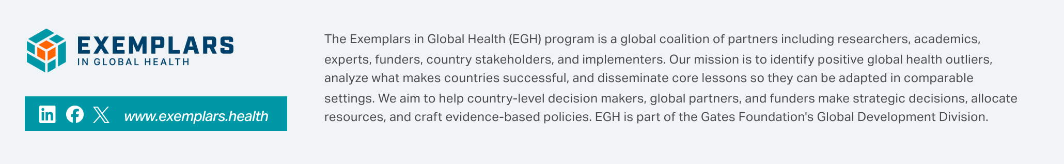

Collaborative Research Approach
The study was co-designed with the Sierra Leone Ministry of Health and Last Mile Health, guided by a 10-member Technical Advisory Group. Focus 1000 implemented the second research phase, with Ministry leadership as co-investigators, ensuring input on methodology and implementation. District M&E staff conducted phone surveys, while national staff oversaw quality assurance. Findings were reviewed, contextualized, and validated through subnational and national dissemination events with key stakeholders.
Last Mile Health partners with governments to build strong community health systems that equip professionalized community health workers to provide essential healthcare in the world’s most remote communities. In Sierra Leone, Last Mile Health accompanies the government to improve the quality of their CHW program and establish systems for evidence-based program management. The team is focused on three key bodies of work: (1) building data and governance systems at the national level, (2) leveraging data to identify gaps in program implementation and develop tools to address them, and (3) implementing and refining these tools in their learning lab district.
FOCUS 1000 is a Sierra Leone based NGO that advocates for and works to ensure children and families across the country have access to basic social services through sustainable initiatives with full community participation and ownership. Focus 1000 works across four key domains: (1) evidence generation, (2) capacity development, (3), community engagement, and (4) advocacy and partnerships. They supported data collection for this study.
