**Application Form Vrije Universiteit Amsterdam**

**Master International Business Law**

For **Dutch** Degree Holders (= Dutch or international students applying with a bachelor from a Dutch University, including VU-students)

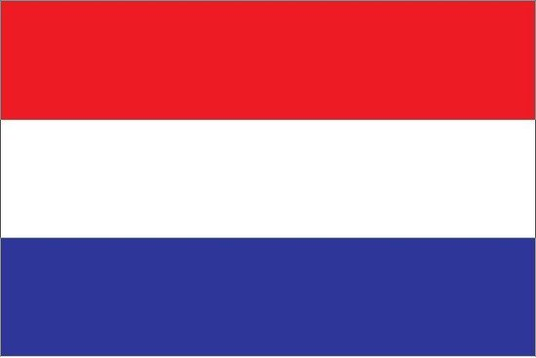

***The application deadline is 1 June.***

**Instructions:** Please put all the required documents in this format. Read the instructions first, then delete the text and paste the requested document onto the page. When you have finished adding all documents, please save the complete file in **.PDF format** and upload it in the *Complete Registration* section of [Your personal dashboard](https://vu.nl/nl/dashboard) on vu.nl. Only submit an application file that includes all required documents in this template.

After submitting your application, we will check all documents. If one or more documents are rejected, you will receive a message informing you what to change. Please replace the document(s) and submit a complete application file again.

|  |  |  |
| --- | --- | --- |
| **Your contact details** | | |
| **Your name and VU student number** |  | |
| **Your e-mail address** |  | |
| **Your telephone number** |  | |
|  | | |
| **Details regarding your *previous* or *current* education**  If you have completed multiple degrees at HBO and/or university level (bachelor, premaster, master), make sure to mention all of them and number them accordingly. | | |
| **Name of the programme and name of the university or higher education institution** | |  |
| **Title of the degree(s)** (Bachelor, master, etc.) | |  |
| **The (expected) date of graduation** | |  |
| **Your current or final GPA (Grade Point Average), also include the maximum possible GPA in your university’s system** (for example: 8/10, 3.27/4, etc.) | |  |

**Letter of Motivation**   
  
A 1-2 page letter stating your reasons for applying to the programme. Also please specify in this letter the name of the **specialization** you are applying for (Climate Change and Corporations / Trade and Investment).

**Proof of academic writing (in English):**

* + final paper or thesis for your academic degree (excerpt, maximum 3-5 pages)
  + if no thesis in English is available: any other 3-5 page piece of academic writing
  + if no academic writing in English is available: write a 3-5 page abstract of an academic paper; include a bibliography (excluded in the 3-5 pages)

Please note we check application documents for plagiarism.

**Letters of recommendation**

2 letters of recommendation from academic referees (if possible including the ranking position of the applicant).

We prefer that you include the reference letters in your application form, but referees may also mail their references directly to [admission.law@vu.nl](mailto:admission.law@vu.nl). The letters of recommendation are taken into account in the assessment of your motivation.

**Curriculum Vitae (CV)**  
  
A curriculum vitae that includes your personal details and lists your previous education and relevant work experience.

**Transcript of records**

Please place a copy of your **official transcript of records** (in English) here, i.e. a transcript of the grades obtained during your previous higher education (bachelor’s and master’s programme). **The transcript must contain your name, the name of the institution, and the GPA.**

Please include all relevant transcripts if you have multiple bachelor's and/or (pre)master's diplomas.

If you did not graduate yet, please send us an official transcript listing the grades you have obtained so far, **including the GPA**.