Grant Agreement for Erasmus+ traineeship
Academic year 2024-2025
Student
Green to be filled out by the student

Blue to be filled out by VU Erasmus+ Office

PREAMBLE
This Agreement (‘the Agreement’) is between the following parties:
on the one part, the Organisation (‘the organisation’),
Vrije Universiteit Amsterdam
Address: De Boelelaan 1105, 0E-68, 1081 HV Amsterdam, The Netherlands
Email: erasmus@vu.nl
Erasmus Code: NL AMSTERD02
Erasmus+ mobility ID number: E10146715
Project code: 2024-1-NL01-KA131-HED-000206022

represented for the purposes of signature of this agreement by Job Mulder, Erasmus+ Grant Coordinator,

and on the other part, the ‘participant’

Student number:
First name(s):
Family name(s):
E-mail:
Date of birth (dd/mm/yyyy):
Gender:
Nationality:
Study programme at VU:
ISCED Field of education (see last page)
Study cycle (Bachelor/Master/other):
Previous participation in Erasmus+ at the same study cycle (in months):
Traineeship details
First working day at the host organisation [dd/mm/yyyy]:
Last working day at the host organisation [dd/mm/yyyy]:
Number of recognized credits (ECTS):
Main language used during internship:
Host institution (abroad)
If a university:
Only mention the Erasmus code :

If it not a university, fill out the subsequent information:

Legal name:
Legal address:
Telephone:
Website:
Country:
Name sector:
Department/unit:
Size of enterprise:

The parties referred to above have agreed to enter into this Agreement.
The Agreement is composed of:
Terms and Conditions (see below)
Annex 1: Erasmus+ learning agreement for student mobility for traineeships (added as separate document)
Annex 2: Erasmus Student Charter (see below)
The terms set out in the Terms and Conditions will take precedence over those set out in the annex.

Mobility barriers
Please thick the box(es) that fit your circumstances, according to your opinion. More than one answer is possible. This information is solely used anonymously, to gather statistics to improve the Erasmus programme, and making it an inclusive programme for all!
- Disability: This includes physical, mental, intellectual or sensory impairments which, due to various barriers, may hinder someone’s full and effective participation in the programme.
- Health problems: Barriers may result from health issues including severe illnesses, chronic diseases, or any other physical or mental health-related situation that prevents from participating in the programme.
- Barriers linked to the educational system: Individuals struggling to perform in education and training systems for various reasons. Educational difficulties can be linked to personal circumstances, but they mostly result from the structural limitations within the educational system. For instance, that the study programme does not provide sufficient elective space making it difficult for the student to participate in the programme, or that the educational system does not fully take into account the individual’s particular needs.
- Cultural differences during the mobility: Being exposed to foreign languages and cultural differences when taking part in an international mobility programme may be a barrier or it can limit the benefits from their participation. It may even prevent potential participants from applying for support through the programme, thereby representing an entry barrier. Cultural differences can be perceived as a barrier to participate by people from any background, and can particularly affect people with fewer opportunities, especially people with a migrant or refugee background, people belonging to a national or ethnic minority, sign language users, people with linguistic adaptation and cultural inclusion difficulties, etc.
- Social barriers: Social barriers can stem from family circumstances, for instance being the first in the family to attend higher education or being a parent (especially a single parent), a caregiver, a breadwinner, or an orphan, or having lived or currently living in institutional care. Other social barriers can stem from social marginalization or social adjustment difficulties such as limited social competences, anti-social or high-risk behaviours, (former) offenders, (former) drug or alcohol abusers.
- Economic barriers: Economic disadvantages like a low standard of living, low income, students who need to work to support themselves, dependence on the social welfare system, in long-term unemployment, precarious situations or poverty, being homeless, in debt or with financial problems, etc., may represent a barrier to participate. Barriers may also stem from difficulties to transfer or continue to receive any (economic) support services during the participants time abroad.
- Barriers linked to discrimination: Barriers can occur because of discriminations linked to gender, age, ethnicity, religion, beliefs, sexual orientation, disability, or as a result of the intersection between two or more of the mentioned barriers.
- Geographical barriers: Geographical barriers can be experienced by people from remote or rural areas, people living in small islands or in peripheral regions, people from urban problem zones, people from less serviced areas (limited public transport, poor facilities).
- None of the above.
Inclusion top-up
The next question is only for students that ticked box 1 ‘disability’ and/or box 2 ‘health problems’ regarding the mobility barriers

Would you like to apply for an Erasmus+ inclusion top-up grant? | o Yes o No
If yes, please include a statement from a health care provider or organization when sending your Grant Agreement to erasmus@vu.nl

- Please note: the Erasmus+ inclusion top- up in case of disability or health problems cannot be combined with the inclusion top-up in case of economic barriers (it is the same top-up).
- Students eligible for an Erasmus inclusion top-up grant will receive an additional top-up for individual support of 250 euro per month.
The following question only applies to applicants that ticked box 6 ‘economic barriers’ regarding the mobility barriers.

Would you like to apply for an Erasmus+ inclusion top-up grant? |  |  | o Yes o No
If yes, please send the most recent official DUO statement showing the award of a supplementary grant (Aanvullende beurs) to erasmus@vu.nl together with this Grant Agreement. In case you are unable to provide such a statement, please send an e-mail.
- Please note: the Erasmus+ inclusion top- up in case of disability or health problems cannot be combined with the inclusion top-up in case of economic barriers (it is the same top-up).
- Students eligible for an Erasmus inclusion top-up grant will receive an additional top-up for individual support of 250 euro per month.

Travel information
What is the direct distance in kilometres (KM) from the VU to your workplace of the internship? | ________ (Use Distance Calculator Erasmus+))
What will be the main means of transportation for your international outward and return travel to and from your host country? Tick one box only. | o Train  o Bus  o Carpooling  o Bike | o Plane  o Car  o Motorbike  o Ship
Will the main means of transportation be sustainable? (see first column: train, bus, carpooling, bike) | o Yes o No
If yes, would you like to apply for the Green Travel top-up? (See for amounts the last page below. ) | o Yes o No
If yes, please include the Statement Green Travel when sending in the Grant Agreement to erasmus@vu.nl
Will you need more than one day for your international outward and return travel? | Yes / No
If yes, how many additional Green Travel days will you need? | ________ days (range 0 – 4 days)
VU travel policy , registration and scholarship application
- I agree with the VU travel policy (see under Step 2 of this webpage) |  |  |  | o Yes o No
- I will register my internship through My dashboard in VU.nl |  |  |  | o Yes o No
- I will apply for the Erasmus+ scholarship through My dashboard in VU.nl |  |  |  | o Yes o No

Section to be completed by VU International Office:

Based on the data provided, the total number of funded days is: ……
(Note: the Erasmus+programme works with a standard full month of 30 days.)

And your provisional calculated Erasmus+ grant is: €…….
(See for monthly rates the last page of this document.)

Including:
X Base amount for individual support for long-term physical mobility
X Top-up amount for traineeships

☐ Top-up amount for students with fewer opportunities on long-term mobility

☐ Travel support (green travel or non-green travel)
☐ Travel days (additional individual support days)
☐ Exceptional cost for expensive travel (based on real costs)
☐ Inclusion support (based on real costs)
SIGNATURES

I. For the participant |  |  | II. For Vrije Universiteit Amsterdam
The participant (full name): |  |  | Erasmus+ Grant Coordinator:
 |  |  | Job Mulder
Place and date: |  |  | Place and date:
 |  |  | Amsterdam,
Signature: |  |  | Signature:

Annex II
Erasmus Student Charter
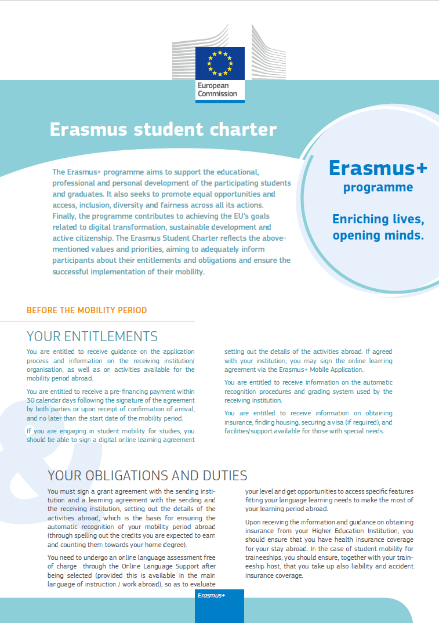

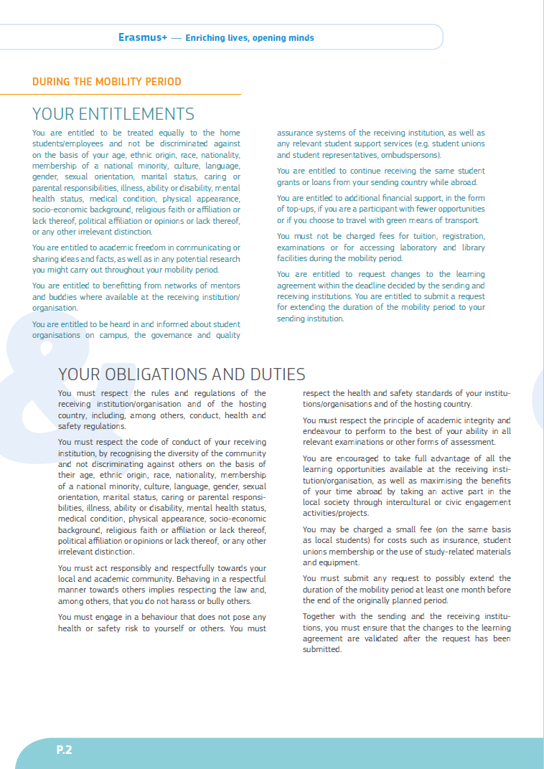

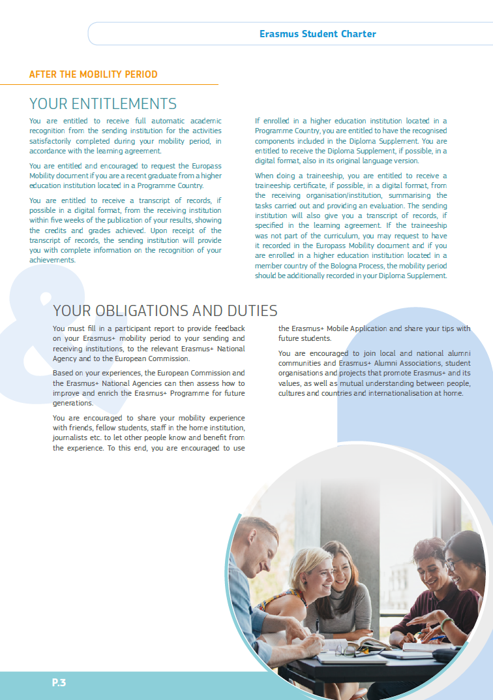

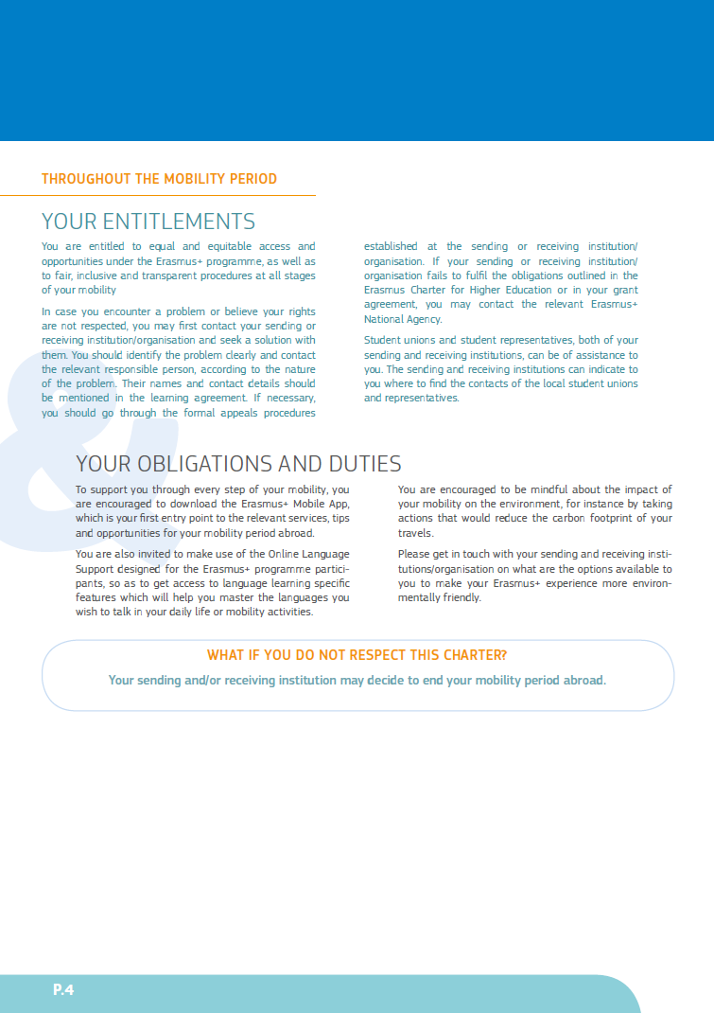

Frequently used ISCED codes
VU Programme | Field of education
PPE | 0288 Inter-disciplinary programmes and qualifications involving arts and humanities
Political science | 0312: Political sciences and civics
Social Psychology | 0313: Psychology
International migration and refugee law | 0421: Law
Neurosciences | 0510 Biological and related sciences not further defined
Biomolecular Sciences | 0510 Biological and related sciences not further defined
Oncology | 0510 Biological and related sciences not further defined
Bioinformatics and Systems Biology | 0510 Biological and related sciences not further defined
Biology | 0511 Biology
Ecology and Evolution | 0529 Environment, not elsewhere classified
Earth Sciences | 0532: Earth Sciences
Artificial Intelligence | 0688: Information and Communication Technologies (ICTs), interdisciplinary programmes
Health Sciences | 0910 Health not further defined
Medicine | 0912: Medicine
Drug Discovery and Safety | 0916 Pharmacy
Management, Policy Analysis and Entrepreneurship in the Health and Life Sciences | 0919 Health, not elsewhere classified
Gezondheid & Leven | 0919 Health, not elsewhere classified
International Public Health | 0919: Health, not elsewhere classified
For a list of all ISCED codes see: |  | ISCED 2013

Annex – relevant applicable rates

1. Travel support

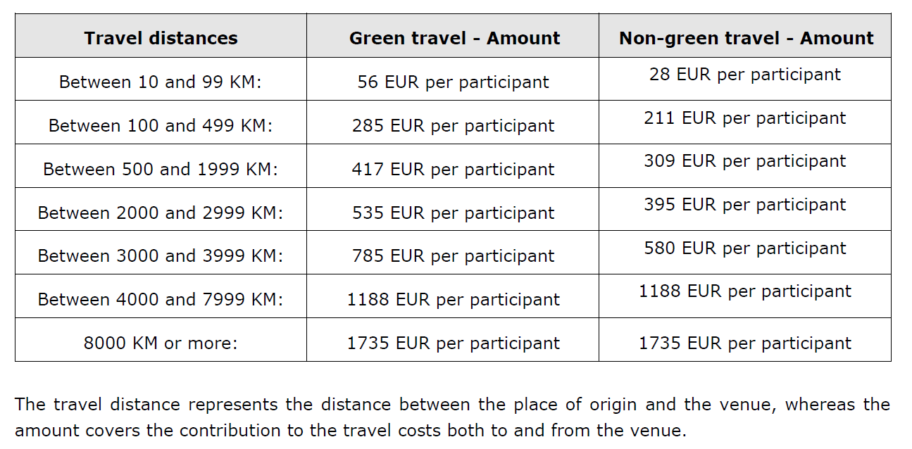

2. Individual support for physical mobility (internships)

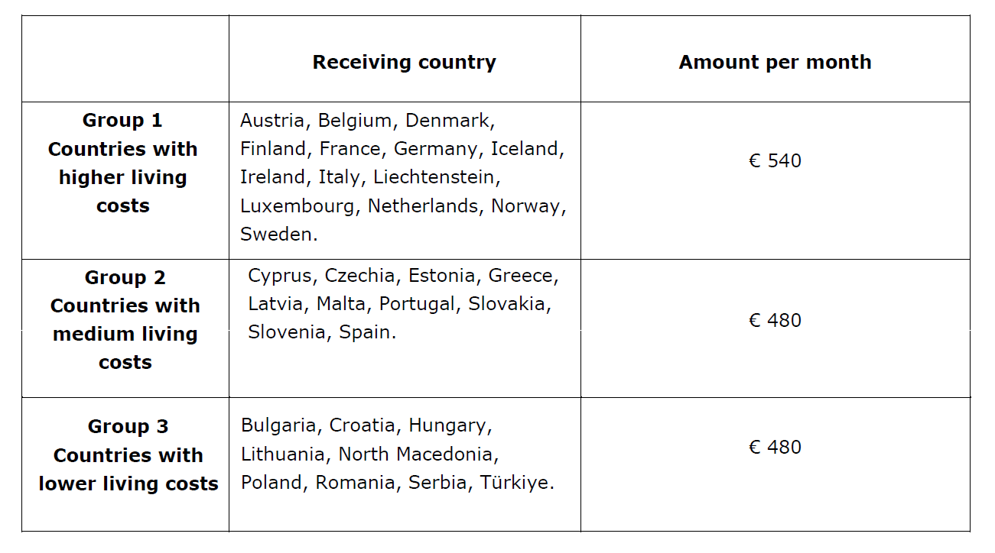

Nationality: country to which the person belongs administratively and that issues the ID card and/or passport.
Study cycle: Short cycle (EQF level 5) / Bachelor or equivalent first cycle (EQF level 6) / Master or equivalent second cycle (EQF level 7) / Doctorate or equivalent third cycle (EQF level 8).
Erasmus code: a unique identifier that every higher education institution that has been awarded with the Erasmus Charter for Higher Education (ECHE) receives. It is only applicable to higher education institutions located in Programme Countries. Search on internet with the name the name of your host university.
The ISCED-F 2013 search tool available at http://ec.europa.eu/education/tools/isced-f_en.htm should be used to find the ISCED 2013 detailed field of education and training that is closest to the subject of the degree to be awarded to the trainee by the sending institution.
The size of the enterprise could be, for instance, 1-50 / 51-500 / more than 500 employees. TERMS AND CONDITIONS ARTICLE 1 – SUBJECT OF THE AGREEMENT - This agreement sets out the rights and obligations and terms and conditions applicable to the financial support awarded to carry out a mobility activity under the Erasmus+ Programme. - The organisation will provide support to the participant for undertaking a mobility activity. - The participant accepts the support or the provision of services as specified in Article 3 and undertakes to carry out the mobility activity as described in Annex 1. - Amendments to this grant agreement will be requested and agreed by both parties through a formal notification by letter or by electronic message. ARTICLE 2 – DURATION OF MOBILITY 2.1 The mobility period will start on the first working day at the host organisation as mentioned above and end on the last working day at the host organisation as mentioned above. 2.2 The period covered by the agreement includes: - a physical mobility period as mentioned in 2.1 - and if relevant (in case of sustainable travel): funded travel days (1 -4 days) 2.3 The traineeship certificate shall provide the confirmed start and end dates of duration of the mobility period, including the virtual component. ARTICLE 3 – FINANCIAL SUPPORT 3.1 The financial support is calculated following the funding rules indicated in the Erasmus+ Programme Guide 2024 version. 3.2 The participant will receive a financial support from Erasmus+ EU funds for the number of days mentioned above. ([The number of days will be equal to the duration of the physical mobility period plus travel days) 3.3 The participant may submit a request concerning the extension of the physical mobility period up to the maximum activity duration set out in the Erasmus+ Programme Guide of 360 days. If the organisation agrees to extend the duration of the mobility period, the agreement will be amended accordingly. 3.4 The organisation shall provide the participant the total financial support for the mobility period and if applicable additional travel days in the form of a payment of EUR … 3.5 The contribution towards costs incurred in connection with green support and/or top-up for fewer opportunities, shall be based on the supporting documents provided by the participant. ARTICLE 4 – ELIGIBIlity of COSTS 4.1 In order to be eligible the costs must be actually used or produced by the participant in the period set out in Article 2 and/or be necessary for implementing the activity in the Annex. The costs must comply with the applicable national law on taxes, labour and social security. 4.2 Regarding actual costs (e.g. inclusion support) they must be based on supporting document such as invoices, receipts, etc. 4.3 The financial support may not be used to cover costs for activities already funded by Union funds. It is nonetheless compatible with any other source of funding. This includes a salary that the participant could receive for their traineeship or teaching activities, or for any work outside their mobility activities as long as they carry out the activities foreseen in Annex 1. 4.4 The participant may not claim reimbursement for currency exchange losses or bank costs charged by the participant’s bank for transfers from the sending organisation. ARTICLE 5 – PAYMENT ARRANGEMENTS 5.1 Payment shall be made to the participant no later than (whichever comes first): - 30 calendar days after the signature of the agreement by both parties - the start date of the mobility period The payment shall be made to the participant representing 70 % of the amount specified in Article 3. In case the participant did not provide the supporting documents in time, according to the funding organisation’s timeline, a later payment of the pre-financing can be exceptionally accepted, based on justified reasons. 5.2 The submission of the participant report via the online EU Survey tool shall be considered as the participant’s request for payment of the balance of the financial support. The organisation shall have 45 calendar days to make the balance payment or to issue a recovery order in case a reimbursement is due. ARTICLE 6 – RECOVERY 6.1 The financial support or part thereof shall be recovered by the sending organisation if the participant does not comply with the terms of the agreement. If the participant terminates the agreement before it ends, the participant shall have to return the amount of the grant already paid, except if agreed differently with the sending organisation. The latter shall be reported by the sending organisation and accepted by the National Agency. ARTICLE 7 – INSURANCE 7.1 The organisation shall make sure that the participant has adequate insurance coverage either by providing itself the insurance, or by making an agreement with the receiving organisation for the latter to provide the insurance, or by providing the participant with the relevant information and support to take an insurance on their own. 7.2 Insurance coverage shall include at minimum a health insurance and a liability insurance and an accident insurance. [Explanation: In the case of intra-European mobility, the participant’s national health insurance will include a basic coverage during their stay in another EU country through the European Health Insurance Card. However, this coverage may not be sufficient for all situations, for example in case of repatriation or special medical intervention or in case of international mobility. In that case, a complementary private health insurance may be needed. Liability and accident insurances cover damages caused by the participant or to the participant during their stay abroad. Varying regulation of these insurances is in place in different countries and participants run the risk of not being covered by standard schemes, for example if they are not considered to be employees or formally enrolled at their receiving organisation. In addition to the above, insurance against loss or theft of documents, travel tickets and luggage is recommended.] 7.3 The responsible party for taking the insurance coverage is the participant. ARTICLE 8 – LANGUAGE LEVEL AND ONLINE LANGUAGE SUPPORT (OLS) 8.1 The participant may carry out the OLS language assessment in the language of mobility (if available) before the mobility period and make use of the language courses available on the OLS platform. ARTICLE 9 – PARTICIPANT REPORT 9.1 The participant shall complete and submit the participant report on their mobility experience (via the online EU Survey tool) within 30 calendar days upon receipt of the invitation to complete it. Participants who fail to complete and submit the online participant report may be required by their organisation to partially or fully reimburse the financial support received. ARTICLE 10 – ETHICS AND VALUES 10.1 The mobility activity must be carried out in line with the highest ethical standards and the applicable EU, international and national law on ethical principles. 10.2 The participant must commit to and ensure the respect of basic EU values (such as respect for human dignity, freedom, democracy, equality, the rule of law and human rights, including the rights of minorities. 10.3 If a participant breaches any of its obligations under this Article, the financial support may be reduced or not be paid. ARTICLE 11 – DATA PROTECTION 11.1 Any personal data under the agreement will be processed under the responsibility of the data controller identified in the privacy statement in accordance with the applicable data provision legislation, in particular Regulation 2018/1725 and related national data protection acts and for the purposes set out in the Privacy Statement available at: https://webgate.ec.europa.eu/erasmus-esc/index/privacy-statement. 11.2 Such data will be processed solely in connection with the implementation and follow-up of the agreement by the sending organisation, the National Agency and the European Commission, without prejudice to the possibility of passing the data to the bodies responsible for inspection and audit in accordance with EU legislation (Court of Auditors or European Antifraud Office (OLAF)). 11.3 The participant may, on written request, gain access to his personal data and correct any information that is inaccurate or incomplete. The participant should address any questions regarding the processing of their personal data to the sending organisation and/or the National Agency. The participant may lodge a complaint against the processing of their personal data to the European Data Protection Supervisor with regard to the use of the data by the European Commission. ARTICLE 12 — AGREEMENT SUSPENSION 12.1 The agreement may be suspended by initiative of the participant or of the organisation if exceptional circumstances — in particular force majeure (see Article 16) — make implementation impossible or excessively difficult. The suspension will take effect on the day agreed by written notification by the parties. The agreement may be resumed afterwards. 12.2 The organisation may — at any moment — suspend the agreement, if the participant has committed or is suspected of having committed: - substantial errors, irregularities or fraud or - serious breach of obligations under this agreement or during its award (including improper implementation of the action, submission of false information, failure to provide required information, breach of ethics rules (if applicable), etc.). 12.3 Once circumstances allow for implementation to resume, the parties must immediately agree on the resumption date (one day after suspension end date). The suspension will be lifted with effect from the suspension end date. 12.4 During the suspension, no financial support will be paid to the participant. 12.5 The participant may not claim damages due to suspension by the organisation. 12.6 Suspension does not affect the organisation’s right to terminate the agreement (see Article 13). ARTICLE 13 – TERMINATION OF THE AGREEMENT 13.1 The agreement may be terminated by either party if circumstances arise that render the execution of the agreement impracticable, impossible or excessively difficult. 13.2 In case of termination due to force majeure (Article 16), the participant will be entitled to receive at least the amount of the financial support corresponding to the actual duration of the activity period. Any remaining funds will have to be recovered. 13.3 In the event of serious breach of obligations or if the participant has committed irregularities, fraud, corruption, or is involved in a criminal organisation, money laundering, terrorism-related crimes (including terrorism financing), child labour or human trafficking the organisation may terminate the agreement by formally notifying the other party. 13.4 The organisation reserves the right to initiate a court action if any requested refund is not voluntarily issued within the deadline notified to the participant by registered letter. 13.5 The termination will take effect on the date specified in the notification; ‘termination date’. 13.6 The participant may not claim damages due to termination by the organisation. ARTICLE 14 – CHECKS AND AUDITS 14.1 The parties of the agreement undertake to provide any detailed information requested by the European Commission, the National Agency of The Netherlands or by any other outside body authorised by the European Commission or the National Agency of The Netherlands to check that the mobility period and the provisions of the agreement are being or were properly implemented. 14.2 Any finding related to the agreement may lead to the measures set in Article 6 or to further legal action in the terms of the applicable national law. ARTICLE 15 – DAMAGES 15.1 Each party of this agreement exonerates the other from any civil liability for damages suffered by them or their staff as a result of performance of this agreement, provided such damages are not the result of serious and deliberate misconduct on the part of the other party or their staff. 15.2 The National Agency of The Netherlands the European Commission or their staff will not be held liable in the event of a claim under the agreement relating to any damage caused during the execution of the mobility period. Consequently, the National Agency of The Netherlands or the European Commission will not entertain any request for indemnity of reimbursement accompanying such claim. ARTICLE 16 – FORCE MAJEURE 16.1 A party prevented by force majeure from fulfilling its obligations under the agreement cannot be considered in breach of them. 16.2 ‘Force majeure’ means any situation or event that: - prevents either party from fulfilling their obligations under the agreement, - was unforeseeable, exceptional situation and beyond the parties’ control, - was not due to error or negligence on their part (or on the part of other participating entities involved in the action), and - proves to be inevitable in spite of exercising all due diligence. 16.3 Any situation constituting force majeure must be formally notified to the other party without delay, stating the nature, likely duration and foreseeable effects. 16.4 The parties must immediately take all the necessary steps to limit any damage due to force majeure and do their best to resume implementation of the action as soon as possible. ARTICLE 17 – LAW APPLICABLE AND COMPETENT COURT 17.1 The agreement is governed by Dutch Law 17.2 The competent court determined in accordance with the applicable national law will have sole jurisdiction to hear any dispute between the organisation and the participant concerning the interpretation, application or validity of this agreement, if such dispute cannot be settled amicably. ARTICLE 18 – ENTRY INTO FORCE The agreement will enter into force on the last date of signature by the parties.

