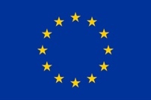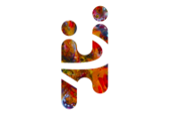  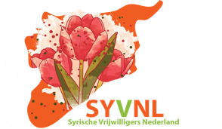

This project was co-financed by the European Union’s Asylum, Migration and Integration   
101038538 — 2incING — AMIF-2020-A

**Advocacy academy**

**Working with migrant and refugee advocates to create effective policies**

Assignment for come-back day –[INSERT DATE AND TIME] (online meeting)

Taking a cue from the discussion we had in the advocacy academy of [INSERT DATE], please formulate one possible intervention that could be done in your own organization, in order to create more space for refugee-led advocacy (or migrant-led advocacy). If possible, try to give this intervention a co-creation element. Describe this intervention: how would this look concretely?

Then try to make this plan ‘polyvocal’: Try talk to people who have as much as possible different positions in relation to this plan and include their perspective in the plan. For instance, policymakers at a higher policy level might have another perspective on what is needed than someone from a refugee/migrant organization, a non-refugee led NGO might have still another perspective. Try to map the different positions and perspectives that are needed to create a plan that is inclusive. Prepare a presentation in which you explain what you did and reflect on the process (max 7 minutes) to share on during the meeting. Try to map the different positions and perspectives that are needed to create a plan that is inclusive. You can use PPT, creative materials, small pieces of interviews with colleagues or advocates in the field, or other.

During the comeback day we will see and discuss the presentations. You can also make the presentation together with your colleagues. If you like, you can invite colleagues of your organization to be present and listen.