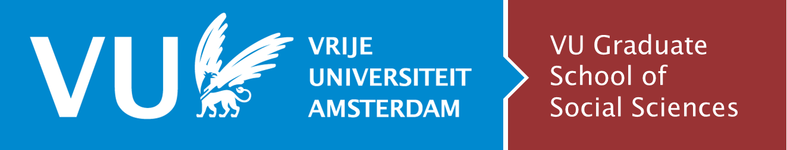
The VU GSSS Graduate Fund
This version is from July 10, 2024

General information
The aim of the Graduate Fund is twofold:
- the Graduate Fund supports a PhD candidate to carry out their research;
- the Graduate Fund stimulates a PhD candidate to orientate themselves internationally in order to promote a broad scientific development.

Research related costs eligible for (partial) coverage from the Graduate Fund
- Data collection, field work
- Translation and language editing
- Attendance at scientific conference, workshop (including accommodation, meals, travelling)
- Summer school or other doctoral training, not organized by the GSSS
- Other research related visits (to Vrije Universiteit, Amsterdam, within the Netherlands, to abroad) or a research stay at a foreign university, including travelling and housing
- Other research-related travel costs

Research related costs not eligible for coverage from the Graduate Fund
- Literature (book or access to a journal article)
- Publication fee (e.g. in cases of open access; many journals offer that the fee of open access publishing an article from Vrije Universiteit staff is charged to Vrije Universiteit)
- Computer and other technical equipment
- Lay-out and printing thesis
- Costs of graduation
- Travel costs and accommodation opposition
- Dissemination of research results

Conditions
- A PhD candidate can only apply when they have passed the Go / No Go assessment (in case the assessment is in procedure, please also submit your application. We can always conditionally approve your application)
- A PhD candidate can only apply when registered in Hora Finita
- The applications should be made before the activity takes place. Applications concerning activities which have taken place in the past are not taken into consideration
- PhD candidates are allowed to submit more than one application during their project
- Funding will be granted on the basis of co-financing: the Graduate Fund covers a maximum of 75% of the needed finances. Applicants will have to find other sources to cover the remaining costs (such as the main grant, subsidy or bench fee of your research project; the department; a specific grant or subsidy from an external party; your employer; your own means)
- The total limit for a candidate is €6000, and the yearly limit is €2000 (there is an exception for a candidate who has obtained personal drawing rights)
- A grant is less likely if the activity is intended to be carried out after three-quarters of the intended project duration (as defined in Hora Finita) or even after the project duration has been exceeded; an additional motivation for carrying out the activity is needed justifying why this will not prevent the rapid completion of the thesis
- Money awarded cannot be used for any other purpose than initially applied for
- Applications regarding activities for which a reasonable alternative is offered in The Netherlands will not be accepted
- VU regulations on sustainability (e.g., preference is given to travel by train over by air) should be followed
- VU regulations on reimbursement have to be followed
- When participating in a conference, workshop: You have to submit a paper, poster or similar kind of contribution.

Submitting your application
- Submissions can be made at any time, but they should be sent before the activity takes place.
- Applicants submit their application to the Director of the Graduate School, through the address of the Graduate School, graduate.school.fsw@vu.nl.
- The application should consist of:
  - A completed VU-GSSS Graduate Fund application form (in English) including a budget that clearly states travel costs, accommodation costs and other costs*
  - Copy of the letter of acceptance of the paper/poster, or a letter of acceptance by the university or research institute (if you do not have a confirmation yet, please send it to us as soon as possible).

Handling the application
- The GSSS management gathers all the applications received in a month and decides on submitted applications at the beginning of the following month.
- The GSSS may contact the applicant, the first supervisor and the other supervisor(s) for necessary clarification or further explanation
- The Program Manager informs the PhD candidate of the outcome
- The financial contribution will be reimbursed in arrears on presentation of a detailed account and by submitting a completed declaration form to the Finance & Control Department (please make sure to mention ‘Graduate Fund’ on the declaration form)
- An advance payment may be requested by filling in the “advance form’, signed by the head of the department.

PhD buddies and VU PhD council members are eligible for an additional €400 per year. Make sure to complete the “Personal drawing right” section in the application form to obtain this funding.
https://vu.nl/en/employee/declarations-and-commute-allowance/sustainable-business-travel
https://vu.nl/en/employee/declarations-and-commute-allowance
https://vu.nl/en/employee/declarations-and-commute-allowance/domestic-business-travel
https://vu.nl/en/employee/declarations-and-commute-allowance/international-business-travel

