Lake Weyba Foreshore

Overview
Council is keen to hear your views as we begin planning for Lake Weyba Foreshore Park’s future. Lake Weyba is a large shallow lake mostly fringed by natural landscapes. Lake Weyba Park is designated in part as a ‘district’ level recreation park and part ‘environmental reserve’. The foreshore currently provides the community with access to the lake for a variety of recreational purposes.
Purpose
Council is developing a landscape plan to guide future improvements to the foreshore and its recreation trails. The landscape plan will provide a vision for the foreshore to meet the growing recreational needs of the community.
The landscape plan will aim to:

- enhance the site’s environmental values
- determine the recreation opportunities and constraints of the site
- improve access to open space and the lake including recreation trails
- reflect the community’s vision, priorities and hopes for the future of the foreshore
Community engagement
You are invited to participate in sharing your ideas on the future use of the foreshore park. Your feedback will help guide the development of a landscape plan for the reserve. The landscape plan will be developed over the next few months and made available on council’s website and on public display for further comment from May 2018.
Have your say
Council invites local residents to the park to discuss issues and opportunities. Come and meet the team and share your thoughts. Look for the Council marquee in the park at Lake Weyba Drive Northern end on Saturday February 24. Between 9.00am-12.00 midday.
Alternatively complete the online survey at councils ‘have your say’ webpage. https://haveyoursay.sunshinecoast.qld.gov.au/
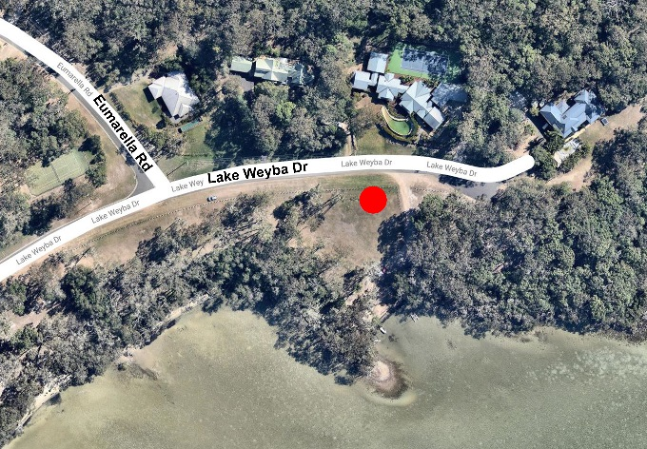
A note from your local councillor
This is a great opportunity for the local community to comment on the Lake Weyba foreshore. Your feedback is welcomed and appreciated. Once feedback has been considered, council will be in a better position to move forward with updating this wonderful community asset.
Cr Stephen Robinson
Further information
Please contact via LandscapeDesignandPlanning@sunshinecoast.qld.gov.au or on the details below.
Figure 1: Map showing the project area.
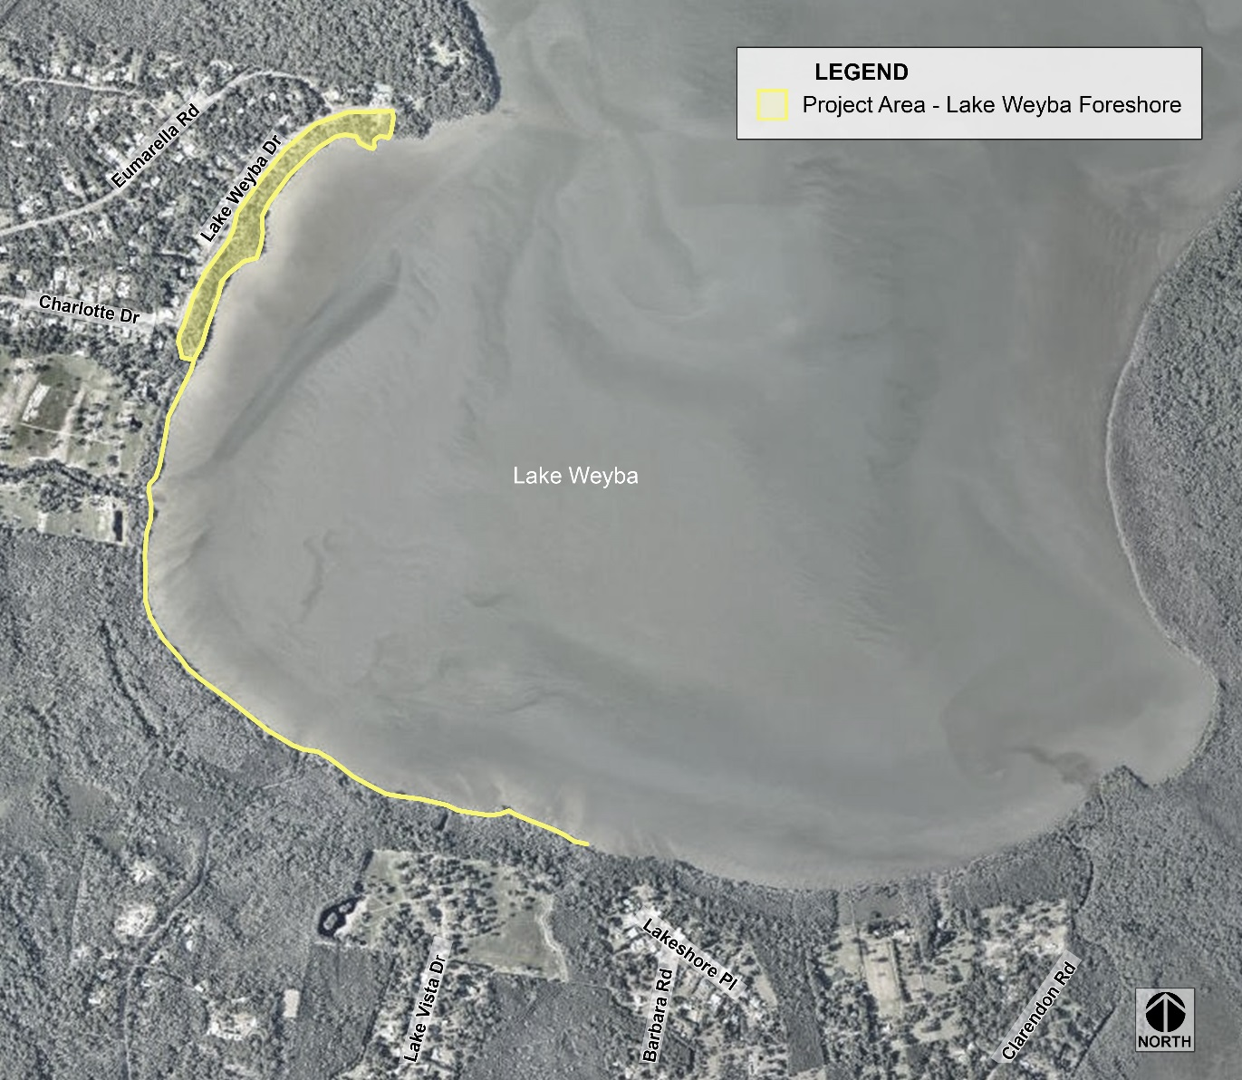
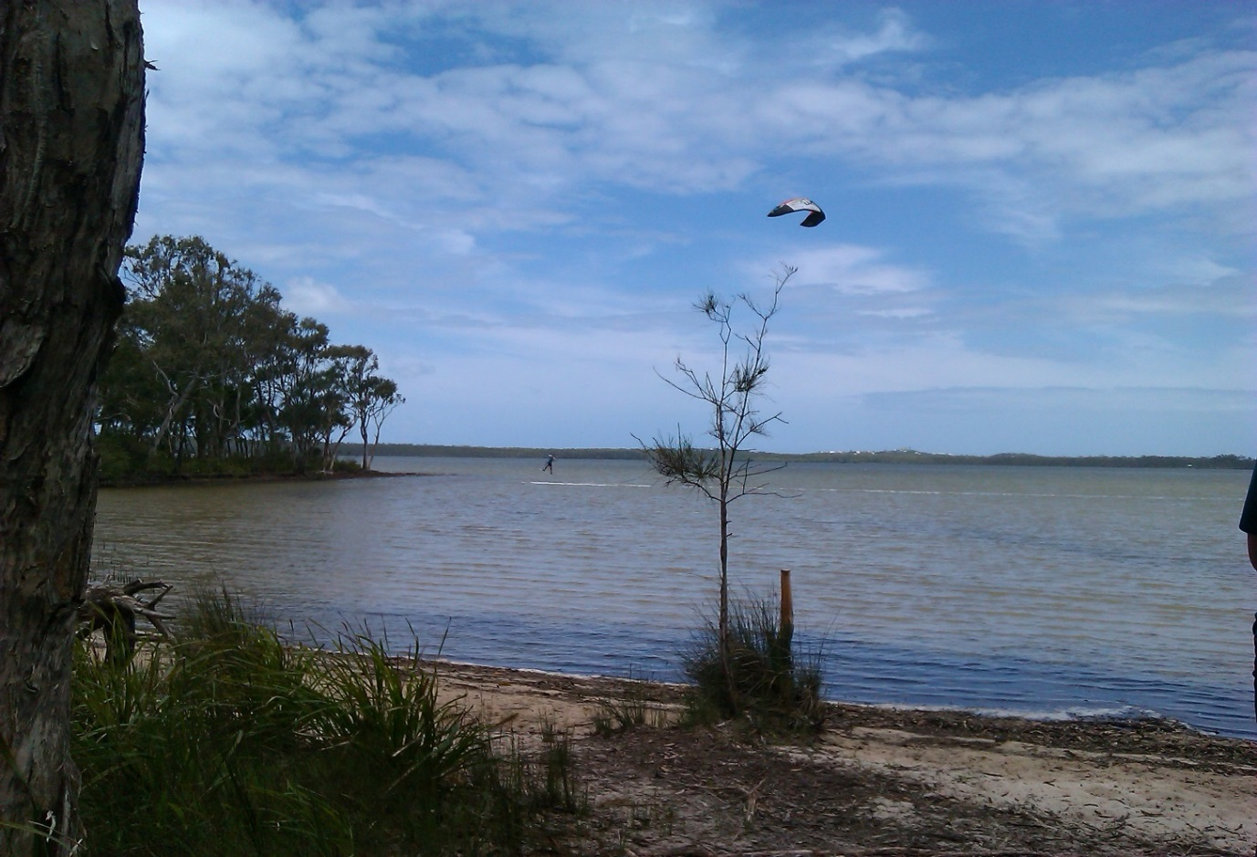
Figure 2: Image Lake Weyba

