<Organisation Name>

<Project Name>

Project Plan

<Date Compiled>

1.0 Project Goal
<Need & Benefit – what are you trying to achieve?>
<What are you proposing to do?>

2.0 Project Summary

2.1 Summary
<How are you going to achieve this?>
<Where are the main activities happening?>

2.2 Reasons for Proposing
<Why does this project need to happen?>

2.3 Impact if not Approved
<>

2.4 Stakeholders
<Who is involved/affected/benefits?>

3.0 Timeframes
<When are the key dates and milestones?>

4.0 Financial Considerations

4.1 Fundraising Plan
<>

4.2 Budget

Income
 | $
 | $ | $0.00

Expenditure
 | $
 | $
 | $
 | $
 | $
 | $ | $0.00

<Make it balance – what are ALL the costs involved?>

5.0 Marketing & Acknowledgement

- <>

6.0 Risk Assessment

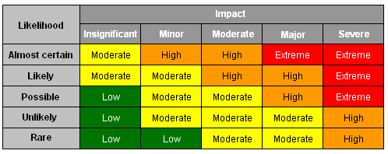

Risk | Likelihood | Consequence | Mitigation Strategy

7.0 Resources
<>
8.0 Governance & Management

Example of infrastructure project

The following will be adhered to:
- Work Health & Safety Act 2011 Qld
- Building & Demolition approval from Sunshine Coast Council

9.0 Action Plan

Activity | Details | Start Date | End Date | Responsibility
Quotes from local providers
Develop Project Plan
Seek funding
Engage contractor
Erection progress
Arrange marketing & promotion
Keep club members updated on developments or changes
Official Opening
Outcome Report for funding

10.0 Appendix
<Include reference to supporting documentation>

