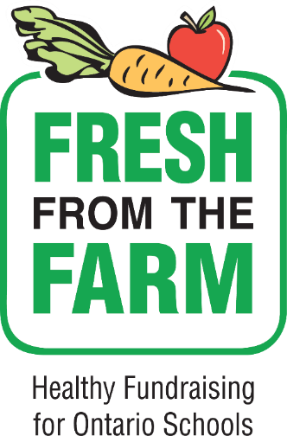

A *fresh* take on school fundraising

**Since 2013 *Fresh from the Farm* school fundraising has connected over 2,200 schools with Ontario farmers and enabled them to raise over $1.9 million for school initiatives by selling over 4.3 million pounds of Ontario grown fruits and vegetables**

**ONLY $3.00/lb**\

**Thank you for supporting school based initiatives and Ontario farmers**

**brought to you by**

**8lb Apple Bundle**

**$24.00**

**NEW - 8 lb bag Ambrosia apples**

**Ambrosia apples are a beautiful bright pinkish red and light yellow coloured apple. They are crisp and juicy with a distinct sweet aroma and sweet low acid flavour. Excellent for eating fresh.**

**14lb Vegetable Bundle**

**$22.00**

**Includes**

* **5 lb bag White Potatoes**
* **3 lb bag Sweet Potatoes**
* **3 lb bag Yellow Onions**
* **3 lb bag Orange Carrots**

**LESS THAN $1.60/lb**