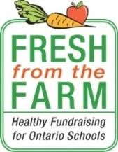
Fresh from the Farm
Healthy Fundraising for Ontario Schools

What is Fresh from the Farm?
Fresh from the Farm is designed to provide a healthy fundraising alternative to schools by selling Ontario-grown fruit and vegetables. Since 2013, over 1700 schools have raised over $1.5 million for school initiatives, selling 3.6 million pounds (lb) of Ontario grown produce.

Why Participate?
- Schools keep 40% of sales.
- Families enjoy fresh, Ontario-grown fruit and vegetables.
- Fresh from the Farm promotes a healthy school environment while providing an opportunity for students to raise money for school initiatives.
- Provides opportunities for students to learn about agri-food and healthy eating
- Supports Ontario farmers and our local economy

What are the Ontario-grown Bundles for sale?
Vegetable Bundle: $
Includes:
- 5 lb bag white potatoes
- 3 lb bag sweet potatoes
- 3 lb bag yellow onions
- 3 lb bag orange carrots

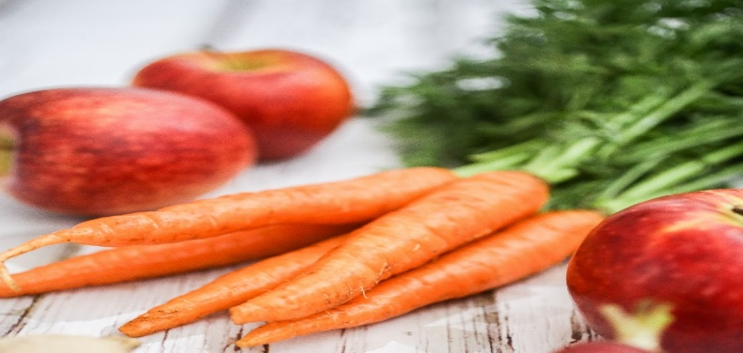

Apple Bundle: $

- 8 lb bag Empire variety apples

How does it Work?
- Schools enrol on www.freshfromfarm.ca by September 30
- Fundraise by selling Ontario grown Vegetable and Apple bundles to family, friends and the school community
- School Champion must submit orders online by October 14
- Schools will receive a 10 day advance delivery notice with specific date and 3 hour delivery window
- Deliveries take place between November 8 and December 9.
- On the delivery day, volunteers receive product and package Vegetable bundles into
Fresh from the Farm bags. Apple bundles arrive pre-packaged in a poly bag.

Instructions to Fundraisers:
- Record customer orders and complete the customer information on the Order Form (back-side of this flyer).
- Collect cash or cheque payment payable to the school.
- Return the Order Form and payment to the school by the date advised by your school.

We appreciate your support – helping students fundraise in a healthier way!

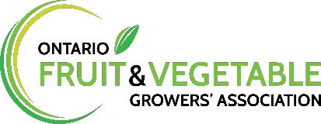
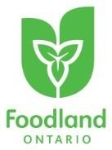
For more information email contact@freshfromfarm.ca or visit www.freshfromfarm.ca

