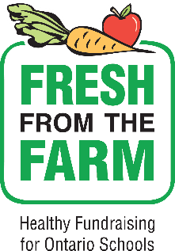**Order Form** School Name: _________________________________

Teacher Name: ­­_______________________________

Student Name: ________________________________

A *fresh* take on school fundraising

**Since 2013 *Fresh from the Farm* school fundraising has connected over 2,200 schools with Ontario farmers and enabled them to raise over $1.9 million for school initiatives by selling over 4.3 million pounds of Ontario grown fruits and vegetables**

**14lb Vegetable Bundle**

**$22.00**

**Includes**

* **5 lb bag White Potatoes**
* **3 lb bag Sweet Potatoes**
* **3 lb bag Yellow Onions**
* **3 lb bag Orange Carrots**

**8lb Apple Bundle**

**$24.00**

**NEW - 8 lb bag Ambrosia apples**

**Ambrosia apples are a beautiful bright pinkish red and light yellow coloured apple. They are crisp and juicy with a distinct sweet aroma and sweet low acid flavour. Excellent for eating fresh.**

|  |  |  |  |  |  |  |  |  |
| --- | --- | --- | --- | --- | --- | --- | --- | --- |
| **Customer Information** | | | **# Vegetable Bundle** | **#**  **Apple Bundle** | **Total $** | **Payment Method** | | **Product Received**  **🗹** |
| **Name** | **Email** | **Phone** | **$22 each** | **$24 each** | **$Veg+$Apple** | **Cash Online** | **Cash or Cheque** |
|  |  |  |  |  |  |  |  |  |
|  |  |  |  |  |  |  |  |  |
|  |  |  |  |  |  |  |  |  |
|  |  |  |  |  |  |  |  |  |
|  |  |  |  |  |  |  |  |  |
|  |  |  |  |  |  |  |  |  |
|  |  |  |  |  |  |  |  |  |
|  |  |  |  |  |  |  |  |  |
|  |  | **TOTAL** | **#** | **#** | **$** | **$** | **$** |  |

***

**Brought to you by:**