|  |  |
| --- | --- |
|  | Eighteenth Sunday in Ordinary Time Yr B 4 August 2024 |
| **Parish Priest: Fr Hien Vu**  **The Parish Office open hours are Tuesday - Friday 9am-4pm** |
| **Pastoral Worker:** George Thommana  **Finance/Admin:** Monique Heckmann [Tue, Wed, Thur: 9am – 4pm]  **Sacraments:** Contact Parish Office [Phone 03 9412 8493]  **Parish Office:** 2-20 Fir Street, Whittlesea 3757 **Postal address:** P.O. Box 221, Mernda 3754 **Phone Number:** 03 9412 8493  **Mobile Number:** 0448 101 401  **Email:** [merndawhittlesea@cam.org.au](mailto:merndawhittlesea@cam.org.au)  **Website:** [**www.christthelightparish.org.au**](http://www.christthelightparish.org.au/) |
| Nazareth Centre, Mernda  (St Joseph*’*s Primary School)  44 Mernda Village Drive Mernda 3754  Confession/Reconciliation: Saturday 4pm Weekend Masses: Saturday 5:30pm Sunday 8am and Sunday 10:30am  Children*’*s Liturgy EVERY Sunday 10:30am | We pray for those who have **died recently**:  And for those whose **anniversaries** occur at this time:  We pray for those who are **ill in our community**: Peter O’Brien, K.P Abraham, Indika Fernando, Maria Ah Kiau, Gina Wherrett, Susan Stocks, Neth Mercado, John Dellamarta |
| St Mary*’*s, Whittlesea  2-20 Fir Street Whittlesea 3757  Weekday Mass: Tuesday & Thursday 9:15am Confession/Reconciliation after  Tuesday & Thursday 9:15am Mass. Weekend Mass: Sunday 10am | **Entrance Antiphon: Gospel Acclamation**  O God, come to my assistance; **Alleluia, alleluia!** No one lives on bread O Lord, make haste to help me! alone, but on every word that comes You are my rescuer, my help; from the mouth of God. **Alleluia!**  O Lord, do not delay. **Gospel:**  **First Reading:** John 6:24-35  Exodus 16:2-4. 12-15  **Responsorial Psalm: Nextweek: 19th Sunday in Ord Time Yr B**  The Lord gave them bread from heaven. First: 1 Kings 19:4-8  Second: Ephesians 4:30 – 5:2  **Second Reading:** Gospel: John 6:41-51 Ephesians 4:17, 20-24 |
| St Mary*’*s, Kinglake  124 Whittlesea-Kinglake Rd Kinglake 3763  Weekend Mass: Sunday 8:30am |
| St Joseph*’*s, Mernda  1490 Plenty Rd Mernda 3754  Weekday Mass: Wednesday & Friday 9:15am Weekend Mass: Sunday 5pm |
| **A reflection…**  Pope Francis encourages us to remember that ‘Jesus came to bring us something more’ than just food or even miracles. Jesus seeks ‘to open our lives to a wider horizon.’  Jesus, the Pope points out, ‘encourages the people to go a step further’ than being receivers of bread. Jesus wants his followers to ponder ‘the significance of the miracle, and not simply to take advantage of it.’  In a sense, the crowd in this Gospel passage got hung up on spiritual work and gain. They ask: what must they do? Jesus  says: believe in him. ‘What work will you do?’, they ask in turn. It is as if their relationship with God was transactional.  Jesus wants his followers to avoid this sort of thinking. ‘This is a common temptation’, the Pope says, where ‘the crowd wants to know from Jesus which actions it must perform in order to please God.’  The reality which Jesus reveals is quite the opposite. Rather, as the Pope puts is, ‘faith in Jesus allows us to carry out God’s works.’  It is, after all, the giver of life itself who is the giver of bread. That creative love precedes any of our thoughts or actions. We receive God’s love by recognising its presence. Which in turn allows us to play our part in making it present to others.  **© Nick Brodie** | |

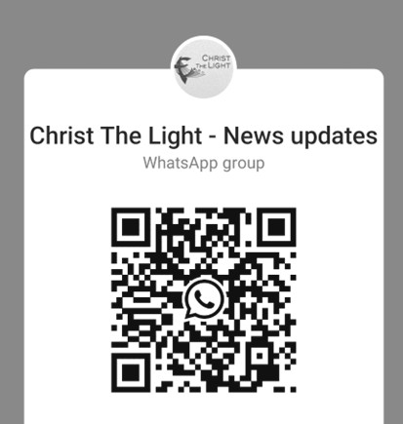

**Join the CTL parish WhatsApp group for regular parish news updates. QR Code also available on the parish website** [**www.christthelightparish.org.au**](http://www.christthelightparish.org.au/)



**New CHURCH Building**

**Account Details:**

If you would like to make a Direct Deposit DONATION* to the

New Church Building account.

**BSB:** **083 - 347**

**Acc No: 135 263 131**

*Any donation made to this account is NOT tax deductible as we are a

Not For Profit organization

**Weekly Quote Quotations of The Prayer of the Frog**

**- Page 137**

A group of expectant fathers sat nervously in the hall. A nurse beckoned to one of them and said, “Congratulations, you have a son!”

Another man dropped his magazine, jumped up and cried, “Hey, what’s the idea? I got here two hours before he did!”

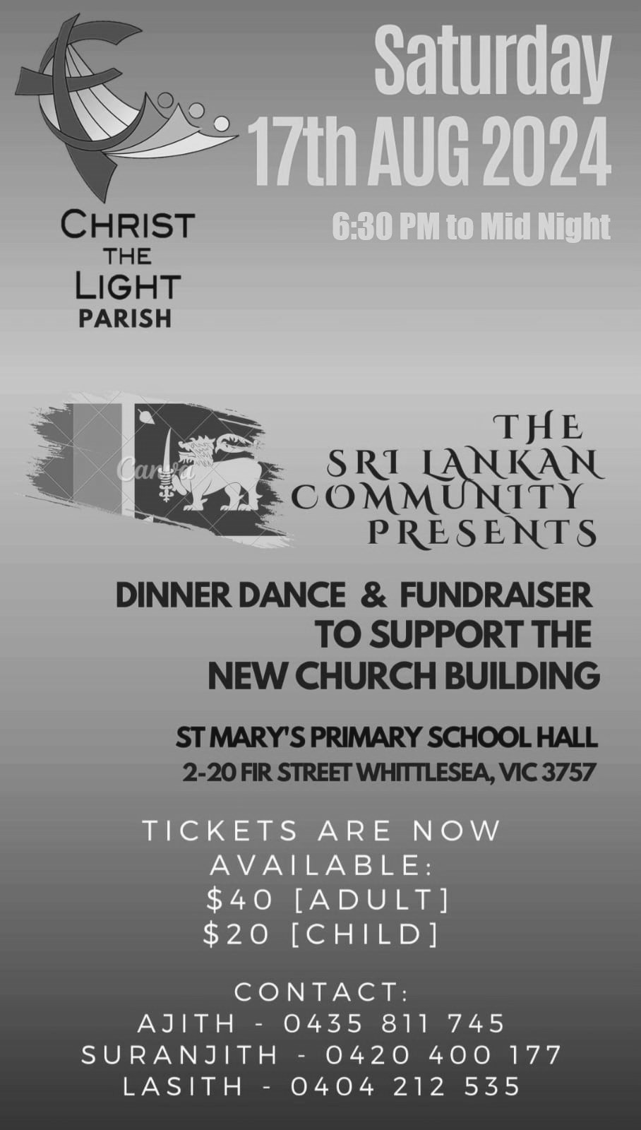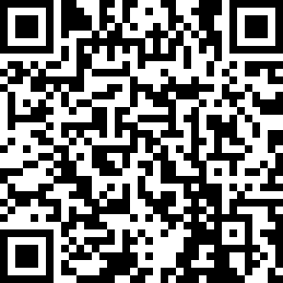

**CONFIRMATION Candidates** - We welcome our Confirmation Candidates, who are to be presented to the community prior to receiving the Sacrament of Confirmation 23rd and 24th August. You are also invited to stay for morning tea after the masses.

**SAVE THE DATE:** - Bunnings Mernda Cake Stall – Saturday, 31st August 2024. Recipes will be available next week. We’re hoping

this year’s stall will be as successful if not better than last year’s cake stall.

**Mission: Transform Lives - theirs...and yours** Have you been considering whether an overseas professional placement with Palms is for you? Wanting to share your skills with communities in the Pacific, Asia or Africa to help develop self-reliance and

sustainable solutions to poverty? Join our Palms’ [Discovery Webinar](https://palms.org.au/event/discovery-online/) online on Thursday 15 August. Meet Carolyn, currently in Timor Leste, and former Palms participants to find out more about [Assignments Aboard.](https://palms.org.au/current-opportunities/) **Venue:** Online via Zoom- register at palms.org.au/event/discovery-online/ **Date:** Thursday 15th August 2024 **Time:** 7:30 pm - 8:30 pm AEST **02 9560 5333**

[**palms@palms.org.au**](mailto:palms@palms.org.au)

**National Vocations Awareness Week** – Vocations come from families, communities and parishes. Strong families and communities are the place where vocations are first nurtured. In this National Vocations Awareness Week, let us pray for all families in our parish, and for those preparing for marriage. Let us also pray that our parish community may always be welcoming and encouraging of vocations to marriage, priesthood and consecrated life.

MINISTRY ROSTER : **10/11 August 2024**

***[W] Welcomer [L] Leader [R] Reader [E] Eucharist [LT] Laptop***

**10am - Whittlesea: *[W]*** *Irene B, Mary S* ***[L]*** *Tracy K* ***[R]*** *Xanda B* ***[E]*** *Joyce L* ***[LT]*** Barry K

**NAZARETH CENTRE SET UP:**

**4:30pm Saturday Month of AUGUST: Contact Parish Office**

please text parish office 0448 101 401 if you are able to assist on any of the following Saturdays 10 / 17 / 24 /31 August

**Nazareth Centre Ministries Roster Platform**[https://www.christthelightparish.org.au/](https://www.christthelightparish.org.au/Document/rosters) [Document/rosters](https://www.christthelightparish.org.au/Document/rosters)



***We are a Child Safe Parish. We hold the care, safety and well-being of children, young people and vulnerable adults as a central and fundamental responsibility of our community.***