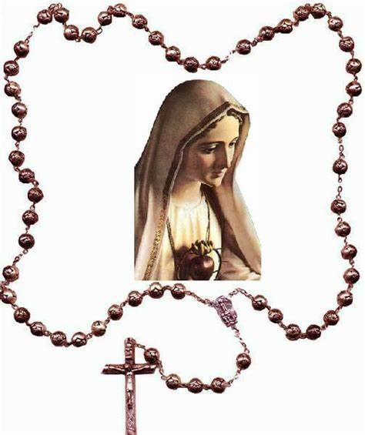The Mysteries of the Rosary
As you pray each mystery meditate on the scripture that accompanies it. Visualise the story being told as you walk through the life of Jesus Christ with his Mother Mary.
The Joyful Mysteries (Mondays and Saturday)
1. The Annunciation – Mary is told by the angel Gabriel that she is to be the Mother of God.
The angel said to her “Do not be afraid Mary, for you have found favor with God. And now, you will conceive in your womb and bear a son, and you will name him Jesus. He will be great, and will be called the Son of the Most High.” (Luke 1:30-32 a)
2. The Visitation – Mary visits her cousin Elizabeth who rejoices in Mary being chosen to be the Mother of God. Mary set out and went with haste to a Judean town in the hill country, where she entered the house of Zechariah and greeted Elizabeth. When Elizabeth heard Mary’s greeting, the child leaped in her womb. (Luke 1:39-41a)
3. The Nativity – Jesus is born!
While they were there, the time came for her to deliver her child. And she gave birth to her firstborn son and wrapped him in bands of cloth, and laid him in a manger, because there was no place for them in the inn.
(Luke 2:6-7)
4. The Presentation -The Infant Jesus is presented in the Temple.
When the time came for purification according to the law of Moses, they brought him up to Jerusalem to present him to the Lord. (Luke 2:22)
5. The Finding of Jesus in the Temple – Jesus is lost for three days and is found by Mary and Joseph in the temple with the teachers listening and asking questions.
When his parents saw him they were astonished; and his mother said to him, “Child, why have you treated us like this?” He said to them, “Why were you searching for me? Did you not know that I must be in my father’s house?” (Luke 2:48-49)
Luminous Mysteries – Mysteries of Light (Thursdays)
1. Baptism of Jesus – Jesus is baptised in the River Jordan by his cousin John the Baptist.
And when Jesus had been baptised, just as he come up from the water, suddenly the heavens were opened to him and he saw the Spirit of God descending like a dove and alighting on him. And a voice from heaven said “This is my Son the Beloved, with whom I am well pleased.” (Matthew 3:16-I 7)
2. Wedding at Cana – Jesus’ miracle at the Wedding of Cana is the first sign of his public ministry.
Jesus did this the first of his signs, in Cana of Galilee, and revealed his glory; and his disciples believed in him. (John 2:7-10,12)
3. Proclamation of the Kingdom of God – Jesus proclaims the Kingdom of God.
The time is fulfilled, and the kingdom of God has come near; repent and believe in the Good News. (Mark 1:15)
4. Transfiguration – Jesus is transfigured on the mountain.
Then from a cloud came a voice that said, “This is my Son the Chosen; listen to him!” (Luke 9:28-29,35)
5. Institution of the Eucharist – (John 13:1) Jesus gives us his Body and Blood.
For as often as you eat this bread and drink the cup, you proclaim the Lord’s death until he comes. (1 Corinthians 11:23-26)
The Sorrowful Mysteries (Tuesday and Friday)
1. The Agony in the Garden – Jesus goes with his disciples to the Garden of Gethsemane to pray.
They came to a place called Gethsemane; and he said to his disciples, “Sit here while I pray.” He took with him Peter and James and John, and began to be distressed and agitated. And He said to them, “I am deeply grieved, even to death.” (Mark 14:32-34)
2. The Scourging of Jesus at the Pillar – Jesus is brought to Pilate for trial. Pilate can see no fault in Jesus.
So Pilate, wishing to satisfy the crowd, released Barabbas for them; and after flogging Jesus, he handed him over to be crucified. (Mark 15:15)
3. The Crowning of Thorns – Jesus is taken by the soldiers who strip him and place a crown of thorns on his head. Then the soldiers led him into the courtyard of the palace (that is, the govérndr’s headquarters); and they called together the whole cohort. And they clothed him in a purple cloak; and after twisting some thorns into a crown they put it on him. And they began saluting him “Hail, King of the Jews” (Mark 15:16-18)
4. The Carrying of the Cross – Jesus carried his cross to the Place of the Skull which in Hebrew is called Golgotha.
Carrying the cross by himself, he went to what is called The Place of the Skull, which in Hebrew is called Golgotha. (John 19:16b-17)
5. The Crucifixion – Jesus is nailed to the cross. With him were criminals who were also being crucified. One criminal evokes Jesus to remember him when he enters into heaven.
When they came to the place of that is called The Skull, they crucified Jesus, there were criminals, one on his right and one on his left. Then he said ‘Jesus remember me when you come into your kingdom. (Luke 23:33,42)
The Glorious Mysteries (Wednesday and Saturday)
1. The Resurrection – After the Sabbath Mary Magdalene and the other Mary went to the tomb of Jesus. An angel appeared to them and told them that Jesus had risen from the dead.
The angel said to the women “Do not be afraid; I know that you are looking for Jesus who was crucified. He is not here; for he has been raised, as he said. Come see the place where he lay.(Matthew 28:5-6)
2. The Ascension – Jesus appears to two of his followers on the road to Emmaus and they do not recognise him until they break together.
Then he lead them out as far as Bethany, and, lifting up his hands, he blessed them, he withdrew from them and was carried up to heaven. (Luke 24:50-51)
3. The Descent of the Holy Spirit – The followers and disciples of Jesus were gathered together on the day of Pentecost. When the day of Pentecost had come, they were all together in one place. And suddenly from heaven their came a sound like a rush of violent wind… All of them were filled with the Holy Spirit and began to speak in other languages, as the Spirit gave them ability. (Acts 2:2-4)
4. The Assumption – After the death of Mary the Mother of Jesus she was taken body and soul into heaven.
My soul magnifies the Lord, and my spirit rejoices in God my Saviour, for he has looked with favour on the lowliness of his servant. Surely from now on all generations will call me blessed; (Luke 1:46-48)
5. The Coronation – Mary the Mother of God is crowned Queen of Heaven.
A great portent appeared in heaven: a women clothed with the sun, with a moon under her feet, and on her head a crown of twelve stars. (Revelation 12:1)

