

IMPORTANT BILLING INSTRUCTIONS TO CARRIERS

In order to facilitate timely payments and accurately reflect Tenneco freight expenses, it is important to adhere to the following instructions:

- Update your billing system to reflect the correct name and address information for the Tenneco shipping locations per the attached Tenneco locations document.

- Ensure EDI and hard copy billing contains full name, address, city, state, and zip code information for the shipper, consignee, and the Tenneco responsible party to pay for all shipment terms (PP, CC, TP)

- Ensure all hard copy billing is accompanied by bill of lading and or other supporting documents for outbound prepaid and third party shipments.

- Ensure all hard copy billing is accompanied by delivery receipt and or other supporting documents for inbound collect shipments.

- Ensure you are using correct payment terms when billing.

  - Tenneco to Tenneco should be collect but may be prepaid
  - Tenneco to non Tenneco should be prepaid
  - Non Tenneco to Non Tenneco should be TP

Note to Carriers: Failure to comply with these instructions may lead to longer payment cycle times or returned invoices.

If you have any questions relative to this document, please contact Hans Kuhn at
847-482-5903 or hans.kuhn@tenneco.com

Thank you in advance for your cooperation
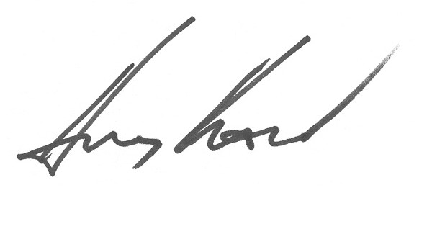
Hans Kuhn
Logistics, Manager – North America

