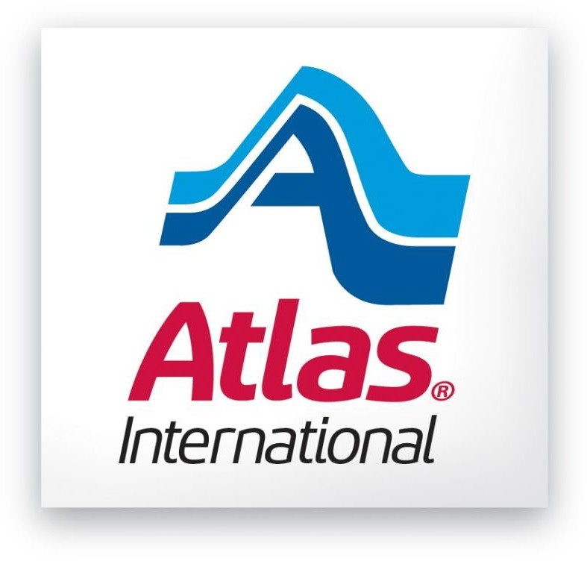

SUPPLIER/AGENT
CODE OF CONDUCT

GENERAL STATEMENT
Atlas World Group International, Inc. and Atlas Van Lines International Corp., together with their subsidiaries (collectively, “Atlas International”) is committed to respecting human rights, fair labor practices, and humane working conditions, as well as environmentally responsible and ethical practices. Atlas International requires all of its suppliers and agents to operate in accordance with the principles and requirements set forth in this Supplier/Agent Code of Conduct (hereinafter, the “Code”), as applicable, and in full compliance with all applicable laws and regulations.

Atlas International will not do business with any supplier or agent who does not abide by the Code. The Code applies to all new and existing Atlas International suppliers and agents, their subsidiaries and affiliates, and any of their subcontractors and sub-tier suppliers (each, a “Supplier/Agent”) that provide goods or services to Atlas International. By providing goods and services to Atlas International, Supplier/Agent represents and warrants its compliance with this Code.

LABOR AND HUMAN RIGHTS
All workers in Atlas International’s supply chain must be treated with the utmost dignity and respect, and Supplier/Agent shall uphold the highest standards of human rights. In this regard, Supplier/Agent must meet the following minimum labor standards with respect to all workers:
- Forced Labor Prohibited. Supplier/Agent must not use forced, bonded (including debt bondage), or indentured labor; indentured child labor; servitude; involuntary prison labor; or slave labor. Supplier/Agent shall respect all rules prohibiting modern slavery and forced labor, and ensure goods and services were not mined, produced, or manufactured (wholly or in part) with prohibited forms of labor. All work must be voluntary, and workers must not be required to surrender any government-issued identification, passports, or work permits as a condition of employment.
- Child Labor Avoidance. Supplier/Agent must not use child labor. The term “child” refers to any person who is younger than the legal minimum age for employment or under the age for completing compulsory education, whichever is higher.
- No Human Trafficking. Supplier/Agent must not engage in human trafficking, including transporting, harboring, recruiting, transferring, or receiving vulnerable persons by means of threat, force, coercion, abduction, or fraud for the purpose of exploitation.

ENVIRONMENTAL PRACTICES
Supplier/Agent must strive to minimize its environmental impact by adopting environmentally sustainable practices. In this regard, Supplier/Agent must adhere to the principles and requirements set forth in Atlas International’s Environmental Policy, as applicable.

ETHICAL PRACTICES
Supplier/Agent must conduct its business affairs with integrity and transparency. In this regard, Supplier/Agent must adhere to the principles and requirements set forth in Atlas International’s Anti-Bribery/Anti-Corruption Charter, Privacy Policy, Data Privacy Protection Procedures, and Corporate Compliance Program & Code, all as applicable.

TRAINING
This Code, in conjunction with the additional policies identified herein, comprise Atlas International’s social compliance program and demonstrate Atlas International’s commitment to ensuring that its environmental, social, and governance goals are achieved. These documents have been communicated to and acknowledged by Atlas International’s internal personnel, and can be found posted online by Atlas International’s private customers and corporate accounts, as well as the suppliers in Atlas International’s supply chain and Atlas International’s agents.

Atlas International commits to provide appropriate training to its internal personnel on an annual basis that focuses on various topics in its social compliance program, including identifying and mitigating risks (such as forced labor) within its supply chains. Atlas International expects and encourages Supplier/Agent to develop and/or maintain a similar training program for its own internal personnel.

CONFIDENTIAL REPORTING OF VIOLATIONS
If you suspect or become aware of misconduct or any violation of the Code (including any involvement in forced labor practices), you must promptly notify Atlas International. The easiest way is to send an email to your primary contact at Atlas International or to call the Compliance Hotline:
- English speaking USA and Canada: 833-210-4025
- Spanish speaking USA and Canada: 800-216-1288
- French speaking Canada: 855-725-0002
- Spanish speaking Mexico: 01-800-681-5340

A report can also be made anonymously in writing to:
Corporate Compliance Officer
Atlas International
1212 Saint George Rd.
Evansville, IN 47711

Every report will be handled confidentially (to the fullest extent possible), investigated thoroughly, and acted upon appropriately. No employee of Atlas International shall be sanctioned, disciplined, or intimidated in any way for his or her good faith reporting of suspected criminal activity or noncompliance with the Code.

Atlas International expects Supplier/Agent to offer its employees and business partners similar adequate reporting channels, including anonymous reporting methods, where they can raise legal or ethical concerns without fear of retaliation.

QUESTIONNAIRES AND CORRECTIVE ACTION
Supplier/Agent shall perform periodic evaluations of its facilities and operations to ensure compliance with this Code and applicable laws and regulations. From time to time, Atlas International may submit questionnaires to Supplier/Agent or request information and documentation from Supplier/Agent to enable Atlas International to review and evaluate Supplier/Agent’s compliance with this Code and applicable laws and regulations. Supplier/Agent shall timely complete such questionnaires and provide the information and documentation reasonably requested. Supplier/Agent shall also have a documented process in place for timely correcting any deficiencies or violations identified by any questionnaire, assessment, audit, or review.

QUESTIONS
For questions or concerns about this Code, please contact Privacy@atlasintl.com.

