Are you struggling to make ends meet on a fixed income?

Attend a FREE financial education workshop!

Savvy Saving Seniors®
Becoming Resource-FULL with the
Help of Benefits and Peace of Mind Savings
Sponsored by the National Council on Aging
and Bank of America Charitable Foundation

DATE at TIME
Name of Organization
Address
City, ST
RSVP by Date to (xxx) xxx-xxxx
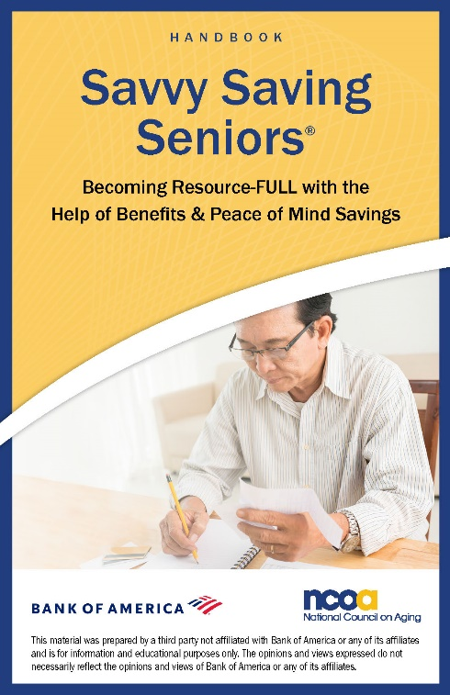
Discover:
- How to budget your money
to stretch your income
- Easy ways to save
- How to set financial goals
- Whether you might qualify for
benefits to help you pay your bills

Plus receive a free financial education handbook!
This is an educational event only—
NO financial products will be sold.

