# What is SNAP?

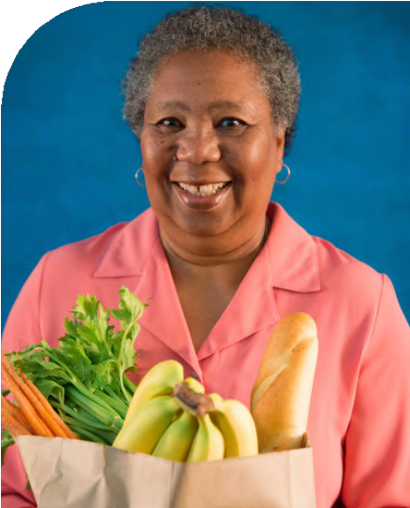

***It’s important to eat right—  
even when money is tight!***

The Supplemental Nutrition Assistance Program (SNAP, formerly food stamps) helps individuals and families with limited incomes buy the food they need to stay healthy.

Roughly 6.5 million households with older adults age 60+ use SNAP to buy healthy food at their local store or market.

Although SNAP is the national name, your state may use a different name.

For more information on SNAP and how to apply, visit:

BenefitsCheckUp.org/SNAP

**LOCAL CONTACT INFORMATION**

Put Healthy Food on Your Table

This brochure was developed with generous support from the Walmart Foundation.

# Why Apply?



Household income from all sources, such as money you get from a job, Social Security, SSI, or interest.

•

You can get help from SNAP if you have limited income and resources. You may also qualify if you have high medical and living expenses.

**The amount you receive may depend on two things:**

**Am I Eligible?**

**If you have limited income, you may qualify.**

How many people live in your

household.

Visit BenefitsCheckUp.org/SNAP   
to find out if you’re eligible.

•

## You’ll get healthy food for yourself and your family.

SNAP can be used to buy healthy food for your household, such as fruits and vegetables, bread, meat, and dairy products.

## You’ll save money on groceries.

On average, SNAP provides households with individuals age 60+ with $188 a month to buy healthy food.

## It’s easy to use.

When you enroll in SNAP, you’ll get money every month on a special debit card you can use to buy food.

## It’s convenient.

Over 265,000 grocery stores, farmers markets, and neighborhood stores across the country accept SNAP.

# Apply in

Visit BenefitsCheckUp.org/SNAP   
to find out if you’re eligible.

**3 Easy Steps**

## Find your state’s program information.

1

Go to BenefitsCheckUp.org/SNAP and enter your ZIP code to find your state’s SNAP application and see if you’re eligible.

## Fill out an application.

2

Depending on where you live, you can apply online, by mail, or in person—and get one-on-one help if you need it.

## Attend an interview.

3

In most states, your local SNAP office will contact you to schedule an interview. You may request a phone interview if you’re not able to go to the office.