Do you know how to protect yourself from scams?

Attend a FREE educational workshop to find out!

Savvy Saving Seniors®
Steps to Avoiding Scams
Sponsored by the National Council on Aging,
Bank of America Charitable Foundation,
and Women’s Institute for a Secure Retirement

DATE at TIME
Name of Organization
Address
City, ST
RSVP by Date to (xxx) xxx-xxxx
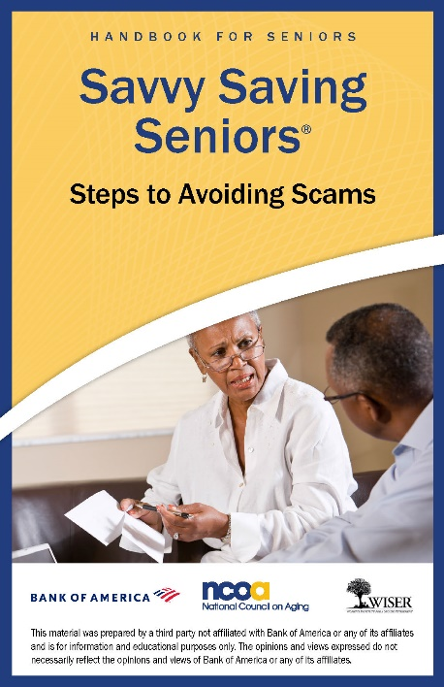
Discover:
- The 10 most popular scams
targeting seniors
- Tips to protect yourself
- What you should do if you’ve
been scammed

Plus receive a free scams handbook
to take home!
This is an educational event only—
NO financial products will be sold.

