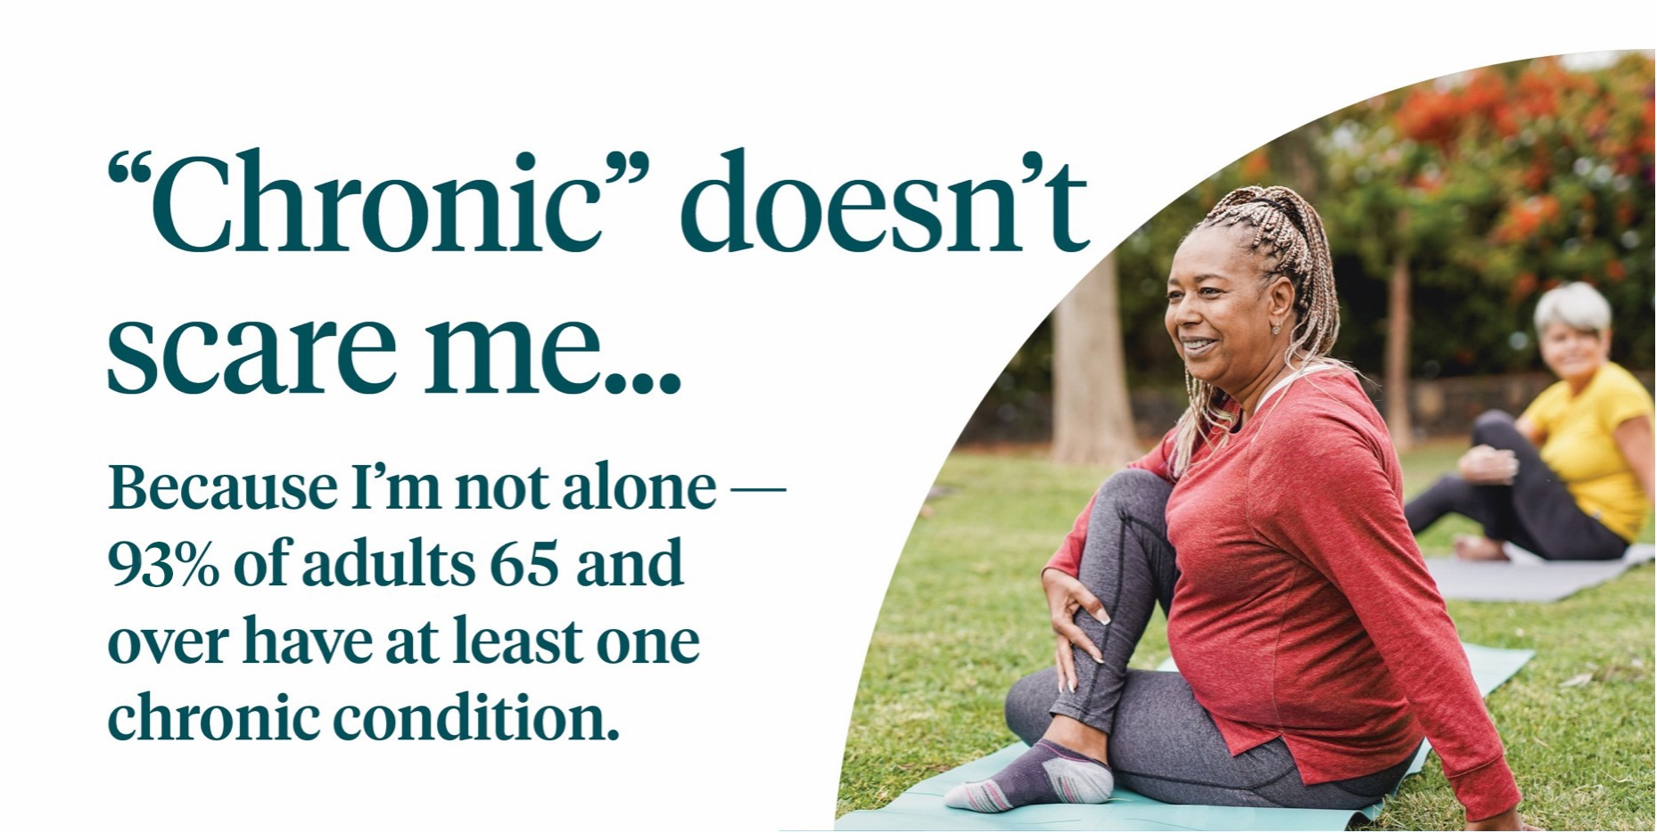
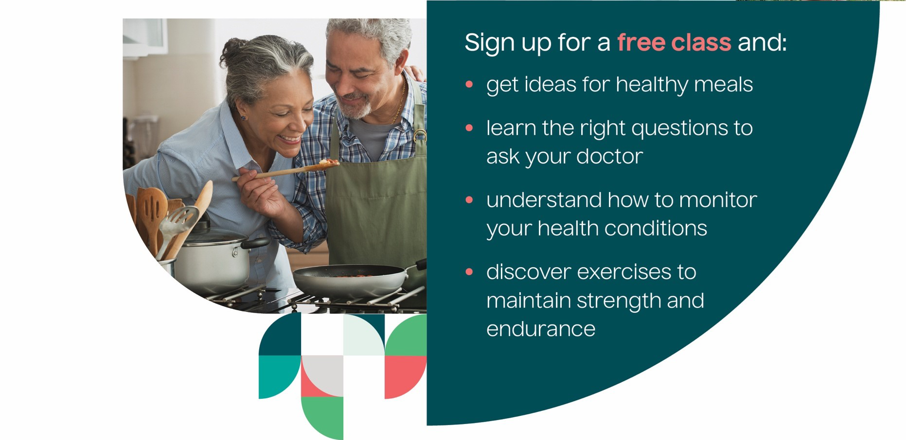
Find out more about classes near you. Contact us at:
xxxxxx@xxxxxxxx OR (xxx) xxx-xxxx
This publication was created as part of a project that is 100% funded by a grant totaling $10 million awarded to NCOA by the U.S. Administration for Community Living (ACL), an operating division of the U.S. Department of Health and Human Services (HHS). It does not necessarily reflect the official views of, or endorsement by, ACL, HHS, or the U.S. Government | Partner logo placeholder | 

