Shape**Appendix G – Application Checklist – *Am I Ready to Apply?***

Use the checklist below to ensure you have completed all requirements for this funding opportunity.

**Application Checklist – *Am I Ready to Apply?***

*Statewide Falls Prevention Coalitions Funding Opportunity*

***Step 1:***

* Review the RFP to familiarize yourself with the application process and project expectations.

***Step 2:*** Set up your account in the application portal.

* Create an account with WizeHive, the host portal you will use to submit all application materials.

***Step 3:*** Submit your Letter of Interest in the application portal.

* Submit your Letter of Interest by providing organization information, confirming eligibility, and indicating the funding opportunity your organization will pursue (Application A: *Develop a coalition in a state that currently does not have an active coalition* or Application B: *Enhance an existing state falls prevention coalition to improve falls prevention activity on a statewide and/or local level*).

***Step 4:*** Submit your application in the application portal.

* Applications must be submitted via the application portal by **Feb. 21, 2025, 11:59 p.m. Eastern Time.**

(Continued on the next page)

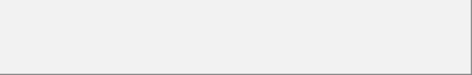**Application A Checklist**

***(Develop a coalition in a state that does not have an active coalition)***

*State coalitions listed as “inactive” or “in development”* [*on this list*](https://www.ncoa.org/page/state-falls-prevention-coalitions/) *are eligible to apply under Application A.*

* Complete the following short answer sections in the narrative application:
* Statement of Need
* Priority Populations and Communities
* Proposed Project
  + - Organization Capacity
* Evaluation Plan
* Sustainability Plan
* Upload Budget – use template in Appendix A
* Upload Budget Narrative – use template in Appendix B
* Upload Work Plan – use template in Appendix C
* Upload Letters of Commitment from Key Partners
* Upload Resume/CVs of Key Personnel
* Upload Audited Financials; include a PDF version of most recent:
  + Audited Financials or 990 Tax Form; and
  + Agency W-9 Form
  + SAM.gov Registration Verification
  + Organization’s Unique Entity Identifier (UEI)
* Upload Proof of Nonprofit Status (as applicable)
* Upload Indirect Cost Agreement (as applicable)

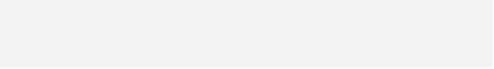

**Application B Checklist**

***(Enhance an existing coalition)***

*State coalitions listed as “active” on this* [*list*](https://www.ncoa.org/page/state-falls-prevention-coalitions/) *are eligible to apply for Application B.*

* Complete the following short answer sections in the narrative application:
  + Coalition Information
  + Statement of Need
  + Priority Populations & Communities
  + Proposed Project
  + Organization Capacity
  + Evaluation Plan
  + Sustainability Plan
* Upload Budget Proposal – use template in Appendix A
* Upload Budget Narrative – use template in Appendix B
* Upload Work Plan – use template in Appendix C
* Upload Letters of Commitment from Key Partners
* Upload Resume/CV of Key Personnel
* Upload Audited Financials; include a PDF version of most recent:
  + Audited Financials or 990 Tax Form; and
  + Agency W-9 Form
  + SAM.gov Registration Verification
  + Organization’s Unique Entity Identifier (UEI)
* Upload Proof of Nonprofit Status (as applicable)
* Upload Indirect Cost Agreement (as applicable)