**“My pain was my boss. It was telling me what I could and couldn’t do. This workshop put ME back in charge.”**

**– Sue from Washington**

 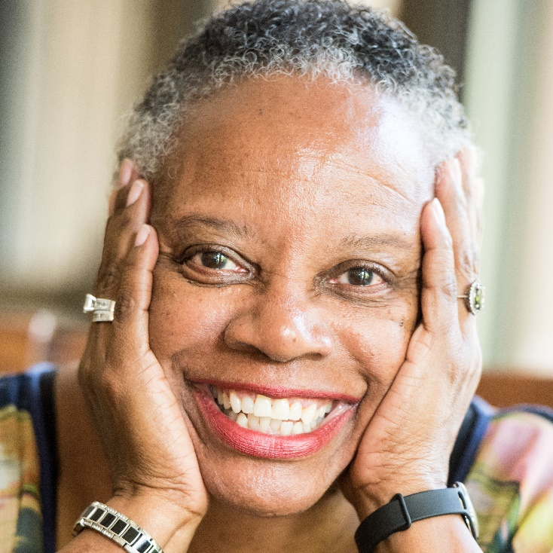

**Don’t let an ongoing health condition rule your life. If you have diabetes, arthritis, high blood pressure, heart disease, pain, anxiety, or another chronic condition, sign up today for [PROGRAM NAME] offered by [ORGANIZATION NAME].**

**Attend a FREE 6-week workshop and discover how to:**

|  |  |
| --- | --- |
| * **Eat well and exercise safely** * **Cope with pain and fatigue** | * **Explore new treatment options** * **Talk with your doctor** |



**Take charge of your health with  
[PROGRAM NAME]**

**Spaces are limited! Call today: xxx – xxx – xxxx**