Do you use government benefits cards,
prepaid debit cards, or gift cards?

Attend a FREE financial education workshop!

Savvy Saving Seniors®
It’s in the Cards
Sponsored by the National Council on Aging, Bank of America Charitable Foundation, and Money Management International

DATE at TIME
Name of Organization
Address
City, ST
RSVP by Date to (xxx) xxx-xxxx
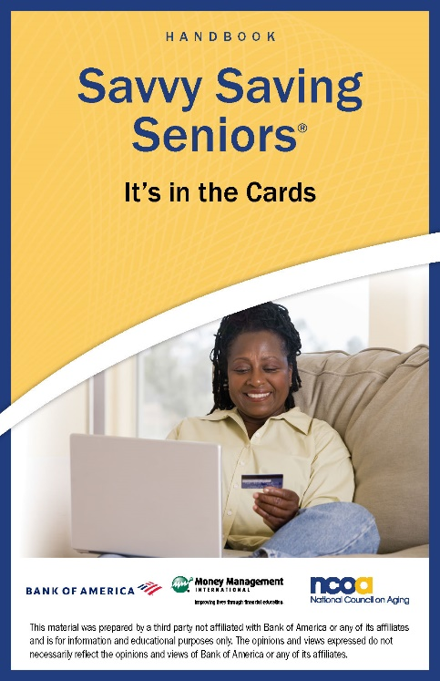
Discover:
- Tips and tricks for managing different
types of cards
- Fees to look for—and scams to avoid
- Names and brands of prepaid cards
on the market

Plus receive a free financial education handbook!
This is an educational event only—
NO financial products will be sold.

