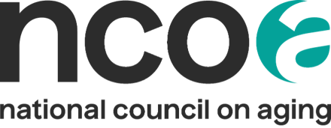

Media Advisory Template
Use a media advisory to highlight events you want media to attend or cover. Email the advisory 2-3 weeks before your event to newspapers, radio stations, and television stations and directly to the reporters on your media list. Follow up with 1-2 phone calls as the event gets closer. Send the advisory again the day before your event because broadcast media, such as television stations, often make decisions about what to cover on a day-to-day basis.
Ensure you have ways for media to access your virtual events through Zoom and that they have ways to interview your organization spokesperson and participants digitally if needed. Also make sure you have visuals such as photos or posters to supplement your story.
[ORGANIZATION LOGO]
CONTACT:
[Name]
[Title]
[Organization]
[Phone]
[Email]
MEDIA ADVISORY
[Date] – for immediate release
[ORGANIZATION] to Mark Falls Prevention Awareness Week
with [NAME OF EVENT] and Free Online Screening Tool for Older Adults
[CITY, STATE] [DATE] — Did you know that falling is NOT a normal part of aging?
[ORGANIZATION] is committed to empowering all older adults in [COMMUNITY NAME] to age well, and that includes avoiding falls. On September 23-27, 2024, we are partnering with the National Council on Aging (NCOA) to observe Falls Prevention Awareness Week.
Falls remain a leading cause of injury for people aged 65 and older. Falls threaten older adults’ safety and independence and generate enormous economic and personal costs. However, through practical lifestyle adjustments, evidence-based falls prevention programs, and clinical-community partnerships, the number of falls among older adults can be substantially reduced.
WHAT:
[Description of the event. Be sure to include planned activities and interesting information, including that you will be offering free falls assessments using www.ncoa.org/fallsfreecheckup]
WHO:
[List of special guests. Make sure to list in order of importance, with elected officials first.]
WHEN:
[Date and time of event]
WHERE:
[Address of event]
About [ORGANIZATION]
[Your organization description]
About NCOA
The National Council on Aging (NCOA) is the national voice for every person’s right to age well. We believe that how we age should not be determined by gender, color, sexuality, income, or ZIP code. Working with thousands of national and local partners, we provide resources, tools, best practices, and advocacy to ensure every person can age with health and financial security. Founded in 1950, we are the oldest national organization focused on older adults. Learn more at ncoa.org and @NCOAging.

