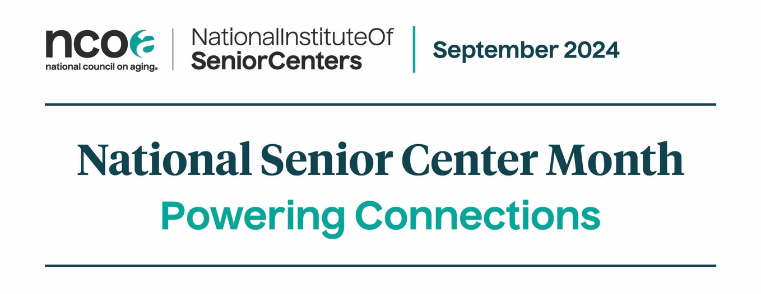
Sample Calendar Announcement
Below is a template calendar announcement you can fill out and send to your local newspaper, TV station, online publication, or municipal office to be included in their local calendar. Typically, you will need to send announcements at least 2-3 weeks before an event. Including a list of invited special guests can help increase media interest in an event. If you don’t have a commitment from all the special guests, but you have a pretty good indication they will attend, you can say “Mayor Jon Smith (invited)” on your materials.

Fill in the indicated information. If there is any information you don’t want to include, be sure to delete the template information.
Contact:
[YOUR FULL NAME]
[TITLE]
[SENIOR CENTER]
[CELL PHONE
[EMAIL]

[SENIOR CENTER] is celebrating National Senior Center Month this September, with the 2024 theme “Powering Connections.” The theme encourages people to come to their senior center—whether they are regulars or if they have never visited.

If you are planning multiple events:
Several activities are planned, including [LIST ACTIVITIES WITH DATES]. Power your own unique connections!

For more information, call [PHONE] or visit [WEBSITE]. [SENIOR CENTER] is located at [STREET ADDRESS] in [CITY].

Or if you are planning one main activity:
Join us [DATE] at [TIME] for [ACTIVITY] to celebrate National Senior Center Month. Power your own unique connections!

For more information, call [PHONE] or visit [WEBSITE]. [SENIOR CENTER] is located at [STREET ADDRESS] in [CITY].

