Application form  Take-off phase 1 spring 2023  Feasibility study WO |  | 
To this form conditions apply from the most recent guidelines ‘Take-off fase 1 - Haalbaarheidsstudies WO’ (January 2023).

Explanation - remove this textbox after filling out the form
Instructions to complete the pre-proposal and full proposal application form can be downloaded in a separate PDF ‘Instruction to complete application form-phase1WO-feasability study-spring2023’ on the callpage: https://www.nwo.nl/calls/take-off-fase-1-haalbaarheidsstudies-wo.

The total number of pages of the full document should not exceed 14 pages in total excluding the front page and appendices C through F. Sections 3 and 4 should not exceed 10 pages.

Submit this form via the application system ‘ISAAC’. Please refer to the Call for Proposals for additional information.

For more information on the Take-off program, see: https://www.nwo.nl/en/researchprogrammes/take

Project title:
Title of the project

1. Administrative information

Who is eligible to apply? See call for proposals section 3.1

1.1 Contact details knowledge institute
Knowledge institute (WO): | Name WO knowledge institute
Name applicant: | Name of applicant
Role: | Role
Salutation: | Select entry
Phone: | +31(0) Click or tap to fill
Email: | Email
Postal address: | Address

1.2 Contact start-up (optional)
For Take-off phase 1 – Feasibility studies WO a start-up is not required (optional). Only fill in the table below in case a start-up, registered at the Netherlands Chamber of Commerce (KVK), is involved in the proposal. If the point of contact for the WO institute and the start-up is the same, please fill in the details in both tables.

Start-up (if applicable): | Name start-up
Point of contact: | Name
Salutation: | Select entry
Phone: | +31(0) Click or tap to fill
Email: | Email
KVK number, corporate structure,  date of establishment: | #, corporate structure, date of establishment
Address of establishment : | Address

1.3 Ownership structure start-up (if involved)
If a start-up is involved, please provide the ownership structure, owners, and share (max. 150 words)

2. Summary

2.1 Summary NWO Domain AES website
Max. 100 words. This English summary should be suitable for publication. Be aware of confidentiality regarding IP and company strategy.

2.2 Project summary
Max. half A4.

3. Business idea
Chapters 3 and 4 should not exceed 10 pages in length.

3.1 Scientific research that lies at the core of the business idea
Please describe the scientific research at the core of the business(idea) and where this scientific basis was created. Please clarify the quality of this research. Furthermore, please indicate the technology readiness level (TRL) of the research to make it clear to the committee what development is necessary before a market introduction could be realised.

3.2 The problem
Please describe which market need or problem has been identified. Describe the target market and how an actor within that target market experiences the need or problem. Use this to illustrate the context in which you provide the solution in the next paragraphs.

3.3 The proposed solution
Please describe your proposed solution, what elements it comprises, and how it would be applied. Please be sure to describe the role of the above described scientific research in this solution.

3.4 Innovative aspects
Please describe the innovative aspects of the anticipated solution or product and what factors make it unique and distinct compared to the current state-of-the-art. What breakthroughs are expected based on the results of the research? Please make a comparison to existing solutions, as well as existing and future competitors.

3.5 Commercial aspects
Please describe the added value to end users. How do you intend to position the new solution within the existing solutions. Please use various models, trends and analyses, business models, SWOT or other to support your position/claim at your discretion.

3.6 The IP position
If no IP exists, please describe the knowledge base further and detail what knowledge or scientific research makes your solution/business unique. Please indicate what Freedom to Operate you deem necessary to operate effectively in the market space, and what agreements you have made at the time of the application.

With regards to IP, if applicable, please provide the following information;
1) title patent;
2) patent owner;
3) patent number;
4) if not published please specify claim.

If no patent exists, please describe the knowledge base further and detail what knowledge or scientific research makes your solution/business unique.

3.7 Business Model Canvas
To provide the committee with an overview of the envisioned value proposition, please provide a Business Model Canvas. A template is provided in appendix E. If you have a version of your own, you can choose to attach that instead.

4. Project plan of the feasibility study

4.1 The aim of the project
Please describe the goals and primary deliverables of the project. When will the feasibility study be a success? Please describe per part of the project if distinctions are made (e.g. technical vs commercial goals). Budget maximum is €40,000.-.

4.2 Description of work
Please describe the assumptions that lie at the core of the business. What goals need to be realized, and what critical success criteria need to be met in order to succeed. Please clarify:
- the intended method to ascertain the commercial feasibility of the solution. What opportunities are expected? What critical problems are expected and if encountered, how are they resolved;
- the intended method to ascertain the technical viability of the envisioned solution. Which breakthroughs need to be realized, and what critical problems are a threat to the success of the feasibility study?

4.3 Milestones, time schedule and budget plan
Please include a project timeline for the duration of the project (maximum of 6 months). Include important milestones. Budget maximum is €40,000.-.

4.4 The project team
Please include the project structure and roles/task distribution of the project participants and organisations. Please include details on potential third party involvement. Per team member, specify name, affiliation, roles and responsibilities, and motivation.

4.5 Training and coaching plan
Please indicate how the team is structured to realize the envisioned business proposition, and describe any envisioned training or coaching activities to improve the entrepreneurial skills of your team during this project period.

5. Budget plan

5.1 Budget
The budget form should be prepared in accordance with the NWO template. This form has restricted fields for budget details, such as maximum hourly rates for personnel and costs of external services. Modifications to this template, such as additional rows, are not allowed, to guarantee consistency and legibility between proposals. Applications with a different budget form, or not adhering to the restrictions in the NWO budget form, will be inadmissible.

You can download this template from the NWO website or via the online application system ISAAC. Editable fields are marked light blue. Complete the budget form and save it as a PDF. The budget form should be readable in its entirety, without parts being removed, in one page (A4). Attach the saved PDF page with your budget to the application form by adding it as appendix F to the PDF file of the application form. Without the budget form as the last page in your application form, your application is not complete and cannot be processed.

5.2 Additional required activities or investments
Please describe the activities or investments that are indispensable for the project plan described in section 3, but which will not be financed from the Take-off budget. This could for instance be required equipment, or work that is required for a successful completion of the project.

6. Statement by the applicant

6.1 Application of NWO research results
If applicable, please provide project number and a short overview of the results.

6.2 Cluster assessing this application
Select an item.

6.3 Statements
Have you simultaneously requested any additional grants for the execution of the above described business plan either from AES or from any other organization or financer? | ☐ NO  ☐ YES:  If yes, provide details
Is this request for a Take-off phase 1 feasibility study a resubmission of an earlier rejected application for a Take-off phase 1 feasibility study? | ☐ NO  ☐ YES:  If yes, provide details

6.4 Signatory
Be aware that the application form for phase 1 feasibility study WO needs to be signed by the main applicant (not the contact person from the start-up if involved).

The signatory declares that all the required documents are enclosed and that the signatory is familiar with the requirements and procedures of the Take-off call. Completed truthfully:

Name: Full name

Place: Place

Date: Press to select a date

7. Appendices

A. Curriculum vitae team members
Max. 2 pages in total for the entire team

B. Selection of key publications of the team
Optional, max. half A4

C. Proof of knowledge transfer
Add to the proposal

D. Letters of support
Optional

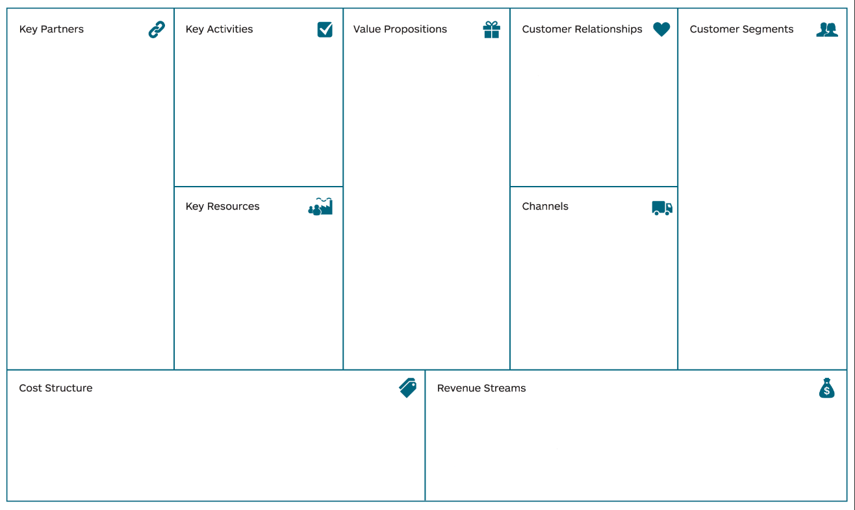
E. Business Model Canvas

F. Budget
Mandatory. Use the template provided by NWO and append this to your proposal.

