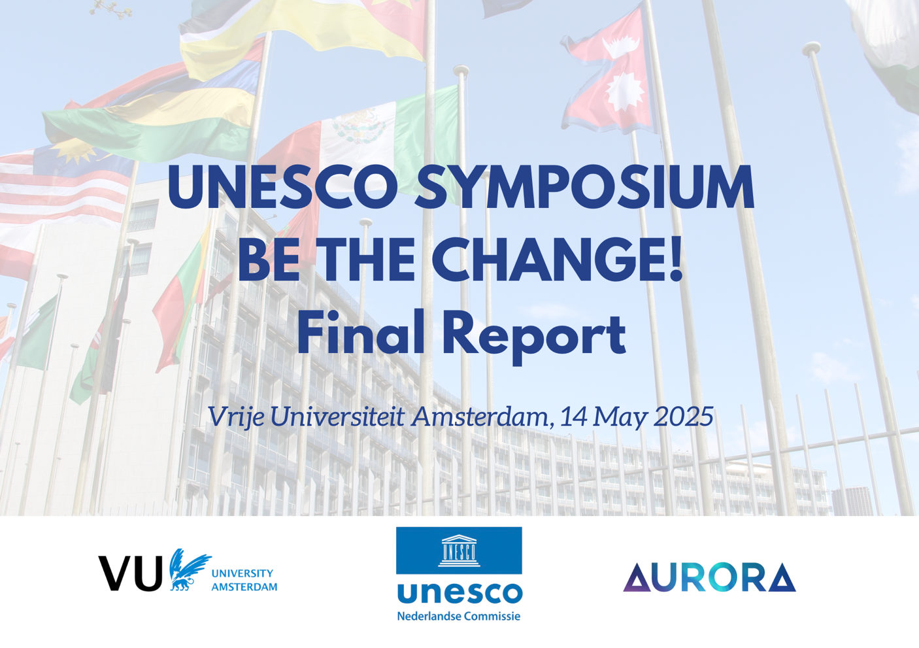
UNESCO Symposium 14 May 2025 (Add the front page with report)
Photo Credits: Philip Boakye and Priscilla Yeboah.

Contents:

Introduction

Program overview

Workshops Contents:
Workshop 1: Knowledge Equity in a Global Context

Workshop 2: Activating Sustainability through the lens of Water Heritage and Values: A Serious Game

Workshop 3: Untangling Knowledge

Workshop 4: Higher Education and Peacebuilding - Cross-Cultural and Emic Perspectives

Workshop 5: Constructing Peace in the Minds of Tomorrow: Conflict Resilience through Coaching and Mentoring in Higher Education & Human Rights

Workshop 6: Shaping the Future of Digital Ecosystems and Platforms in Advancing Fairness in the Context of Generative AI

Workshop 7: VU Memory of the World NL recognition: from Kuyper to King

Networking Reception

Introduction:

On Wednesday, 14 May 2025, VU Amsterdam hosted Be the Change, an international symposium co-organised by the Netherlands Commission for UNESCO and the AURORA network. This event brought together scientists, policymakers, (refugee) students, and UNESCO Chairholders to explore how education, science, culture, and diplomacy can contribute to a more just and peaceful society.

Through workshops, poster sessions and a roundtable, participants engaged with themes such as knowledge equity, social justice, intercultural dialogue, peacebuilding, and the future of our digital ecosystems. Rooted in UNESCO’s mission and linked to several Sustainable Development Goals (SDGs), the symposium fostered exchange across generations, disciplines, and cultures.

We are looking back on an inspiring day of connection, creativity and critical reflection – and help shape the ideas and actions that will drive meaningful change.

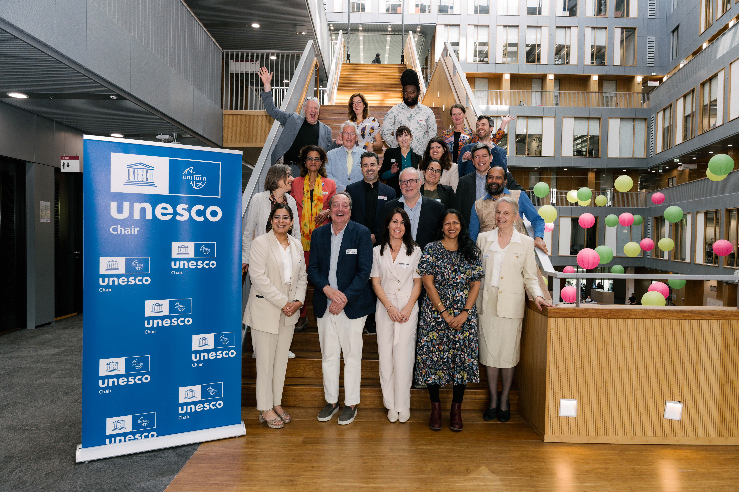

A strong presence of UNESCO Chairs marked the symposium, with numerous Chairs from the Netherlands and international Chairholders actively contributing to the programme. For many, it was a valuable opportunity to reconnect, meet new colleagues, and strengthen their shared network. Workshops were hosted by nine members of Chair teams in the Netherlands – each bringing a unique perspective on human rights, digital ethics, heritage, and inclusion. The active participation of Chairholders and team members including Andrea Broderick, Bruce Mutsvairo, Ana Pereira Roders, Bart Barendregt, Louise Bezuidenhout, André Brasil, Léa Kayrouz, John Johnston, Sylvia van de Bunt, Jaap Gordijn, Lampros Stergioulas, Mirjam Shatanawi, and Felisa Tibbitts reflected the network’s strong engagement and their shared commitment to UNESCO’s values of dialogue, knowledge-sharing, and international cooperation.

Program Overview:

12:30: Registration of symposium guests (Outside Theatre 1)

THEATRE 1, NU Building

13:00 - 13:20: Welcome by Speaker: Kathleen Ferrier, Chair of the Netherlands Commission for UNESCO.
13:10 - 13:20: Opening Address by Prof. dr. Jeroen Geurts, Rector Magnificus of VU Amsterdam and member of the Netherlands Commission for UNESCO.
13:20 - 13:25: Address by dr. Sylvia van de Bunt, UNESCO chairholder 'Cross-Cultural Sustainability' and co-director SERVUS at the Department M&O, SBE VU Amsterdam
13:25 - 13:30: Artistic Performance by Saumya Shukla, Kathak artist and teacher dedicated to intercultural dialogue through Indian classical dance
13:30 - 14:30: Panel Discussion with VU Rector, VU Professor, Chair of the UNESCO Youth Commission, and (international) UNESCO Chairs
Moderator: Sem Barendse: VU Dialogue Coordinator
Panelists:
- Prof. dr. Jeroen Geurts: Executive Board, Rector Magnificus VU Amsterdam; Netherlands Commission for UNESCO.
- Prof. dr. Fons Trompenaars, Professor Cross-Cultural Management VU Amsterdam
- Prof. dr. Bruce Mutsvairo, UNESCO NL Chair Data, Disinformation and Democracy, Utrecht University
- Dr. Rina Malagayo Alluri, UNESCO Chair for Peace Studies, Unit for Peace and Conflict Studies, University of Innsbruck
- Anas Kjidaâ, Chair of the UNESCO Youth Committee

Format: Plenary exercise in pairs, Moderated discussion in pairs, audience Q&A.
14:30 - 14:40: Artistic Performance by Saumya Shukla, Kathak artist and teacher dedicated to intercultural dialogue through Indian classical dance
14:45: Practical Remarks on the flow of workshop-assigned buddies

LOBBY CAMPUS SQUARE (2ND FLOOR) CAMPUS SQUARE, 2nd Floor

15:00 - 16:00: Tea/Coffee Break: Refreshments and informal networking
15:00 - 15:45: Poster Session - Posters displayed in the Lobby Campus Square (2nd floor), allowing participants to view and interact with students regarding their work during the tea and coffee break. Groups showcased posters aligned with the themes of the seven workshops conducted after. These posters were presented by students from (international) secondary schools, and The Netherlands UNESCO Youth Commission and focused on the solutions in the sustainable development areas. Additionally, we aimed to establish a broader connection between UNESCO and the VU-led Dutch chapter of the UNSDSN (www.unsdsn.org). The VU will lead this chapter, culminating in a conference in June 2025.

15:50 - 16:00: Transfer to workshop rooms
16:00 - 17:00: Interactive Parallel Workshops, led by distinguished workshop leaders and moderators
17:15 – Informal Reception / Closing Remarks
The reception included a small ceremony for refugee-students, to recognize their successful completion of the 3rd annual Lecture Series ‘We Shall Overcome’ (WSO), January-February 2025. WSO co-organizer Sanaz Kateb, and on her behalf WSO mentor and M&O colleague Diana Kushnir delivered Sanaz' congrats message for the WSO refugee students. Sanaz donated her Young Academy Reward (AYA 2024) to the refugee students: https://vu.nl/en/news/2024/winners-amsterdam-young-academy-aya-recognition-rewards-awards-2024

The Symposium starts…
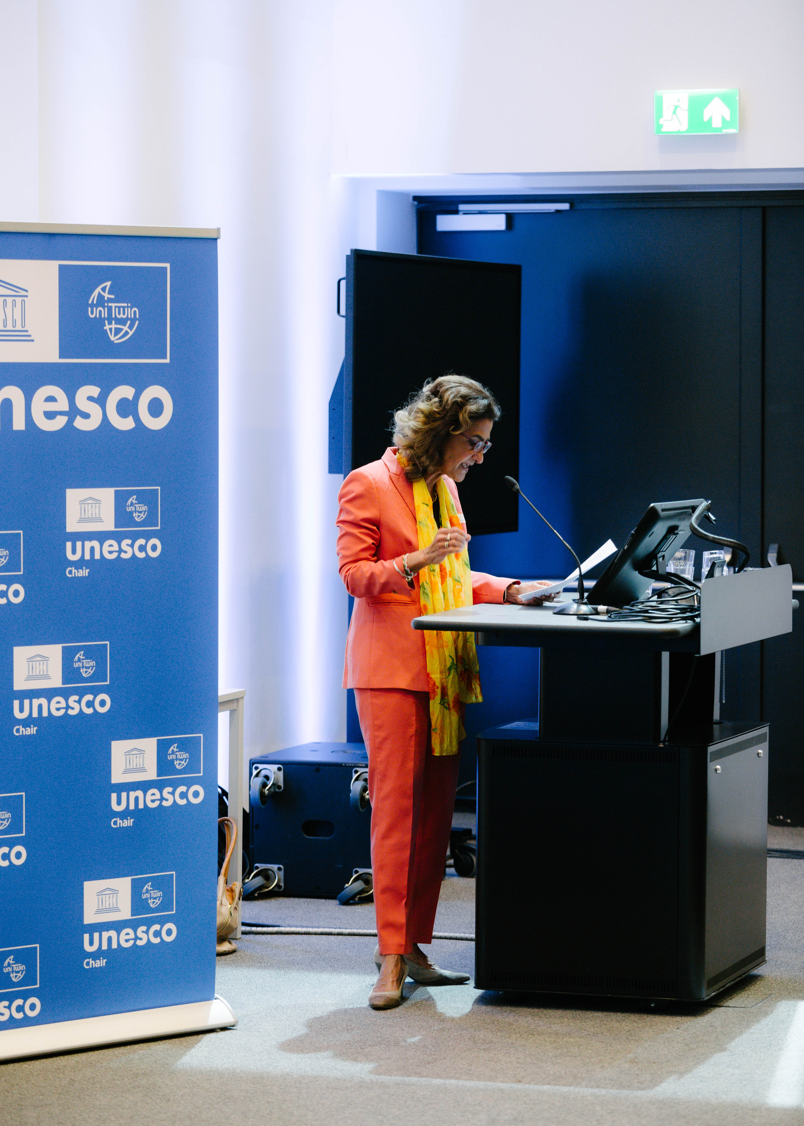
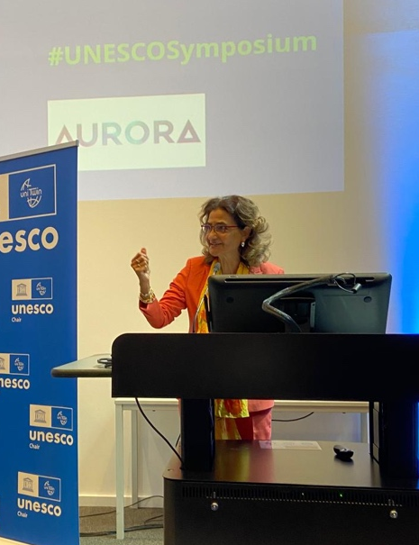
Welcome Speech by Kathleen Ferrier, Chair of the Netherlands Commission for UNESCO

A Warm Welcome Speech by Kathleen Ferrier:

“Good afternoon everyone,
It's wonderful to welcome you all here today: our UNESCO Chairs, colleagues from the AURORA network, policymakers, students, all of you changemakers. And a very special welcome to Tymofii Brik, Rector of Kyiv School of Economics in Ukraine, and Harcourt Klinefelter, former press officer to Dr. Martin Luther King.
UNESCO is the UN organization for education, science, culture, and media. We represent soft power in a world that may seem to have taken a hard turn. More than ever, our world needs this gentle strength. Mutual understanding can sometimes seem distant. But we all know peace truly begins in the minds of people.
We at the Netherlands Commission for UNESCO would be able to achieve very little without our special UNESCO networks. Today, I would like to specifically celebrate our remarkable network of Chairs. They, the Chairs and their teams, are at the heart of our mission, in the Netherlands and around the globe.
Our UNESCO Chairs depart from one simple belief: that knowledge can offer a path to a more peaceful and sustainable world. Their strength is in numbers. There are more than a thousand UNESCO Chairs worldwide, forming a network that has been active for over three decades.
We don’t have to go back thirty years to look for impact. Recently, for example, Chairs in Botswana, Zimbabwe, and Morocco have been helping to protect world heritage in ways meaningful to their local communities – not just applying Western models. Chairs in Brazil, Qatar, and Portugal are mapping ocean biodiversity, connecting societies to their oceans. These Chairs do not just produce knowledge, but aim to actively strengthen the crucial bond between people and the world they live in.
It's genuinely inspiring. Especially now, when some countries seem increasingly inward-looking in their scientific cooperation. UNESCO Chairs set a vital example – crossing borders, fostering development through collaboration and partnership, with allies like ALLEA and many other networks and stakeholders.
In the Netherlands, our vibrant network of 15 UNESCO Chairs covers diverse and impactful fields – from education and culture to science and media. They advise the Dutch government on AI policies, and municipalities on heritage management. They help teachers use technologies in a human-centred way. And they work together with UNESCO headquarters in Paris, advocating to make science itself more open and more inclusive.
Knowledge forms the foundation upon which peace is built. Many Chairs here today will share their inspiring work through workshops, offering just a taste of their important contributions.
So today is an opportunity to meet people who are working towards peace – day in, day out. But I’m sure it’s not just our Chairs, or our UNESCO Commission, who strive towards this goal. We are also very eager to hear from you today, the audience, what we can do together: scholars, changemakers, policymakers. And I would especially single out young voices. They are critical if we truly aim for a brighter future.
We want to inspire concrete action today. How can we collaborate more effectively? How can we amplify our collective impact? Your active participation is crucial. So, I ask you: what do you want to achieve today? How can we, together, make today count?
Thank you—and let's make this day meaningful.”

Reflections from participants
“In her speech, she clearly explained how positive change can only really come about by sharing knowledge between cultures, having respect and working together internationally. Especially because we now live in a time in which more and more countries around the world are starting to look inwards and international cooperation seems to be declining, Ferrier's speech was very inspiring and relevant. She made it clear that peace can only be achieved through cooperation, tolerance and empathy for others. Her speech at Be the Change was therefore one of the major highlights of the symposium.” By T.W., high school student from the PUC course.
“She speaks with sincerity about the role of UNESCO, describing to us that its real strength lies in what she calls "soft power", which she describes as the ability to create change through education, culture, and mutual respect, rather than force. Throughout her speech, Kathleen highlights the work of the UNESCO chairs, showing us how they're not just academic figures but people actively involved in communities around the world.” By S.T., CCM student.

“She was calm and collected, and her presence was warm. You could tell that people were really paying attention. It's about being aware not just of the injustices in the world, but also of your own role in them. Ferrier asked us to consider our privileges and blind spots, not to make us feel bad, but to encourage us to take action. Katheen Ferrier says that phrases like “be the change” are not just slogans. They are promises to ourselves to live differently and to lead with honesty.” By L.V.D.G., CCM student.

“A central idea in her speech was the importance of interconnectivity: peacebuilding requires us to strengthen the bond between people and their environments actively. Ferrier made a strong call to action, particularly for young people, asking: "How can we together be the change?" This reflects UNESCO's broader vision of inclusive global citizenship and foregrounds the urgency of youth engagement in addressing pressing global challenges.” By R.V.H., CCM student.

“Her international lifestyle has played an important role in who she is today and has strongly influenced her professional journey. Throughout her career, Ferrier has worked with various international organizations, non-governmental organizations, in politics, and with the United Nations. One of her most important contributions has been her involvement in the creation of the Sustainable Development Goals, which are still a key part of global efforts toward sustainability and equality.” By N.B., CCM student.

Call to Action from the workshop
“A central idea in her speech was the importance of interconnectivity: peacebuilding requires us to strengthen the bond between people and their environments actively. Ferrier made a strong call to action, particularly for young people, asking: "How can we together be the change?" This reflects UNESCO's broader vision of inclusive global citizenship and foregrounds the urgency of youth engagement in addressing pressing global challenges.” By R.V.H., CCM student.

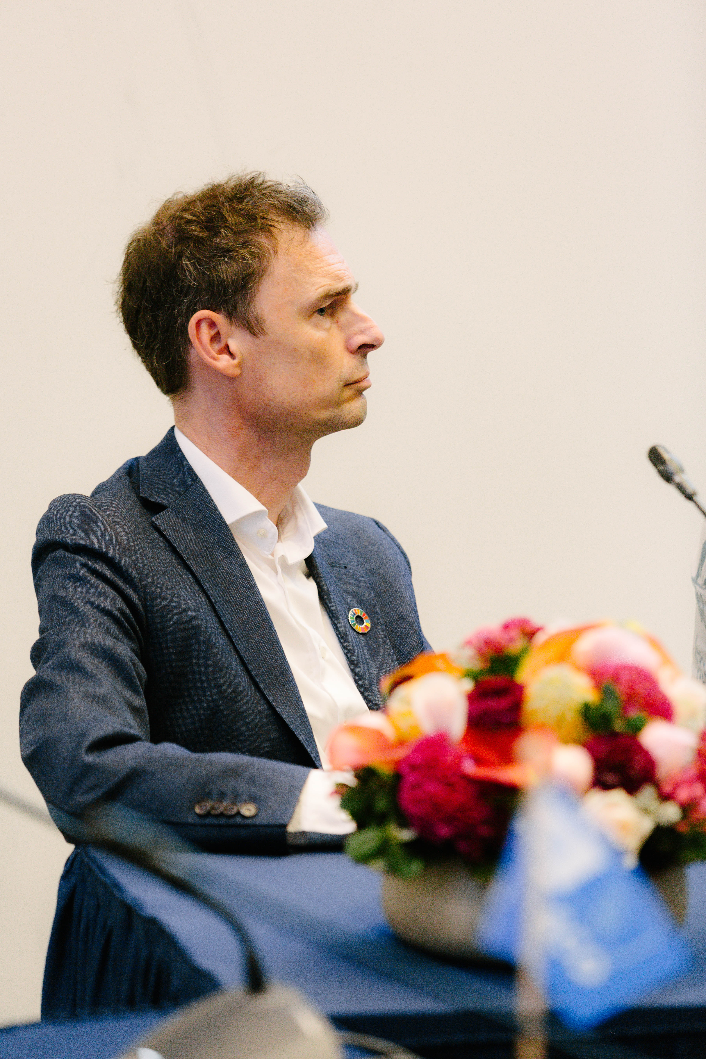
Opening Speech by Prof. dr. Jeroen Geurts, Rector Magnificus of VU Amsterdam and member of the Netherlands Commission for UNESCO

A Personal Message from Prof. dr. Jeroen Geurts:
“Dear colleagues, students, and fellow changemakers from UNESCO, the Aurora Universities Network, and VU Amsterdam, Today’s symposium is not just another event. is a signal moment—where we choose whether to remain victims of a fractured world, or become co-creators of something better.

Quote: “The best way to predict the future is to create it.” – Peter Drucker

We live in a paradoxical world: hyperconnected, yet increasingly divided. Digital technology erases borders in milliseconds, and still—miscommunication, injustice, and conflict grows. The call for change becomes louder and more urgent every day. As such, “Be the Change” is much more than a slogan. It is a moral imperative: to rethink our roles, act with courage, and imagine a future not shaped by fear or rivalry, but by solidarity and care.

Quote: “Education is the most powerful weapon which you can use to change the world.”– Nelson Mandela

At VU Amsterdam, we believe global citizenship is not a title to claim. It is a practice to live. We call this ‘developing a broader mind’—an invitation to engage with perspectives beyond our own, to reflect deeply on ourselves and each other, and to take responsibility for the world we inhabit. This spirit runs through our education, our research, and our partnerships. Students co-create local solutions to global problems. We work with inner-city communities, international science networks, and interfaith platforms. We invest in dialogue, because we believe it is the starting point for transformation. When people dare to step into complexity, something changes—not only around them, but within them.

Quote: “Act as if what you do makes a difference. It does.” – William James

And so, this symposium is an opportunity—not just to sit and listen, but to connect. Let us not leave here as individuals with good intentions. Let’s build bridges between our institutions, disciplines, and communities. True peacebuilding does not happen in plenary sessions. It happens in the slow, patient weaving of trust. It happens when networks stay alive after the applause has faded. When we decide to reach out and collaborate—again and again.

Quote: “Coming together is a beginning; keeping together is progress; working together is success.” – Henry Ford

Let this symposium not end in inspiration alone. Let it be the start of something real. Let it be the moment we commit—not to resume business as usual—but to connect, to organize ourselves, and then to act. Peacebuilding is not high diplomacy. It is network-building. It is scaffolding the world—together.

Quote: “To build peace, we must build bridges, not walls.” – Pope Francis

The power of this day lies not in the words spoken, but in the actions that follow. If we leave here unconnected, the ripple ends. But if we link our efforts—if we make a plan to click our networks together and agree on an agenda to make those networks act in unison —then today becomes the launch of something far greater. "Be the Change" is not a motto. It is a shared strategy. So, let me ask each and any one of you: is this the place where change begins?”

Reflections from participants
“His focus was not on Al or technology alone, but on our moral response to these trends. He called for solidarity, care, and active participation. According to him, "Be the change" is not just a slogan, it's a "moral imperative." This framing challenged me to rethink the way I engage with global issues: not as abstract topics, but as deeply human responsibilities.” By N.N., CCM student.

“His description of global citizenship as a "practice to live" rattled my own assumptions. In CCM, we investigated Cultural Intelligence (CQ), which entails not only understanding cultural differences but also adjusting behavior accordingly. Geurts said it beautifully: global citizenship is action, not status. It's about accepting responsibility, pondering carefully, and engaging in hard talks.” By K.B., CCM student.

“Geurts also called for greater ethical reflection in how scientific progress is pursued. As technological advancements accelerate, he reminded us that we must ensure they serve human dignity and equity, rather than deepen existing divides. Overall, his keynote served as a powerful call to action, especially for young people and students, to be both critical thinkers and changemakers.” By N.L., CCM student.

“These words made me reflect on when I for example waited to long with reaching out for a job interview, which ended by me not getting the internship, I was waiting for the right time, or for someone else to take the lead. Especially as a student and hopefully future consultant, I realized how important it is to sometimes act before you’re 100% sure, learning is something you do by doing. ” By J.V.K., CCM student.

“I found that hopeful, but also a bit challenging. It made me think: am I actually doing enough to contribute beyond my own bubble? His talk was a powerful reminder that being part of a university community comes with a responsibility to help shape the world for the better.” By M.W., CCM student.

“Mr. Jeroen Geurts began the day with an idea that stuck with me: allowing ourselves to remain victims or choosing to empower change. His speech wasn’t just a welcome; it was a wake-up call. He reminded us that in today’s world, being passive is no longer an option.” By C.S., high school student.

Call to Action from the workshop

“Let this symposium not end in inspiration alone. Let it be the start of something real. Let it be the moment we commit—not to resume business as usual—but to connect, to organize ourselves, and then to act. Peacebuilding is not high diplomacy. It is network-building. It is scaffolding the world—together.
The power of this day lies not in the words spoken, but in the actions that follow. If we leave here unconnected, the ripple ends. But if we link our efforts—if we make a plan to click our networks together and agree on an agenda to make those networks act in unison —then today becomes the launch of something far greater. "Be the Change" is not a motto. It is a shared strategy. So, let me ask each and any one of you: is this the place where change begins?” By dr. Jeroen Geurts.

“Geurts also called for greater ethical reflection in how scientific progress is pursued. As technological advancements accelerate, he reminded us that we must ensure they serve human dignity and equity, rather than deepen existing divides. Overall, his keynote served as a powerful call to action, especially for young people and students, to be both critical thinkers and changemakers.” By N.L., CCM student.

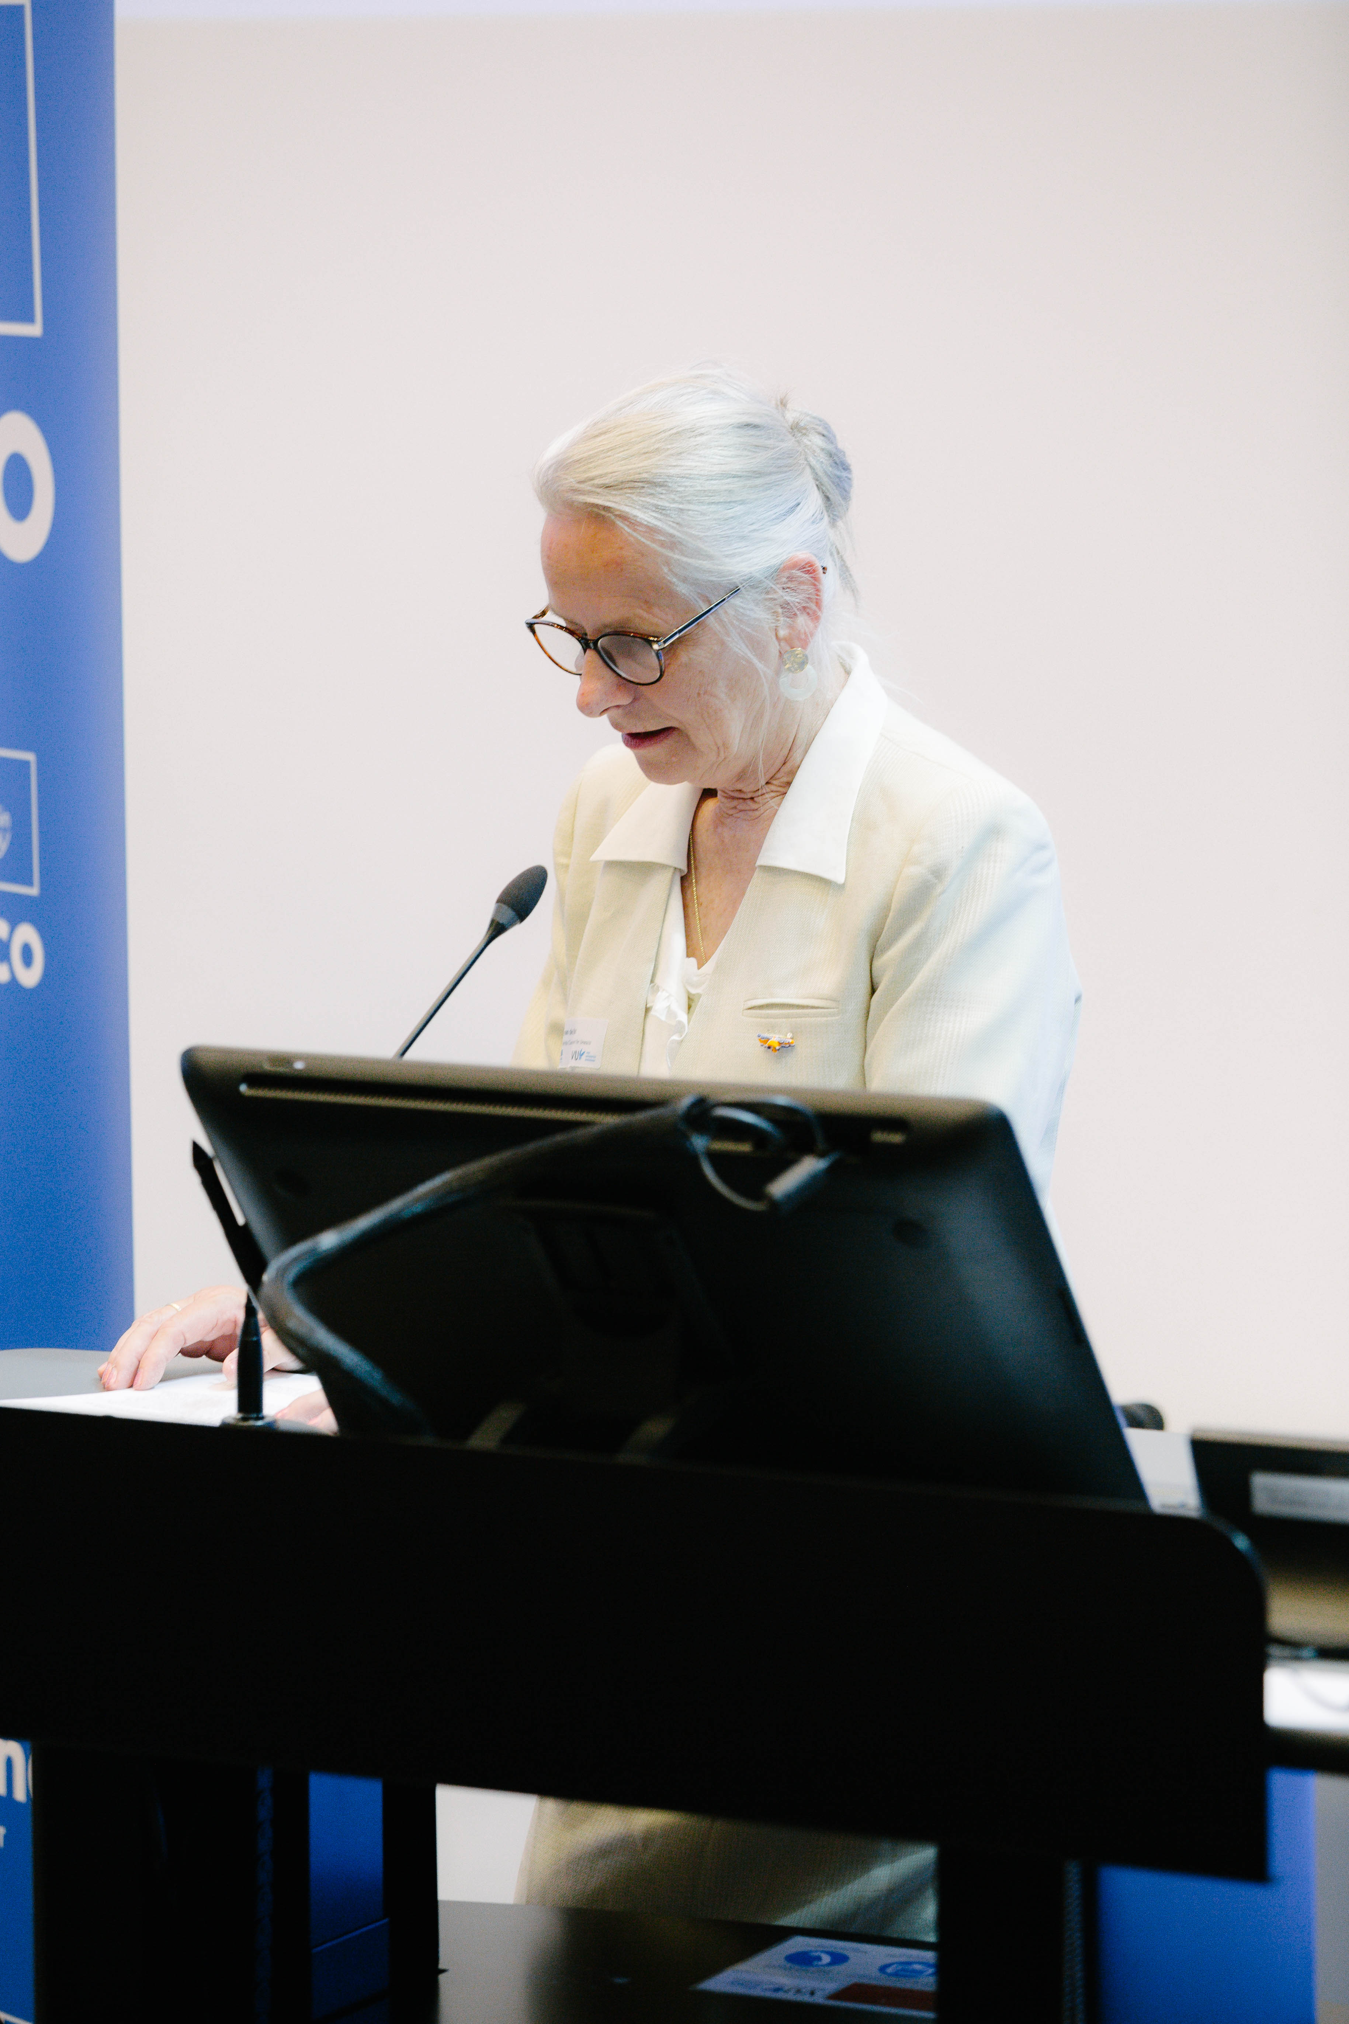
Welcome Address by dr. Sylvia van de Bunt, UNESCO chairholder 'Cross-Cultural Sustainability' and co-director SERVUS at the Department M&O, SBE VU Amsterdam

“It’s a particular honour to speak to you today, on this special event that brings together so many colleagues and friends motivated to Be the Change. Given the turbulence in the world today, this event is also a Call to Action for all of us, a golden thread across the program. Let’s create momentum together! Here I will share 4 highlights you will experience this afternoon.
1. Intergenerational cooperation is on top of our agenda to understand more deeply each others' perspectives. Today visualized through dialogue, for knowledge sharing and innovation. Special reference to the next panel discussion by junior and seniors, with Anas Kjidaa, chairperson of the UNESCO Youth Commission taking part.
2. Poster sessions, during the tea break, to spread the voice of youth about Sustainable Development Solutions, thus beyond SDGs. High school students will present their Call to Action:
- Sissi will share her volunteer experience helping a Burmese migrant school in Thailand. Myanmar suffers 77 years of conflict. Students drop out of school due to violence and fear, 25 million adolescents do not attend school. Through fundraising they were able to help install solar panels and a water fountain. Also, the students were taught about clean energy and recycling and were engaged in fundraising for sanitation.
- Colin’s key question is -after living in Mexico, Hungary and Sudan, what can we learn from youth movements about how to engage communities for justice? Shared leadership across generations made movements in these countries more effective and resilient.
- Eline wants to remove higher-lower education labels from education, reduce bullying and amplify social skills, call education with the actual names.
- Tommy presented a Call to Action for the humanitarian crisis in Sudan war. NL should help improve food security, infrastructure and education in Sudan.
- Lucy and Amara‘s Call to Action is to fight against educational inequality. It’s not just a practical issue; it's a moral issue. Solving requires not only policy changes but also ethical awareness and international solidarity.
- the Netherlands UNESCO Youth Commission and their Call to Action is about the fight for press freedom, equal rights and quality education. Give youth a place at the table in organizations. Partner up and work together towards a sustainable and greener world.
3. Inner Development Skills, A call for the inner soul to accomplish external (SG) goals represented in the 7 workshops of today.
4. Tribute to the legacy of dr. Martin Luther King. King’s legacy illustrates the impact of a servant-leader who inspires generations (and VU) after 6 decades in his fight for human rights, peace and social justice. Today's impact is represented by e.g. refugee-students who are with us today. These students successfully completed the We Shall Overcome Masterclass. Also, with reference to UNESCO symposium workshop 5 on mentoring and coaching in crisis situations. And the recent UNESCO NL Memory of the World recognition where a.o. dr. King is living history. https://vu.nl/en/news/2025/vu-amsterdam-archive-included-in-unesco-heritage-list
Last but not least, a special thanks to CvB, UBVU and M&O who supported us so generously to realize this event. Without their moral and financial support an event like this could not be realized.
Thank you. “

Reflections from participants
“The grace of Van de Bunt's presentation, coupled with the depth of her message, was compelling. It was a reminder that sustainable change is not solely about policy or innovation that it starts with finding peace within us.” By K.A., CCM student.

“When analysing her core message, I saw a good alignment between her message and UNESCO’s broader peacebuilding goals through education. Her specific example not only strengthens UNESCO’s broader goals but also shows the practical execution to reach these goals. This gave me a better understanding of her core message and UNESCO’s goals, where education is more than just transferring knowledge. Educational institutions also need to focus on human connection, the power of mentorship, and ethical responsibility.” By Z.E., CCM student.

Artistic Performance by Saumya Shukla, Kathak artist and teacher dedicated to intercultural dialogue through Indian classical dance

Introduced by Sylvia van de Bunt:
“As we reflect on our shared values, let us take a moment to connect through movement and culture. Please welcome Saumya Shukla, a Kathak artist whose work bridges tradition and intercultural dialogue. With her love for sharing her art, Saumya is on a journey of storytelling, self-discovery and knowledge exchange. Let her performance speak across boundaries.”
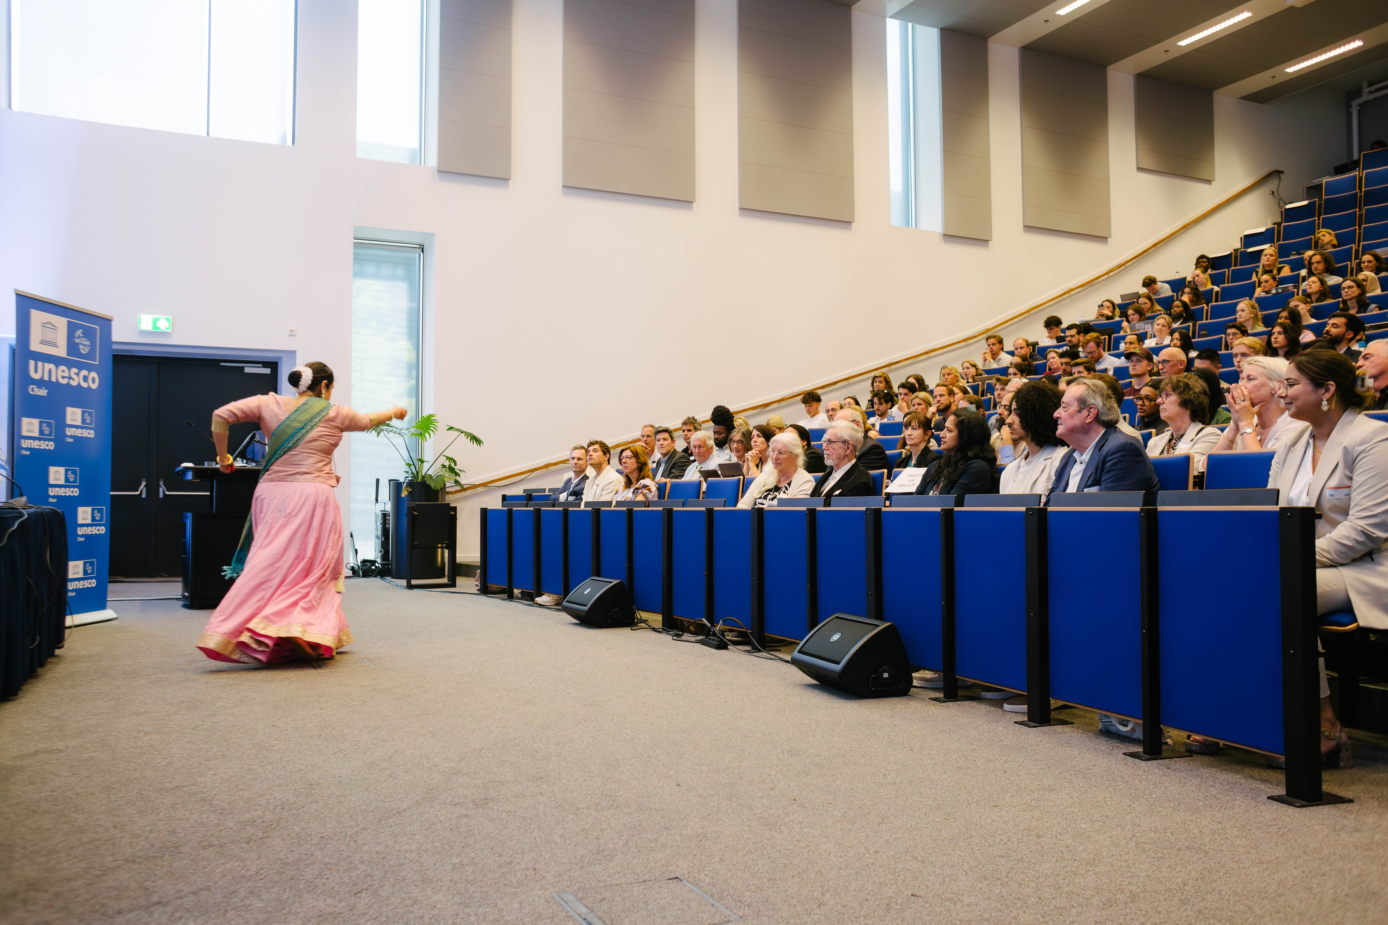
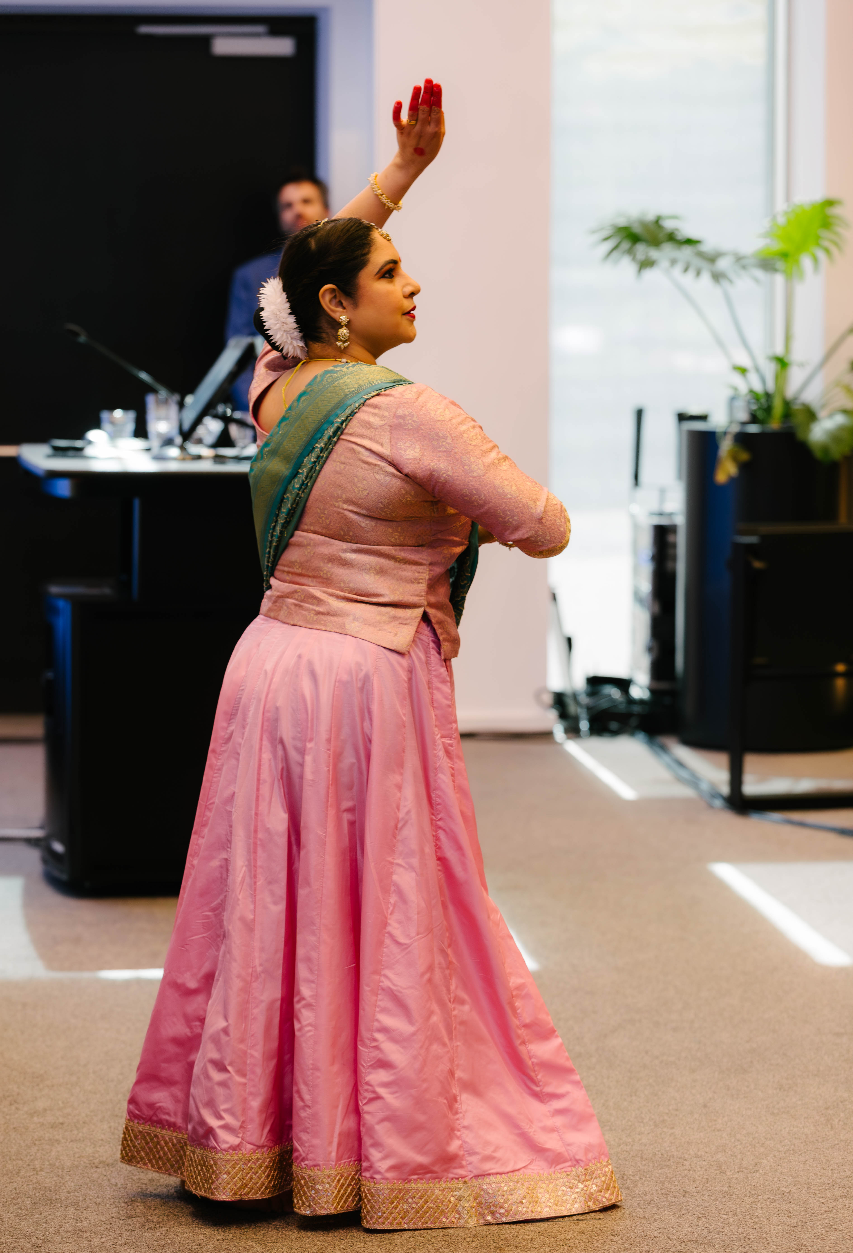

Reflections from participants
“Dressed in beautiful traditional Indian attire, she performed two dances, both centered on the theme of freedom. Without uttering a single word, she conveyed enormous emotion and meaning through her movements. It made me feel that freedom is not only political but also deeply personal—something you carry with your history and culture. Her dance will stay with me for a long time.” By A.H., high school student from the PUC course.
“At first, I watched with curiosity, but soon I felt completely absorbed by the rhythm and emotion of her performance. It was as if the values she expressed moved directly from her to us, without the need for words. The performer spoke briefly about how her art is both cultural and spiritual, a form of communication that expresses values deeply embedded in tradition. It reminded me that in many cultures, knowledge and communication are not strictly verbal or written. They’re embodied. They’re emotional. They live in rituals, art, and gestures. As someone raised in a more Western educational system, where knowledge is often measured in rational arguments and written texts, this experience was humbling. It challenged me to recognize that not all understanding is linear, and not all expression is verbal.” By E.T., CCM student.

Panel Discussion with VU Rector-Magnificus, VU Professor, Chair of the UNESCO Youth Commission, and (International) UNESCO Chairs

Moderator: Sem Barendse: VU Dialogue Coordinator

Panelists:
- Prof. dr. Jeroen Geurts: Executive Board, Rector Magnificus VU Amsterdam; Netherlands Commission for UNESCO.
- Prof. dr. Fons Trompenaars, Professor Cross-Cultural Management VU Amsterdam
- Prof. dr. Bruce Mutsvairo, UNESCO NL Chair Data, Disinformation and Democracy, Utrecht University
- Dr. Rina Malagayo Alluri, UNESCO Chair for Peace Studies, Unit for Peace and Conflict Studies, University of Innsbruck
- Anas Kjidaâ, Chair of the UNESCO Youth Committee

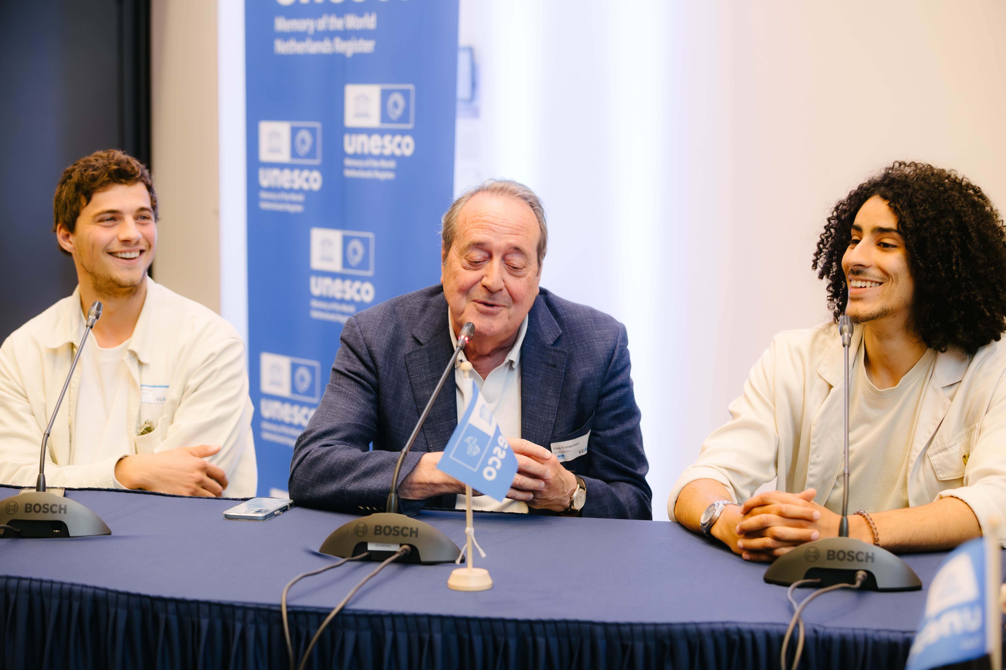
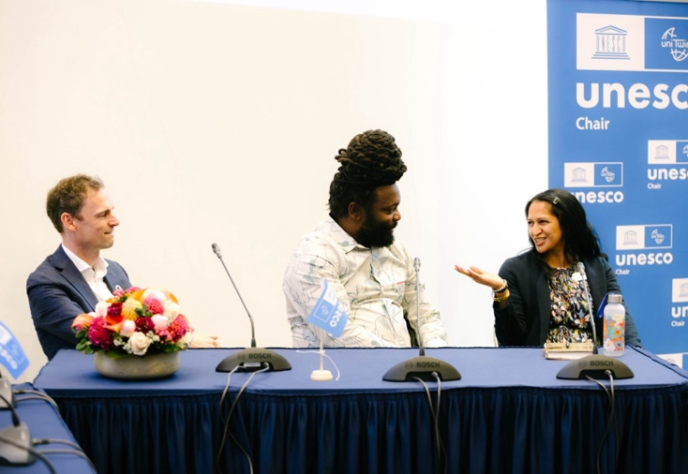From left to right, Prof. dr. Jeroen Geurts, Prof. dr. Bruce Mutsvairo, and Dr. Rina Malagayo Alluri.
From left to right, Sem Barendse, Prof. dr. Fons Trompenaars, and Anas Kjidaâ.

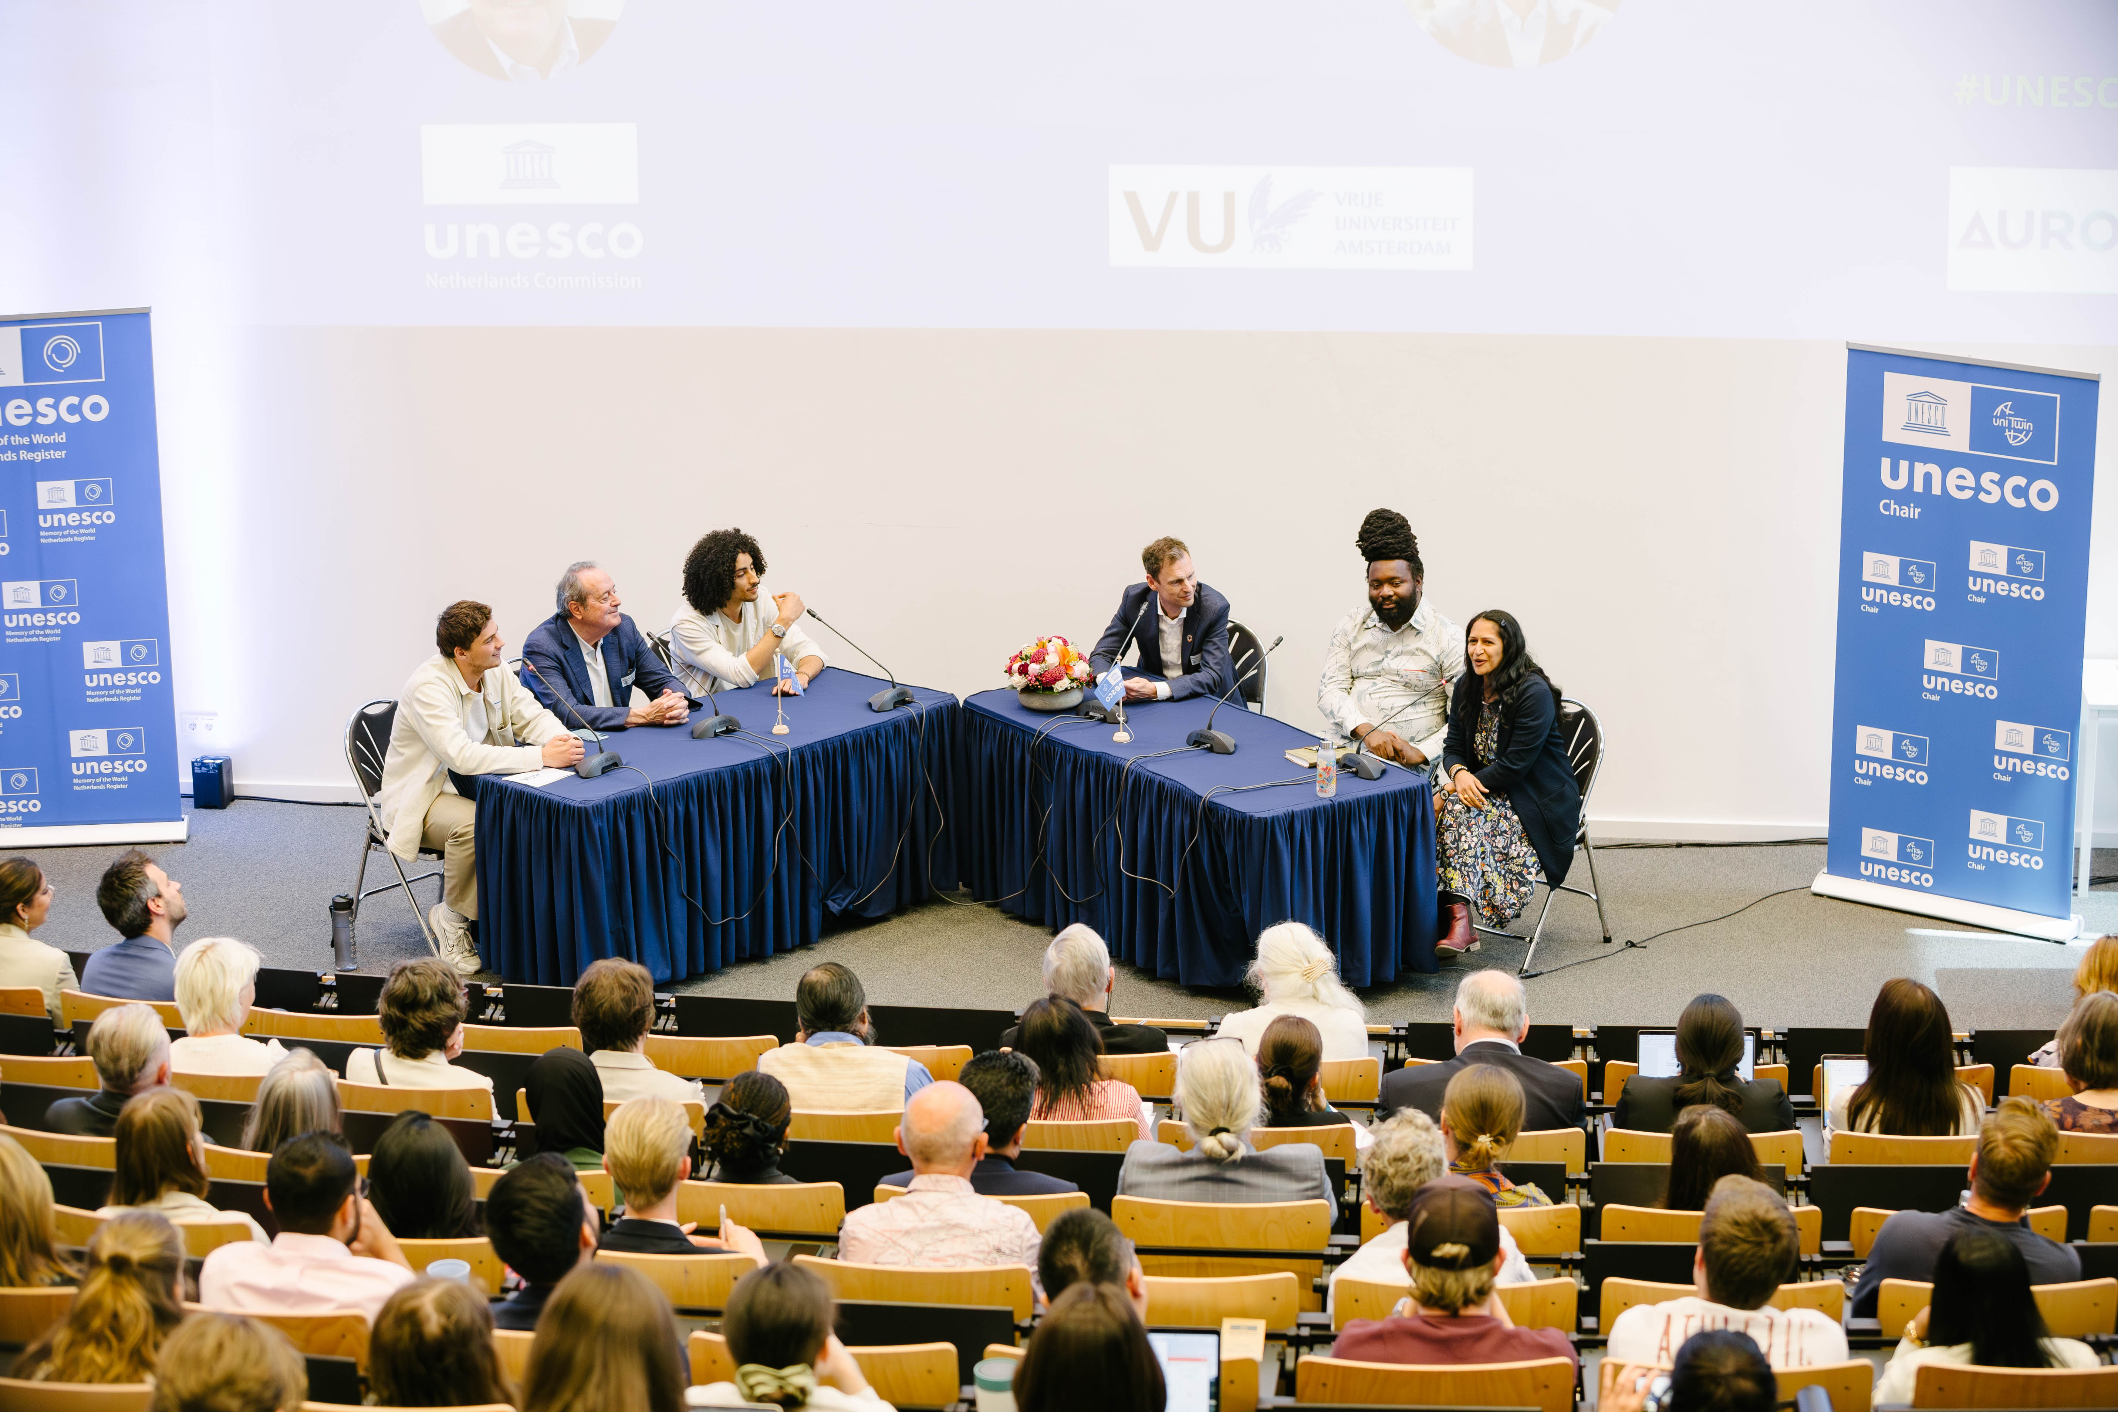
Insights from the Panel Discussion by Arwin Quaak

Moderator Sem opens the session by expressing the hope of engaging in meaningful conversations during the panel discussion. He has agreed with the panellists that they will each take us back to a moment of peace and transformation they have personally experienced.

Bruce Mutsvairo
Bruce shares an important lesson with the audience: ‘As a professor, you don’t know anything at all.’ To illustrate this, he talks about a research project in Norway focused, among other things, on disinformation. Initially, he thought he already had a clear understanding of what disinformation was — but after three years, he had learned so much more. ‘If you want to truly learn, you must be modest and acknowledge the knowledge of others.’ Bruce also stresses the importance of being present in the field as a researcher: ‘When I go into the field, I’m not a UNESCO chair. It’s good to simply be a normal person sometimes.’

Rina Malagayo Alluri
Rina picks up on Bruce’s remark about the importance of being present in the field as a researcher. She shares her experience conducting fieldwork in Sri Lanka after the war, a time marked by tension, kidnappings, and human rights violations. During her stay in a guest house, she met an elderly man who had grown up in Sri Lanka and kept returning to see his place of birth. Through his story, Rina became a witness to the profound changes the country had undergone, the impact on everyday life, and the remarkable resilience of its people. ‘These moments of learning are actually those precious moments of peace,’ she reflects. When Jeroen asks what is needed to begin building peace, Rina responds: ‘Re-humanisation of our understanding of peace and conflict.’

Anas Kjidaâ
Anas shares his experience from secondary school, where he attended the pre-university track (vwo). After one year, he had to repeat a year, and his mentor at the time did not believe he was capable of handling the academic level and becoming a lawyer. This underestimation had a significant impact on his self-esteem. Anas continued his education at a vocational college (mbo), where his mentor instead encouraged him, saying: ‘You have the capacity to do more.’ Anas went on to complete a university of applied sciences degree (hbo), and he is now studying at a research university and participating in the honours college. To him, it feels like making a statement — as if he is sending a message: ‘Be your own prediction of the future.’

Jeroen points out that first-generation students, like Anas and himself, often experience a sense of disconnection from their backgrounds, particularly in terms of values. Anas agrees, noting that while his family is proud of him, the university remains a ‘black box’ to them. At the same time, he emphasises how important universities are: ‘Knowledge is necessary for peace.’

Fons Trompenaars
According to Fons, the value of a value lies in the ability to connect with one another on a higher level. He shares that he comes from a multicultural family and always felt connected to both sides of his family, albeit for very different reasons. Later in life, someone chose to collaborate with him specifically because of his multicultural background. This person recognised in Fons a unique combination of individualism and collectivism — two values that, in his view, only work when combined. As he puts it: ‘Great individuals are great because they give something back to society.’

At the end of the panel discussion, Bruce makes a call to action to recognise the contributions people make to research. ‘We ourselves even try to co-publish with them, rather than having them participate only as research subjects.’ Rina adds: ‘We shouldn’t place ourselves at the centre as experts but instead reflect carefully on who we are actually learning from.’

Reflections from participants
“The choice to start with a roundtable approach rather than lectures caught my attention right away. This small gesture represented a larger idea: that everyone can contribute, regardless of background or position. A crucial factor in cross-cultural situations, it questioned hierarchical presumptions and emphasized the importance of achieved status over ascribed status.” By K.B., CCM student.
“Another key takeaway came from the panel discussion featuring several practitioners and professors. When Dr. Bruce said, “Let us be a person again, not just a title,” it really resonated with me. In my national culture (Chinese), titles are sometimes used to intimidate rather than connect. His comment reminded me of the importance of seeing one another as people first.” By K.Y.W, CCM student.

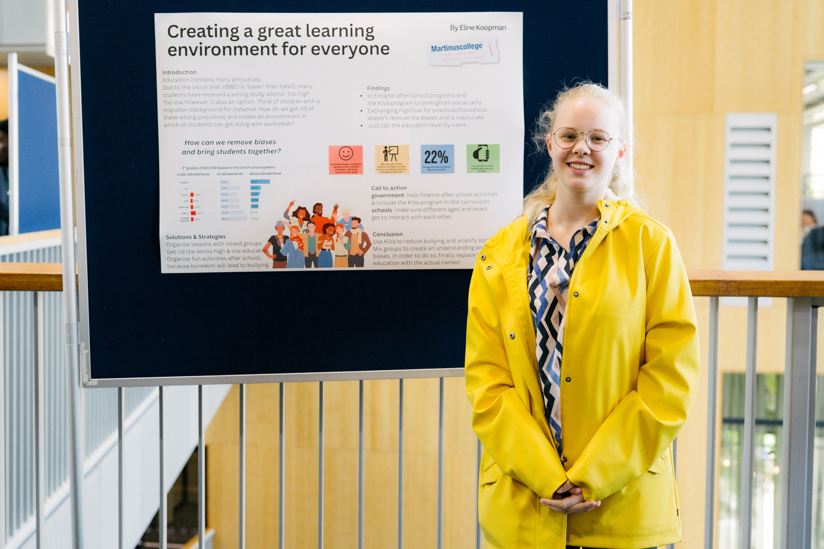
Student Poster Session: Showcasing Youth Perspectives
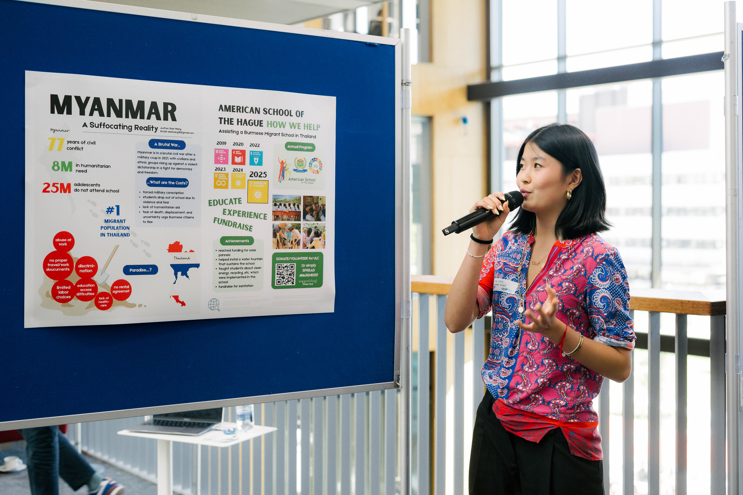
On the left, Sissi Wang and on the right, Eline Koopman.

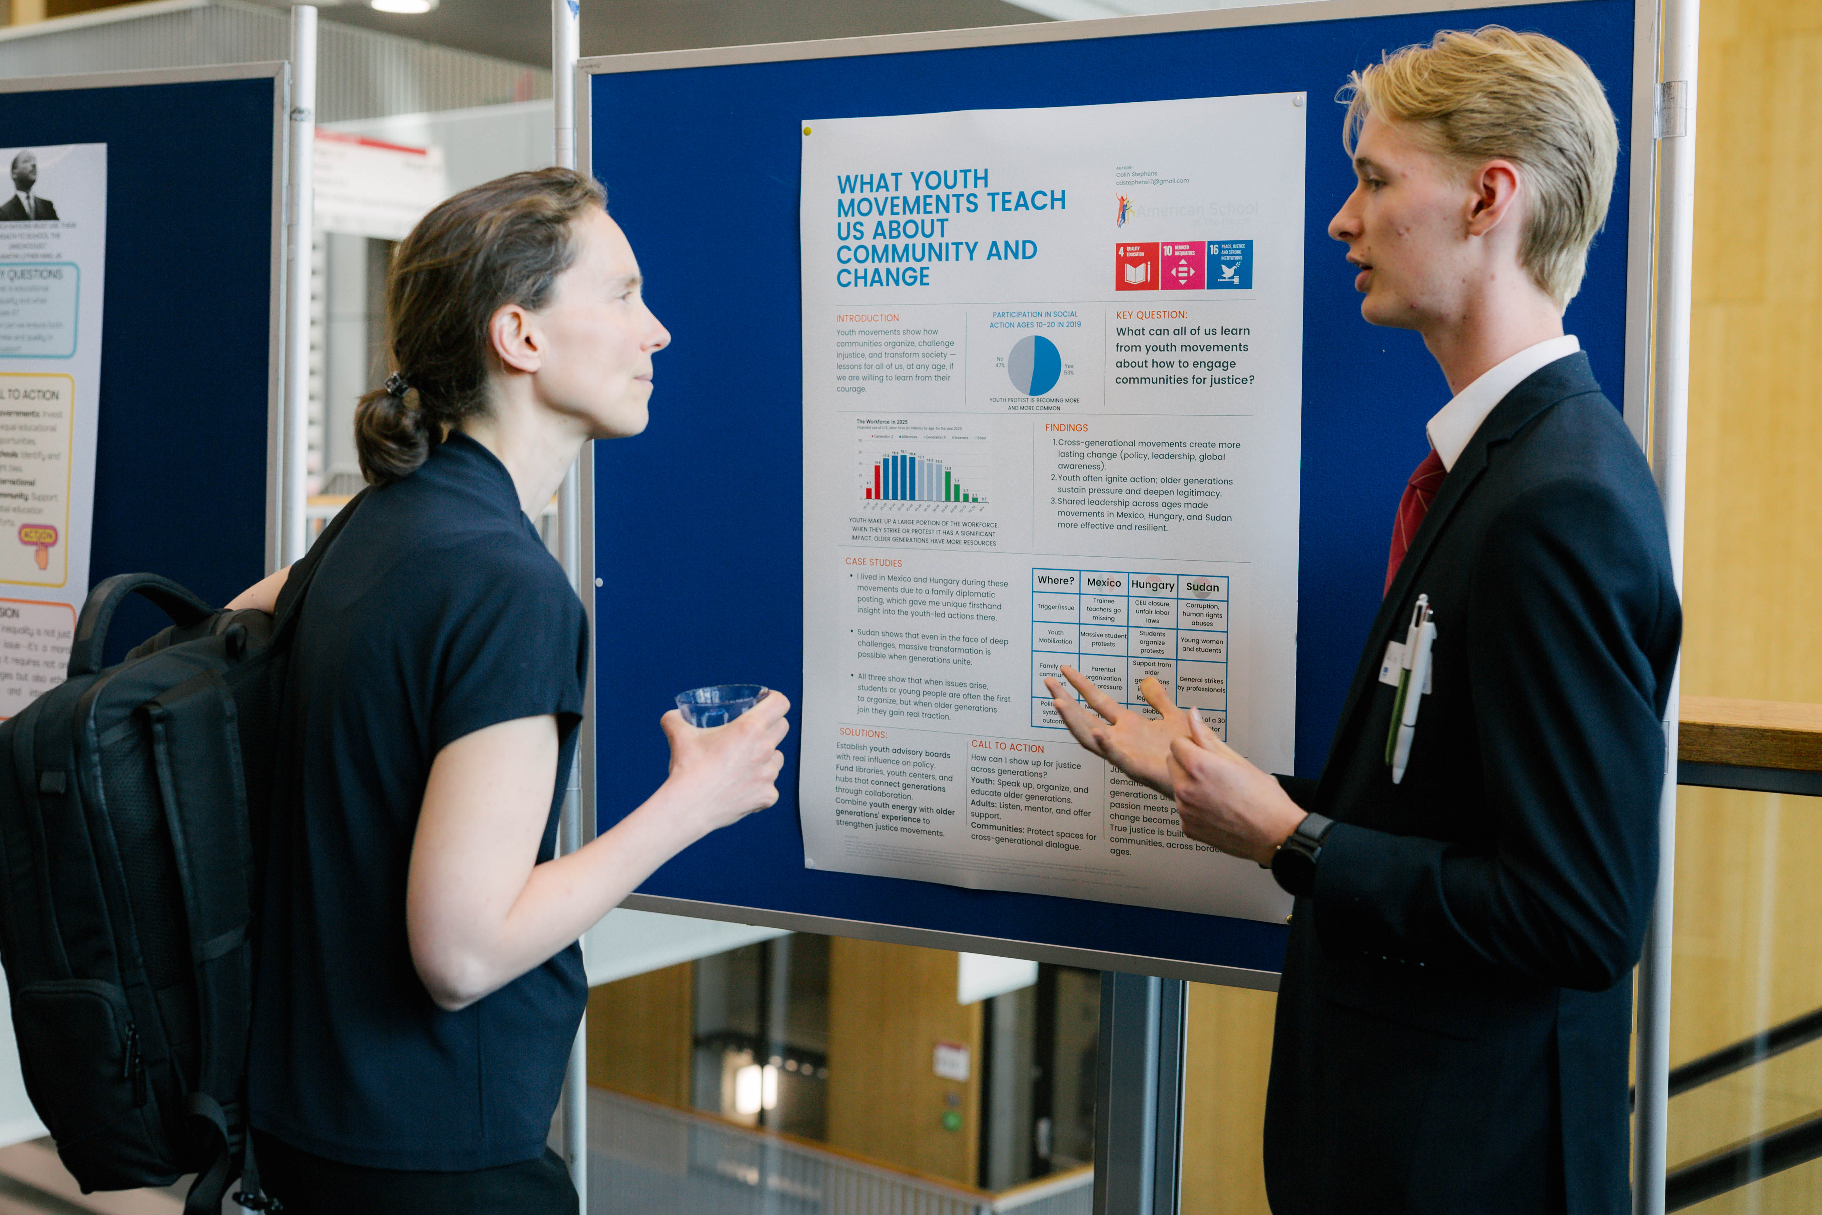
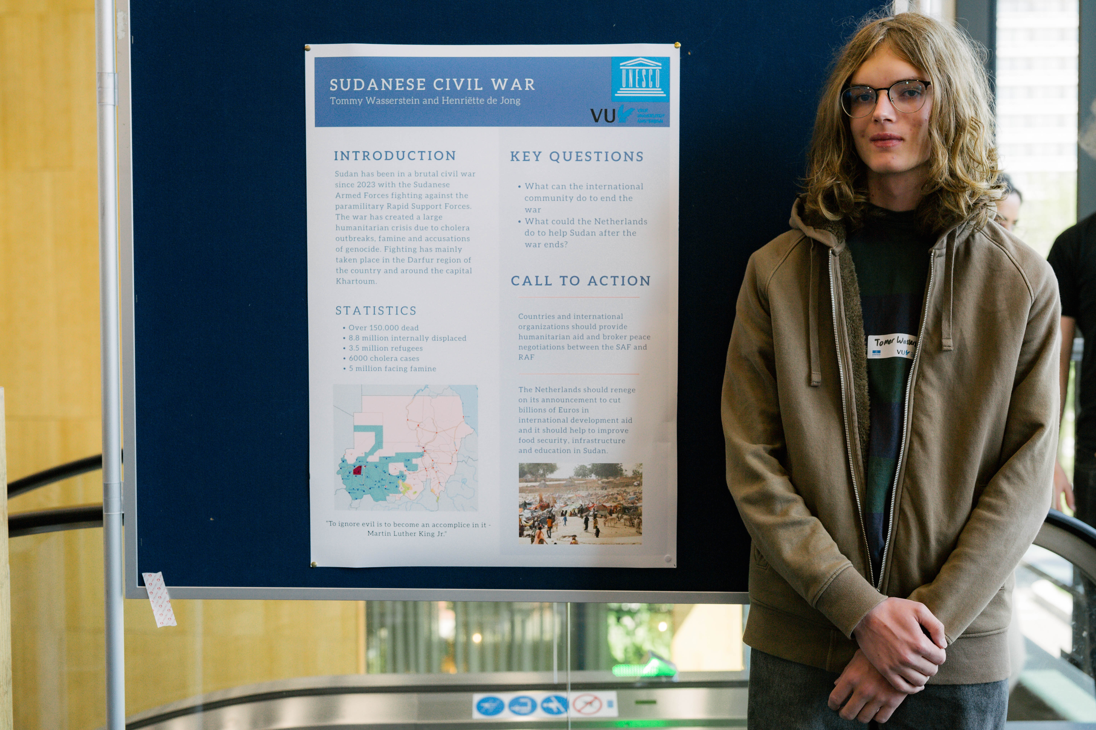
On the left, Tommy Wasserstein and on the right, Colin Stephens.

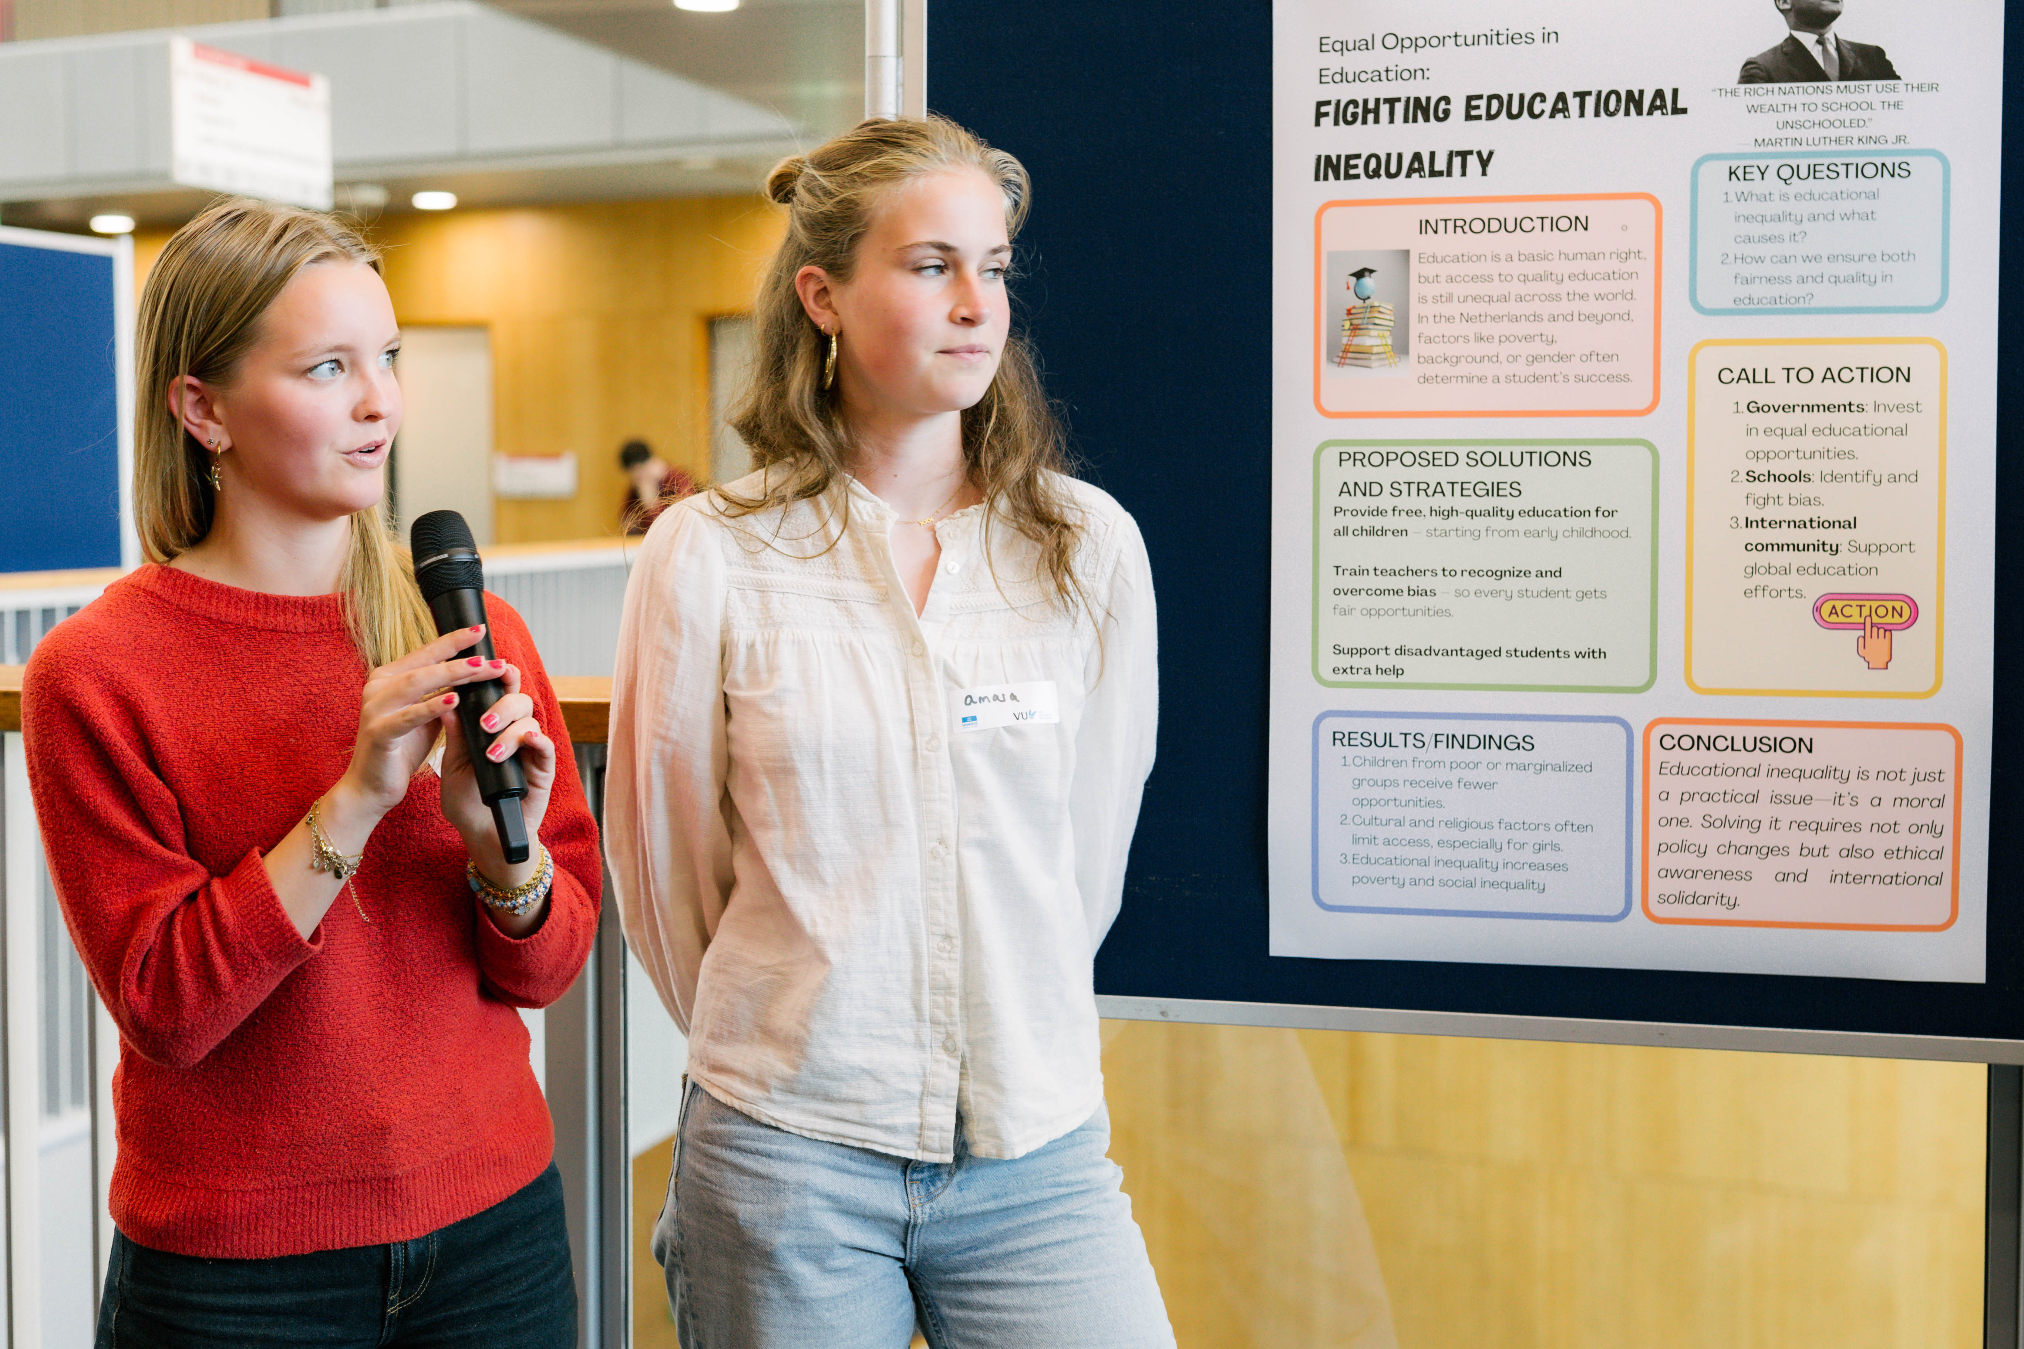
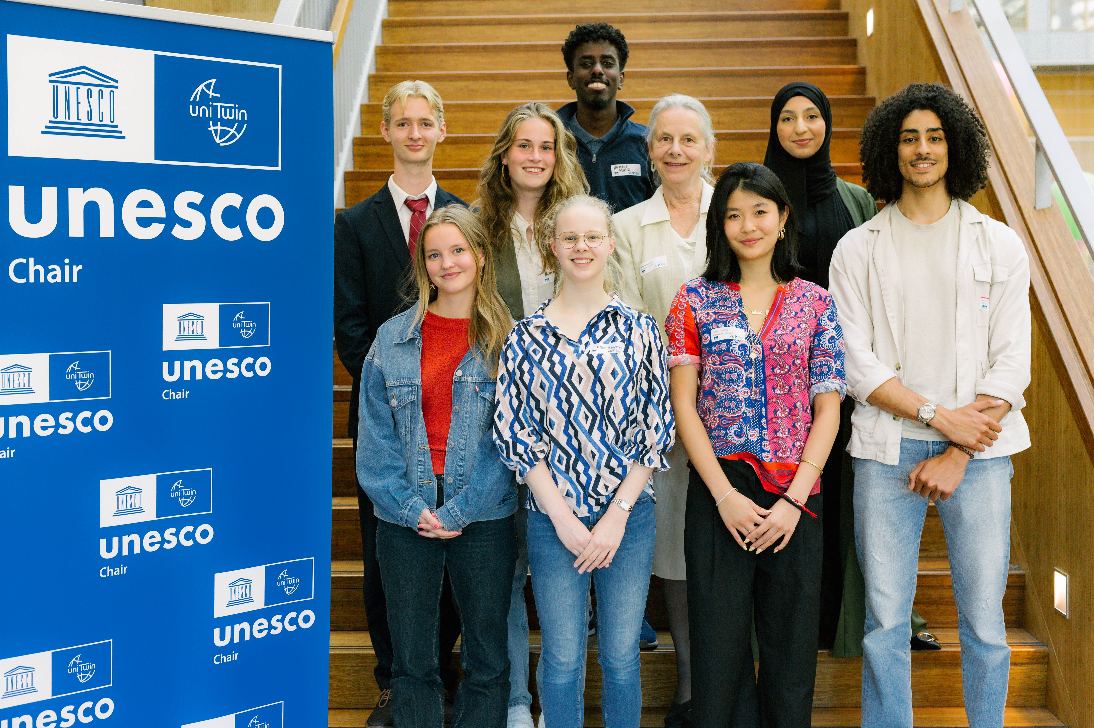
On the left, Lucy Rogaar and on the right, Amara Hage.

Reflections from participants
“In my poster presentation, I focused on how youth movements can shape policy and create real social change. That work is based on the belief that young people’s voices, and knowledge, matter. Being at the symposium helped me see that this belief isn’t just something I talk about. It’s something I have to keep practicing.” By C.S., high school student.

Workshop 1: Knowledge Equity in a Global Context
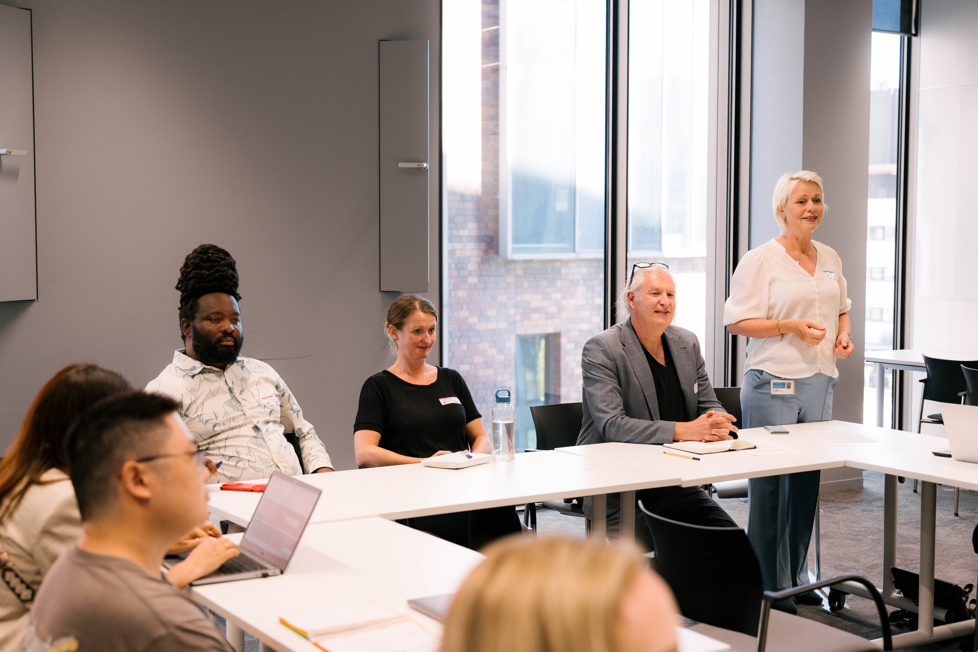

Moderator: Hilde van Wijngaarden, Director of the University Library at VU Amsterdam

The current situation in the USA places knowledge equity firmly in the forefront of discussions on access to education and academic freedom. It is becoming increasingly apparent that having power to decide what is knowledge (or what is not) has far-reaching consequences on individual, national and global levels. As a major provider of research data, infrastructures and funding, the entire world is vulnerable to the geopolitical situation in the USA.

In this workshop we look at what we can learn from this situation. What steps can we take to safeguard knowledge creation and to ensure that voices from marginalized groups continue to be represented in knowledge production? We look at the inherent challenges hindering equitable access to knowledge production and distribution, and its vulnerability to power relations. Through group discussion we will identify practical solutions to this ubiquitous problem. We will not only explore barriers faced by various groups in their quest to participate in and embrace open and equitable knowledge but also identify ways to dismantle gaps and disparities in reliable and ethical knowledge attainment.

About the session
After some short scene-setting talks from the workshop leaders, the participants will have the opportunity to discuss the current situation in the USA from a number of overlapping perspectives. The discussions from these breakout groups will be used to mind map strategies for combating knowledge inequity and epistemic injustice in a highly politicized world.

This session will have discussions led by thematic leaders:
- Louise Bezuidenhout: political influence over research infrastructures and data
  - Geopolitical and commercial control over infrastructures
  - Manipulation of data access
- Bruce Mutsvairo: misinformation and false narratives
  - Removing checks and balances from integrating misinformation and false narratives
  - Silencing diverse voices
- Bart Barendregt: politics and research agendas
  - Manipulation of research topics to align with political ideologies

About the Workshop Leaders:
Dr. Louise Bezuidenhout, UNESCO Chair on Diversity and Inclusion in Global Science, CWTS, Leiden University.
Prof. Dr. Bruce Mutsvairo, UNESCO Chair on Data, Disinformation, and Democracy, Utrecht University.
Prof. Dr. Bart Barendregt, UNESCO Chair on the Anthropology of Digital Diversity, Leiden University.
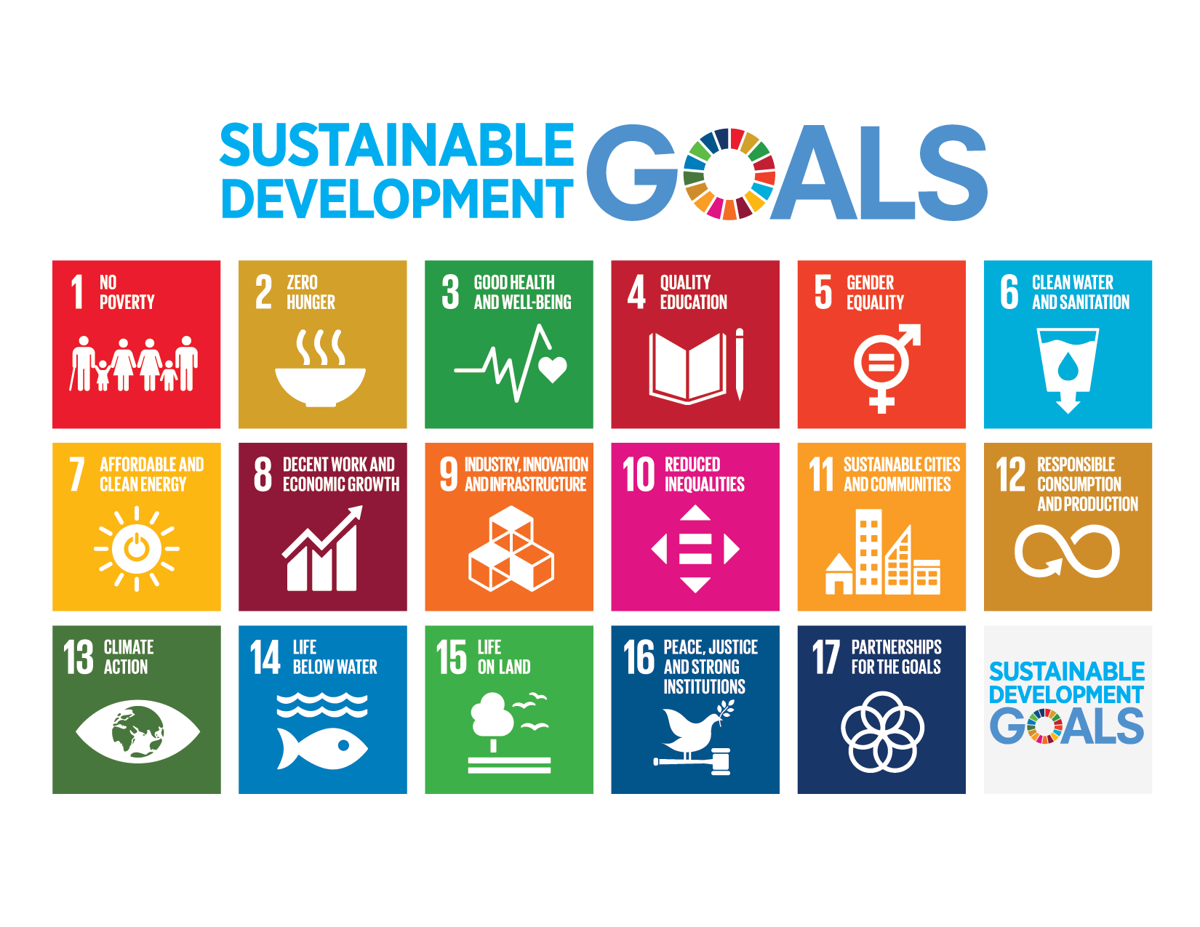

Reflections from participants
“It also raised more political and structural questions, such as who owns the information and who controls the narratives. This workshop made me realize that access to information is not only a technical issue, but also an ethical and cultural one; it reinforced my awareness that building an equitable information ecosystem requires conscious effort and shared responsibility from all of us.” By Z.T., CCM student.

“What was very interesting to me was how often knowledge systems are shaped by invisible decisions. Such as who designs the curriculum, what is included in textbooks, and which voices are invited into academic spaces. The workshop did not offer fixed solutions, but it did challenge us to think about our own roles. As students, researchers, or professionals, we are not just consuming knowledge, we are also part of the system that shapes it, so we need to be aware of these issues.” By A.M., CCM student.

“An interesting point was made when comparing the vastly superior way of distributing government funds to academic institutions to ensure equal access to resources in Brazil compared to us in Europe. The workshop served as a call to action for institutions and individuals to commit to creating a more just and equitable academic environment where all voices are heard and valued. In essence, the “Knowledge Equity in a Global Context” workshop underscored the imperative of transforming academic structures to ensure that knowledge creation and sharing are accessible and inclusive, reflecting the rich diversity of global perspectives.” By S.C., CCM student.

“The first question in the discussion (before the panelists spoke) was about the definition of knowledge equity. In my mind, I thought that it meant equal access to information around the world. But it’s so much more than that. Firstly, there is a huge difference between equality and equity. Equality is evenly distributed tools and resources, while equity is customized tools that identify and address inequality. This was eye-opening in itself, and applied to our discussion, made me realize that knowledge equity is much more complex than knowledge equality.” By K.W., CCM student.
“What really stood out was the idea that it’s not enough to just build new tools for the underrepresented. If the system doesn’t give everyone the same opportunities to use those tools, then we’re not really solving the problem. It made me realize that access to knowledge isn’t just about education, it’s about justice. And if we care about justice, we need to care about who gets left out and why.” By C.S., high school student.

Call to Action from the workshop
Development of knowledge diversity actions

Workshop 2: Activating Sustainability through the lens of Water Heritage and Values: A Serious Game
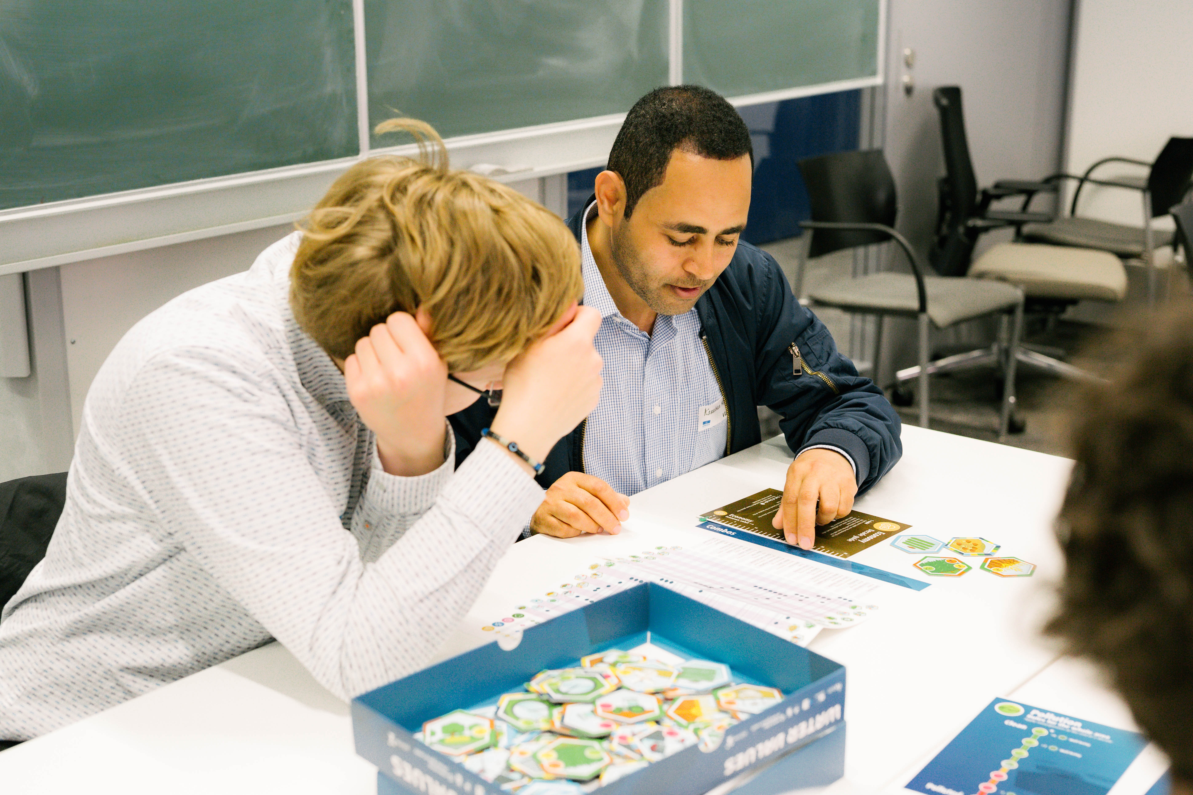
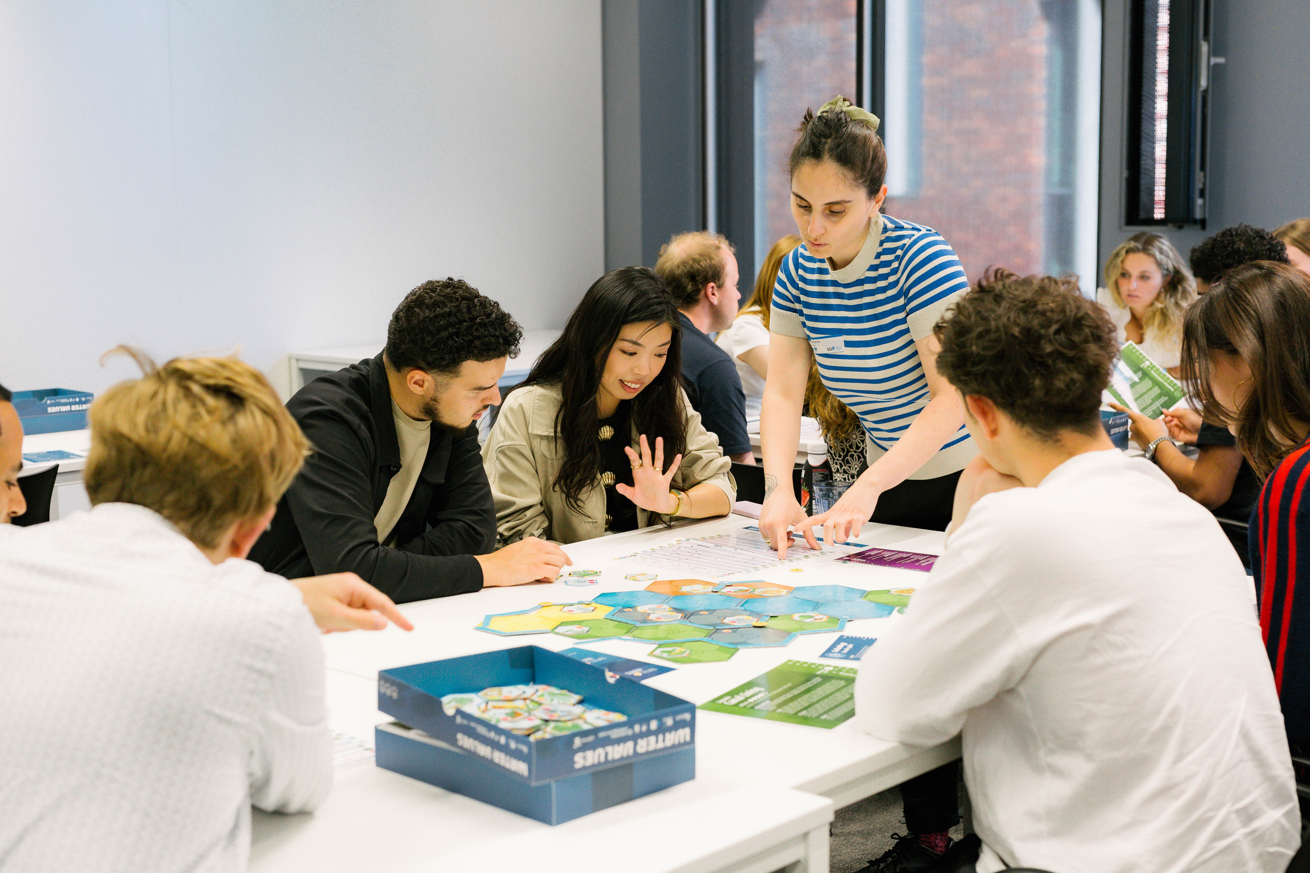

Moderator: Sem Barendse, Dialogue Coordinator, VU Amsterdam
Focus:
- Understanding the role of historical context in shaping sustainable urban planning.
- Exploring strategies to activate sustainability through multi-stakeholder engagement with existing cultural landscapes.
- Engaging participants in a serious game to simulate decision-making processes for sustainable urban solutions through the lens of water and heritage.

About Workshop Leaders:
Ing. Léa Kayrouz, TU Delft, where she participates in research at the intersection of urban planning, water management, and cultural heritage as part of the UNESCO Chair on Water, Ports, and Historic Cities (Leiden Delft Erasmus university consortium) led by Prof. dr. Ing. Carola Hein.
Prof. Dr. Ana Pereira Roders, UNESCO Chair on Heritage and the Reshaping of Urban Conservation for Sustainability, TU Delft.

Reflections from participants
“The game made it clear that water is not merely an environmental or technical issue. It is deeply embedded in social, cultural, and economic systems. Our choices demonstrated that sustainability is rarely straightforward; it often involves trade-offs and moments when one must prioritize long-term ecological resilience over short-term economic success. One of the workshop’s most valuable lessons was the importance of compromise and integrated decision-making. It reinforced the idea that sustainable development requires alignment across different sectors and values.” By A.Y., CCM student.

“One of the key takeaways from the session was the acknowledgment of cultural differences and how they influence perspectives on resource management. The woman who created the board game highlighted that it was fun to see how playing this game with different people from various cultural backgrounds allowed her to observe how cultural values emerged and influenced the game. This diversity, in some cases, enhanced the decision-making process toward collective goals, but some cultural clashes posed challenges in reaching common ground.” By M.T., CCM student.

“When we build bridges, by listening, negotiating, and aligning priorities, we can create more resilient, sustainable cities. The workshop effectively demonstrated the importance of integrating historical and cultural values in sustainability planning. It also reinforced the broader message of the symposium: that achieving the Sustainable Development Goals requires meaningful partnerships, mutual understanding, and shared responsibility.” By M.V.R., CCM student.

“For me, the core message was that sustainability isn’t just about planting more trees or solving technical problems. It goes way deeper than that. It’s about understanding values, making trade-offs, and working together on cultural, technical, and economic challenges. The workshop was a creative and fun way to explore these serious challenges, and it really made me think about how we manage landscaping and what we consider important in building our future.” By S.T., CCM student.

“The main lesson I learned from this workshop and game is that collaboration is key to creating meaningful and long-lasting value. It became clear that the environmental, social, and governance aspects are deeply connected. If one of them is ignored, the overall value will be limited. For example, ecological improvements without considering the social impact might lead to unfair outcomes, while strong governance without environmental care will not lead to real sustainability.” By S.B., CCM student.

Call to Action from the workshop
“The main lesson I learned from this workshop and game is that collaboration is key to creating meaningful and long-lasting value. It became clear that the environmental, social, and governance aspects are deeply connected. If one of them is ignored, the overall value will be limited. For example, ecological improvements without considering the social impact might lead to unfair outcomes, while strong governance without environmental care will not lead to real sustainability.” By S.B., CCM student.

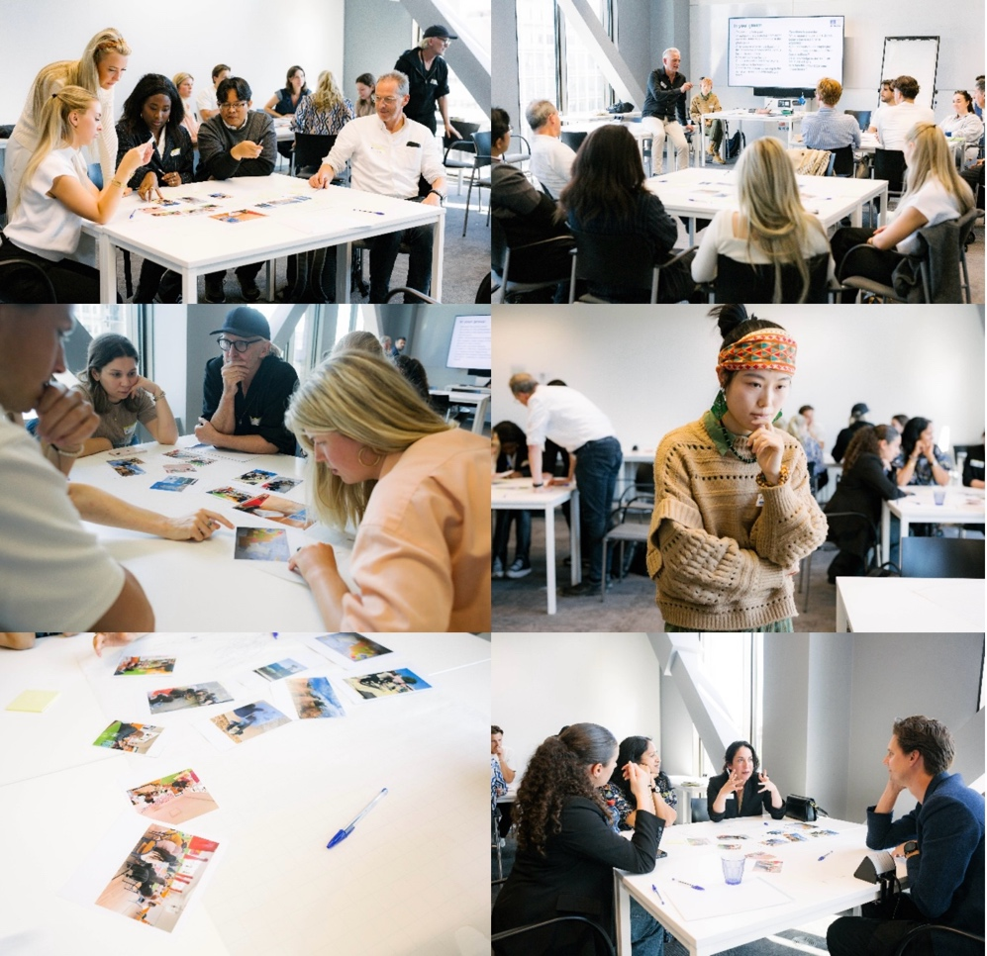
Workshop 3: Untangling Knowledge
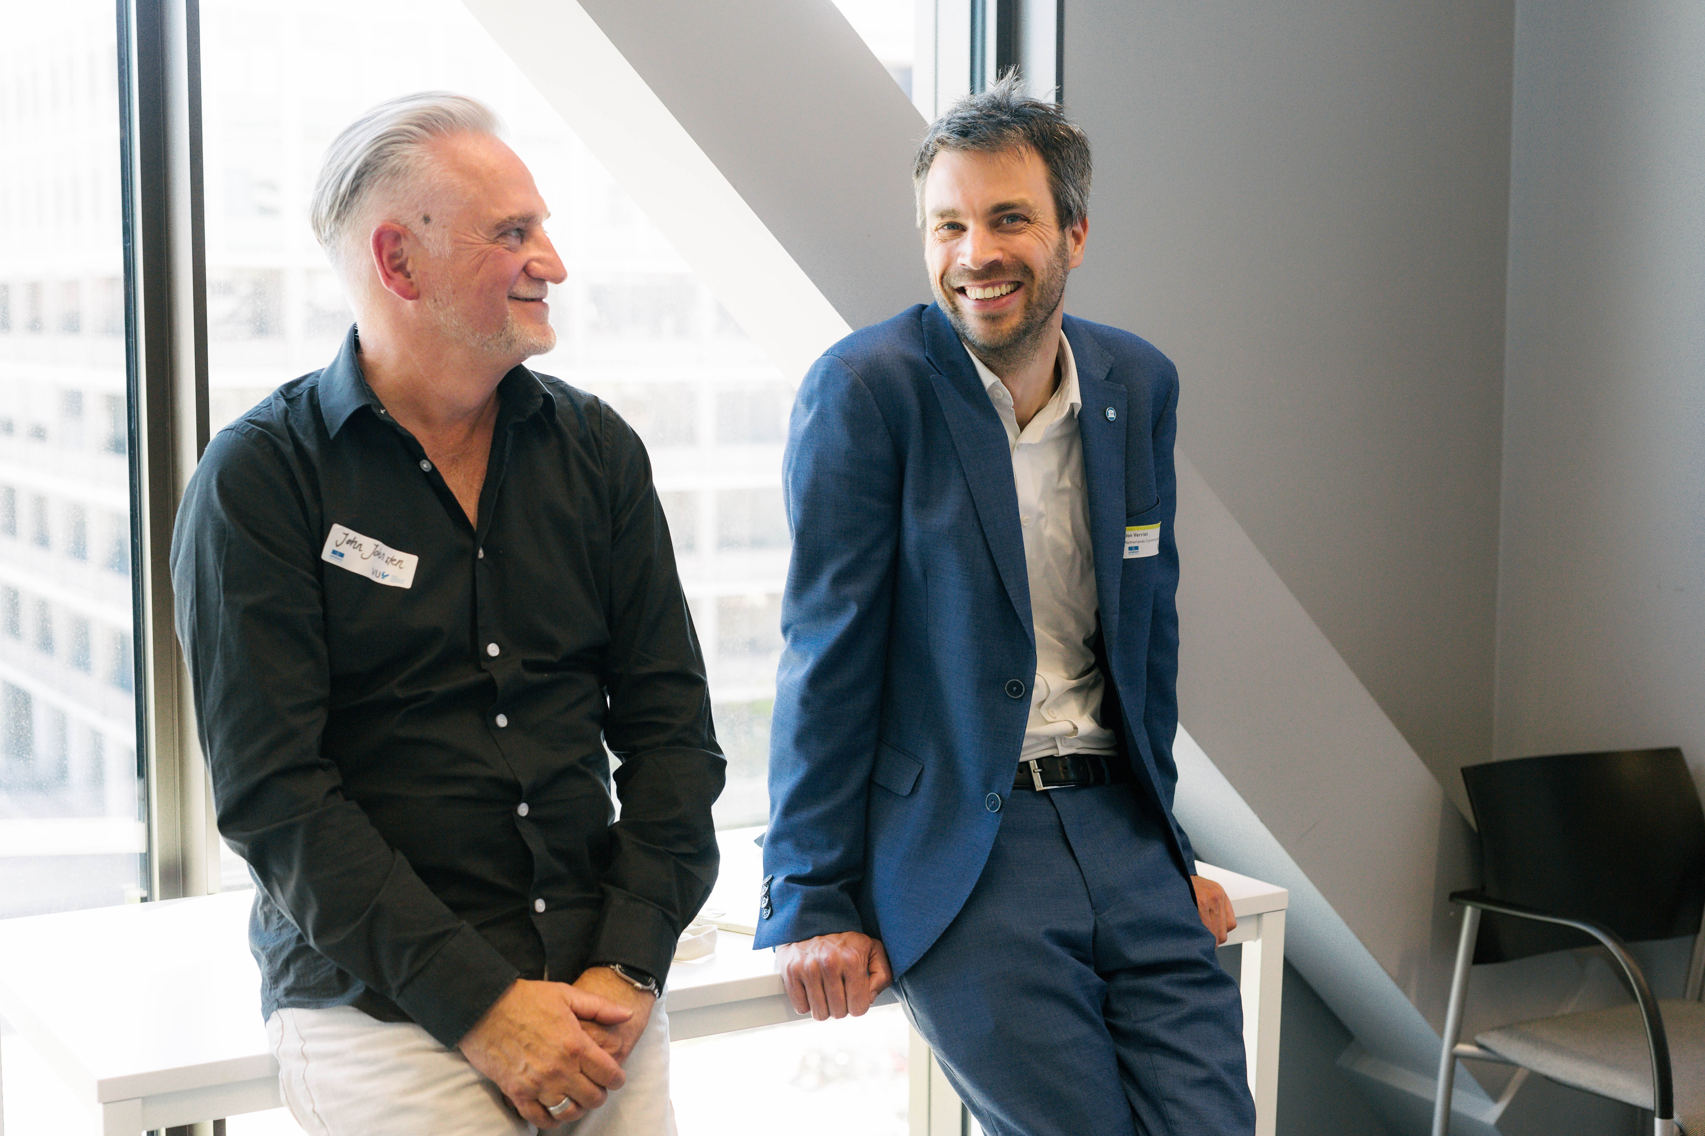
Moderator: Dr. Jon Verriet, Senior Science Advisor, Netherlands Commission for UNESCO.
About the Workshop Leader:
Dr. John Johnston, UNESCO Chair on Issues Based Arts Education, Intercultural Dialogue and Social Cohesion, ArtEZ University of the Arts, Arnhem

Focus: Identifying and isolating data drawn from an artistic process is a fundamental challenge for artistic researchers. Furthermore, analysing this data and excavating the knowledge derived from the process is crucial if the artwork is to represent new knowledge and be ultimately described as research.

In his workshop “Untangling Knowledge,’ Dr. John Johnston, UNESCO Chair of Issues Based Arts Education and Conflict Prevention at ArtEZ University of the Arts, will begin by presenting the concepts and purpose of his research, and offer participants the opportunity to engage in a process of analysis and investigation.
Working in small groups you will explore and untangle a number of past and current artistic projects notating the ‘imagined‘ issues and methods embedded in the process of production. Each group will be presented with an image/s and some basic information about the project to establish a basis for their analysis.

This is an exercise of un-entanglement, working from the product of a socially engaged arts practice to decouple the process from the product to recover the multiple relationships, issues and imaginaries involved in the entanglement arts led research.

Shared Takeaways from Dr. John Johnston and Dr. Jon Verriet
Workshop Overview
This workshop explored how socially engaged art practices can generate new knowledge through artistic research. Dr. Johnston introduced the methodology of Issues-Based Arts Education, focusing on the role of the artist-educator as both creator and researcher. Participants analysed a case study from artist-researcher Xiaobing Lin to unravel the multiple layers of meaning embedded in art projects. They critically examined how knowledge is produced and interpreted through artistic methods, and how art can build empathy.

Key Themes
• Artistic research as knowledge production
• Socially engaged art and community narratives
• The politics of place, identity, and memory in research
Xiaobing Lin’s project on storks nesting at UNESCO World Heritage Site Chellah in Rabat (Morocco) emphasized the role of positionality and reflexivity in research documentation. It used fictional or metaphorical mapping (e.g. “Stork’s Map”) to reframe spatial narratives. And it demonstrated the importance of creating space for personal and collective stories in data interpretation.

Major Insights
• Artistic research can surface alternative forms of knowledge often overlooked in traditional academic settings
• The act of “untangling” fosters a deeper understanding of lived experiences and collective memory
• Participants valued the open-ended, investigative format and the space for multiple interpretations

Call to Action
The UNESCO Chair at ArtEZ University of the Arts would like to encourage the integration of artistic research methods in broader academic contexts. It is also seeking to further explore collaborations between UNESCO Chairs working at the intersection of art, memory, and social justice.
One of the Chair’s major viewpoints is that education and research should be about embracing the unknown and stepping into the world. Not just about society but with society. The Chair would like to inspire others to transform education along these lines and to connect applied science (‘hbo’) and science (‘wo’).

Reflections from participants
“The workshop highlighted the potential of art to be employed in the service of broader discourse on social change. By contextualizing the process of generating art within matters of peace, equality, and sustainable communities, the session highlighted that the work of art can also be a process of generating knowledge. This process is consistent with many of the United Nations Sustainable Development Goals (SDGs), particularly those focused on education, gender equity, and inclusive institutions.” By K.A.S., CCM student.

“Dr. Johnston explained that artistic research is not just about the final product, but also about the process of creation. That process can reveal important insights into social and cultural issues. By examining the photos and reflecting as a group, we could uncover different layers of meaning and connect them to larger topics.” By M.D.S., CCM student.

“We were invited to analyze artistic processes and extract knowledge in a way that felt somewhat abstract and unfamiliar. For someone like me, trained to think in a structured, outcome-driven way, this was mentally demanding, and also since the time was limited a little stressful. Working with artistic material, without predefined frameworks or clear "right answers", was a real challenge. But that's also what made it valuable.” By C.L., CCM student.

“This workshop focused on how art can be used as a way to bring people closer together and to share knowledge. One of the key points discussed was the challenge artistic researchers face in identifying and separating the data that comes from the creative process. According to John Johnston, it is important for artists to collect and analyze this data to discover the knowledge it holds. Only then can the artwork be seen as a valid form of research that generates new understanding.” By N.B., CCM student.

“My main takeaway from the workshop was that research is not always about finding one correct answer. It can also be about how we interpret things, what question we ask, and how we choose to present the knowledge we uncover. I realized that this process is actually very creative. So, in a way, researchers are artists too.” By D.J., CCM student.

Call to Action from the workshop
“The workshop highlighted the potential of art to be employed in the service of broader discourse on social change. By contextualizing the process of generating art within matters of peace, equality, and sustainable communities, the session highlighted that the work of art can also be a process of generating knowledge. This process is consistent with many of the United Nations Sustainable Development Goals (SDGs), particularly those focused on education, gender equity, and inclusive institutions.” By K.A.S., CCM student.

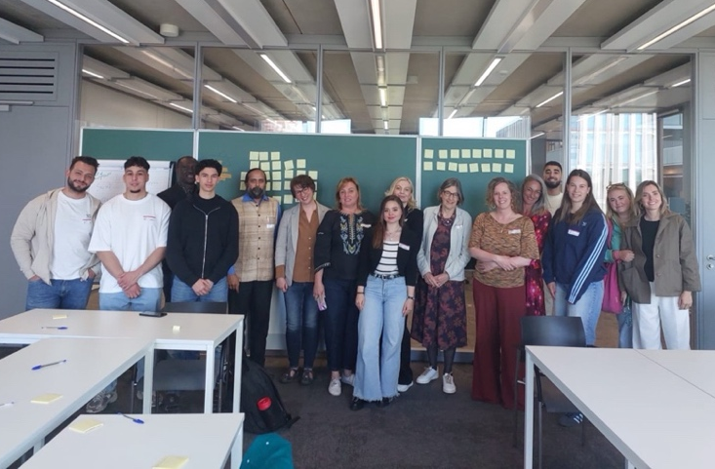
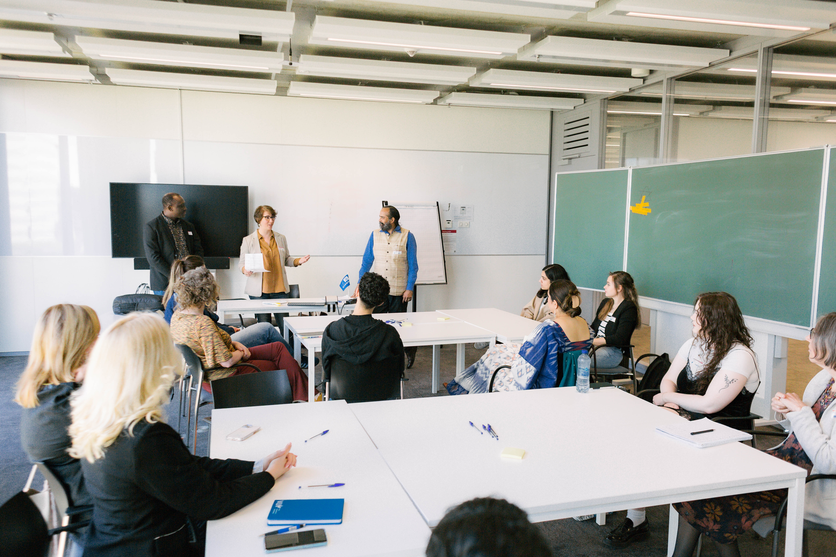
Workshop 4: Higher Education and Peacebuilding - Cross-Cultural and Emic Perspectives

(This workshop is organised with AURORA and UNESCO Chairs. See here)
Moderator: Dr. Selma Porobić, Aurora Institutional Coordinator, UPOL

Focus: This workshop brings together diverse global perspectives to explore how peace, justice, and ethical leadership can be meaningfully integrated into higher education. Led by scholars Selma, Pius, and Puneet - drawing from Bosnia, Swedish, African (Bantu), and Indian epistemologies - it invites participants to examine challenges such as epistemic violence, polarization, and inequity in academia. Through dialogue, collaborative visioning, and reflective exercises, the workshop encourages the co-creation of a peace-centered university model rooted in intercultural understanding, social justice, and spiritual literacy.

Workshop Theme:
- Higher Education Institutions (HEIs) as agents of peace: focus on curriculum design, emic approaches, and community outreach
- Exploring peace education hubs in conflict zones (Ukraine case study)
- Reframing academic freedom and cultural heritage as tools for reconciliation

About the workshop leaders

- Dr. Selma Porobić, Aurora Institutional Coordinator, UPOL. is an international scholar researching the cross-cutting themes of education in meeting global inequalities, human rights, justice and peacebuilding. She holds a PhD in migration studies from Lund University in Sweden and several academic diplomas from American University in Cairo, Fordham University in New York and Oxford University, UK. Dr. Porobić has published widely on displacement and post-war recovery, focusing on asylum and returnee rights, refugee experience and trauma, post-war recovery, gender, mental health, and education. Her recent book is entitled Forced Migration, Gender and Wellbeing. The Long-Term Effects of Displacement on Women.'(Edward Elgar, UK). Her latest research focuses on social trauma and peace education in post-conflict societies. She heads the Aurora Capacity Development Support Programme in Central-Eastern Europe and the Karzin University Peace Education Hub in Ukraine.
- Dr. Pius Mosima, researcher in African / Intercultural Philosophy; Globalization and Culture, Moral and Political Philosophy, CLUE+, VU. Dr. Pius Mosima teaches Philosophy at the University of Bamenda, Cameroon; Assistant Chief Examiner for Philosophy at the Cameroon General Certificate of Education Board (CGCEB) and Fellow at the African studies Center Leiden, the Netherlands. He holds a PhD in Philosophy from Tilburg University, the Netherlands. His research interests include African / Intercultural Philosophy; Globalization and Culture, Moral and Political Philosophy. In his research, Pius Mosima focusses on the debates surrounding Temples’ Bantu Philosophy and their implications.
- Dr. Puneet K. Bindlish, Assistant Professor Faculty of Religion Beliefs and Practices, CLUE+ VU. Some of the notable topics he researched and taught include Hindu spirituality, Indian ancient knowledge traditions, yoga, leadership, integrative intelligence, indigenous research methodology, organizational behavior, and holistic health.

The workshop leaders will share multicultural perspectives from AURORA universities
Puneet: Hindu perspective
Pius: African Bantu perspective
Selma: Ukraine perspective, Bosnian peace scholars perspective, Minority insider views, non-western views

Shared Takeaways from Dr. Puneet K. Bindlish

Workshop 4, “Peacebuilding in Higher Education,” examined how universities can foster peace through curriculum, culture, and community outreach. Drawing on African, Indian, and Bosnian perspectives, the session addressed epistemic violence, polarization, and academic inequity. Participants engaged in visioning exercises to co-create models of peace-centered universities, incorporating concepts like integrative intelligence and spiritual literacy. Emphasis was placed on ethical leadership, intercultural empathy, and the transformative role of education. Post-it reflections and a collaborative word cloud captured participants’ visions of peace education. The workshop concluded with commitments to future dialogue and highlighted the significance of higher education as a catalyst for social healing.

Reflections from participants

“The workshop's main message was clear: peacebuilding in education involves more than just books and lessons. It calls for a broader shift in how we think about learning. This includes becoming more emotionally aware, thinking in terms of community, and ensuring that different voices and experiences are truly represented in the classroom.” By L.V.D.G, CCM student.

“We shared our personal views about peace, war, and silence. After that conversation, one question stuck with me: Can silence about war be as damaging as a war? In my culture, we do not always talk about painful things; we usually avoid them. However, when we do not speak of pain and wounds, they do not disappear. Instead, they stay inside us, and we get used to this silence over time. Finally, it moves from one generation to the next. As a result, it creates distance. That moment helped me see something about myself and my own story.” By S.B., CCM student.

“We were not able to come to a specific solution, but what we definitely where able to discuss about issues, understand other perspectives, and recognize how these could contribute to peace on a bigger scale. Different perspectives bring different insights. So, by sharing these different insights, a more peaceful and sustainable world could be created. The idea that resonated with me the most was the use of storytelling in a way to bring together people within and outside universities. Stories move people. When it is told by people that have truly experienced them, they can create real impact by inspiring and creating understanding.” By Y.A., CCM student.

“What I really enjoyed was that the workshop didn’t stay theoretical. It was very interactive and engaging. We were asked to share ideas on what disrupts peace in universities and how we can change that. But the most powerful moment for me was an exercise by Dr. Puneet Bindlish. He had a big white poster and asked each person in the room to give one word to describe the theme of the day. I was one of the last to speak, and I chose the word “peace.” Everyone was surprised, not because it was a new word, but because somehow it had been forgotten until then. That moment made me feel like I had something meaningful to contribute.” By M.S., CCM student.

“Discussion topics were largely centred around challenges to peace in universities, including epistemic violence, polarization, and inequity in academia. The focus of the moderator’s addresses, and of the group discussions, was lived experience, with attendees from different backgrounds sharing their experiences and opinions about challenges to peace in today’s world. These discussions particularly revolved around epistemic violence, its presence in participants lives and also in academia, which when it occurs in education systems often results in the marginalization of non-Western knowledge systems and the perpetuation of power imbalances.” By A.D., CCM student.

“In essence, it is more difficult to start a conflict with a friend and dear one, than with a stranger. It became clear that art has a transformative power, through its conventions, allowing us to change roles and live in someone else’s world. It breaks language and cultural barriers, able to touch that part in people’s soul that is rarely invited to see the light of day in the way we have built our society nowadays – engulfed in technology that isolates us, overwhelmed by tons of (mis)information, pushed for productivity and performance and forgetting to connect with our inner world, with others and with nature. This brings a lot of frustration, depression, anxiety, anger and entitlement.” By F.L.E., CCM student.

Call to Action from the workshop

“The workshop's main message was clear: peacebuilding in education involves more than just books and lessons. It calls for a broader shift in how we think about learning. This includes becoming more emotionally aware, thinking in terms of community, and ensuring that different voices and experiences are truly represented in the classroom.” By L.V.D.G, CCM student.

Workshop 5: Constructing Peace in the Minds of Tomorrow: Conflict Resilience through Coaching and Mentoring in Higher Education & Human Rights
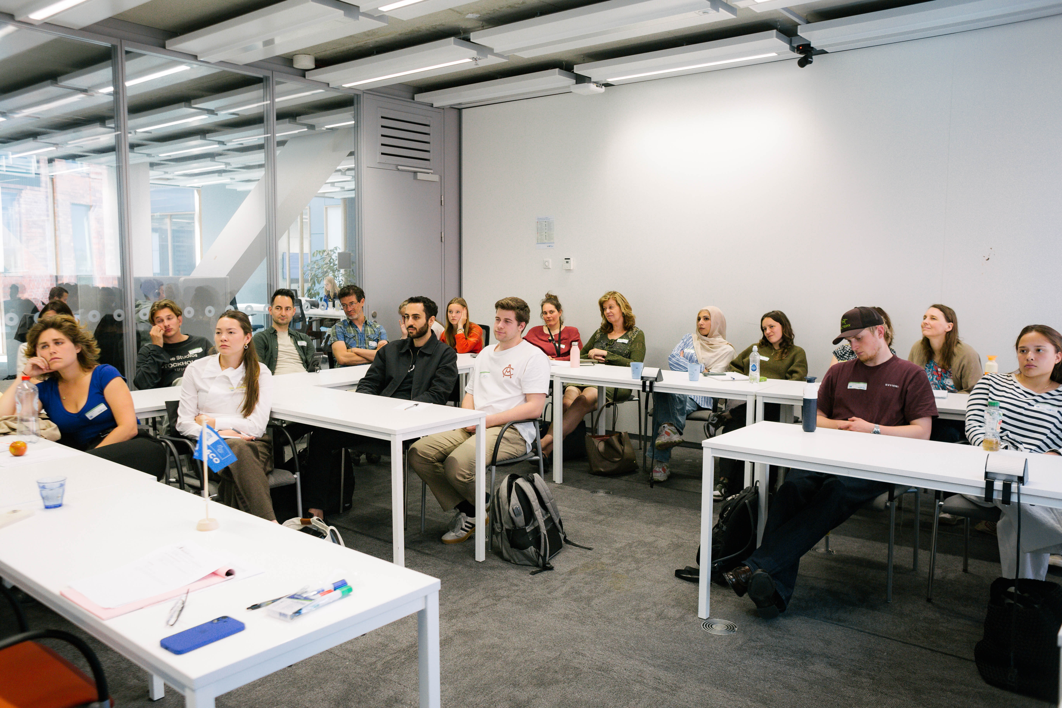
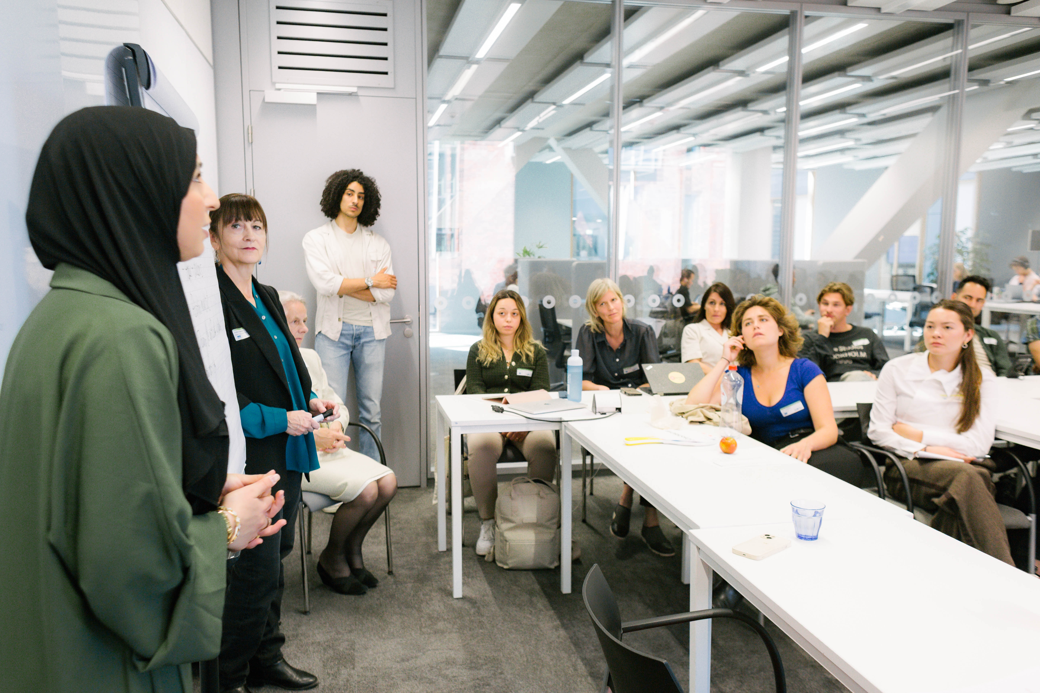

Moderator: Ms. Lenka Hora Adema, (international) mediator, coach, and trainer. Lecturer Faculty of Law VU Amsterdam.

About the Workshop Leader:
Prof. dr. Felisa Tibbitts, UNESCO Chair on Human Rights in Higher Education. Utrecht University. Prof. Tibbitts is renowned for her extensive work in human rights education, focusing on areas such as global and democratic citizenship education, and education for sustainable development.
Focus: The workshop is titled “Constructing Peace in the Minds of Tomorrow: Conflict Resilience through Coaching and Mentoring in Higher Education & Human Rights.” This session aims to develop participants’ conflict resilience skills by integrating personal storytelling, practical exercises, and theoretical insights. The workshop will include a theoretical reflection by Prof. Dr. Felisa Tibbitts, the UNESCO Chair in Human Rights in Higher Education at Utrecht University. Prof. Tibbitts is renowned for her extensive work in human rights education. Her work includes research on critical pedagogy and methods of learning, aiming to strengthen university practices in non-discrimination, historical accountability, inclusion, and diversity. Participants will gain valuable insights into how engaging with inner conflict can contribute to building peace in future generations.
This workshop will feature Aelaf Mohammed, Member of the UNESCO Youth Commission. She advocates for young people who have been forced to leave their homelands due to unsafe conditions. Through guest lectures, she aims to raise awareness about their rights to live, grow, and thrive in peace in the Netherlands. At the same time, she encourages Dutch society to reflect on its privileges, fostering greater gratitude, understanding, and solidarity.

Note: A few student-refugees and their mentors will attend.

Shared Takeaways from Prof.Dr. Felisa Tibbitts and Aelaf Mohammed
The workshop illustrated the importance of proving forums for refugees and displaced persons to share their personal stories of struggle and survival. In this session, we heard the story of Aelaf Mohammed who fled from Iraq with her family when she was a young girl was extraordinarily moving. You realize that people fleeing such circumstances do not have a choice. Even though they may be viewed as ‘searching for a better life’ there are stresses, and even traumas, associated with (a) having to leave your home, (b) the trip to the host country, and (c) settling into a new country.
The workshop discussions also revealed that there remains a gap in providing basic services to refugees once they arrive in the Netherlands. Aelaf as well as other refugees in the room, shared challenges such as having access to Dutch language lessons, finding a permanent home outside of the refugee camp, and completing paperwork that would make them eligible to attend school and go to work. They also emphasized how important it was to keep their hopes and dreams alive, regardless of setbacks.
Points made specifically by Aelaf:
We were not offered any psychological support. Considering the amount of trauma we experienced, it would have been essential to have access to someone we could speak with unfortunately, that support was not provided.
Life in the asylum seekers' center was indescribable. Some individuals did not treat us with the dignity we deserved, and the living conditions were unacceptably poor. Rather than discussing us or seeking to remove us, it would be more constructive to invest in basic necessities such as proper beds and essential daily items.
Engage in dialogue with us, not merely about us. Understanding our needs requires asking us directly, rather than making assumptions on our behalf.
There is a need to establish more safe and supportive spaces where individuals can share their experiences, in order to foster deeper empathy and understanding.
In reflecting on these points and the implications for higher education, a few points were made by Felisa as well as others who attended the session.
- It is essential that refugees and displaced people are given a meaningful role in influencing policies and practices affecting their access to and experiences in higher education. Their voices need to be made central, not supplemental or tokenistic. Refugees also need to become familiarized with the political system of their host country, including how to vote.

- There are many ways that universities can support the inclusion and development of students who are refugees. These include mentoring relationships with adults and other students; academic coaching; and spaces to socialize and have fun. Ideally university staff and faculty will themselves reflect the diversity of the student body.

- Efforts to facilitate refugee access to higher education by recognizing educational merit and learning the language of the host country must continue. In environments where language learning courses are not readily available – for example for adult newcomers who are no longer attending school – university students might volunteer to assist.

- The university has a special role to play in being both a welcoming community to students who are refugees and displaced, as well as to their families and communities. University relationships with community groups can be mutually enriching.

Reflections from participants
“Together with the other workshop participants, we discussed how universities can do more for refugees and migrants—not only by providing greater access to education but also through mentorship, support, and genuine inclusion. These conversations made a deep impression on me. They taught me that peace is not merely an abstract concept; it is something you build every day by listening and collaborating with others. For each person, peace means something slightly different, as the workshop clearly illustrated.” By A.H., high school student from the PUC course.
“Through conversations with both Dutch citizens and refugees, I realized that our societal systems are not set up to facilitate true integration, even though refugees are eager to learn the language, find work, and become part of their new communities. I recognize my own privilege as a young man with a loving family, stable finances, and strong social connections, which makes me ready and willing to help refugees settle here. Yet I find myself with virtually no opportunity to do so because the asylum system isolates newcomers in centers where everyday interaction with Dutch society is nearly impossible.” By M.V.D.B., CCM student.
“The overall message was clear and it was agreed that integration should be seen as a shared opportunity, not just a challenge. By sharing her story, Aelaf helped us understand the importance of empathy, human connection, and inclusive policies. The facilitators made a strong case for making coaching and mentoring a regular part of university life. Instead of waiting for problems to get worse, we can support students early on, so they feel more confident and connected.” By J.G.C., CCM student.

“Aelaf’s story deeply moved everyone in the room. It brought a real-world, emotional context to the abstract discussions we often have about refugees and global issues. After she spoke, we discussed the psychological and emotional effects of such experiences and what kind of support structures are needed. We talked about the importance of community, education, and mental health support for people dealing with trauma and displacement.” By A.B., CCM student.

“Aelaf’s story left everyone speechless, as they listened attentively and visibly showed happiness after she told them she was doing well now and attending school. After she finished her story, we were assigned to think about how we overcame a difficult time in our lives and how we demonstrated resilience. People gave answers such as faith, family, or mental health support.” By E.D.K., CCM student.

Call to Action from the workshop

“There are many ways that universities can support the inclusion and development of students who are refugees. These include mentoring relationships with adults and other students; academic coaching; and spaces to socialize and have fun. Ideally university staff and faculty will themselves reflect the diversity of the student body.
Efforts to facilitate refugee access to higher education by recognizing educational merit and learning the language of the host country must continue. In environments where language learning courses are not readily available – for example for adult newcomers who are no longer attending school – university students might volunteer to assist.
The university has a special role to play in being both a welcoming community to students who are refugees and displaced, as well as to their families and communities. University relationships with community groups can be mutually enriching.” By Prof.Dr. Felisa Tibbitts.

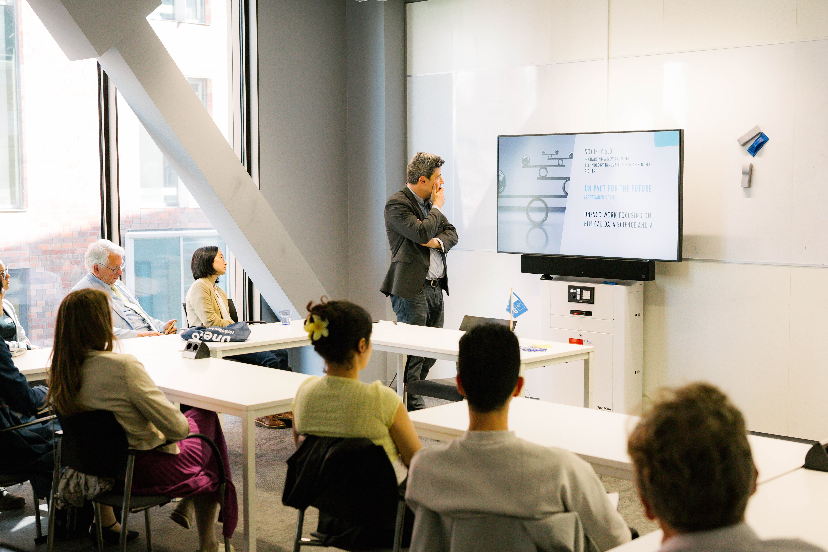
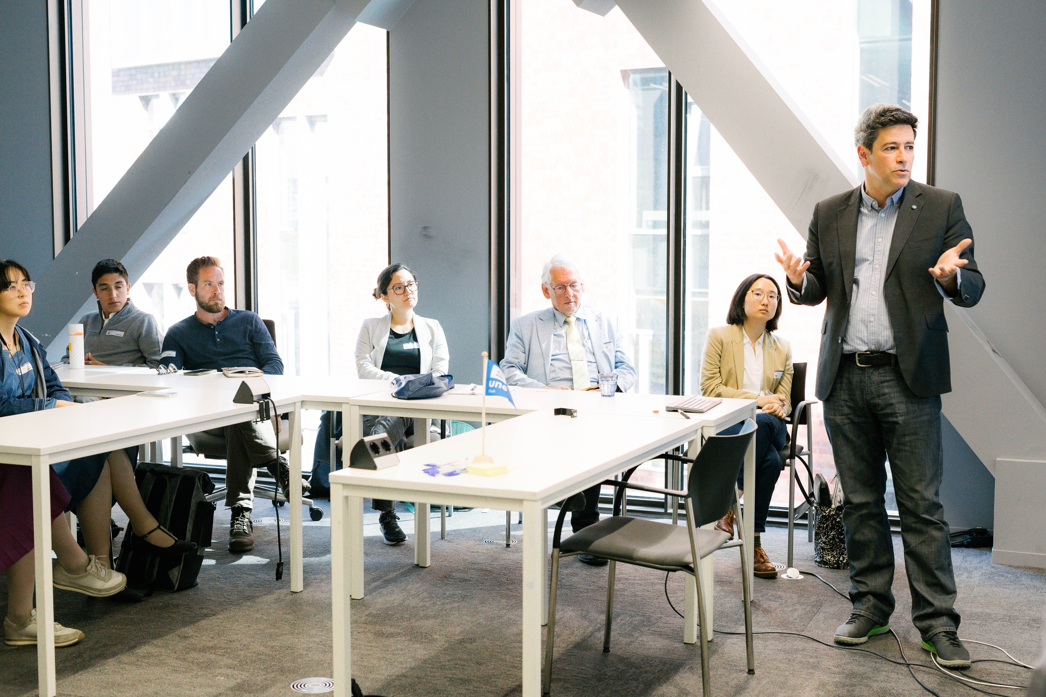
Workshop 6: Shaping the Future of Digital Ecosystems and Platforms in Advancing Fairness in the Context of Generative AI

Moderator: Dr. Piet Kommers, Professor in Learning Technologies and Media Design, University of Twente.

About the Workshop leaders:
- Dr. Jaap Gordijn, UNESCO Chair on Decentralized Information Society Engineering, VU Amsterdam.
- Dr. Lampros Stergioulas, UNESCO Chair on AI & Data Science for Society, The Hague University of Applied Sciences.

In this workshop, we discuss generative AI, which can generate new recordings and musical works out of existing ones. Generate AI uses various forms of learning, which all suppose a large base of knowledge to learn from. In the music sector, this knowledge base in practice is a large database of recordings and musical works.

Following law on intellectual property right, music of creative entities is used by others in their productions, a fee has to be paid to original creative entities for using the intellectual property. In many cases, the original recordings and works can be traced back to the original recordings and works.

With generative AI, traceability is much more difficult to achieve. For example, generative AI can generate completely new lyrics, which are recorded by using the generated voice of a famous artist who never agreed to so. In many other cases, traceability is even more fuzzy.

This poses a number of questions regarding fairness. For example:
- How to ensure that rightsholders are paid, if their works are input to the ML algorithm and used in a generated song
- And similarly, how to deal with ‘borrowing’ someone’s voice?
- Should generative AI learning algorithms have free access to data sources, in this case recordings or works? Or should there be a fee to be paid for including recordings and works in an AI database?
- Can we implement traceability in generative AI? In practice, is it technically possible to relate a generated piece of music to sources it is based upon?
- Would it be possible that generated AI is more interesting than original recordings? Is it really an alternative?
- What will be the quality of generated music on the long term? And: is the current database of all recordings enough to generate all possibly interested recordings? Or should we still create original recordings and works, because there is still something new to be created?

Format:
• Jaap Gordijn introduces the music ecosystem, and the intellectual property rights associated with it
• Lampros Stergioulas introduces generative AI
• Piet Kommers will moderate a discussion session about the above questions.

Reflections from participants
“The presentation went on to discuss how the use of AI may affect the music industry, and the possible challenges and limitations that come with it. This raised important questions about authorship, originality and the future of human creativity. The ability to generate content so quickly and convincingly is both impressive and worrying, challenging our traditional understanding of what means to create something. It also made me think about how technology might devalue artistic labor if ethical and legal frameworks don’t evolve accordingly.” By M.J.S., CCM student.

“Overall, the workshop made clear that while AI offers exciting tools, human oversight, ethical frameworks, and adaptive education are essential for shaping a fair and creative digital future.” By N.N., CCM student.

“The first speaker discussed the disruptive role of Generative AI in the music industry. They demonstrated how entire songs could now be generated using AI, all melodies, lyrics, and vocals included. While these AI-generated songs sounded impressively authentic, they raised serious concerns about copyright, ownership, and the future of human creativity.” By N.L., CCM student.

“I was particularly struck by how fast AI is evolving and how slowly our legal and ethical systems are keeping up. One of the more constructive discussions centered around potential solutions, such as royalty-sharing models for original creators and more transparent training data practices. It became clear to me that collaboration between technology, law, and ethics will be crucial in addressing the future of AI.” By C.A., CCM student.

”We talked about music made by AI, and the question of who owns creativity if a machine can make a song in two hours. Some participants including myself worried about losing the “human” in art; others saw new possibilities for expression and collaboration. What I realized during this workshop, everyone, not just the young/smart/rich/influenceful but also for example older people can bring up points that can guide a conversation into something interesting.“ By J.V.K., CCM student.

Call to Action from the workshop
“Overall, the workshop made clear that while AI offers exciting tools, human oversight, ethical frameworks, and adaptive education are essential for shaping a fair and creative digital future.” By N.N., CCM student.

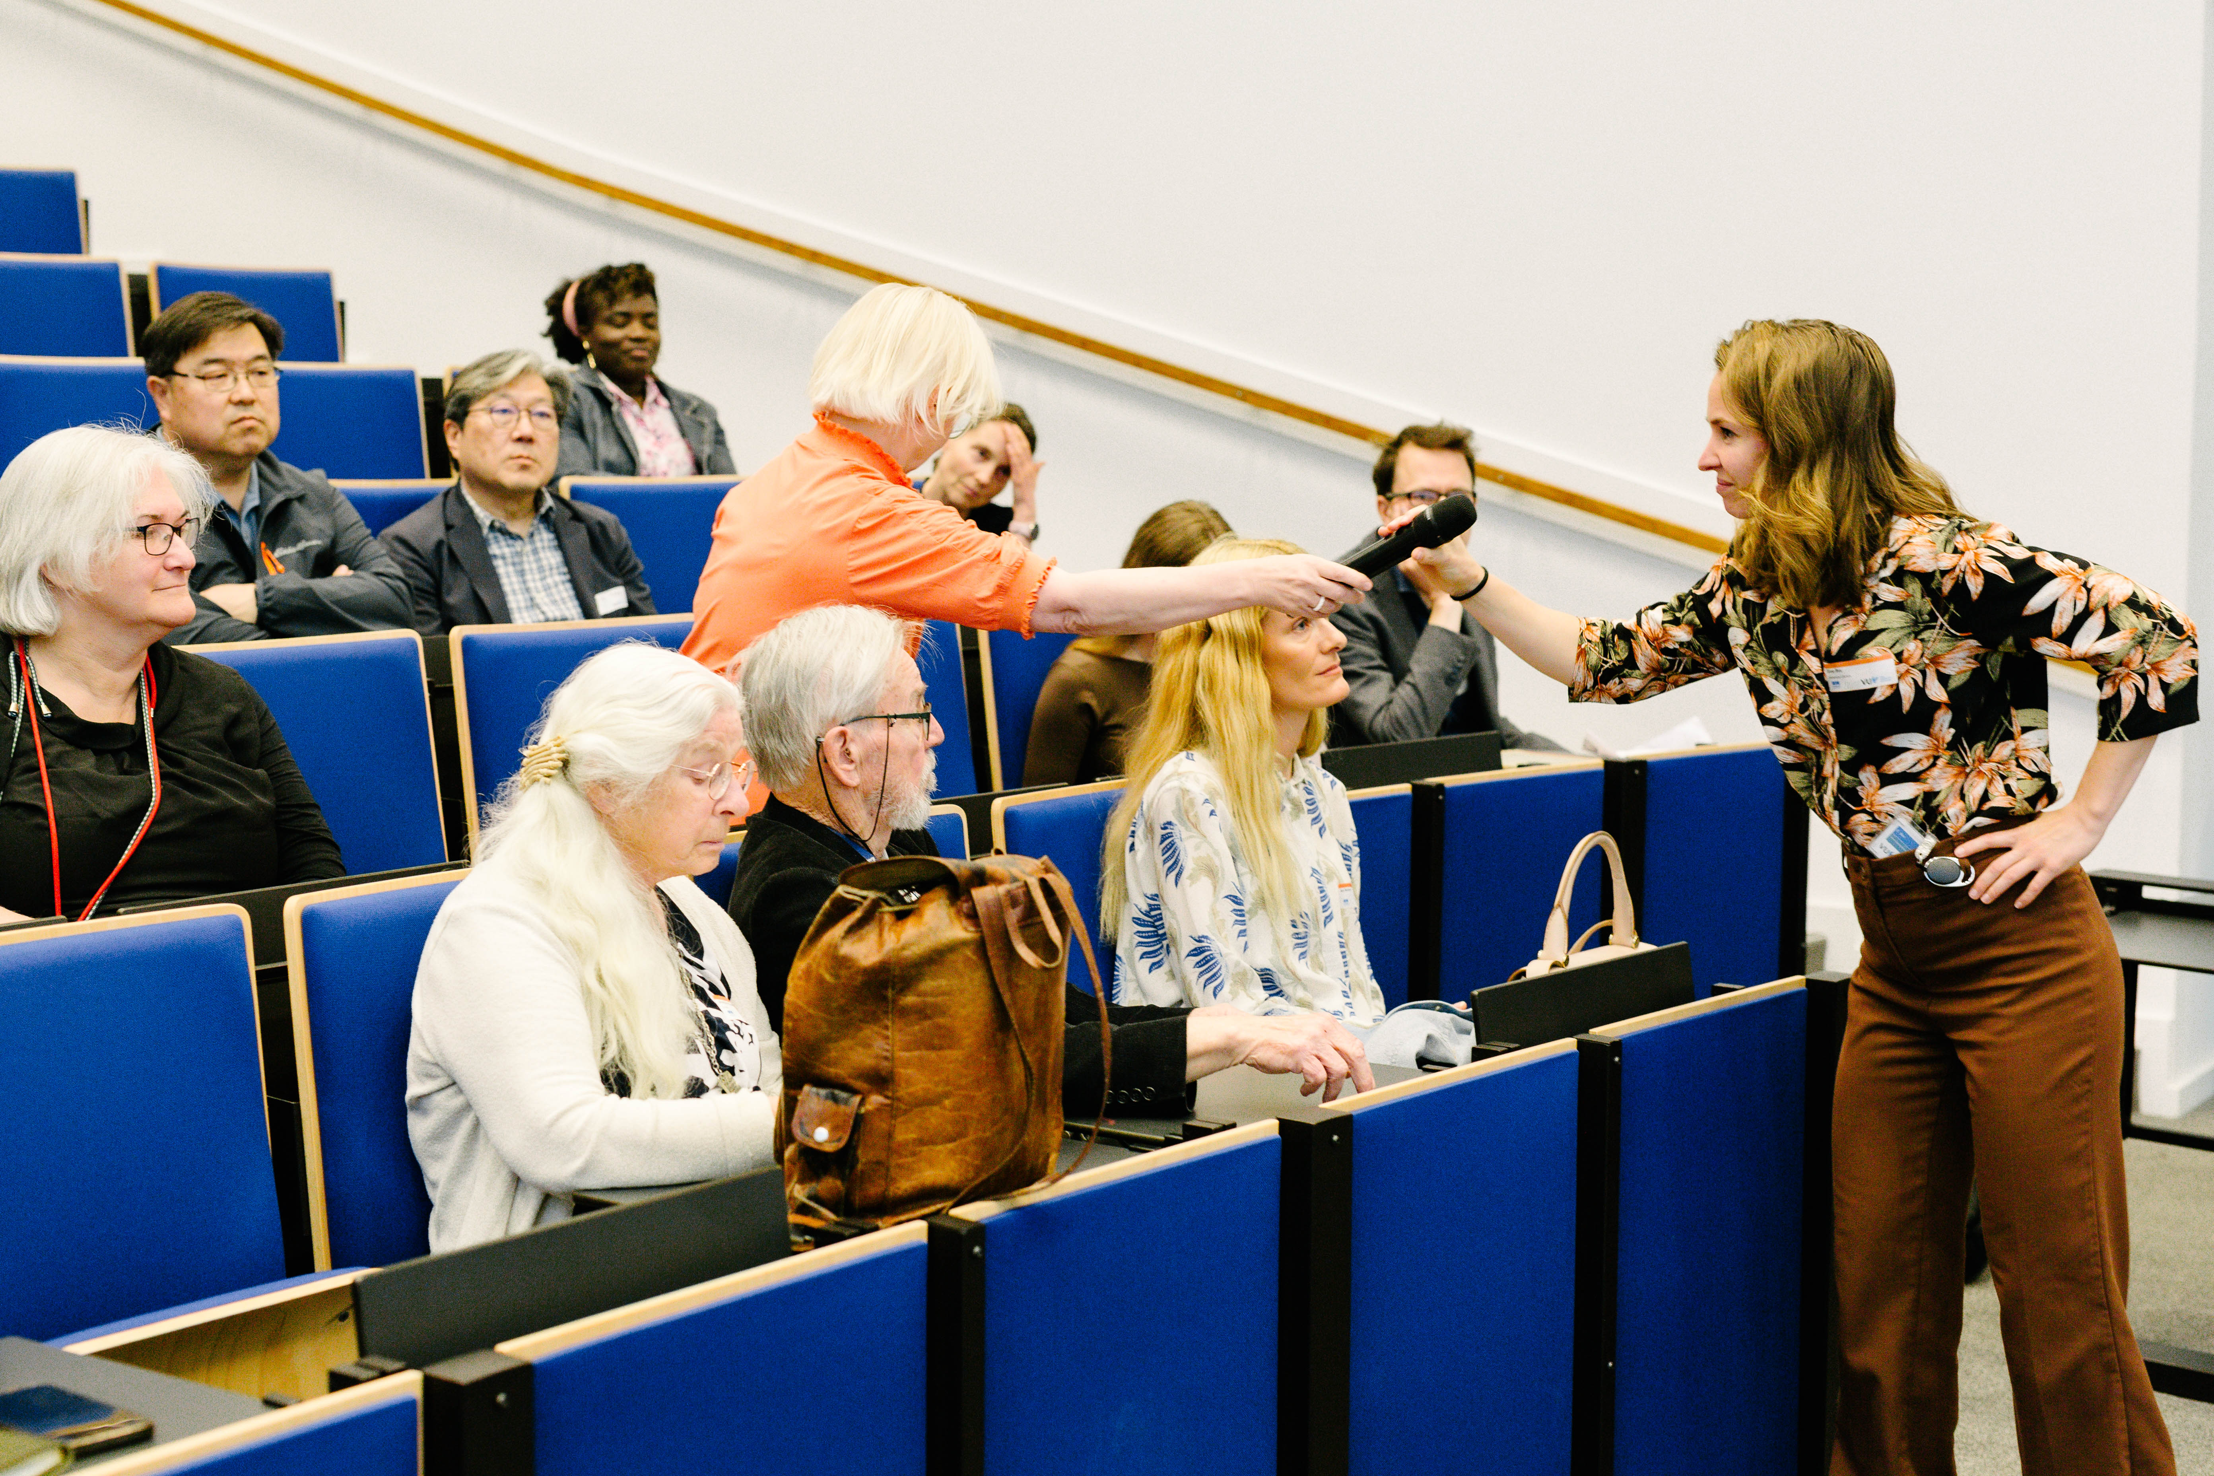
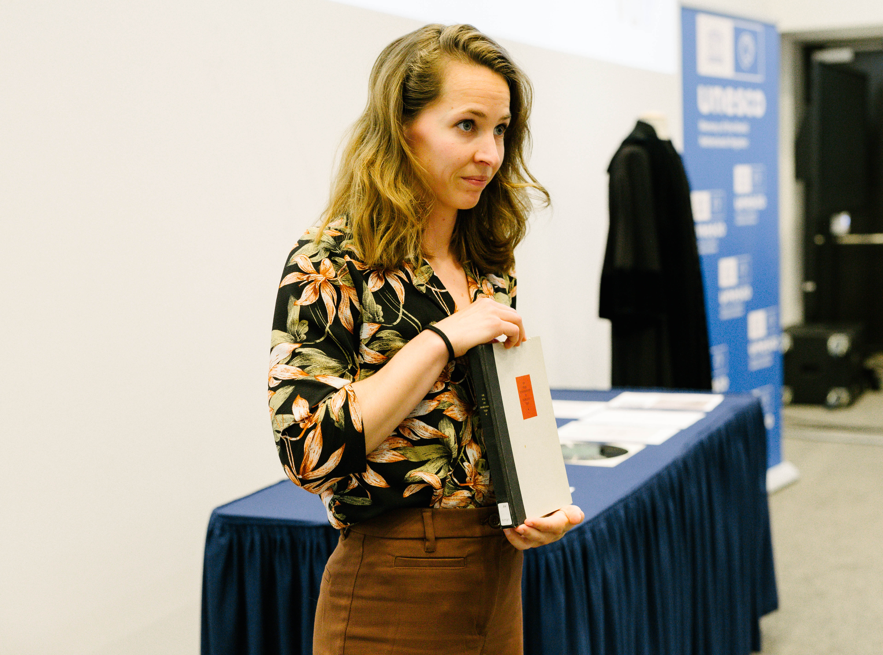
Workshop 7: VU Memory of the World NL recognition: from Kuyper to King

Moderator: Eline Bos, curator Academic Heritage, Team Special Collections VU Amsterdam,

About the Workshop leaders:
Eline Bos; https://vu.nl/en/about-vu/divisions/university-library/more-about/academic-heritage
Dr. A.C. Flipse, University Historian, Faculty of Humanities, Art and Culture, History, Antiquity, background information: http://www.geheugenvandevu.nl/
Prof. dr. Jeroen Geurts Executive Board, Rector Magnificus VU Amsterdam; Netherlands Commission for UNESCO.

Workshop Overview:
​​Starting point is the latest news that VU archives from the period 1879-1972 are included in the UNESCO heritage list. https://vu.nl/en/news/2025/vu-amsterdam-archive-included-in-unesco-heritage-list. and https://www.unesco.nl/nl/artikel/nederlandse-memory-world-lijst-uitgebreid-met-drie-inschrijvingen
They provide a valuable window into developments in education, religion, politics, and broader cultural life in the Netherlands. Heritage and history play a key role in thinking about academic values ​​and freedom. What happens when academic freedom and values are endangered? In this workshop participants will study one chapter from the VU history themselves in which academic freedom and values were under scrutiny, using original heritage materials from VU’s Special Collections. Rector Magnificus Jeroen Geurts will introduce this workshop.

- Materials group 1: Abraham Kuyper's speech ‘Sphere Sovereignty’ (Soevereiniteit in eigen kring), prints about Kuyper's School struggle for special education, portrait of Kuyper.
- Materials group 2: article by Prof. Rutgers in the resistance newspaper Trouw, correspondence about resistance activities by Prof. Waterink/Coops, painting of the laboratory on De Lairessestraat.
- Materials group 3: minutes about the choice of MLK for an honorary doctorate, physical LP and audio fragment of MLK's speech for LANX (1965), MLK gown worn during the presentation.
VU’s University historian will ask about the participants' findings and dive deeper into the stories behind the heritage materials.

Shared Takeaways from Eline Bos, Myrthe Bleeker, and Dr. A.C. Flipse

On April 17th, 2025, historical archives of Vrije Universiteit Amsterdam were officially registered in the UNESCO Memory of the World Dutch Register. Therefore, in this workshop, participants were given the opportunity to study some important archival documents now labeled UNESCO heritage. Specifically, documents from VU’s history in which the academic freedom was under pressure like in many places in the world at the moment, including the US and the Netherlands. The three chapters included the founding of the university in 1880, the university during the Second World War and the awarding of an honorary doctorate for human rights activist Dr. Martin Luther King jr. in 1965.
Upon entering, the participants were greeted by the robe Dr. Martin Luther King jr. wore when visiting VU in 1965. The workshop was kicked off by an interview with rector magnificus professor Jeroen Geurts about the ways in which the university’s heritage impacts his work. He told the audience that most of the stories from the university’s history inspire him in his policy making today: ‘We have always been a university with social impact, and we continue to be so.’ Geurts admitted that he had even been studying Kuyper’s hard-to-read Sphere Sovereignty (1880) recently. An original 145-year-old copy of the university’s opening speech was present in the room. In this work, VU-founder Abraham Kuyper explains his philosophy of different societal spheres in which people deserve to be free and independent. VU was meant to become the scientific sphere where scientists are free from freedom from church and state.
After the interview, the workshop participants had the opportunity to freely study original documents that the curators of the university library had brought to the classroom. One participant admitted she was surprised to see so many parallels between present day considerations in international academic cooperations now and just before the outbreak of World War II. Other participants highly appreciated touching the original materials that most likely have been held by Kuyper himself. As one of the curators mentioned, the group that studied the honorary doctorate of Martin Luther King jr. had a so-called ‘living historical source’ among them. They were honored with the presence of Hartcourt Klinefelter, the former press administrator of dr. King. He added wonderful stories to the heritage already present.
The workshop concluded with the participants sharing their experiences and impressions after getting up close with history.

Reflections from participants

“The workshop “From Kuyper to King” also made a big impact on me. Seeing the real speech by Martin Luther King was powerful. It showed me that history is not just something you study—it’s something that still shapes our lives today. The workshop also helped me understand that not all people from the past were perfect, and that’s okay. What matters is that we learn from their stories and use them to make better choices now.” By A.H., CCM student.

Call to Action from the workshop

“The workshop “From Kuyper to King” also made a big impact on me. Seeing the real speech by Martin Luther King was powerful. It showed me that history is not just something you study—it’s something that still shapes our lives today. The workshop also helped me understand that not all people from the past were perfect, and that’s okay. What matters is that we learn from their stories and use them to make better choices now.” By A.H., CCM student.

Thank you by Sanaz Kateb
“...Dear mentors and mentees,
I’m truly sorry I can’t be there with you today – I was really looking forward to meeting you in person. Due to my pregnancy, I need to take things a bit slower, which unfortunately means that traveling isn’t always possible.
Still, I want to let you know how much I appreciate your contribution to the program. Your dedication and engagement have truly made a difference.
As a small token of thanks, I’m giving you a voucher. I hope you’ll treat yourself to something nice – you’ve certainly earned it!
I hope our paths will cross again in the near future.
Warm regards, Sanaz …"

Closure by Sylvia van de Bunt
“As we draw this meaningful day to a close, we want to express our sincere gratitude to all of you - participants, speakers, performers, volunteers - for your presence, your insights, and your spirit. Today reminded us that dialogue is not a destination, but a doorway. A place where knowledge becomes shared, and where action becomes possible. Whether through a panel or a poster, a conversation or a dance, each moment was a step toward change. Following the discourse in your workshops, let me highlight a few Call-to-Action notes and invite you for a few spontaneous remarks by some participants. Let us carry the energy of this day forward - into our communities, our classrooms, our cultures. Thank you once again, and please join us now for an informal closing reception. Let this symposium not be remembered only for the ideas shared, but for the change they inspire.”

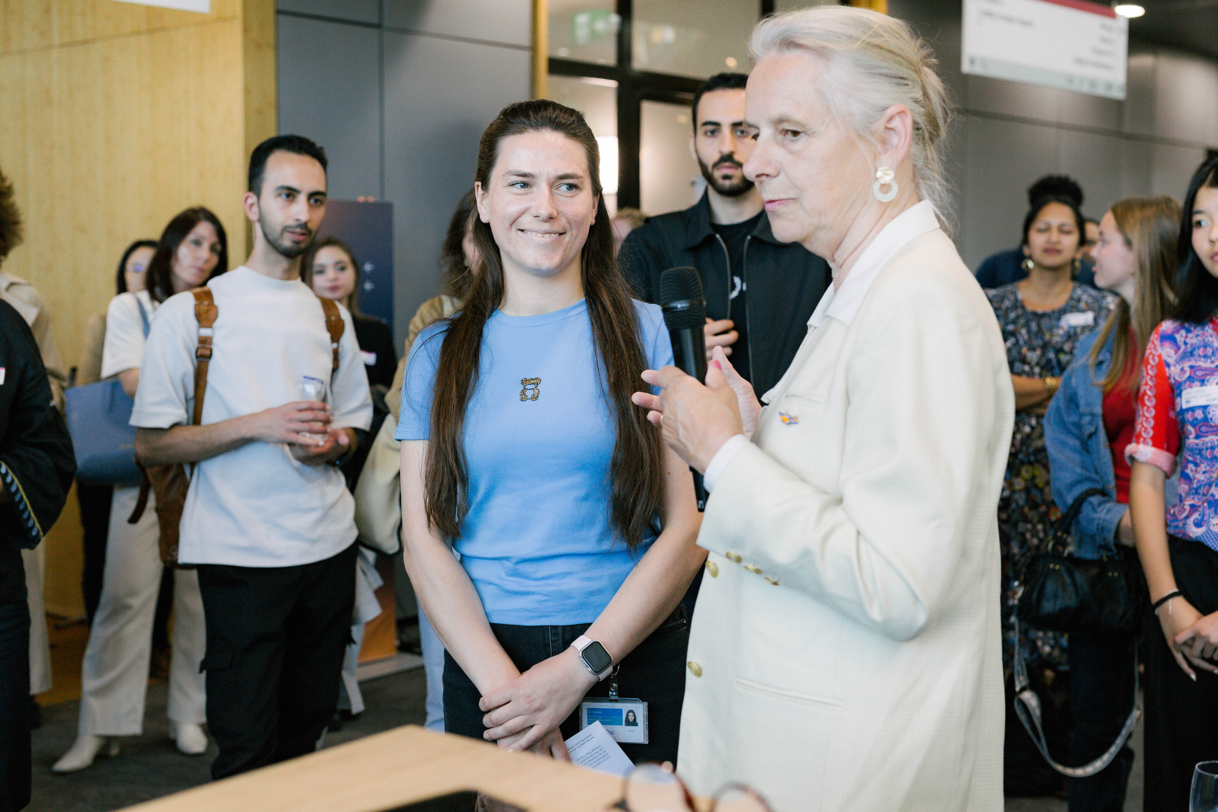
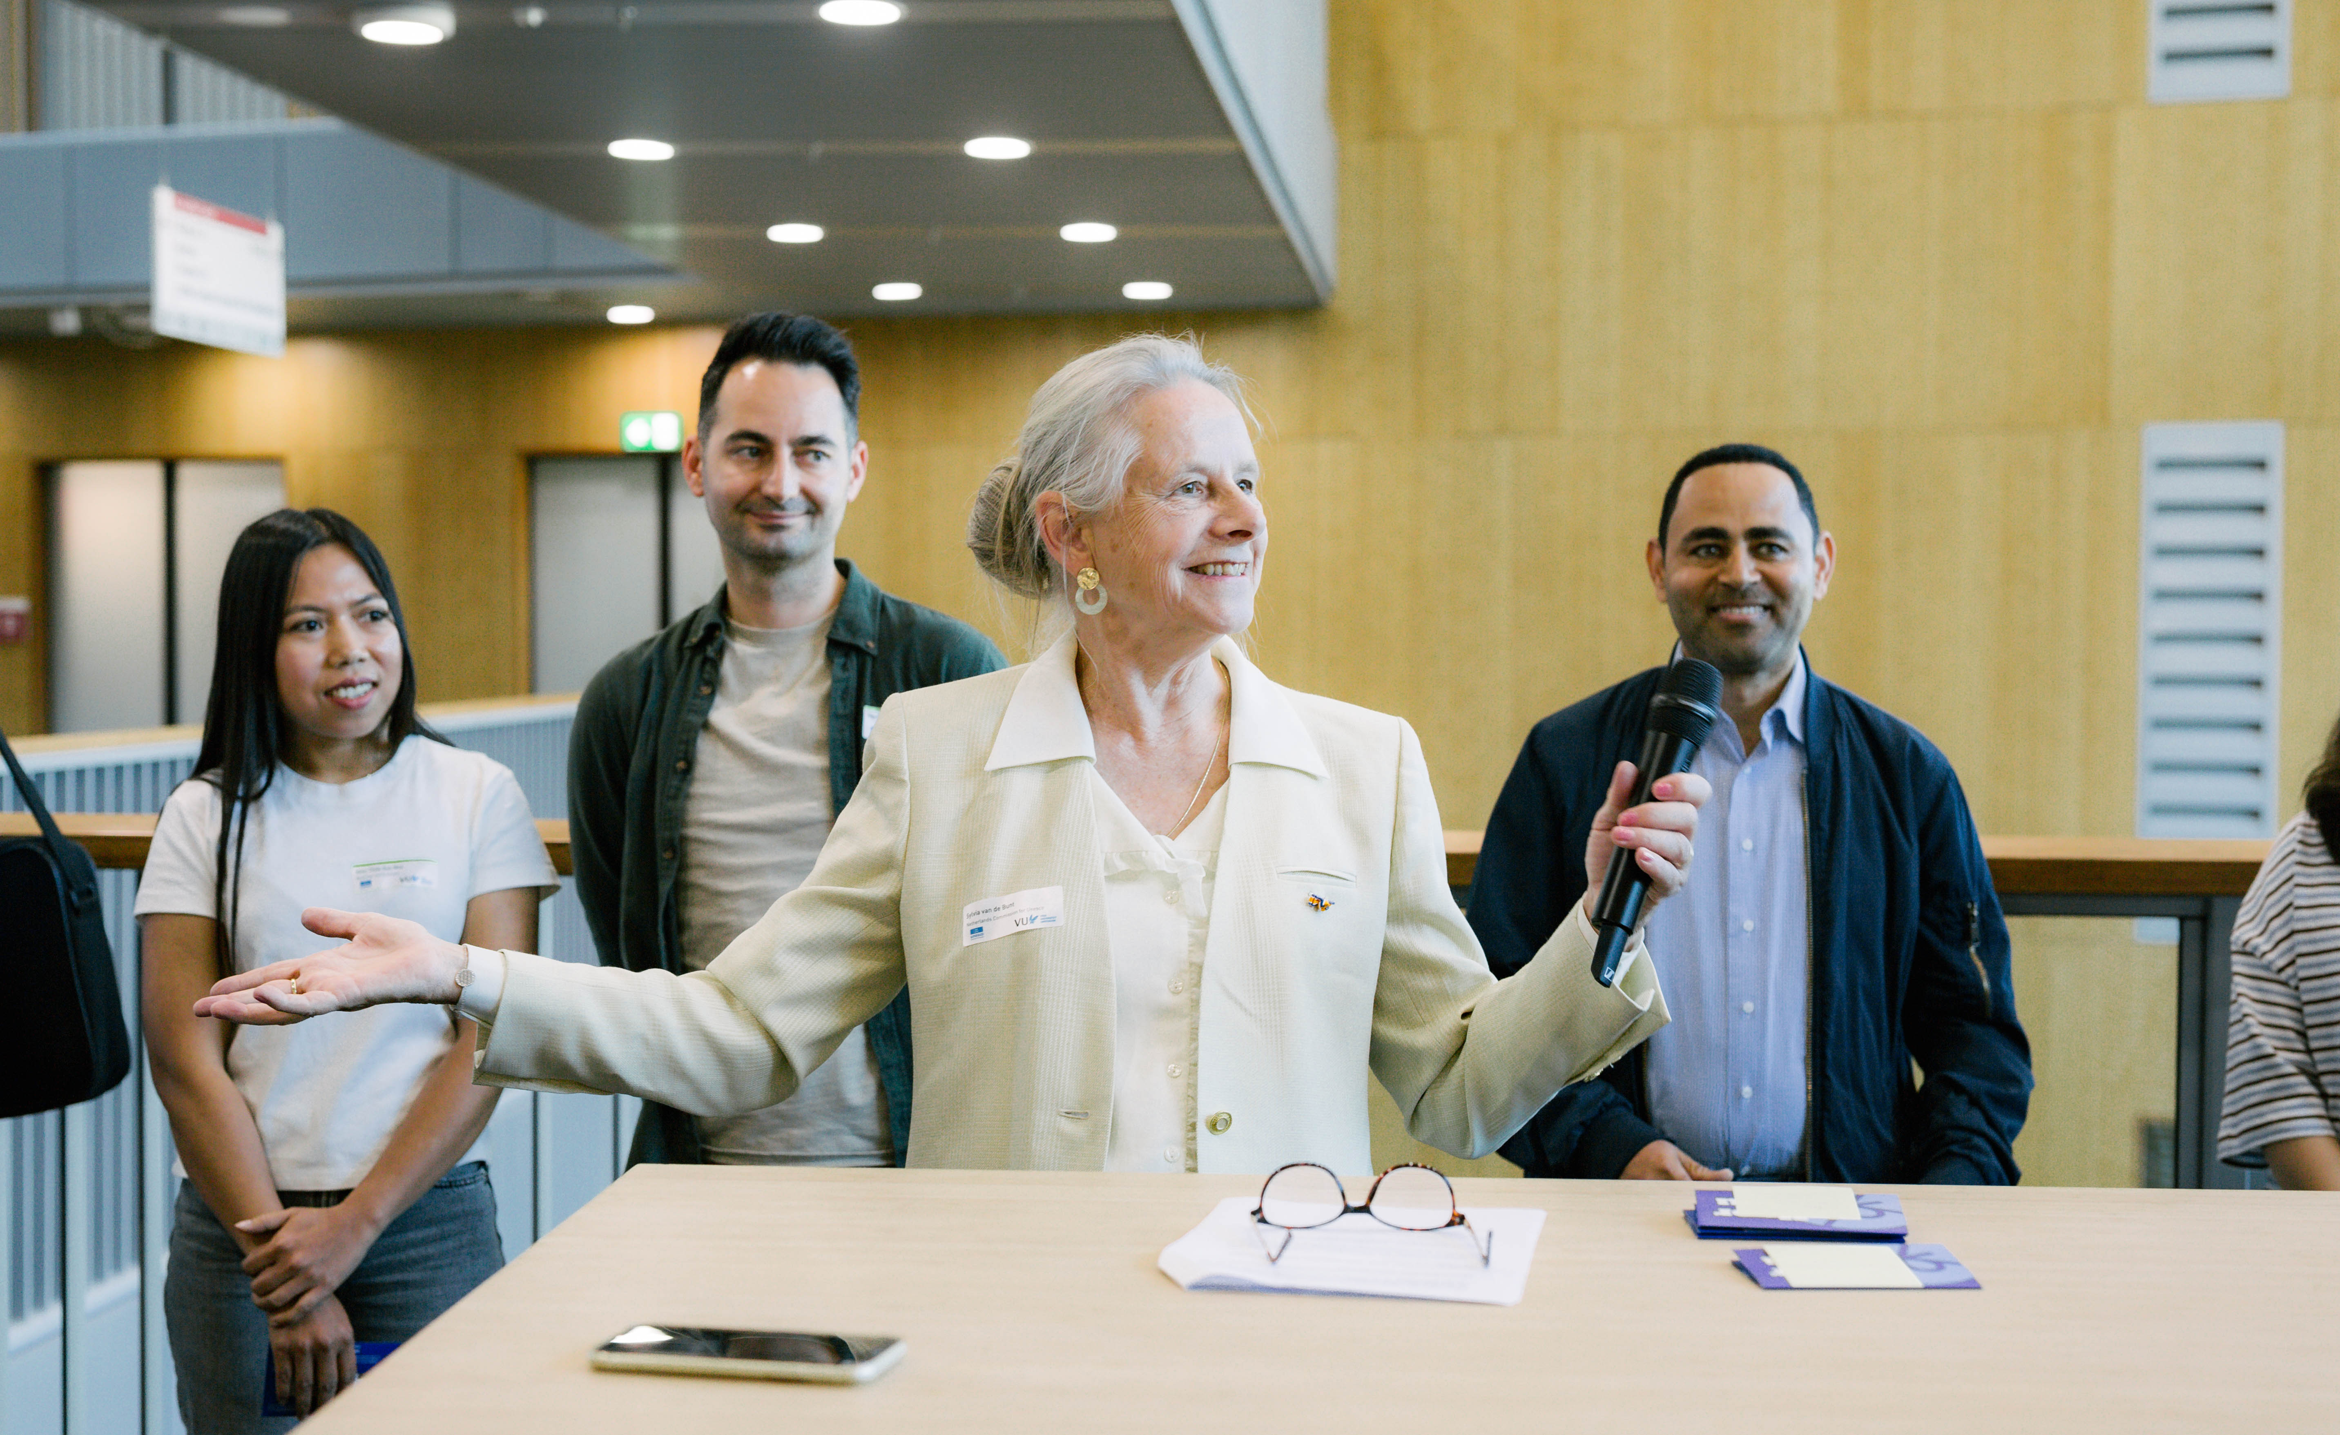

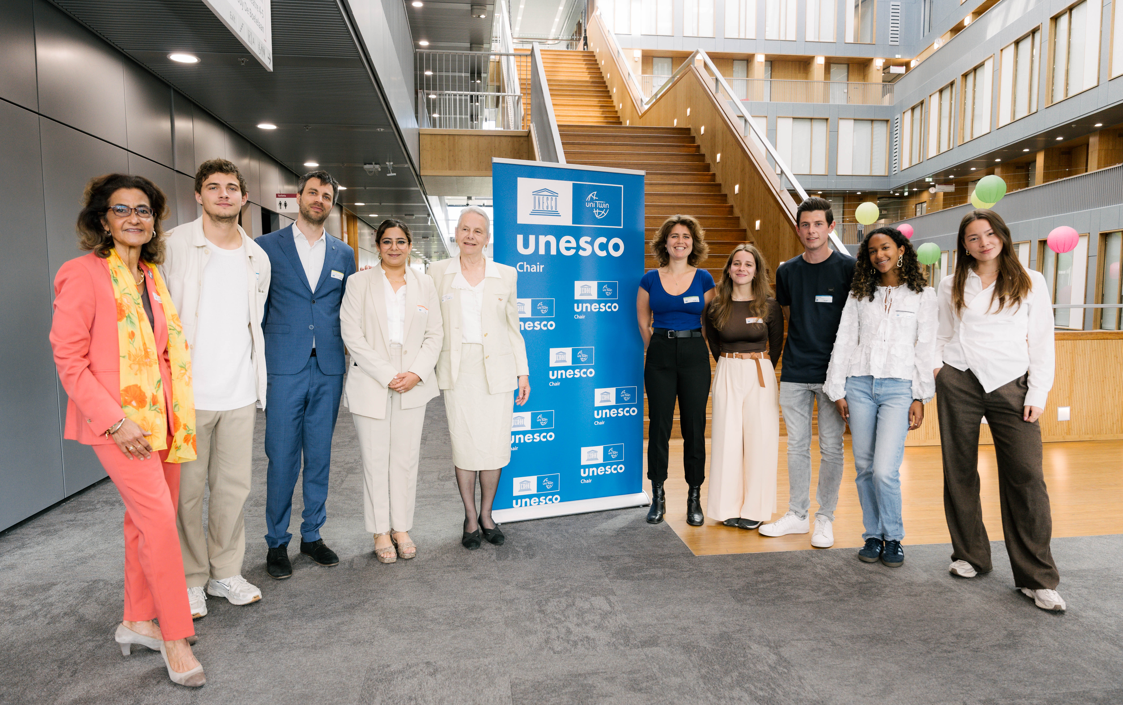

From left to right, Kathleen Ferrier, Sem Barendse, Jon Verriet, Gagan Kaur, Sylvia van de Bunt, Verena Jackwerth, Eleonora Tonazzoli, Arwin Quaak, Nova Latuhihin, and Anjuli van den Bosch.

The Symposium comes to a close, but its message lives on…
Together, we listened, we shared and imagined a better future. Now it’s time to be the change we wish to see.

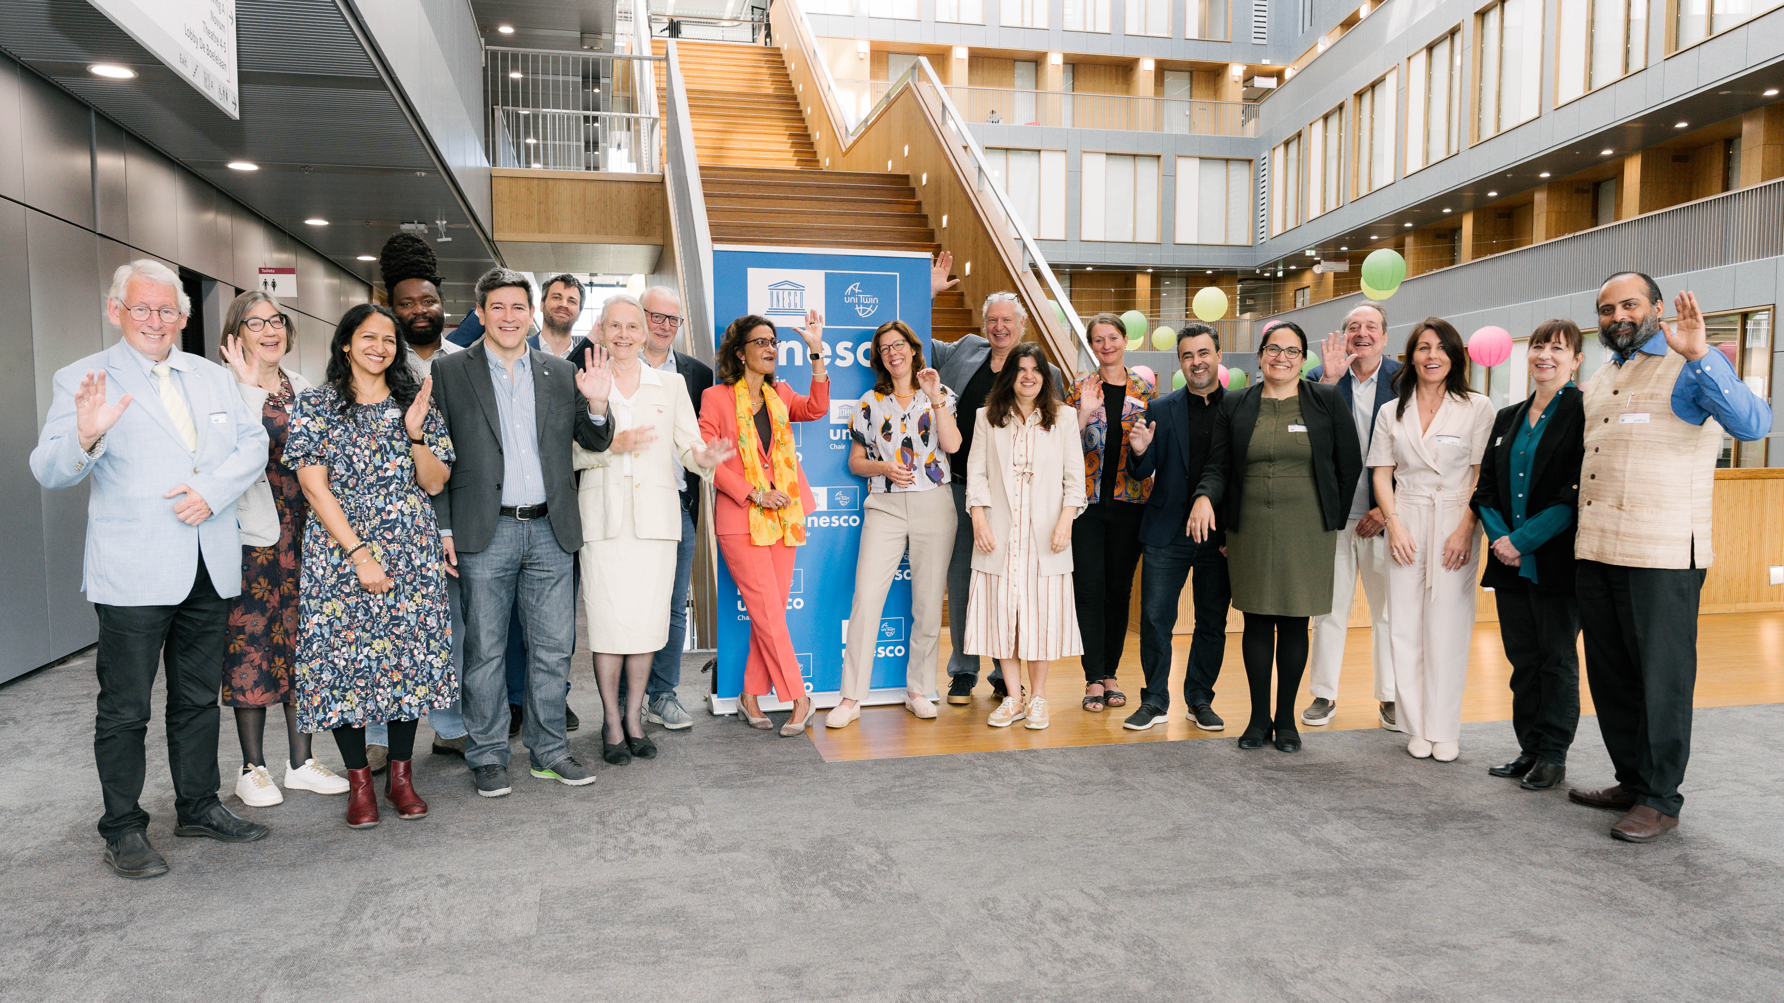

From left to right, Piet Kommers, Josje van de Linden, Rina Malagayo Alluri, Bruce Mutsvairo, Lampros Stergioulas, Jon Verriet, Sylvia van de Bunt, Jaap Gordijn, Kathleen Ferrier, Sarah de Rijcke, Bart Barendregt, Mirjam Shatanawi, Louise Bezuidenhout, André Brasil , Ana Pereira Roders, Fons Trompenaars, Andrea Broderick, Felisa Tibbitts, and Puneet Bindlish.

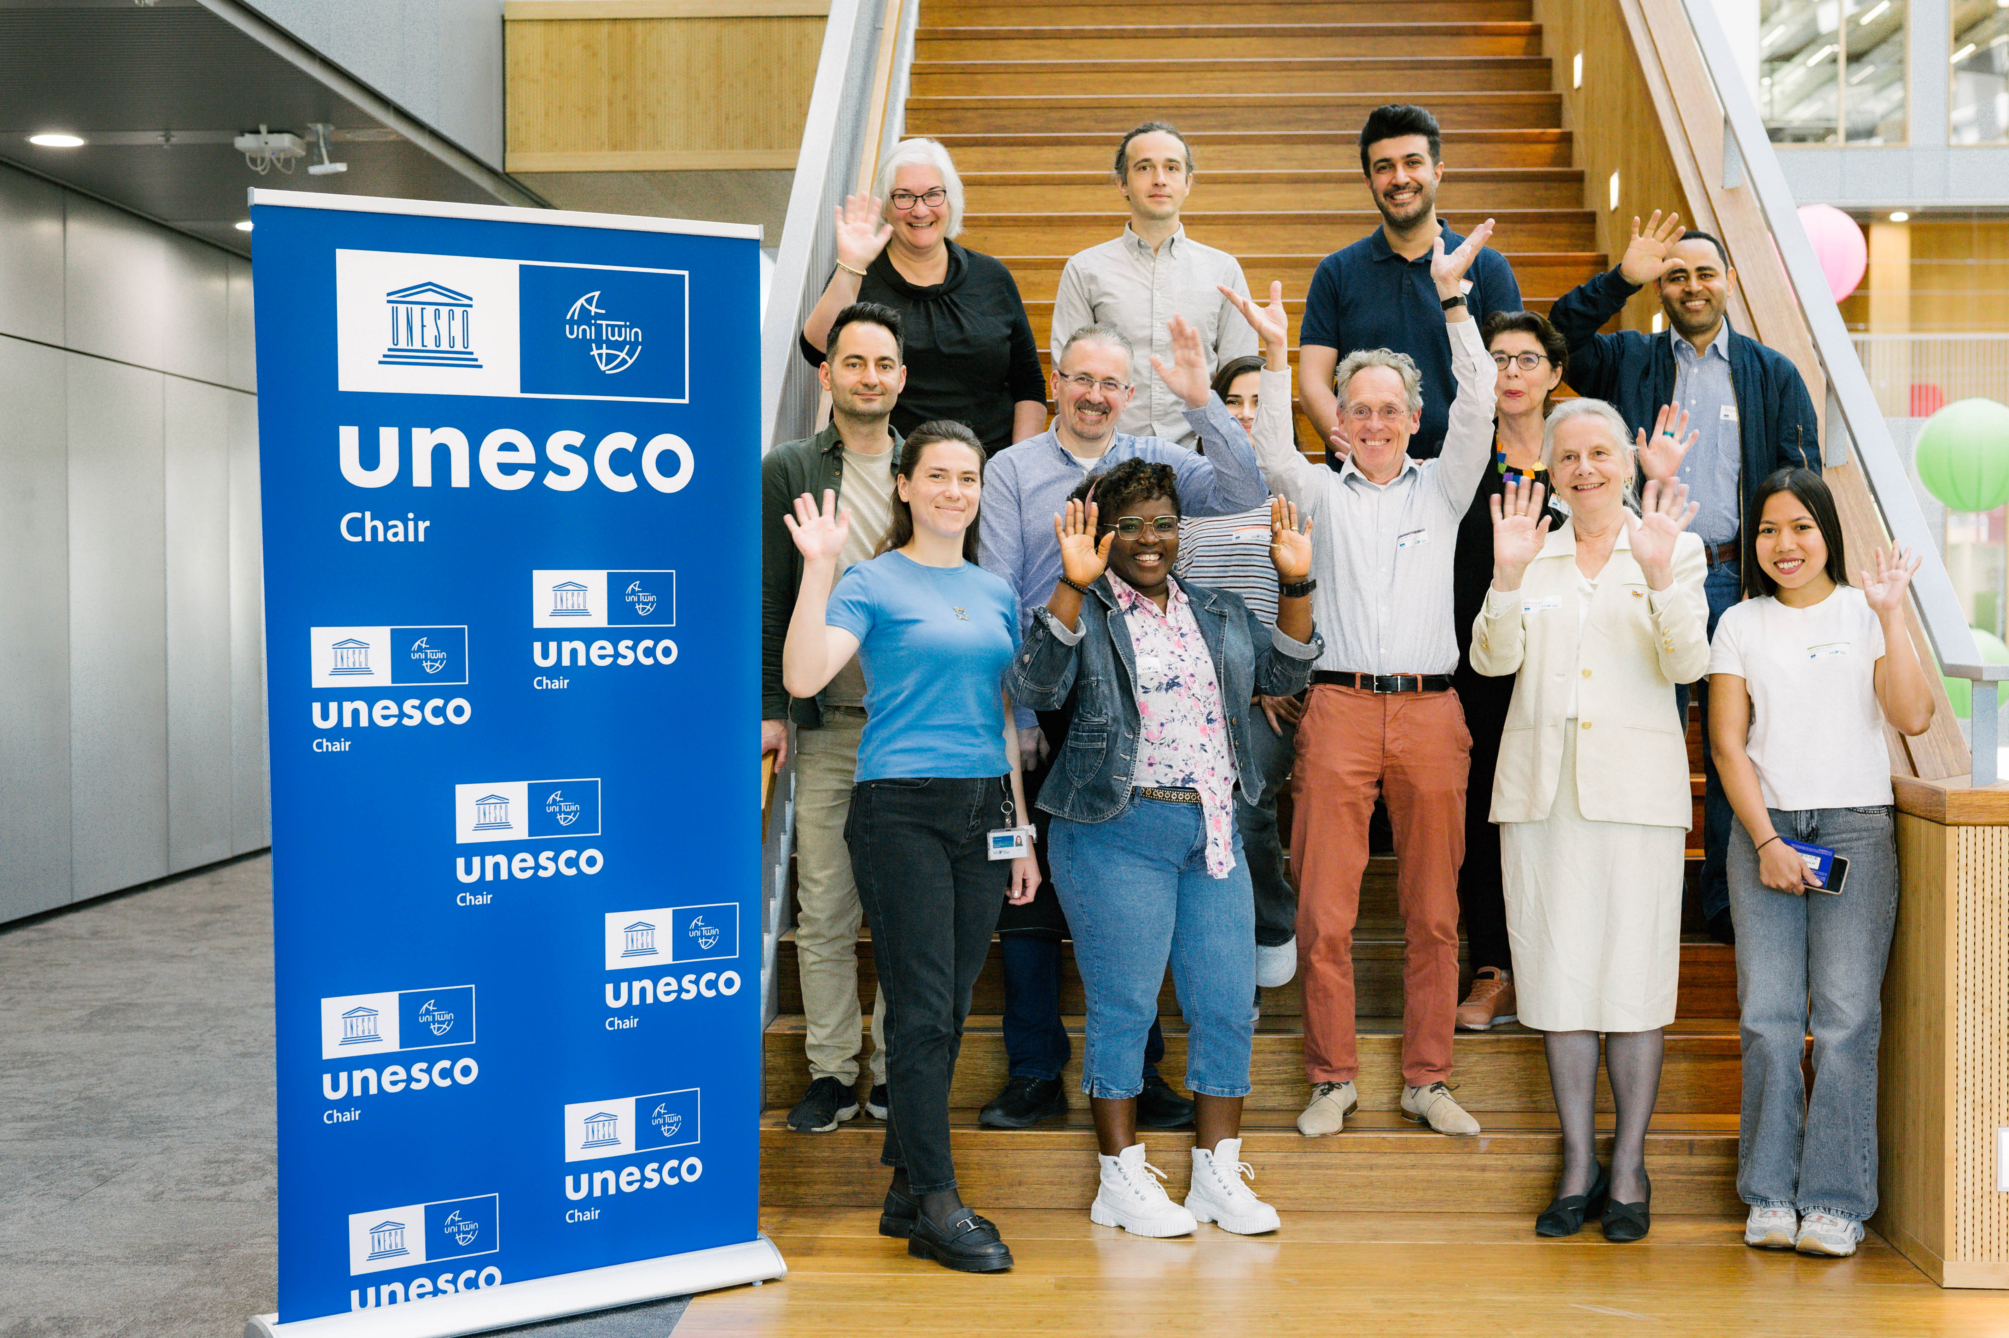

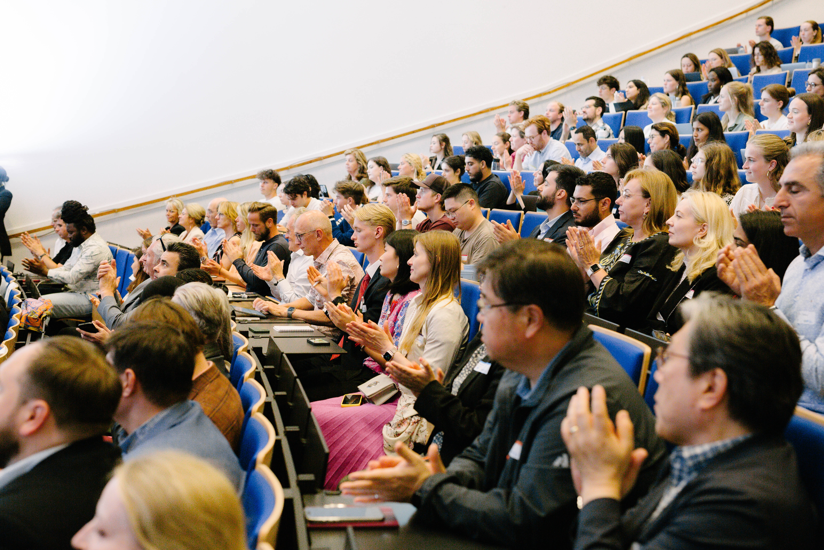

Applause and thank you to all the participants, (high school) students, staff, speakers, moderators, co-organizers, and volunteers for making this event a big success.

We hope meeting you again next year!
The project leaders and co-hosts of this UNESCO Symposium

Sylvia van de Bunt and Gagan Kaur

Photo Credits: Philip Boakye and Priscilla Yeboah.

