Guide signing up for departmental courses

- Go to the page where you always sign up for your courses. It should look like the screen below.

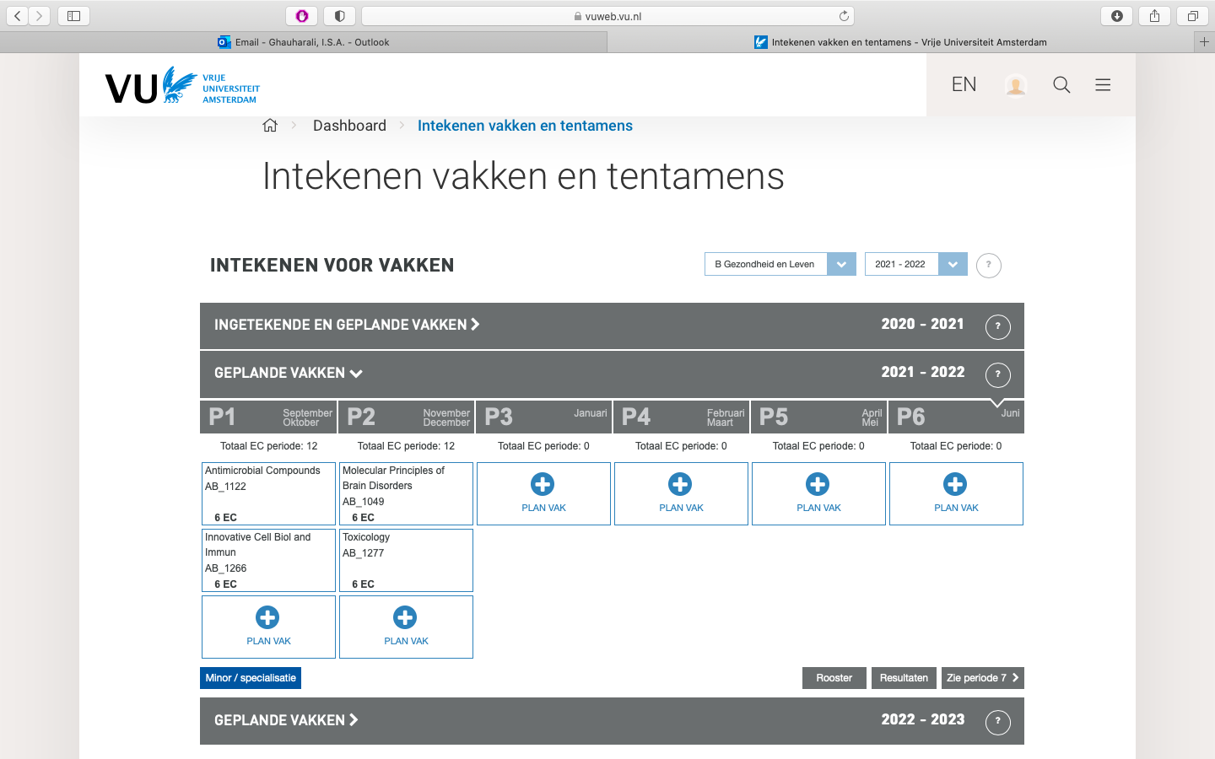

- Click on “plan vak” or “add course” in the period that is applicable to your specific course.

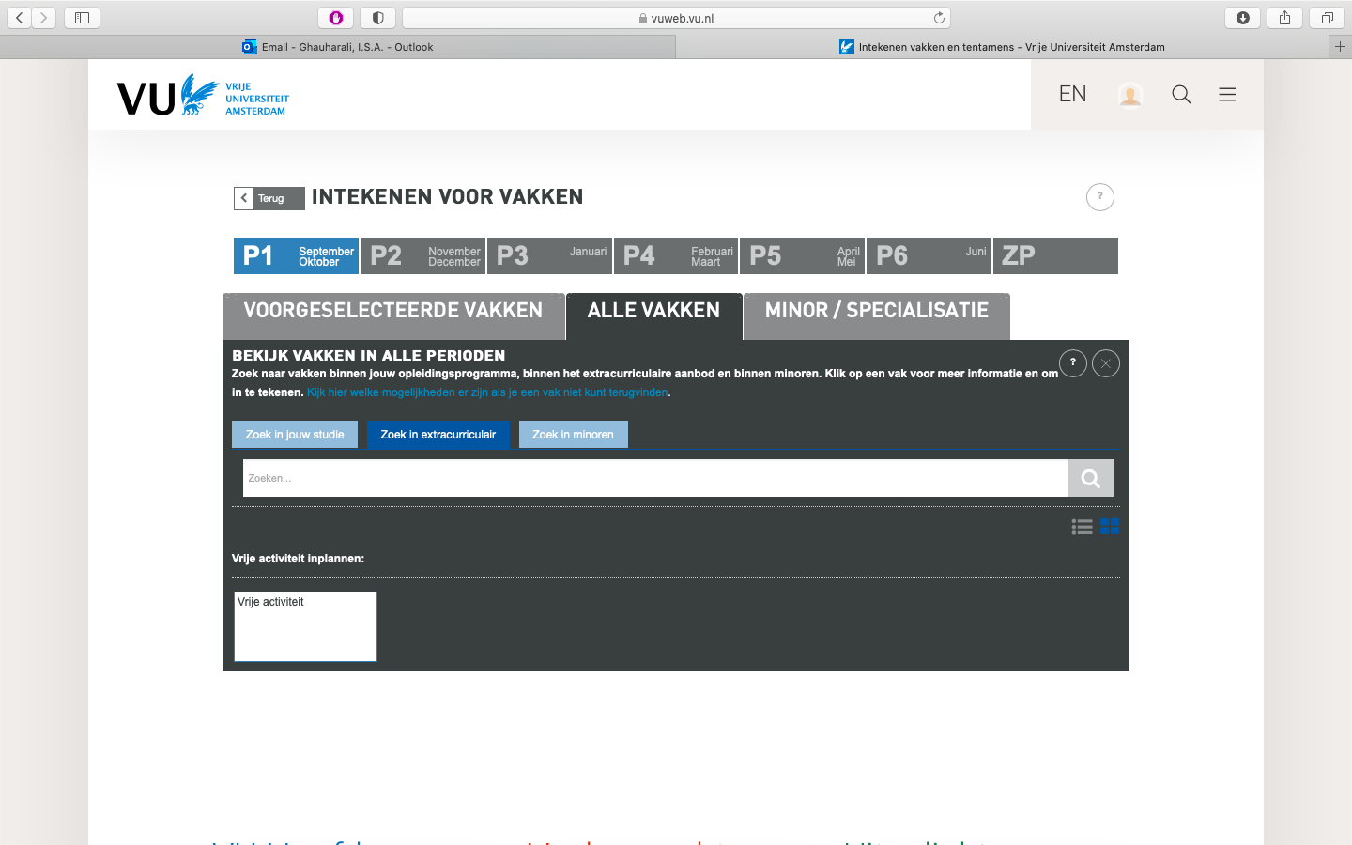

- Click on “all courses” and then the second tab “extracurriculars.” Then search your course:

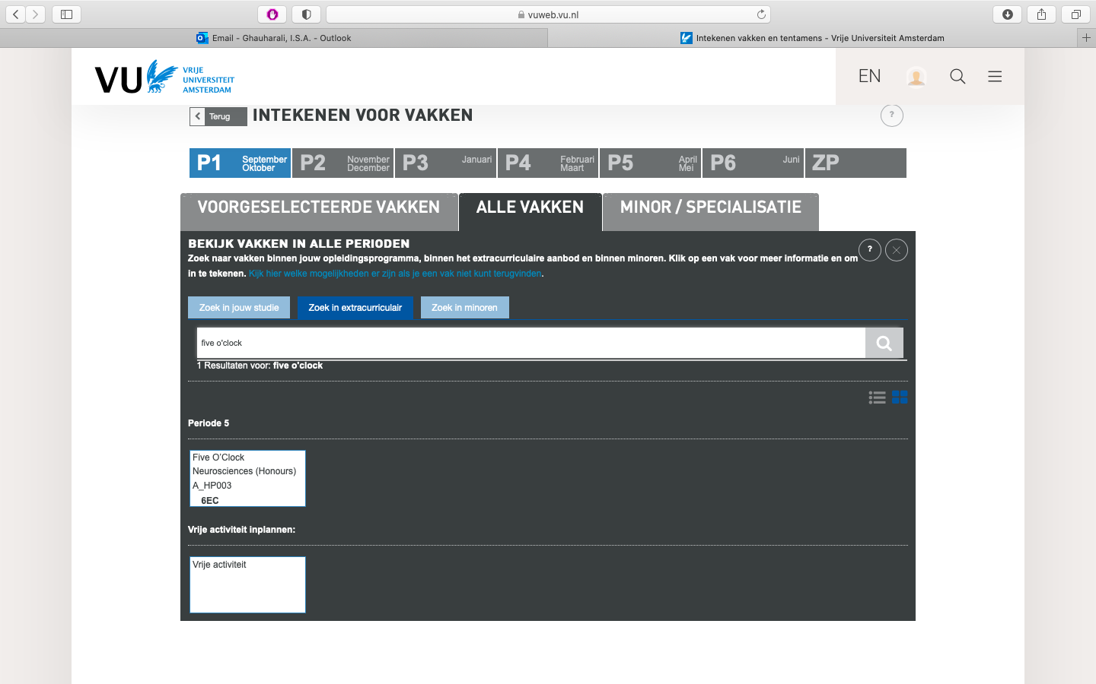

- Select the course and click on “plan.” When the option is available, click on subscribe or add course (the blue box on the screen below)

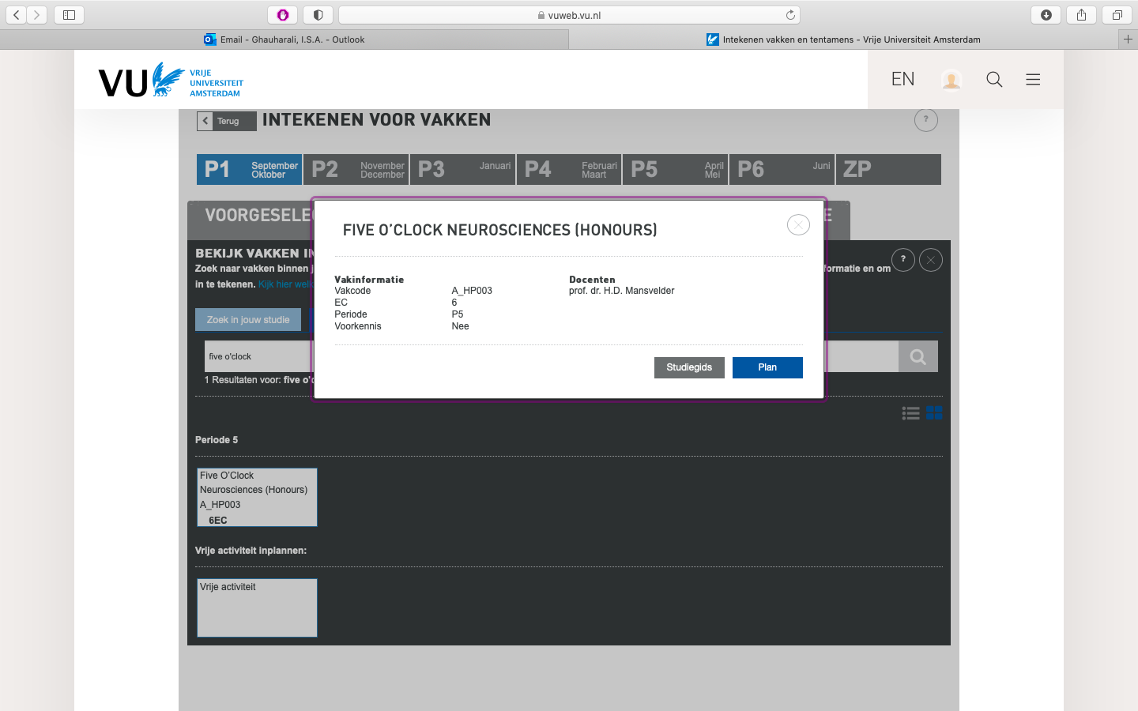

- You’re done!

