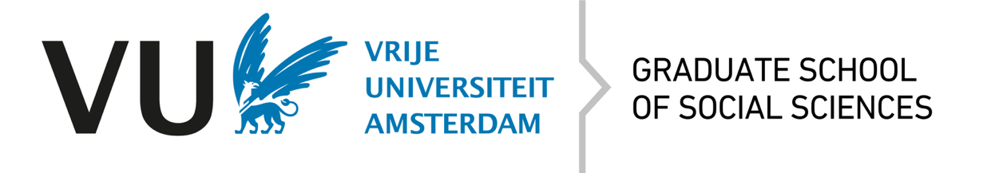

Authorization form for VU-GSSS for Marie Curie (or similar) grant applications
This version is from September 2, 2025

Information needed prior to the actual application:

Start date and duration of PhD project
Overview of all (university) network partners
Number of PhD projects, start date, duration (4 years fulltime is required – in case only 3 years is covered by the grant, please specify how the 4th year is funded)
Role of VU in the process | - Main beneficiary  - Other
Envisaged VU promotors/co-promotors per PhD trajectory

Furthermore, it is important to be aware of the following:
- VU-GSSS admission guidelines. Note that we only accept projects with funding for 4 years.
- VU Doctorate Regulations have to be met at all times.
- In a case of a Joint Doctorate (JD), the Doctorate Regulations of both institutions need to be satisfied. Exemptions are not possible. Setting up a JD can be a lengthy and challenging part of the process and needs to be arranged by the end of the first year latest. Keep this in mind when working on your application. In case a JD applies, please read through the information here: https://vu.nl/en/research/more-about/in-which-case-a-joint-doctorate.
- Training: 30 ECs are required. For more information, see the GSSS website.
When proceeding with the application, the applicant confirms being aware of and complying with the VU regulations and the VU-GSSS regulations in particular. Please send your completed form to graduate.school.ssw@vu.nl. Contact us whenever you have any questions or in case you are in doubt; we are always happy to assist in the process.

