
Roadmap Erasmus+ scholarship for internships
Before the start of your internship
- At least one month before the start of your internship, send an email to Erasmus@vu.nl to announce your intention to apply for an Erasmus+ scholarship for internships. Please indicate the start date of your internship.
- Read the information about the International Travel Policy of the VU. Please check the travel advice (in Dutch) of the Ministry of Foreign Affairs for your host country. In case of code orange or red you are not allowed to travel abroad for study, work or research purposes.
- Download the scholarship forms (Grant Agreement, the Learning Agreement and Green Travel Statement) from VU.nl.
- Fill out the Learning Agreement in consultation with your VU supervisor and your on-site supervisor abroad. All three parties involved have to sign the completed Learning agreement. When this is done convert the Learning agreement to a PDF.
- One month before the start of your internship, fill out and sign the Grant Agreement and – if relevant – the Green Travel Statement and send them to erasmus@vu.nl They will be completed and signed by the Erasmus+ officer in charge and returned to you by email.
- When your Grant Agreement and Learning Agreement are completely filled out and signed, register your internship through your dashboard in VU.nl. (See instruction below. Choose as reason of your stay abroad Internship/stage or coschap/medical internship). After registration another button (Apply for a scholarship) appears in this dashboard section. Apply for the scholarship and upload the forms as PDFs. Note: it is not necessary to upload the Green Travel Statement.
- Send an email to erasmus@vu.nl before the start of your internship to indicate that you have complete the steps above.
- If all steps are taken, the first installment of your scholarship of 70% will be transferred to your account.
During your internship
If there are changes in the duration, content or supervisors of your internship, please send the section During the mobility of your Learning Agreement to erasmus@vu.nl as soon as possible. Make sure to add your VU supervisor and your on-site supervisor in the Cc. The deadline for a prolongation of your internship scholarship is one month before the originally planned end date. Approval for the prolongation has to be given by the VU International Office.
At the end of your internship
You have 2 weeks after the end of your internship to complete the following steps:
- Before the end date of your scholarship, request your on-site supervisor to fill out and sign the Traineeship Certificate. You find the form in the Dutch section or English section on VU.nl. Please make sure that the same start date and end date are used as mentioned on the Grant Agreement.
- Upload the completed Traineeship Agreement through your dashboard in VU.nl.
- Fill out the Participant Survey. You get an invitation by email from the Erasmus+ programme shortly after the end date you mentioned on your Grant Agreement. The invitation will be sent to the email address you mentioned on your Grant Agreement. Please check your spam folder.
- Send an email to erasmus@vu.nl to indicate you have taken all steps to meet the requirements of your scholarship. (If you expect that you will not be able to meet the deadline of 2 weeks after the end date of your internship, you can request for an extension by email at erasmus@vu.nl. Please indicate the reasons for the delay.)
- If all is completed, the second installment of your scholarship of 30% will be transferred.
Note: if you do not meet all requirements, your entitlement to the Erasmus+ scholarship will expire and you will have to refund the first installment.

How to apply for an Erasmus+ scholarship for internship in VU.nl?

Step 1
Go to your dashboard on VU.nl click on Scholarship application:
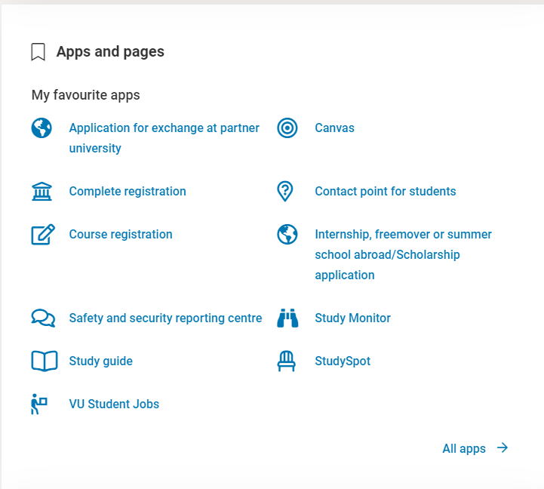
(if you don’t see this, please click on All apps)
Step 2
Now you see your Exchange overview. Here you click on Registration internship/freemover
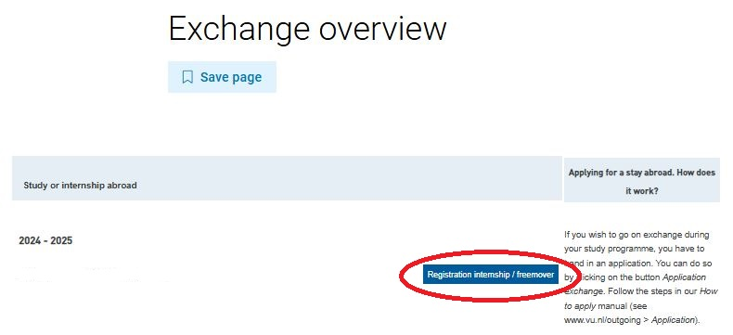
Step 3
Please fill out all the boxes and submit the form.
Choose as reason of your stay abroad: internship/stage or coschap (medical internship).
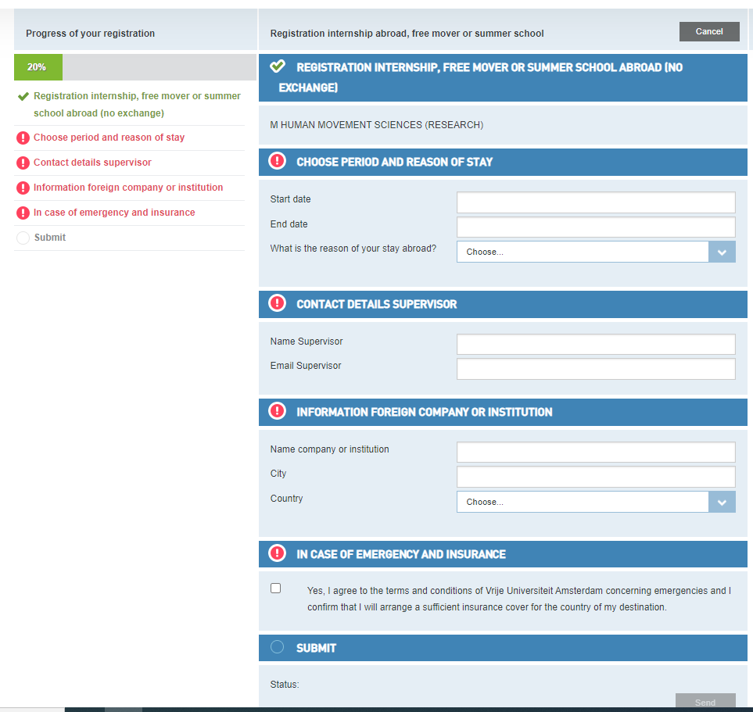
Note: if you fill out this form only after the start use the current date as start date. Past dates cannot be registered.
Step 4
After the registration you go back and you will find Apply for a scholarship (again) (in Dutch: Vraag beurs (opnieuw) aan). Click on Apply (in Dutch: Aanvragen).
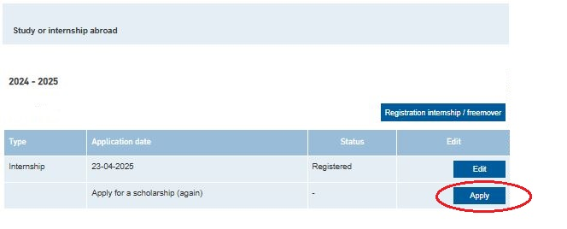
Step 5
Please fill out all the boxes, apply for the Erasmus+ internship and upload your Grant agreement and Learning agreement. We only accept complete documents (with all the signatures on it).
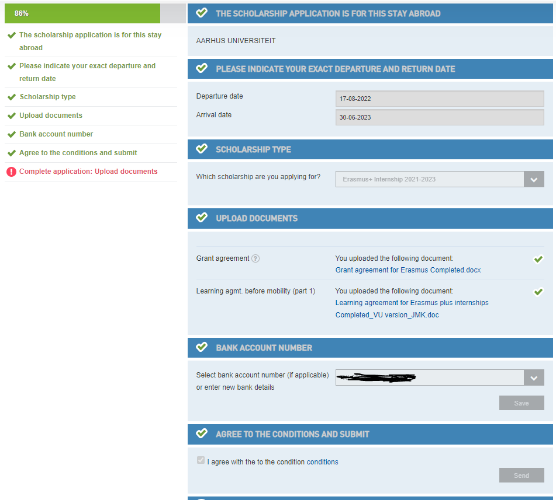

The grant will be awarded on the condition that all criteria are met. 70% of the grant will be paid as an advance. You can expect the payment within one month once all criteria are met.

