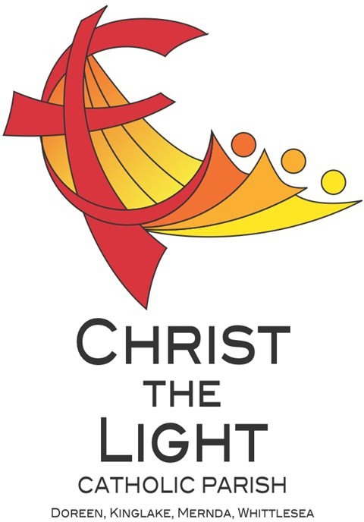 | Tenth Sunday in Ordinary Time Yr B
 | 9 June 2024
Parish Priest: Fr Hien Vu
The Parish Office open hours are Tuesday - Friday 9am-4pm Assistant Priest: Fr George Hogarty SSC
Pastoral Worker: George Thommana
Finance/Admin: Monique Heckmann [Tue, Wed, Thur: 9am – 4pm]
Sacraments: Contact Parish Office [Phone 03 9412 8493]
Parish Office: 2-20 Fir Street, Whittlesea 3757 Postal address: P.O. Box 221, Mernda 3754 Phone Number: 03 9412 8493
Mobile Number: 0448 101 401
Email: merndawhittlesea@cam.org.au
Website: www.christthelightparish.org.au
Nazareth Centre, Mernda  (St Joseph’s Primary School)  44 Mernda Village Drive Mernda 3754  Confession/Reconciliation: Saturday 4pm Weekend Masses: Saturday 5:30pm Sunday 8am and Sunday 10:30am  Children’s Liturgy EVERY Sunday 10:30am | We pray for those who have died recently: Sr Maureen Delaney rsc And for those whose anniversaries occur at this time:  We pray for those who are ill in our community: Peter O’Brien, K.P Abraham, Indika Fernando, Maria Ah Kiau, Gina Wherrett, Susan Stocks, Neth Mercado, John Van Kalken
St Mary’s, Whittlesea  2-20 Fir Street Whittlesea 3757  Weekday Mass: Tuesday & Thursday 9:15am Confession/Reconciliation after  Tuesday & Thursday 9:15am Mass. Weekend Mass: Sunday 10am | Entrance Antiphon:  The Lord is my light and my salvation; whom shall I fear? The Lord is the stronghold of my life; whom should I dread? When those who do evil draw near, they stumble and fall.  First Reading:  Genesis 3:9-15  Responsorial Psalm:  With the Lord there is mercy and fullness of redemption.  Second Reading:  2 Corinthians 4:13-5:1 | Gospel Acclamation  Alleluia, alleluia! The prince of this world will now be cast out, and when I am lifted up from the earth I will draw all to myself, says the Lord. Alleluia!  Gospel:  Mark 3:20-35  Nextweek: 11th Sunday in Ord Time Yr B  First: Ezekiel 17:22-24  Second: 2 Corinthians 5:6-10  Gospel: Mark 4:26-34
St Mary’s, Kinglake
124 Whittlesea-Kinglake Rd Kinglake 3763
Weekend Mass: Sunday 8:30am
St Joseph’s, Mernda
1490 Plenty Rd Mernda 3754
Weekday Mass: Wednesday & Friday 9:15am Weekend Mass: Sunday 5pm
A reflection… |  |  | Weekly Quote Quotations of  The Prayer of the Frog  - Page 105  A public sinner was excommunicated and forbidden entry to the church.  He took his woes to God. “They won’t let me in, Lord, because I am a sinner.”  “What are you  complaining  about?’ said God.  “They won’t let me in either!”
Reflecting on today’s Gospel, Pope Francis says that ‘Jesus’ response was not a lack of respect for his
mother and his brethren.’ He was not turning away from family, but rather widening the very concept.
‘Jesus formed a new family,’ the Pope explains, ‘no longer based on natural ties, but on faith in him, on
his love which welcomes us and unites us to each other, in the Holy Spirit.’
This is especially poignant when we remember that Jesus was just accused of being devilish. While
Jesus’ clever riposte turns the logic of the scribes upside down and puts them on the backfoot, the
Pope suggests that ‘this episode contains an admonishment which is useful to all of us.’
He points out that ‘it can happen that deep envy of a person’s goodness and good works can drive one
to falsely accuse him or her.’ This, after all, was the root of the accusation against Jesus. We must be
alert to this temptation ourselves, especially in the Church.
We should also be alert to a little detail in this Gospel which is easily overlooked. Pope Francis draws
our attention to it, because it highlights why Jesus attracted both accusations and concerns in the first
place.
Jesus, the Pope points out, ‘did not even have time to eat.’ He was too busy encountering people and
encouraging them. ‘Jesus,’ the Pope says, ‘was like that: people first; serving people; helping people;
teaching people; healing people. He was for the people. He did not even have time to eat.’
© Nick Brodie

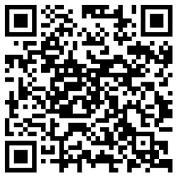
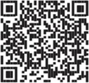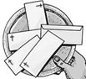
Our Nazareth Centre Kruoz team have been working hard putting together some short ‘How-to’ videos which are
available via the link below or by scanning the barcode. These video will help guide you on how to navigate certain actions on the Kruoz platform.
https://www.youtube.com/channel/UCHlGYRoWARX2aza3j8FA2-A
STEWARDSHIP ENVELOPES are AVAILABLE from the BACK of CHURCH this WEEKEND Please collect your envelopes and statements today. If possible we ask that if you are able to deliver a neighbours it would be
appreciated to save the parish the cost of postage. Direct Deposit statements are now available from the back of church this weekend. If your credit card or bank account details require updating, please contact the parish
office 0448 101 401.

NEXT weekend Sunday 16 June is the 2024 Propagation of the Faith Appeal In Mongolia, Chuluunbaatar suffered a life-altering injury while trying to rescue a submerged vehicle, leaving him unable to work and reliant on scarce support services for basic needs. Without shelter and food, Chuluunbaatar
faces the real risk of freezing to death. Resources are limited, but the Church in Mongolia is working hard to provide essential services to people in need. We invite you to extend your generosity to help enhance these vital services. Your support can make a significant difference to the lives of many, offering hope and tangi- ble assistance to individuals like Chuluunbaatar.
Inclusions for the weekly Newsletter...If you would like any notices, anniversaries or prayers for the sick included in the Sunday newsletter we kindly request that you email, text or call with details: merndawhittlesea@cam.org.au or 0448 101 401 prior to 4pm WEDNESDAYS. Thank you

St Mary’s Whittlesea JUNE Trading Table $107.30 Your ongoing support is appreciated!

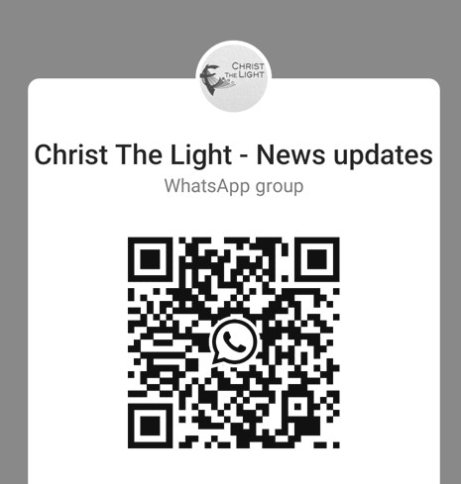

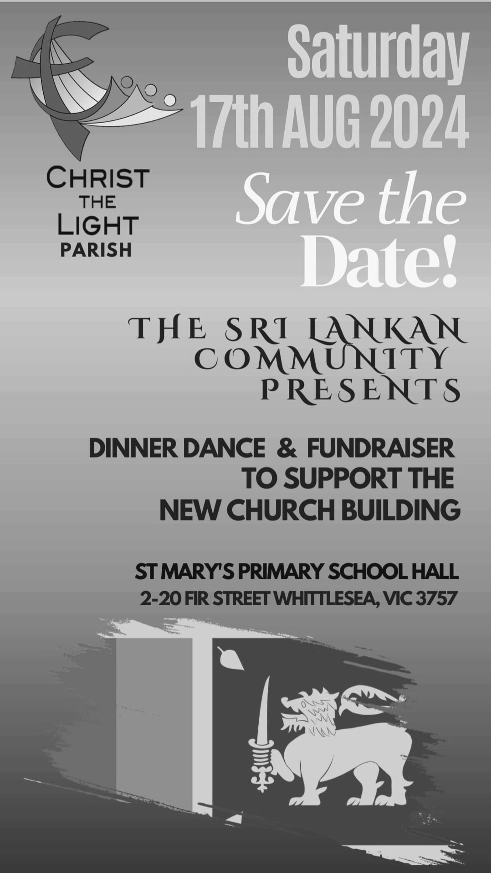
We are a Child Safe Parish. We hold the care, safety and well-being of children, young people and vulnerable adults as a central and fundamental responsibility of our community.

Join the CTL parish WhatsApp group for regular parish news updates. QR Code also available on the parish website
www.christthelightparish.org.au

New CHURCH Building Account Details:

If you would like to make a Direct Deposit DONATION* to the
New Church Building account.
BSB: 083 - 347
Acc No: 135 263 131

*Any donation made to this account is NOT tax deductible as we are a
Not For Profit organization
MINISTRY ROSTER : 15/16 June 2024
[W] Welcomer [L] Leader [R] Reader [E] Eucharist [LT] Laptop
10am - Whittlesea: [W] Nuccia R, Joyce L [L] Maria M [R] Sean S [E] John F [LT] Barry K

NAZARETH CENTRE SET UP:
4:30pm Saturday Month of JUNE: Charles Fernando - Team B
please text parish office 0448 101 401 if you are able to assist
Nazareth Centre Ministries New Roster Platform
https://www.christthelightparish.org.au/Document/rosters


