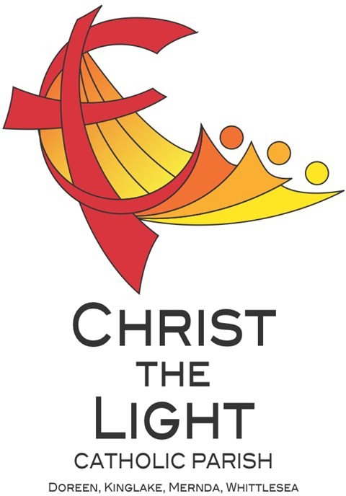 | Thirteenth Sunday in Ordinary Time Yr B
 | 30 June 2024
Parish Priest: Fr Hien Vu
The Parish Office open hours are Tuesday - Friday 9am-4pm Assistant Priest: Fr George Hogarty SSC
Pastoral Worker: George Thommana
Finance/Admin: Monique Heckmann [Tue, Wed, Thur: 9am – 4pm]
Sacraments: Contact Parish Office [Phone 03 9412 8493]
Parish Office: 2-20 Fir Street, Whittlesea 3757 Postal address: P.O. Box 221, Mernda 3754 Phone Number: 03 9412 8493
Mobile Number: 0448 101 401
Email: merndawhittlesea@cam.org.au
Website: www.christthelightparish.org.au
Nazareth Centre, Mernda  (St Joseph’s Primary School)  44 Mernda Village Drive Mernda 3754  Confession/Reconciliation: Saturday 4pm Weekend Masses: Saturday 5:30pm Sunday 8am and Sunday 10:30am  Children’s Liturgy EVERY Sunday 10:30am | We pray for those who have died recently:  And for those whose anniversaries occur at this time: Fredrick Ah Kiau,  Chris Montalti Snr, Jordan Beaine  We pray for those who are ill in our community: Peter O’Brien, K.P Abraham, Indika Fernando, Maria Ah Kiau, Gina Wherrett, Susan Stocks, Neth Mercado, John Van Kalken, John Dellamarta
St Mary’s, Whittlesea  2-20 Fir Street Whittlesea 3757  Weekday Mass: Tuesday & Thursday 9:15am Confession/Reconciliation after  Tuesday & Thursday 9:15am Mass. Weekend Mass: Sunday 10am | Entrance Antiphon:  All peoples, clap your hands. Cry to God with shouts of joy!  First Reading:  Wisdom 1:13-15; 2:23-24  Responsorial Psalm:  I will praise you, Lord, for you have rescued me.  Second Reading:  2 Corinthians 8:7. 9. 13-15 | Gospel Acclamation Alleluia, alleluia!  Our Saviour Jesus Christ has done away with death and brought us life through his gospel. Alleluia!  Gospel:  Mark 5:21-43  Nextweek: 14th Sunday in Ord Time Yr B  First: Ezekiel 2:2-5  Second: 2 Corinthians 12:7-10  Gospel: Mark 6:1-6
St Mary’s, Kinglake
124 Whittlesea-Kinglake Rd Kinglake 3763
Weekend Mass: Sunday 8:30am
St Joseph’s, Mernda
1490 Plenty Rd Mernda 3754
Weekday Mass: Wednesday & Friday 9:15am Weekend Mass: Sunday 5pm
A reflection…

The lack of acceptance that Jesus encountered in ‘his home town,’ Pope Francis suggests, was the product of habit and prejudice. As the Pope points out, ‘it is difficult to open ourselves to what is new and allow ourselves to be amazed.’
Jesus has something of an image problem, in the sense that his fellow countryfolk had a certain image of him they could not shake off. They saw a tradesman, whose family they knew, yet Jesus confounded their preconceptions.
Today’s Gospel remains especially relevant for those who cling to certain images of Jesus. There is a risk, the Pope says, that we ‘think we know Jesus, that we already know so much about Him and that it is enough to repeat the same things as always.’ We can easily slip into comforting habits of religion and a prejudicial type of belief.
The Pope encourages us to embrace ‘openness to what is new’ and ‘openness to God’s surprises.’ He wants us to be amazed again!
As the Pope puts it, we should be amazed because ‘God incarnated Himself: God is humble, God is tender, God is hidden, he draws near to us, living the normality of our daily life.’ And what is more amazing than the idea of God being among us?
© Nick Brodie

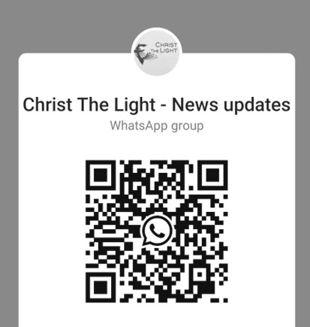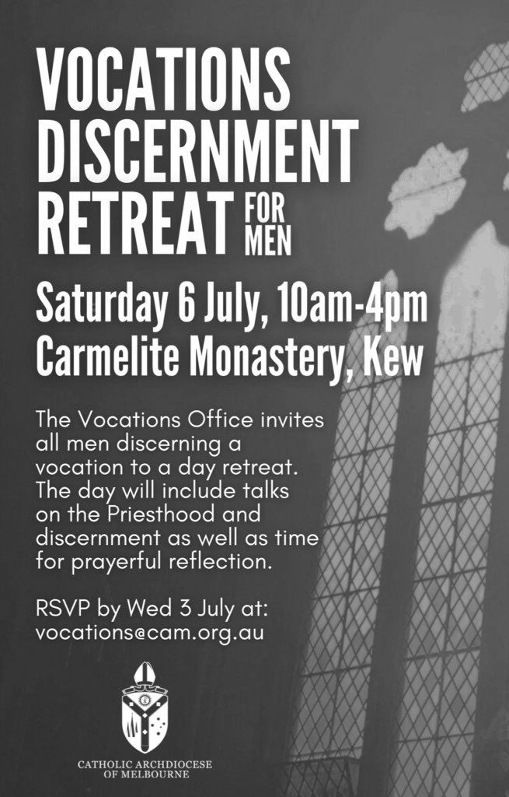
Weekly Quote Quotations of When I talk to You M Lenig - Page 58
God help us to rise up from my struggle.
Like a tree rises up from the soil.
Our roots reaching down to our troubles.
Our rich dark dirt of existence.
Finding nourishment deeply and holding us firmly. Always connected, growing upwards and into the sun.
Amen
ANOINTING MASS Next THURSDAY 4 July 10am St Mary’s Whittlesea We require the help of volunteers to assist with morning tea and transportation. Please contact the parish office via email merndawhittlesea@cam.org.au or TEXT 0448 101 401
Your assistance would be much appreciated.
ADORATION OF THE BLESSED SACRAMENT Next FRIDAY 5 July straight after morning mass finish at 11am Joseph’s Church 1490 Plen-
ty Mernda
St Vincent de Paul This year is the 170th Anniversary of the First SVDP Conference in Melbourne !
The local community of Vinnies is a community of ordinary people, attempting to build a more just society through Advocacy and Direct Assistance for Vulnerable and Disadvantaged People in our local Community.
Visiting people in their homes is at the heart of SVDP work, offering help to people in our local community, regardless of their Faith, Ethnicity, Social Background, Gender or Political Opinions.
A small group of local Volunteers do this work, each week in our community. As you will no doubt be aware, the costs involved in every day life have increased, causing hardship for many in our community.
Over the past 12 months, the local SVDP has visited approximately 1000 Adults & 800 children in 420 Households. SVDP has distributed approximately $45,000 in Food Vouchers alone ! Other areas of Assistance are in Transport, Utilities, Educational Needs, and
Assistance with Medication.
We thank you for your past assistance, and hope that you may be able to assist SVDP in the future !
We would also like to acknowledge the generous assistance of the local schools with our Christmas Hampers! Particularly Marymede College, Mernda Central, St Joseph’s P.S, Laurimar P.S and Hazel Glen Kindergarten. Mernda Conference SVDP

Join the CTL parish WhatsApp group for regular parish news updates. QR Code also available on the parish website www.christthelightparish.org.au
New CHURCH Building Account Details:

If you would like to make a Direct Deposit DONATION* to the
New Church Building account.
BSB: 083 - 347
Acc No: 135 263 131

*Any donation made to this account is NOT tax deductible as we are a
Not For Profit organization

We are a Child Safe Parish. We hold the care, safety and well-being of children, young people and vulnerable adults as a central and fundamental responsibility of our community.
MINISTRY ROSTER : 6/7 July 2024
[W] Welcomer [L] Leader [R] Reader [E] Eucharist [LT] Laptop
10am - Whittlesea: [W] Maria M, Peter R [L] Warner B [R] Mary S [E] John S [LT] Barry K

NAZARETH CENTRE SET UP:
4:30pm Saturday Month of JULY: Ray Rosales and Team
please text parish office 0448 101 401 if you are able to assist
Nazareth Centre Ministries New Roster Platform
https://www.christthelightparish.org.au/Document/rosters


