The Most Holy Body and Blood of Christ Yr B 2 June 2024
Parish Priest: Fr Hien Vu
The Parish Office open hours are Tuesday - Friday 9am-4pm Assistant Priest: Fr George Hogarty SSC
Pastoral Worker: George Thommana
Finance/Admin: Monique Heckmann [Tue, Wed, Thur: 9am – 4pm]
Sacraments: Contact Parish Office [Phone 03 9412 8493]
Parish Office: 2-20 Fir Street, Whittlesea 3757 Postal address: P.O. Box 221, Mernda 3754 Phone Number: 03 9412 8493
Mobile Number: 0448 101 401
Email: merndawhittlesea@cam.org.au
Website: www.christthelightparish.org.au

Nazareth Centre, Mernda

(St Joseph’s Primary School)
44 Mernda Village Drive Mernda 3754
Confession/Reconciliation: Saturday 4pm Weekend Masses: Saturday 5:30pm Sunday 8am and Sunday 10:30am
Children’s Liturgy EVERY Sunday 10:30am
We pray for those who have died recently:
And for those whose anniversaries occur at this time: Regina Ganlath, Antoinette
Antony
We pray for those who are ill in our community: Sr Maureen Delaney rsc,
Peter O’Brien, K.P Abraham, Indika Fernando, Maria Ah Kiau, Gina Wherrett, Susan Stocks, Neth Mercado, John Van Kalken

St Mary’s, Whittlesea

2-20 Fir Street Whittlesea 3757
Weekday Mass: Tuesday & Thursday 9:15am Confession/Reconciliation after
Tuesday & Thursday 9:15am Mass. Weekend Mass: Sunday 10am

St Mary’s, Kinglake

124 Whittlesea-Kinglake Rd Kinglake 3763
Weekend Mass: Sunday 8:30am

St Joseph’s, Mernda

1490 Plenty Rd Mernda 3754
Weekday Mass: Wednesday & Friday 9:15am Weekend Mass: Sunday 5pm

Entrance Antiphon:
He fed them with the finest wheat
and satisfied them with honey from the rock
First Reading:
Exodus 24:3-8
Responsorial Psalm:
I will take the cup of salvation,
and call on the name of the Lord.
Second Reading:
Hebrews 9:11-15

Gospel Acclamation
Alleluia, alleluia! I am the living bread from heaven, says the Lord; whoever eats this bread will live for ever.
Alleluia!
Gospel:
Mark 14:12-16, 22-26
Nextweek: 10th Sunday in Ord Time Yr B
First: Genesis 3:9-15
Second: 2 Corinthians 4:13-5:1
Gospel: Mark 3:20-35

A reflection…

Pope Francis points that at the Last Supper Jesus ‘breaks himself apart’. In doing so, the Pope suggests, Jesus shows his followers ‘that the aim of life lies in self-giving.’
The Pope reminds us that ‘we find the greatness of God in a piece of Bread, in a fragility that overflows with love, that overflows with sharing.’ In the fragility of the Eucharist,
the Pope adds, we find ‘the strength of the love that becomes small so it can be welcomed and not feared.’
The Pope also highlights how the Eucharist reveals ‘the strength to love those who made mistakes.’ It was on the night he was betrayed, with Judas at the table, that Jesus ‘responds to Judas’ “no” with the “yes” of mercy.’
‘When we receive the Eucharist,’ the Pope explains, ‘Jesus does the same with us: he knows us; he knows we are sinners; and he knows we make many mistakes, but he does not give up on joining his life to ours. He knows that we need it, because the Eucharist is not the reward of saints, no, it is the Bread of sinners.’
‘The Eucharist,’ the Pope says, ‘is not a prize for the perfect but a powerful medicine and nourishment for the weak.’ That being the case, this Sunday we might do well to ask ourselves what situation or person we are being strengthened to help.
Weekly Quote Quotations of When I talk to You M Lenig
- Page 54

God help us to live slowly:
To move simply:
To look softly:
To allow emptiness:
To let the heat create for us. Amen

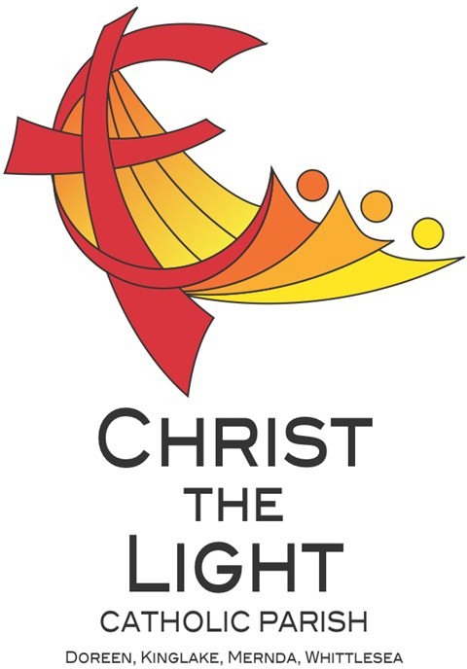

© Nick Brodie

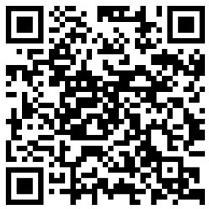

Our Nazareth Centre Kruoz team have been working hard putting together some short ‘How-to’ videos which are
available via the link below or by scanning the barcode. These video will help guide you on how to navigate certain actions on the Kruoz platform.
https://www.youtube.com/channel/UCHlGYRoWARX2aza3j8FA2-A
We Congratulate and welcome young Parishioners from our School and our
Parish-based sacrament programme as they receive the Sacrament of Eucharist for the first time. Please keep these children and their families in your prayer!
STEWARDSHIP ENVELOPES are AVAILABLE from the BACK of CHURCH this WEEKEND
Please collect your envelopes and statements today. If possible we ask that if you are able to deliver a neighbours it would be appreciated to save the parish the cost of postage. Direct Deposit statements will be available from the back of church next week. If your credit card or bank account details require updating, please contact the parish office 0448 101 401
ANOINTING MASS NEXT THURSDAY 6 June 10am St Mary’s Whittlesea We require the help of volunteers to assist with morning tea and transportation. Please contact the parish office via email merndawhittlesea@cam.org.au or
TEXT 0448 101 401 Your assistance would be much appreciated.

ADORATION OF THE BLESSED SACRAMENT NEXT FRIDAY 7 June straight after morning mass finish at 11am
Joseph’s Church 1490 Plenty Mernda

The Archdiocese’s Annual May Mass Count A very big ‘Thank you’ to those who took the count at all our Masses during the month of May.

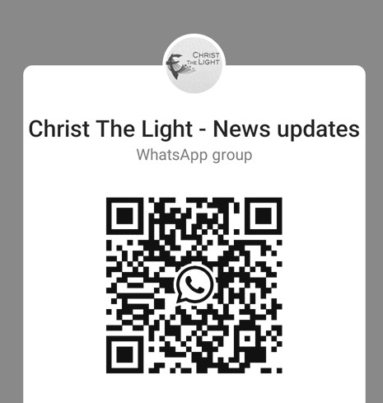

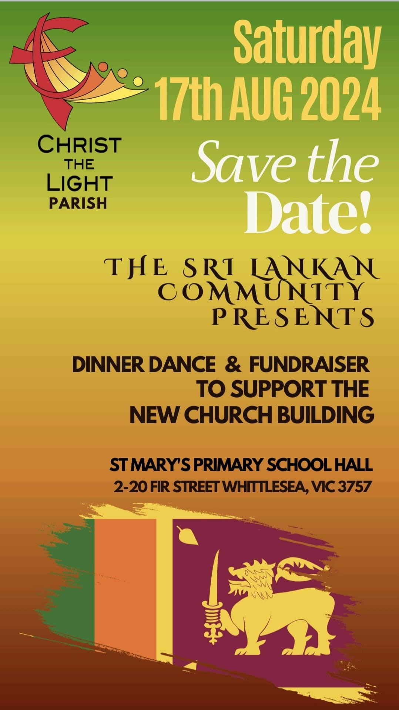
We are a Child Safe Parish. We hold the care, safety and well-being of children, young people and vulnerable adults as a central and fundamental responsibility of our community.

Join the CTL parish WhatsApp group for regular parish news updates. QR Code also available on the parish website
www.christthelightparish.org.au

New CHURCH Building Account Details:

If you would like to make a Direct Deposit DONATION* to the
New Church Building account.
BSB: 083 - 347
Acc No: 135 263 131

*Any donation made to this account is NOT tax deductible as we are a
Not For Profit organization
MINISTRY ROSTER : 8/9 June 2024
[W] Welcomer [L] Leader [R] Reader [E] Eucharist [LT] Laptop
10am - Whittlesea: [W] Irene B, Alice A [L] Lynn O [R] Peter R [E] John O [LT] Barry K

NAZARETH CENTRE SET UP:
4:30pm Saturday Month of JUNE: Charles Fernando - Team B
please text parish office 0448 101 401 if you are able to assist
Nazareth Centre Ministries New Roster Platform
https://www.christthelightparish.org.au/Document/rosters


