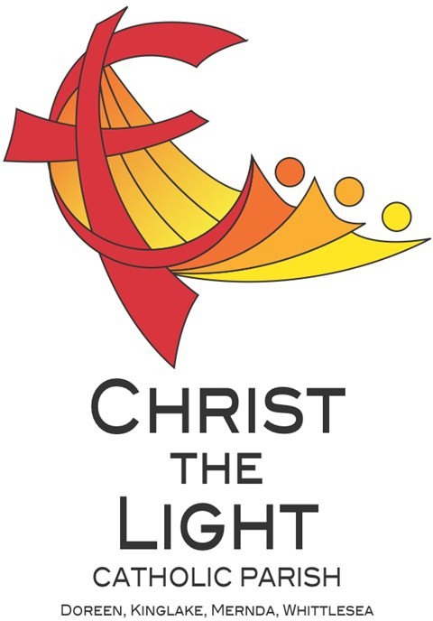 | The Most Holy Trinity Yr B
 | 26 May 2024
Parish Priest: Fr Hien Vu
The Parish Office open hours are Tuesday - Friday 9am-4pm Assistant Priest: Fr George Hogarty SSC
Pastoral Worker: George Thommana
Finance/Admin: Monique Heckmann [Tue, Wed, Thur: 9am – 4pm]
Sacraments: Contact Parish Office [Phone 03 9412 8493]
Parish Office: 2-20 Fir Street, Whittlesea 3757 Postal address: P.O. Box 221, Mernda 3754 Phone Number: 03 9412 8493
Mobile Number: 0448 101 401
Email: merndawhittlesea@cam.org.au
Website: www.christthelightparish.org.au
Nazareth Centre, Mernda  (St Joseph’s Primary School)  44 Mernda Village Drive Mernda 3754  Confession/Reconciliation: Saturday 4pm Weekend Masses: Saturday 5:30pm Sunday 8am and Sunday 10:30am  Children’s Liturgy EVERY Sunday 10:30am | We pray for those who have died recently: Ingram Mirando, Melville Perera, Lalaka Peirs  And for those whose anniversaries occur at this time:  We pray for those who are ill in our community: Peter O’Brien, K.P Abraham, Indika Fernando, Maria Ah Kiau, Gina Wherrett, Susan Stocks, Neth Mercado, John Van Kalken
St Mary’s, Whittlesea  2-20 Fir Street Whittlesea 3757  Weekday Mass: Tuesday & Thursday 9:15am Confession/Reconciliation after  Tuesday & Thursday 9:15am Mass. Weekend Mass: Sunday 10am | Entrance Antiphon:  Blest be God the Father,  and the Only Begotten Son of God, and also the Holy Spirit,  for he has shown us his merciful love.  First Reading:  Deuteronomy 4:32-34. 39-40  Responsorial Psalm:  Happy the people the Lord has chosen  to be his own.  Second Reading:  Romans 8:14-17 | Gospel Acclamation  Alleluia, alleluia! Glory to the Father, the Son, and the Holy Spirit: to God who is, who was, and who is to come.  Alleluia!  Gospel:  Matthew 28:16-20  Next week: The Most Holy Body and  Blood of Christ Yr B  First: Exodus 24:3-8  Second: Hebrews 9:11-15  Gospel: Mark 14:12-16, 22-26
St Mary’s, Kinglake
124 Whittlesea-Kinglake Rd Kinglake 3763
Weekend Mass: Sunday 8:30am
St Joseph’s, Mernda
1490 Plenty Rd Mernda 3754
Weekday Mass: Wednesday & Friday 9:15am Weekend Mass: Sunday 5pm
A reflection…
I wonder if you remember when you first learned how to make the Sign of the Cross. For most of us this would have been very early in our childhood, possibly before we went to school. Once learnt, the action became second nature – we do not need to think about it. The action is of course accompanied by the words with which we are so familiar, again we able to say them without much thought at all – In the name of the Father, and of the Son, and of the Holy Spirit, Amen. At Baptism, we were marked with this sign, and set apart to become a member of God’s holy people.

This simple gesture, a combination of actions and words, conveys two of the greatest truths of our faith. Firstly, that Jesus of Nazareth died on a cross, rose from the dead, and is now proclaimed as the Christ, the Son of God, the one who brought us the good news of God’s infinite love and mercy. The second great truth is that our God, the one living and true God (unlike the stone or wooden gods of some other religions), is a community of three loving persons which we name as Father, Son, and Holy Spirit. By His life, death and resurrection, Jesus has invited us to share in the community that is God and to be community people, people of loving service.

When we make the Sign of the Cross we are making two public statements. The first is that we are disciples of Jesus, the crucified One, and we belong to Him. The second is that we are community people, people who live with and for others, in the manner of the Most Holy Trinity. Every time we make the Sign of the Cross let us do it consciously,
remembering who we are called to be and what we are called to do!
Chris Blake



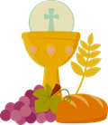
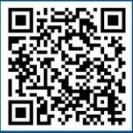
We Congratulate and welcome young Parishioners from our School and our Parish-based sacrament programme as they receive the Sacrament of Eucharist
for the first time. Please keep these children and their families in your prayer!

ANOINTING MASS THURSDAY 6 June 10am St Mary’s Whittlesea We require the help of volunteers to assist with morning tea and transportation. Please contact the parish office via email merndawhittlesea@cam.org.au or TEXT 0448 101 401 Your assistance would be much appreciated.

ADORATION OF THE BLESSED SACRAMENT FRIDAY 7 June straight after morning mass finish at 11am
Joseph’s Church 1490 Plenty Mernda

THANK YOU Christ the Light would like to thank the Parish Community for your ongoing support of the
First Collection - Presbytery and Second Collection - Stewardship. We would also like to acknowledge our appreciation for your presence and participation in our parish communities.
If your credit card details require updating, please email them to the parish office merndawhittlesea@cam.org.au
Thank you

The Archdiocese’s Annual May Mass Count continues this weekend and through the weekends of May. Thank you to those who take the count at all our Masses during the month.

CDF Catholic Development Fund are currently offering 5.35% p.a. 12-month term investment 5.05% p.a. 6-month term investment Call 1800 134 135 OR visit catholicdevelopmentfund.org.au/community fund/offer to open account and for disclosure detail, or scan the QR code
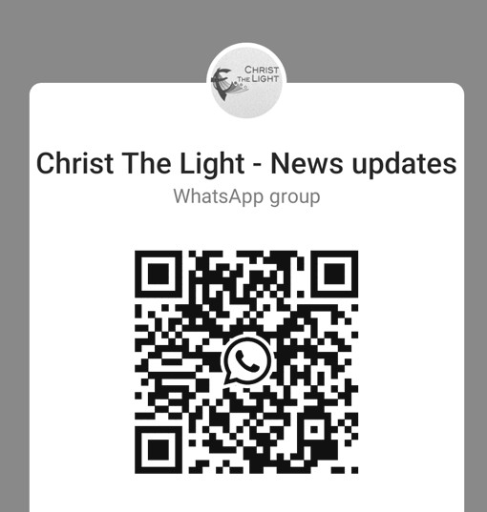
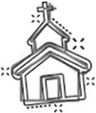

Join the CTL parish WhatsApp group for regular parish news updates. QR Code also available on the parish website www.christthelightparish.org.au

New CHURCH Building Account
Details:

If you would like to make a Direct Deposit DONATION* to the
New Church Building account.
BSB: 083 - 347
Acc No: 135 263 131

*Any donation made to this account is NOT tax deductible as we are a
Not For Profit organization
Weekly Quote Quotations of
Daily Steps for God Chicks
- Page 40
The Lord said to me,
“I chose you before I gave you life, and before you were born, I selected you to be a prophet to all nations.” Jeremiah 1:4
Your life has value. The sooner you realize that the sooner you can make a difference in your world.
And that is why we were all
created – to make a difference. We will each do it in a different way…. but we will all make a
difference.
Portraying William Wallace in the movie ‘Braveheart’, Mel Gibson said, “Every man dies, but not every man really lives.” Make this a day that you really live!
We are a Child Safe Parish. We hold the care, safety and well-being of children, young people
and vulnerable adults as a central and fundamental responsibility of our community.
MINISTRY ROSTER : 1/2 June 2024
[W] Welcomer [L] Leader [R] Reader [E] Eucharist [LT] Laptop
10am - Whittlesea: [W] Maureen C, Peter C [L] John O [R] Moira T [E] Nuccia R [LT] Barry K

NAZARETH CENTRE SET UP: 4:30pm Saturday Month of JUNE: Charles Fernando -
Team B
please text parish office 0448 101 401 if you are able to assist
Nazareth Centre Ministries New Roster Platform
https://www.christthelightparish.org.au/Document/rosters


