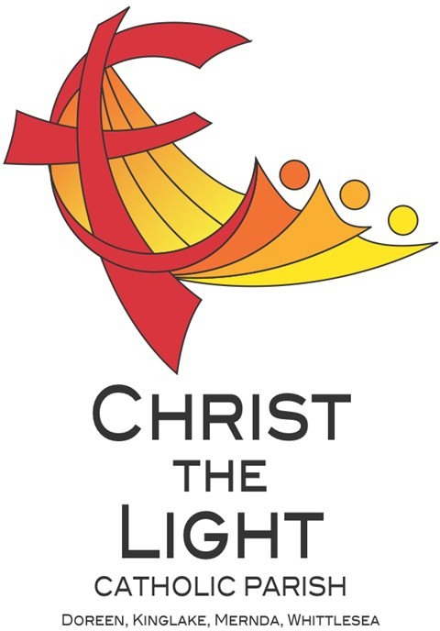 | Nineteenth Sunday in Ordinary Time Yr B 11 August 2024
Parish Priest: Fr Hien Vu
The Parish Office open hours are Tuesday - Friday 9am-4pm
Pastoral Worker: George Thommana
Finance/Admin: Monique Heckmann [Tue, Wed, Thur: 9am – 4pm]
Sacraments: Contact Parish Office [Phone 03 9412 8493]
Parish Office: 2-20 Fir Street, Whittlesea 3757 Postal address: P.O. Box 221, Mernda 3754 Phone Number: 03 9412 8493
Mobile Number: 0448 101 401
Email: merndawhittlesea@cam.org.au
Website: www.christthelightparish.org.au
Nazareth Centre, Mernda | We pray for those who have died recently:
(St Joseph’s Primary School) | And for those whose anniversaries occur at this time: Eufemia Rosales,
44 Mernda Village Drive Mernda 3754 | James [Jim] McMahon, Ingrid Pinghe, Kathleen Harte, Carmel O’Brien
Confession/Reconciliation: Saturday 4pm | We pray for those who are ill in our community: Peter O’Brien, K.P Abraham,
Weekend Masses: Saturday 5:30pm | Indika Fernando, Maria Ah Kiau, Gina Wherrett, Susan Stocks, Neth Mercado,
Sunday 8am and Sunday 10:30am | John Dellamarta, Felix Pereira, Michael O’Brien
Children’s Liturgy EVERY Sunday 10:30am
St Mary’s, Whittlesea | Entrance Antiphon: Gospel Acclamation  Look to your covenant, O Lord, Alleluia, alleluia! I am the living bread and forget not the life of your poor ones from heaven, says the Lord; whoever  for ever. Arise, O God, and defend your eats this bread will live for ever. Alleluia!  cause, and forget not the cries of those Gospel:  who seek you. John 6:41-51  First Reading:  1 Kings 19:4-8 Nextweek: 20th Sunday in Ord Time Yr B  Responsorial Psalm: First: Proverbs 9:1-6  Taste and see the goodness of the Lord. Second: Ephesians 5:15-20  Gospel: John 6:51-58  Second Reading:  Ephesians 4:30 – 5:2
2-20 Fir Street Whittlesea 3757
Weekday Mass: Tuesday & Thursday 9:15am
Confession/Reconciliation after
Tuesday & Thursday 9:15am Mass.
Weekend Mass: Sunday 10am
St Mary’s, Kinglake
124 Whittlesea-Kinglake Rd Kinglake 3763
Weekend Mass: Sunday 8:30am
St Joseph’s, Mernda
1490 Plenty Rd Mernda 3754
Weekday Mass: Wednesday & Friday 9:15am
Weekend Mass: Sunday 5pm
A reflection…

Today is the third of five Sundays in which we are reading from chapter 6 of John’s gospel. The two main themes of this chapter are that Jesus is the new Moses, and that he is the Bread of Life. John’s community were Jewish Christians who were very familiar with the Hebrew scriptures (Old Testament) and for whom the story of Moses was a key part of their religious tradition. As we know, Moses led the Israelites from their slavery in Egypt to the freedom of the promised land, the land of Canaan. As we heard last week, God provided food for their long journey in the wilderness. The bread from heaven (manna) kept their physical bodies alive until they could provide for themselves in their new homeland. Nevertheless, eventually all of them died, including Moses, who did not live to enter the promised land.
John proclaims that Jesus is the new Moses. Jesus leads us from the slavery of ignorance, anxiety and sin to the freedom of understanding, trust and virtue. Once again, God provides food for this new journey. The food that God provides is Jesus himself, who has come from God. Jesus is the Bread of Life. We receive this food in a variety of ways – through prayer and the sacraments, through gathering in community to praise and thank God, by listening to God’s Word, and especially by receiving Jesus in the Eucharist. In an act of faith, when we consume the bread and wine of the Eucharist, we are inviting Jesus to fill us with his own life. Unlike the manna from heaven, this bread provides life for eternity. We are truly blessed!
Chris Blake

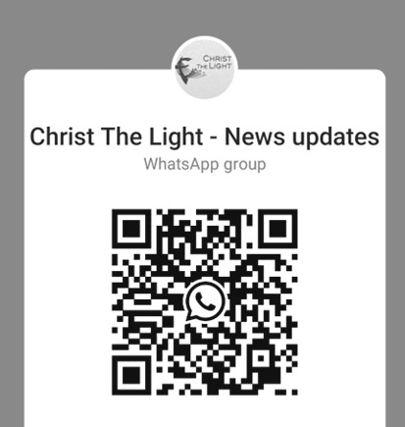
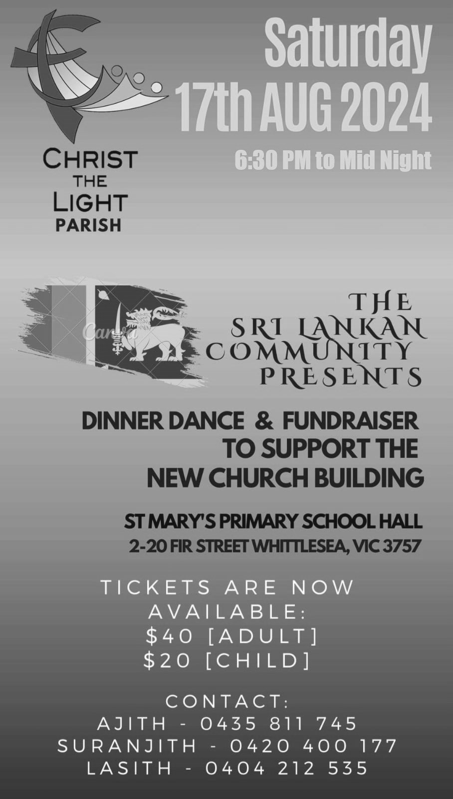
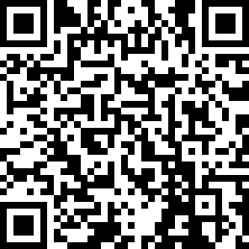


Join the CTL parish WhatsApp group for regular parish news updates. QR Code also available on the parish website www.christthelightparish.org.au
BUNNINGS CAKE STALL - We have been given the opportunity to host a cake stall at Bunnings Mernda on Saturday, 31st August (Fathers’ Day weekend).
Last year this event was so extremely successful in making money to support the building of a new church, as well as working together and socializing with other parishioners.
Popular cake stall items are: honey joys, cupcakes, choc dipped mallows, chocolate crackles, choc chip cookies, choc brownies, mars bars slice and M & M slice;
recipes can be accessed on the parish website as well as there being recipe sheets at the rear of each of the mass centres. - “ingredients labels” will be available for these recipes.
Please feel free to bake your favourite recipe, but be aware that we can't have anything with fresh cream, perishable items, or those that require refrigeration. Additionally, no items containing nuts are allowed due to allergy reasons. Thank you for your understanding and cooperation.
We’ll also require volunteers to man the stall on 31st August.
Please address any enquiries to Liz Blake 0407 832 296, eachblake@bigpond.com or the parish office.
Together we can make it a successful day by raising funds for the parish as well as reaching out to the broader community.
5:30pm MASS NEXT SATURDAY 17 August
will be celebrated at St Mary’s Church Whittlesea. There will be NO 5.30pm Mass at the Nazareth
Centre Mernda

St Mary’s Whittlesea Trading Table - Sunday 4 August $102.50. Thank you


New CHURCH Building
Account Details:

If you would like to make a Direct Deposit DONATION* to the
New Church Building account.
BSB: 083 - 347
Acc No: 135 263 131

*Any donation made to this account is NOT tax deductible as we are a
Not For Profit organization
Weekly Quote Quotations of
Daily Steps for God Chicks - Page 49
Proverbs 3:13-14 states that wisdom is more profitable than silver and gold.
God blesses everyone who has wisdom and common sense.
Wisdom sees people where they are and is kind enough to always speak to the treasure inside of their heart, hence allowing them to be. There is a treasure in your soul that your heavenly
Father is always speaking to.
So……pursue the voice of wisdom and you will find all that you are….and all that you need.

MINISTRY ROSTER : 17/18 August 2024
[W] Welcomer [L] Leader [R] Reader [E] Eucharist [LT] Laptop
10am - Whittlesea: [W] Alice A, Nuccia [L] Maureen E [R] John F [E] Mary S [LT] Barry K

NAZARETH CENTRE SET UP:
4:30pm Saturday Month of AUGUST: Contact Parish Office
please text parish office 0448 101 401 if you are able to assist on any of the following Saturdays 24 /31 August
Nazareth Centre Ministries Roster Platformhttps://www.christthelightparish.org.au/ Document/rosters

We are a Child Safe Parish. We hold the care, safety and well-being of children, young people and vulnerable adults as a central and fundamental responsibility of our community.

