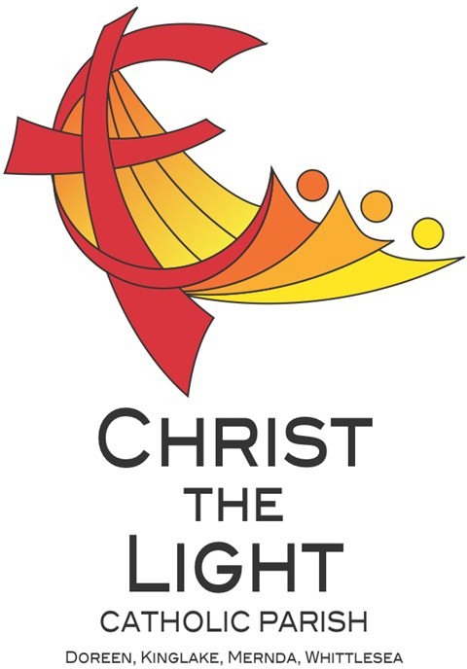 | Seventeenth Sunday in Ordinary Time Yr B 28 July 2024
Parish Priest: Fr Hien Vu
The Parish Office open hours are Tuesday - Friday 9am-4pm
Pastoral Worker: George Thommana
Finance/Admin: Monique Heckmann [Tue, Wed, Thur: 9am – 4pm]
Sacraments: Contact Parish Office [Phone 03 9412 8493]
Parish Office: 2-20 Fir Street, Whittlesea 3757 Postal address: P.O. Box 221, Mernda 3754 Phone Number: 03 9412 8493
Mobile Number: 0448 101 401
Email: merndawhittlesea@cam.org.au
Website: www.christthelightparish.org.au
Nazareth Centre, Mernda  (St Joseph’s Primary School)  44 Mernda Village Drive Mernda 3754  Confession/Reconciliation: Saturday 4pm Weekend Masses: Saturday 5:30pm Sunday 8am and Sunday 10:30am  Children’s Liturgy EVERY Sunday 10:30am | We pray for those who have died recently:  And for those whose anniversaries occur at this time: Ravi Yesudasan, Susan Jacin-  tha, Annete Maureen, Mary Murin Perera, Lionel Gamlath  We pray for those who are ill in our community: Peter O’Brien, K.P Abraham, Indika Fernando, Maria Ah Kiau, Gina Wherrett, Susan Stocks, Neth Mercado, John Dellamarta
St Mary’s, Whittlesea  2-20 Fir Street Whittlesea 3757  Weekday Mass: Tuesday & Thursday 9:15am Confession/Reconciliation after  Tuesday & Thursday 9:15am Mass. Weekend Mass: Sunday 10am | Entrance Antiphon: Gospel Acclamation  God is in his holy place, God who unites Alleluia, alleluia! A great prophet has those who dwell in his house; he himself appeared among us; God has visited his gives might and strength to his people. people. Alleluia!  First Reading: Gospel:  2 Kings 4:42-44 John 6:1-15  Responsorial Psalm:  The hand of the Lord feeds us; he Nextweek: 18th Sunday in Ord Time Yr B  answers all our needs. First: Exodus 16:2-4. 12-15  Second: Ephesians 4:17, 20-24  Second Reading: Gospel: John 6:24-35 Ephesians 4:1-6
St Mary’s, Kinglake
124 Whittlesea-Kinglake Rd Kinglake 3763
Weekend Mass: Sunday 8:30am
St Joseph’s, Mernda
1490 Plenty Rd Mernda 3754
Weekday Mass: Wednesday & Friday 9:15am Weekend Mass: Sunday 5pm
A reflection…

Pope Francis draws our attention to the boy’s role in today’s Gospel passage. He ‘makes us think’, the Pope says. ‘His compassion moved him to offer what he had.’
There is no suggestion in the Gospel that the loaves and fish were forcibly taken from the boy. Rather, it is implied that they were his gift. An act of human charity is, therefore, a key element in Jesus’ miracle.
Another noteworthy factor is Jesus’ sense of priority. This episode, the Pope points out, ‘shows us again that
Jesus is attentive to people’s primary needs’. This has implications for we who seek to follow him.
After all, the boy was discovered because Jesus prompted his disciples to think about how they could feed the crowd. As the Pope says, ‘the people were hungry and Jesus engaged his disciples so that this hunger could be satisfied.’
While Jesus offered the crowd much more than food – ‘his Word, his solace, his salvation, ultimately his life’ – he did not neglect their physical needs. ‘And we, his disciples, cannot ignore this’, the Pope affirms. We are
called to follow the example of Jesus, his apostles, and the boy with a few loaves and fish. We must not turn our backs on the people or retreat from the world. We must face up to the reality we find – and do what we can.
© Nick Brodie

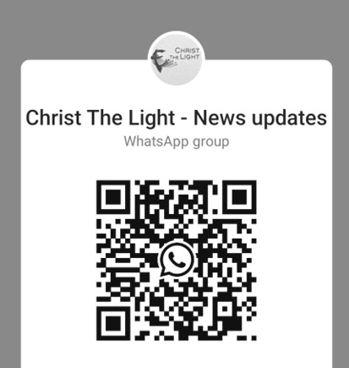
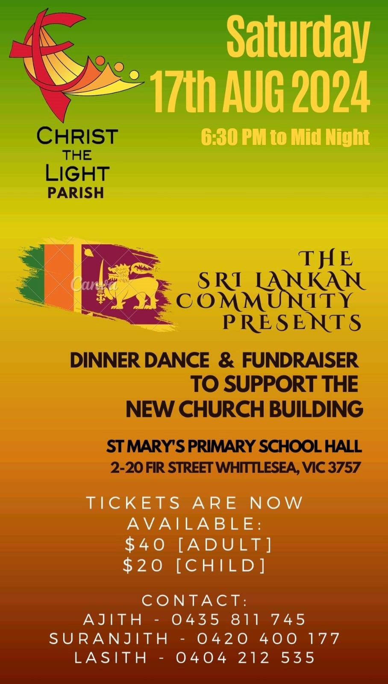
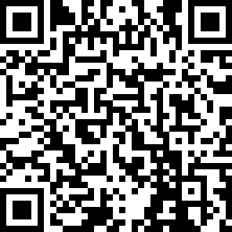





Join the CTL parish WhatsApp group for regular parish news updates. QR Code also available on the parish website www.christthelightparish.org.au
Weekly Quote Quotations of When I Talk to You - M Lenig
- Page 62
We welcome summer and the glorious blessings of light. We are rich with light: we are loved by the sun.
Let us empty our heats into the brilliance. Let us pour our darkness into the glorious, forgiving light.
For this loving abundance let us give thanks. Amen
MINISTRY ROSTER : 3/4 August 2024
[W] Welcomer [L] Leader [R] Reader [E] Eucharist [LT] Laptop
10am - Whittlesea: [W] Maureen C, John S [L] Sean S [R] Maria M [E] Paula B [LT] Barry K

NAZARETH CENTRE SET UP:
4:30pm Saturday Month of AUGUST: Contact Parish Office
please text parish office 0448 101 401 if you are able to assist on any of the following Saturdays 3 / 10 / 17 / 24 /31 August
Nazareth Centre Ministries Roster Platformhttps://www.christthelightparish.org.au/ Document/rosters

We are a Child Safe Parish. We hold the care, safety and well-being of children, young people and vulnerable adults as a central and fundamental responsibility of our community.
New CHURCH Building
Account Details:

If you would like to make a Direct Deposit DONATION* to the
New Church Building account.
BSB: 083 - 347
Acc No: 135 263 131

*Any donation made to this account is NOT tax deductible as we are a
Not For Profit organization
Winter Appeal Thank you The St Vincent de Paul Society would like to THANK YOU the parish community for their generous donation to Vinnies Winter Appeal of $3200.00.
Donations can still be made visiting the website: https://donate.vinnies.org.au
Please come along to one of the Ministry Roster in-person training [KROUZ] AFTER ALL Nazareth Centre MASSES this WEEKEND
5.30pm Mass Saturday 27 July 8am Mass Sunday 28 July 10.30am Mass Sunday 28 July
If you are having difficulties navigating the Ministry Roster Platform, are new to the platform or have any questions.
ADORATION OF THE BLESSED SACRAMENT FRIDAY 2 AUGUST straight after morning mass finish at 11am Joseph’s Church 1490 Plenty Mernda
ANOINTING MASS - There will be NO August Anointing Mass. The next Anointing Mass will be celebrated THURSDAY 5 September.

CONFIRMATION Candidates - Next weekend we welcome our Confirmation Candidates, who are to be presented to the community prior to receiving the Sacrament of Confirmation 23rd and 24th August. You are also invited to stay for morning tea after the masses.
SAVE THE DATE: - Bunnings Mernda Cake Stall – Saturday, 31st August 2024

