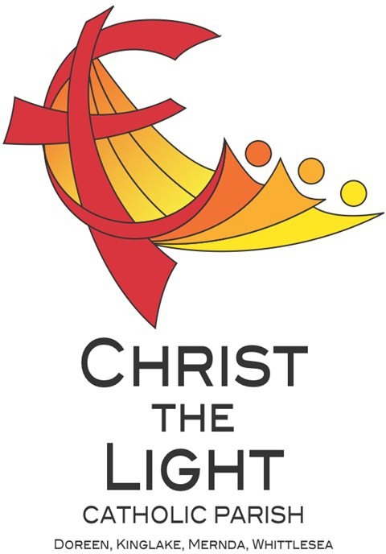 | Fourteenth Sunday in Ordinary Time Yr B
 | 7 July 2024
Parish Priest: Fr Hien Vu
The Parish Office open hours are Tuesday - Friday 9am-4pm Assistant Priest: Fr George Hogarty SSC
Pastoral Worker: George Thommana
Finance/Admin: Monique Heckmann [Tue, Wed, Thur: 9am – 4pm]
Sacraments: Contact Parish Office [Phone 03 9412 8493]
Parish Office: 2-20 Fir Street, Whittlesea 3757 Postal address: P.O. Box 221, Mernda 3754 Phone Number: 03 9412 8493
Mobile Number: 0448 101 401
Email: merndawhittlesea@cam.org.au
Website: www.christthelightparish.org.au
Nazareth Centre, Mernda  (St Joseph’s Primary School)  44 Mernda Village Drive Mernda 3754  Confession/Reconciliation: Saturday 4pm Weekend Masses: Saturday 5:30pm Sunday 8am and Sunday 10:30am  Children’s Liturgy EVERY Sunday 10:30am | We pray for those who have died recently: John Van Kalken And for those whose anniversaries occur at this time:  We pray for those who are ill in our community: Peter O’Brien, K.P Abraham, Indika Fernando, Maria Ah Kiau, Gina Wherrett, Susan Stocks, Neth Mercado, John Dellamarta
St Mary’s, Whittlesea  2-20 Fir Street Whittlesea 3757  Weekday Mass: Tuesday & Thursday 9:15am Confession/Reconciliation after  Tuesday & Thursday 9:15am Mass. Weekend Mass: Sunday 10am | Entrance Antiphon: Gospel Acclamation  Your merciful love, O God, we have Alleluia, alleluia! The Spirit of the Lord is received in the midst of your temple. upon me; he sent me to bring Good Your praise, O God, like your name, News to the poor. Alleluia!  reaches the ends of the earth; your right Gospel:  hand is filled with saving justice. Mark 6:1-6
St Mary’s, Kinglake  124 Whittlesea-Kinglake Rd Kinglake 3763  Weekend Mass: Sunday 8:30am  St Joseph’s, Mernda  1490 Plenty Rd Mernda 3754  Weekday Mass: Wednesday & Friday 9:15am Weekend Mass: Sunday 5pm | First Reading:  Ezekiel 2:2-5 Nextweek: 15th Sunday in Ord Time Yr B  Responsorial Psalm: First: Amos 7:12-15  Our eyes are fixed on the Lord, pleading Second: Ephesians 1:3-14  for his mercy. Gospel: Mark 6:7-13  Second Reading:  2 Corinthians 12:7-10
A reflection…
We all have weaknesses. Many a time we find ourselves facing challenges that highlight our weaknesses across different facets of our lives that include at work, at home or socially. Something happens that has us questioning our self-worth and often leads us to putting ourselves down. We then begin to doubt ourselves and what we are capable of.
Conversely, our strengths when in overplay can also become our weakness. Paul in the Second Reading brings this into some perspective. His understanding of his ‘thorn in the flesh’ is to help him avoid the risk of ‘getting too proud’. And though he states that he has sought for this ‘thorn’ to be removed, God’s reply is to ask Paul to lean on Him.
On the other hand, the people in Nazareth perceive Jesus’ identity as a weakness and this prevents them from seeing him in all his
glory. Here, it is not the element of self-perception, but rather the opinions of others that have contributed to Jesus not being able to bring about God’s Kingdom in Nazareth, as he had done in other places. We too may experience the nay-sayers in our own lives who doubt our ability, and this can affect our sense of self-worth.
Whether it be from an internal perception or from external sources, we are reminded that what we or others see as a weakness, might not be the case. God reaffirms Ezekiel regardless of the response of the people he will be addressing. He lets Paul know that His grace is enough for us and that His power is best in our weaknesses. Let us then, have the confidence to know that God always walks with us especially in those moments of doubt. Let us fully lean on His power and strength to help us overcome those trying moments. Let us continue on our own journeys and hold fast to the faith that will allow others to see the power and face of God through us.
Laetitia Malusu



We are a Child Safe Parish. We hold the care, safety and well-being of children, young people and vulnerable adults as a central and fundamental responsibility of our community.
MINISTRY ROSTER : 13/14 July 2024
[W] Welcomer [L] Leader [R] Reader [E] Eucharist [LT] Laptop
10am - Whittlesea: [W] Lynne O, Peter C [L] Tracy K [R] Xanda B [E] Carol C [LT] Barry K

NAZARETH CENTRE SET UP:
4:30pm Saturday Month of JULY: Ray Rosales and Team
please text parish office 0448 101 401 if you are able to assist
Nazareth Centre Ministries New Roster Platform
https://www.christthelightparish.org.au/Document/rosters
This year is the 170th Anniversary of the First SVDP Conference in Melbourne!
The local community of Vinnies is a community of ordinary people, attempting to build a more just society through Advocacy and Direct Assistance for
Vulnerable and Disadvantaged People in our local Community.
Visiting people in their homes is at the heart of SVDP work, offering help to people in our local community, regardless of their Faith, Ethnicity, Social Background, Gender or Political Opinions.
A small group of local Volunteers do this work, each week in our community. As you will no doubt be aware, the costs involved in every day life have increased, causing hardship for many in our community.
Over the past 12 months, the local SVDP has visited approximately 1000 Adults & 800 children in 420 Households. has distributed approximately $45,000 in Food Vouchers alone ! Other areas of Assistance are in Transport, Utilities, Educational Needs, and Assistance with Medication.
We thank you for your past assistance, and hope that you may be able to assist SVDP in the future !
We would also like to acknowledge the generous assistance of the local schools with our Christmas Hampers! Particularly, St Paul the Apostle, Marymede College, Mernda Central, St Joseph’s P.S, Laurimar P.S and Hazel Glen Kindergarten.
Mernda Conference SVDP
Today, we join the Australian Bishops and the National Aboriginal and Torres Strait Islander Catholic Council in celebrating
Weekly Quote Quotations of
Martin Luther King Jr- Page 17
Darkness cannot drive out darkness; only light can do that.
Hate cannot drive out hate; only love can do that.
Aboriginal and Torres Strait Islander Sunday. As Australians, we are fortunate to share our home with the world’s oldest continuing culture. On this day, we honour and acknowledge God’s presence in the
lives of Aboriginal and Torres Strait Islander Peoples, who have upheld their rich and
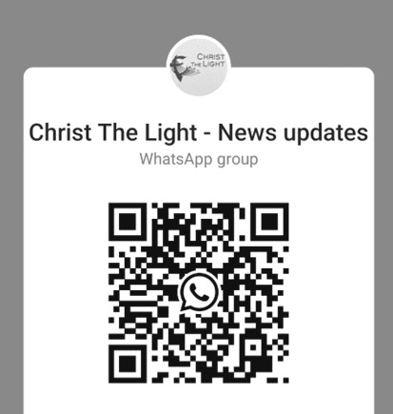

diverse Cultual Traditions for thousands of years. We give thanks for the deep and enduring legacy of these ancient peoples and their contributions to our Continent.

Join the CTL parish WhatsApp group for regular parish news updates. QR Code also available on the parish website www.christthelightparish.org.au
New CHURCH Building
Account Details:

If you would like to make a Direct Deposit DONATION* to the
New Church Building account.
BSB: 083 - 347
Acc No: 135 263 131

*Any donation made to this account is NOT tax deductible as we are a
Not For Profit organization
Let us also take a moment to recognise and appreciate the land on which our Parish is situated and the people who have nurtured it over time. Together, let us continue to
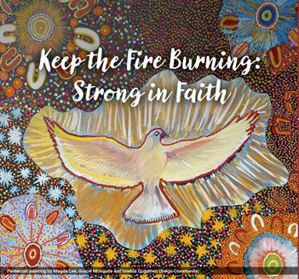
cultivate a spirit of unity and respect for all cultures and traditions within our community.

