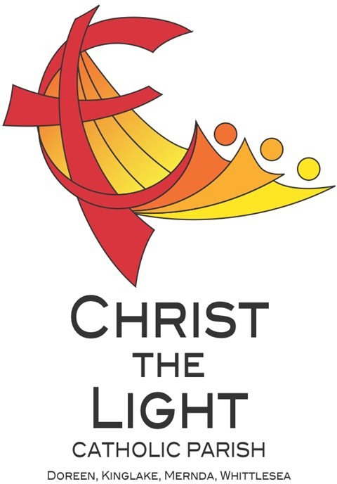 | Twelfth Sunday in Ordinary Time Yr B
 | 23 June 2024
Parish Priest: Fr Hien Vu
The Parish Office open hours are Tuesday - Friday 9am-4pm Assistant Priest: Fr George Hogarty SSC
Pastoral Worker: George Thommana
Finance/Admin: Monique Heckmann [Tue, Wed, Thur: 9am – 4pm]
Sacraments: Contact Parish Office [Phone 03 9412 8493]
Parish Office: 2-20 Fir Street, Whittlesea 3757 Postal address: P.O. Box 221, Mernda 3754 Phone Number: 03 9412 8493
Mobile Number: 0448 101 401
Email: merndawhittlesea@cam.org.au
Website: www.christthelightparish.org.au
Nazareth Centre, Mernda  (St Joseph’s Primary School)  44 Mernda Village Drive Mernda 3754  Confession/Reconciliation: Saturday 4pm Weekend Masses: Saturday 5:30pm Sunday 8am and Sunday 10:30am  Children’s Liturgy EVERY Sunday 10:30am | We pray for those who have died recently: Sheamus McCarney, Neil Moohan And for those whose anniversaries occur at this time:  We pray for those who are ill in our community: Peter O’Brien, K.P Abraham, Indika Fernando, Maria Ah Kiau, Gina Wherrett, Susan Stocks, Neth Mercado, John Van Kalken, John Dellamarta
St Mary’s, Whittlesea  2-20 Fir Street Whittlesea 3757  Weekday Mass: Tuesday & Thursday 9:15am Confession/Reconciliation after  Tuesday & Thursday 9:15am Mass. Weekend Mass: Sunday 10am  St Mary’s, Kinglake  124 Whittlesea-Kinglake Rd Kinglake 3763  Weekend Mass: Sunday 8:30am  St Joseph’s, Mernda  1490 Plenty Rd Mernda 3754  Weekday Mass: Wednesday & Friday 9:15am Weekend Mass: Sunday 5pm | Entrance Antiphon: Gospel Acclamation  The Lord is the strength of his people, Alleluia, alleluia! A great prophet has a saving refuge for the one he has appeared among us; God has visited his anointed. Save your people, Lord, and people. Alleluia!  bless your heritage, and govern them for Gospel:  ever. Mark 4:35-41  First Reading:  Job 38:1. 8-11 Nextweek: 13th Sunday in Ord Time Yr B  Responsorial Psalm: First: Wisdom 1:13-15; 2:23-24  Give thanks to the Lord, his love is Second: 2 Corinthians 8:7. 9. 13-15  everlasting. Gospel: Mark 5:21-43  Second Reading:  2 Corinthians 5:14-17
A reflection…

In recent years the motto “Keep calm and carry on” has become common and can be purchased as a poster or imprinted on shirts, mugs, bags and other goods. It was originally coined by the government in Great Britain in the first days of the Second World War but, surprisingly, was not used (look it up on Google!).
In today’s Gospel Mark relates the story of Jesus and the disciples being caught up in a storm on the Sea of Galilee. The disciples, full or fear and anxiety, rouse Jesus from his sleep because they fear for their lives. Jesus’ response was to quell the storm and he commanded the wind and the water to “Be Calm!”. There are two main points to the story. The first is that Jesus has authority over the elements – in the Old Testament such authority belongs to God, and so in this story
Mark is revealing the true identity of Jesus. The second point is that even though life has many trials and worries, we, just as Jesus expected the disciples to do, should trust in Him.
Perhaps the motto from today’s Gospel could be “Keep calm and trust in God”. This does not mean that bad things do not happen to us and to others, they do – just read or watch the news on any day. As people of faith, we know that both in good times and in bad we are always loved by God and, although fear and anxiety are part of our human condition, the power of God will prevail in our own lives and in our world.
Chris Blake

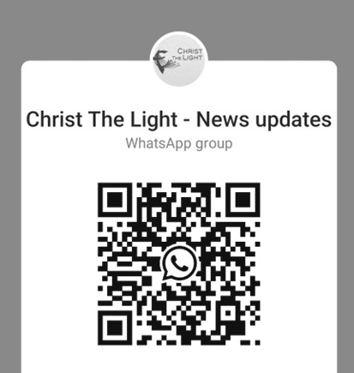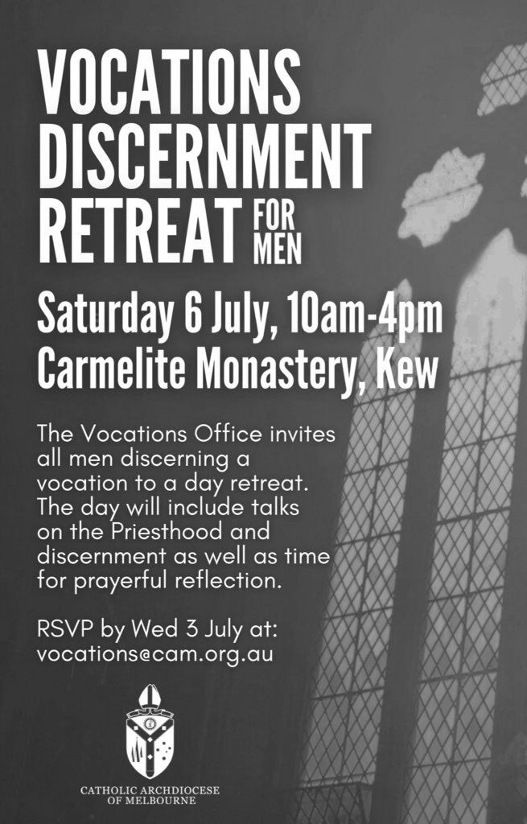
Weekly Quote Quotations of Daily Steps for God Chicks - Page 42
I am waiting for the day my son will leap up from the table and say, “Mom, why don’t you sit on the couch, and I will clean the kitchen.” I am waiting for my husband to give me the remote control and say, “We’ll watch whatever you want to watch, honey.” I am waiting for there to be no traffic on the freeway between my home and the office. I am waiting for chocolate brownies to be good for me… and the list continues.
Second Peter 3:8-9 tells us, “There is no difference in the Lord’s sight between one day and a thousand years.”
Well, sometimes there is, I often think to myself…. At least according to my schedule. Don’t you often feel the same?
St Vincent de Paul This year is the 170th Anniversary of the First SVDP Conference in Melbourne !
The local community of Vinnies is a community of ordinary people, attempting to build a more just society through Advocacy and Direct Assistance for Vulnerable and Disadvantaged People in our local Community.
Visiting people in their homes is at the heart of SVDP work, offering help to people in our local community, regardless of their Faith,
Ethnicity, Social Background, Gender or Political Opinions.
A small group of local Volunteers do this work, each week in our community. As you will no doubt be aware, the costs involved in every day life have increased, causing hardship for many in our community.
Over the past 12 months, the local SVDP has visited approximately 1000 Adults & 800 children in 420 Households. SVDP has distributed approximately $45,000 in Food Vouchers alone ! Other areas of Assistance are in Transport, Utilities, Educational Needs, and
Assistance with Medication.
We thank you for your past assistance, and hope that you may be able to assist SVDP in the future !
We would also like to acknowledge the generous assistance of the local schools with our Christmas Hampers! Particularly Marymede College, Mernda Central, St Joseph’s P.S, Laurimar P.S and Hazel Glen Kindergarten. Mernda Conference SVDP
ANOINTING MASS THURSDAY 4 July 10am St Mary’s Whittlesea We require the help of volunteers to assist with morning tea and transportation. Please contact the parish office via email merndawhittlesea@cam.org.au or TEXT 0448 101 401
Your assistance would be much appreciated.
ADORATION OF THE BLESSED SACRAMENT FRIDAY 5 July straight after morning mass finish at 11am Joseph’s Church 1490 Plenty
Mernda

Join the CTL parish WhatsApp group for regular parish news updates. QR Code also available on the parish website www.christthelightparish.org.au
New CHURCH Building Account Details:

If you would like to make a Direct Deposit DONATION* to the
New Church Building account.
BSB: 083 - 347
Acc No: 135 263 131

*Any donation made to this account is NOT tax deductible as we are a
Not For Profit organization

We are a Child Safe Parish. We hold the care, safety and well-being of children, young people and vulnerable adults as a central and fundamental responsibility of our community.
MINISTRY ROSTER : 29/30 June 2024
[W] Welcomer [L] Leader [R] Reader [E] Eucharist [LT] Laptop
10am - Whittlesea: [W] John F, Michelle J [L] Maureen C [R] Barry K [E] Irene B LT] Barry K

NAZARETH CENTRE SET UP:
4:30pm Saturday Month of JUNE: Charles Fernando - Team B
please text parish office 0448 101 401 if you are able to assist
Nazareth Centre Ministries New Roster Platform
https://www.christthelightparish.org.au/Document/rosters


