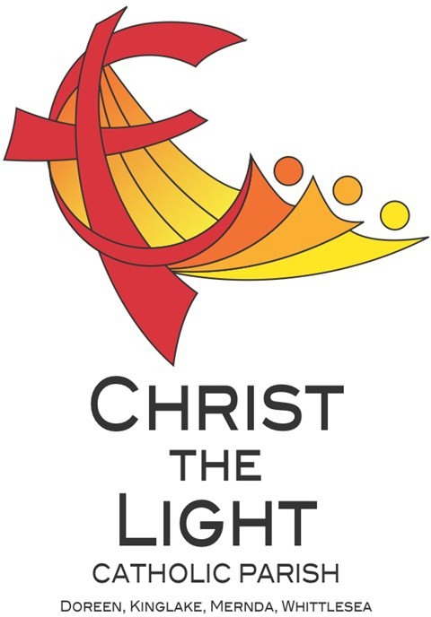 | Eleventh Sunday in Ordinary Time Yr B
 | 16 June 2024
Parish Priest: Fr Hien Vu
The Parish Office open hours are Tuesday - Friday 9am-4pm Assistant Priest: Fr George Hogarty SSC
Pastoral Worker: George Thommana
Finance/Admin: Monique Heckmann [Tue, Wed, Thur: 9am – 4pm]
Sacraments: Contact Parish Office [Phone 03 9412 8493]
Parish Office: 2-20 Fir Street, Whittlesea 3757 Postal address: P.O. Box 221, Mernda 3754 Phone Number: 03 9412 8493
Mobile Number: 0448 101 401
Email: merndawhittlesea@cam.org.au
Website: www.christthelightparish.org.au
Nazareth Centre, Mernda  (St Joseph’s Primary School)  44 Mernda Village Drive Mernda 3754  Confession/Reconciliation: Saturday 4pm Weekend Masses: Saturday 5:30pm Sunday 8am and Sunday 10:30am  Children’s Liturgy EVERY Sunday 10:30am | We pray for those who have died recently: Dot Martin, Fr Brendan Dillon PE And for those whose anniversaries occur at this time: Christie De Silva  We pray for those who are ill in our community: Peter O’Brien, K.P Abraham, Indika Fernando, Maria Ah Kiau, Gina Wherrett, Susan Stocks, Neth Mercado, John Van Kalken
St Mary’s, Whittlesea  2-20 Fir Street Whittlesea 3757  Weekday Mass: Tuesday & Thursday 9:15am Confession/Reconciliation after  Tuesday & Thursday 9:15am Mass. Weekend Mass: Sunday 10am | Entrance Antiphon: Gospel Acclamation  O Lord, hear my voice, for I have called Alleluia, alleluia! The seed is the word to you; be my help. Do not abandon or of God, Christ is the sower; all who come forsake me, O God, my Saviour! to him will live for ever. Alleluia!  First Reading: Gospel:  Ezekiel 17:22-24 Mark 4:26-34  Responsorial Psalm:  Lord, it is good to give thanks to you. Nextweek: 12th Sunday in Ord Time Yr B  First: Job 38:1. 8-11  Second Reading: Second: 2 Corinthians 5:14-17  2 Corinthians 5:6-10 Gospel: Mark 4:35-41
St Mary’s, Kinglake
124 Whittlesea-Kinglake Rd Kinglake 3763
Weekend Mass: Sunday 8:30am
St Joseph’s, Mernda
1490 Plenty Rd Mernda 3754
Weekday Mass: Wednesday & Friday 9:15am Weekend Mass: Sunday 5pm
A reflection… |  |   Weekly Quote Quotations of  When I Talk to You M Lenig - Page 104  God accept our prayers, send us tears in return. Give freedom to this exchange, let us pray inwardly.  Let us weep outwardly, this is the breathing of the soul. This is vitality of the spirit, for this we give thanks. Amen.
In today’s Gospel, Pope Francis reminds us, Jesus ‘teaches us that even everyday things … are inhabited by God’s hidden presence.’
This should encourage us. As the Pope suggests, ‘with this parable Jesus wants to instil us with confidence.’ We can trust that God is still mysteriously at work building His Kingdom.
After all, the Kingdom of God is already growing – even if we do not readily see it. ‘At times,’ the Pope says, ‘the din of the world, along with the many activities that fill our days, prevent us from stopping and seeing how the Lord is conducting history.’
‘The Gospel asks us to take a fresh look at ourselves and at reality,’ the Pope says. He adds that ‘it asks us to have bigger eyes, that are able to see further, especially beyond
appearances, in order to discover the presence of God who as humble love is always at work in the soil of our life and that of history.’
We should, therefore, be open to seeing God at work in the smallest of places.
But we are also called to be more than passive spectators. Jesus wants us to become
cultivators of the Kingdom. While the mysterious growth of the Kingdom is the work of God, we all have a part to play in God’s plan. ‘It is up to us to sow,’ the Pope points out, ‘and to sow with love, with dedication and with patience.’
© Nick Brodie

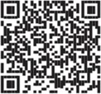

RCIS Program – The parish will be running a special sacramental program for secondary school students [Yr 7 and above] who have missed out on receiving the sacrament of Confirmation. Sessions will be held at the Nazareth Centre St Joseph’s
P.S. 44 Mernda Village Drive Mernda from 4pm-5pm on the following Saturdays: 22 June, 20 July and 3 August. Please contact the parish office on 0448 101 401 and leave a message or visit the website www.christthelightparish.org.au for more information
THIS weekend Sunday 23 June is the 2024 Propagation of the Faith Appeal In Mongolia, Chuluunbaatar suffered a life-altering injury while trying to rescue a submerged vehicle, leaving him unable
to work and reliant on scarce support services for basic needs. Without shelter and food, Chuluunbaatar faces the real risk of freezing to death. Resources are limited, but the Church in Mongolia is working hard to provide essential services to people in need. We invite you to extend your generosity to help enhance these vital services. Your support can make a significant difference to the lives of many, offering hope and tangible assistance to individuals like Chuluunbaatar.
Inclusions for the weekly Newsletter...If you would like any notices, anniversaries or prayers for the sick included in the Sunday newsletter we kindly request that you email, text or call with details: merndawhittlesea@cam.org.au or 0448 101 401 prior to 4pm WEDNESDAYS. Thank you
STEWARDSHIP ENVELOPES are AVAILABLE from the BACK of CHURCH this WEEKEND Please collect your envelopes and
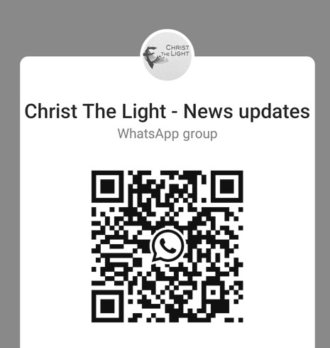

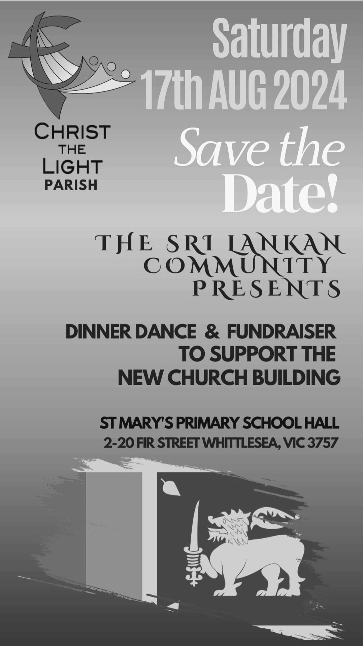

statements today. If possible we ask that if you are able to deliver a neighbours it would be appreciated to save the parish the cost of postage. Direct Deposit statements are also available from the back of church this weekend. If your credit card or bank account details require updating, please contact the parish office 0448 101 401.

Join the CTL parish WhatsApp group for regular parish news updates. QR Code also available on the parish website
www.christthelightparish.org.au

New CHURCH Building Account Details:

If you would like to make a Direct Deposit DONATION* to the
New Church Building account.
BSB: 083 - 347
Acc No: 135 263 131

*Any donation made to this account is NOT tax deductible as we are a
Not For Profit organization
Our Nazareth Centre Kruoz team have been working hard putting together some short
‘How-to’ videos which are available via the link below or by scanning the barcode. These video will help guide you on how to navigate certain actions on the Kruoz platform.
https://www.youtube.com/channel/UCHlGYRoWARX2aza3j8FA2-A

We are a Child Safe Parish. We hold the care, safety and well-being of children, young people and vulnerable adults as a central and fundamental responsibility of our community.
MINISTRY ROSTER : 22/23 June 2024
[W] Welcomer [L] Leader [R] Reader [E] Eucharist [LT] Laptop
10am - Whittlesea: [W] Moira T, Joyce L [L] John F [R] Maureen E [E] Lynne F [LT] Barry K

NAZARETH CENTRE SET UP:
4:30pm Saturday Month of JUNE: Charles Fernando - Team B
please text parish office 0448 101 401 if you are able to assist
Nazareth Centre Ministries New Roster Platform
https://www.christthelightparish.org.au/Document/rosters


