Elanco’s Global Sustainability-Focused Packaging Strategy
Elanco is committed to meet sustainable packaging goals that align with regulatory requirements, corporate social responsibility, and its core mission of Go Beyond, Make Life Better™. This strategy focuses on lower impact practices through innovative design, material choices, and strategic partnerships to minimize the environmental footprint across all product categories.

When designing packaging, multiple influencing factors must be considered, such as functionality, customer experience, distribution channel, sustainability, and cost. The final packaging solution represents a compromise that balances all these considerations.
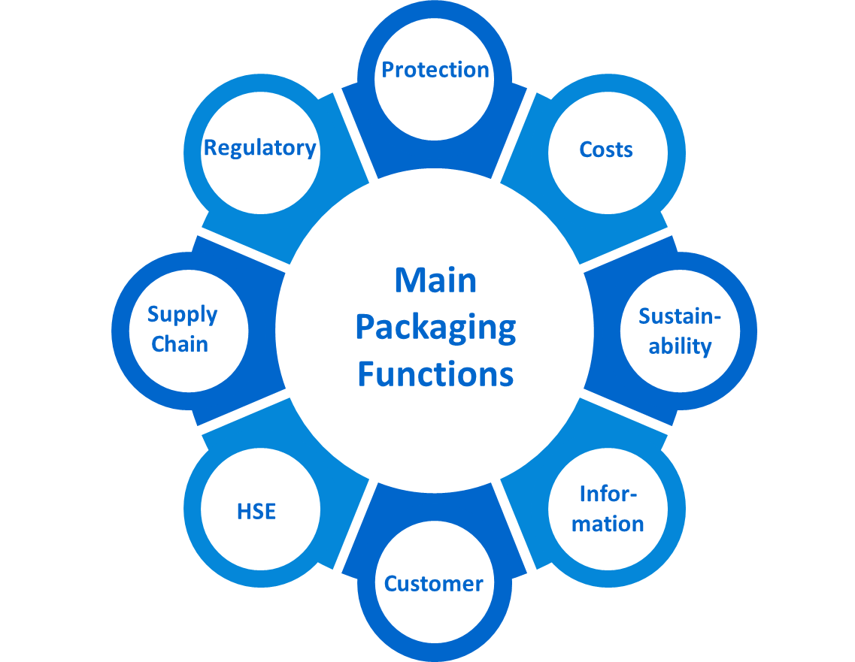
Vision & Mission: Elanco aims to integrate more sustainable packaging into product development and packaging lifecycle management whilst maintaining high standards of product quality and safety.
Importance and Objectives: This strategy is vital, as it provides a structured approach to develop, communicate, and implement more positive packaging solutions. It supports Elanco’s corporate strategy & fulfills ESG commitments.
Key Initiatives:
- Reduce and eliminate harmful substances like PFAS and PVC.
- Align packaging designs with recycling guidelines and enhance consumer interaction.
- Incorporate the seven R principles: Reduce, Reuse, Recycle, Replace, Refuse, Reject, Rethink.
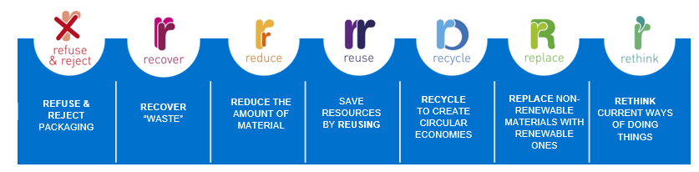
Phased implementation plans aim to gather data, promote sustainable activity pilot practices, and scale successful solutions across our products. Regular updates, collaboration and expansion ensure sustained progress towards meeting our environmental objectives.

