New Options for Viewing Meetings and Meeting Materials
We have made several changes for viewing agenda and attachments. Many of these changes are designed to make viewing on devices such as tablets or smartphones easier.

Regarding Attachments:
On both the View Meeting Details, and Meeting Quick View screens we’ve made navigating attachments and identifying attachments to which you have added annotations easier.

Navigating Attachments on an Agenda Item:
Once you open an attachment you’ll notice three new buttons just below the attachment name. As seen below, you will have an X, a back and forward buttons.

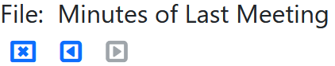

The X button closes the attachment.
The arrow buttons will let you move between attachments on the agenda item.
If there is only a single attachment you will see the button options shown in the screenshot above where either the X, or the back button will close the attachment. The forward button is not available as there is only a single attachment on this item.

Identifying attachments with annotations:
Attachments to which you have added annotations will now have an indicator making it easy to identify these attachments. In the screenshots below the speech bubble with three dots indicates attachments with annotations. This indicator appears both in the navigation sidebar of the View Meeting Details screen and in the item view as well as the item view on the Meeting Quick View screen. Note that in the sidebar this simply indicates one or more attachments have annotations.

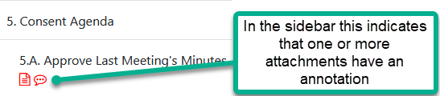

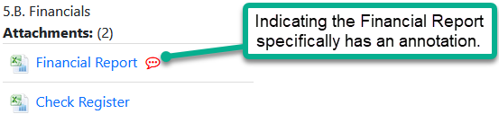
If you are not aware, as a user, you can add notes or highlighting to attachments. You can learn more about this by watching the video ‘Working with Annotations and Highlighting when Viewing Attachments’ on our Board Member and Other Viewer help page. This support page can be reached by clicking on the blue circle with the question mark (found at the top of the page) and selecting ‘BoardBook Board Member and other Viewer Help’.

Hide the sidebar in View Meeting Details
We now have an account level option to hide the sidebar on the View Meeting Details screen:
This is an account level change which will have the following results:
The sidebar will not display or be available for your users, or on the public projector.
Navigating on the view meeting details screen will rely solely on the next and back buttons in the blue tool bar.
The screenshots below show the View Meeting Details screen with and without the sidebar:

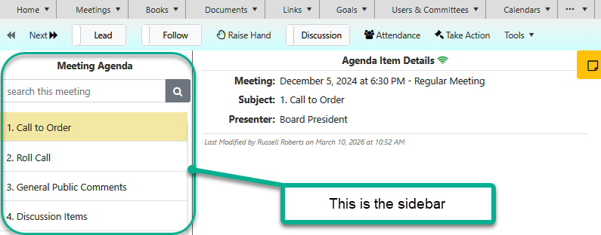

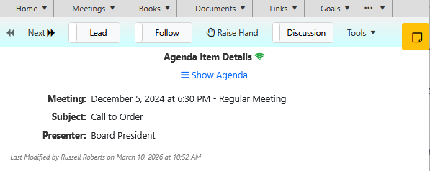

Account level option to change the name of the notes / personal notes available for users.
On both the View Meeting Details, and Meeting Quick View screens your users have the option to add notes, sometime called personal notes to individual agenda items. This feature has the following options:
It can be enabled or disabled for individual users.
It can be disabled at the account level.

