New minutes approval process and options
There are a number of updates to the minutes approval process as well as how minutes templates are used and their capability. The interaction of these changes is a bit complex so this document will break this down based on how the draft minutes are treated by your organization in order to help understand how the changes will, or may impact you.

NOTE: This is a process change. Historically approved minutes are uploaded as the custom minutes and the meeting is moved to completed. This is changed with this update. The updated process that is the smallest change from what we have historically taught is the ‘My organization posts approved minutes only, and does not post draft minutes’ process.

My organization posts approved minutes only, and does not post draft minutes
Information on this process is found starting on page 2

My organization posts draft minutes and then when available posts approved minutes
Information on this process is found starting on page 4

Options for identifying the draft/unapproved minutes:
Information on this subject is found starting on page 8

Signature option for either of the above minutes processes
Information on this subject is found starting on page 12

My organization posts approved minutes only, and does not post draft minutes
Note: This process will be the closest to the process we have historically taught, where approved minutes are uploaded as the custom minutes and the meeting is moved to completed is changed with this update. The primary change is an explicit step to approve the minutes.

As before, our meeting is kept in the Published status until the board has approved the minutes and the approved minutes have been uploaded as the Custom Minutes.

Meeting remains in the Published status

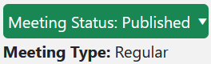

The ‘Custom Minutes’ option is chosen from the Date, Time, Title link for the meeting



The approved minutes are identified and selected using the gray ‘Browse’ button then uploaded using the blue ‘Upload Custom Minutes’ button

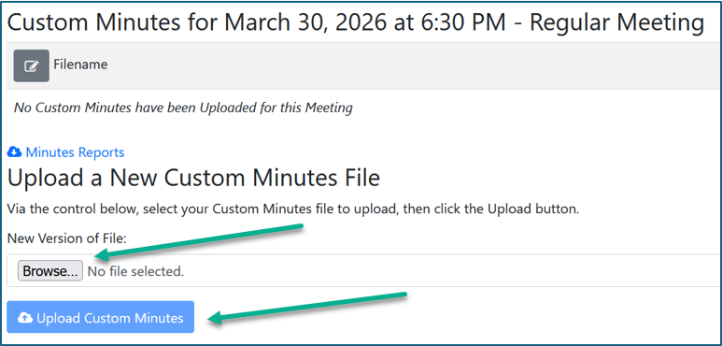

The meeting is moved to the Completed status

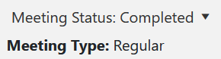

The new ‘Approve Minutes’ option on the Date, Time, Title menu is selected to mark the minutes approved in the system. Note that this requires the Minutes Manager permission.

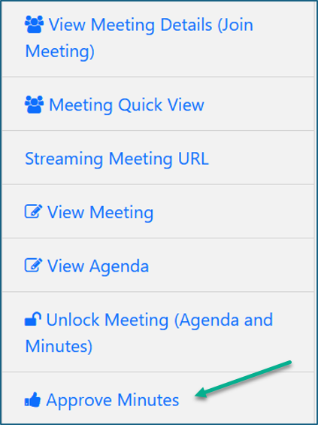

As you can see, compared to the older process we’ve simply added one step.

My organization posts draft minutes and then when available posts approved minutes
Note: The primary changes involve being able to explicitly identify draft/unofficial minutes and an explicit step to approve the minutes.

First, we’ll cover the processes for uploading your draft minutes and making them available to your users and public and approving those minutes, then we will discuss the options for identifying the draft/unapproved minutes for your viewers.

The processes

Once the meeting has been held, and the draft/unofficial minutes are available, they are uploaded as the Custom Minutes.

The ‘Custom Minutes’ option is chosen from the Date, Time, Title link for the meeting

The draft/unapproved minutes are identified and selected using the gray ‘Browse’ button then uploaded using the blue ‘Upload Custom Minutes’ button

The meeting is moved to the Completed status

Once the minutes are approved, the next step depends on whether there are any changes that need to be made to the draft minutes. This would include both changes to the documented information as well as the addition of any signature(s) or stamps.

If there are no changes:

The new ‘Approve Minutes’ option on the Date, Time, Title menu is selected to mark the minutes approved in the system. Note that this requires the Minutes Manager permission.

If there are changes:

The meeting is unlocked using the ‘Unlock Meeting (Agenda and Minutes) from the Date, Time Title menu.

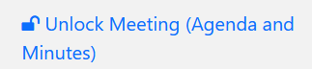

The ‘Custom Minutes’ option is chosen from the Date, Time, Title link for the meeting

The draft minutes are deleted using the red trash can icon.

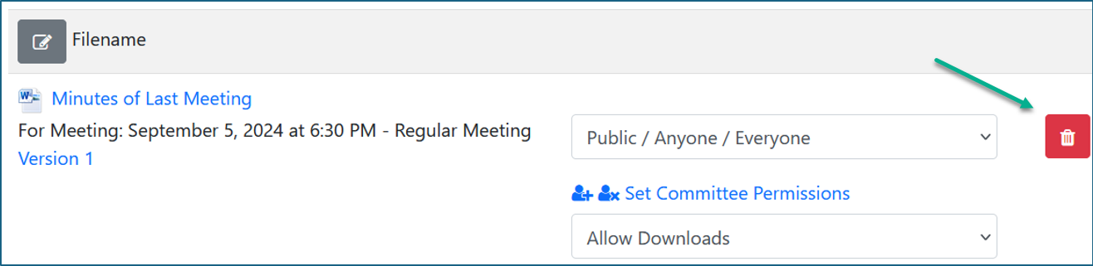

Navigate back to the Meetings, Minutes, and Agendas screen.

The approved minutes are identified and selected using the gray ‘Browse’ button then uploaded using the blue ‘Upload Custom Minutes’ button

The new ‘Approve Minutes’ option on the Date, Time, Title menu is selected to mark the minutes approved in the system. Note that this requires the Minutes Manager permission.

Options for identifying the draft/unapproved minutes:
With this update two options exist in the program to help clearly identify draft/unapproved minutes to your viewers. Both of these options involve working in the settings and require the Settings Manager permission.

NOTE: Changing system settings incorrectly can cause issues which may be very difficult to recover from. Many of the settings are NOT intuitive. Please only change or update settings as specifically described in these or other specific BoardBook supplied instructions. If you have questions about other settings, please contact us before making any changes.

If you do not feel comfortable making the changes yourself, please see the final page of this document which identifies what you need in order to ask us to make the changes for your organization.

What options are available:

Supporting Text:
Text identifying the draft/unapproved minutes can be added in settings. The text you wish to appear is entered in settings. The text will be removed by the system once the minutes are marked as approved. The setting This text appears above the document in the PDF viewer as shown below:

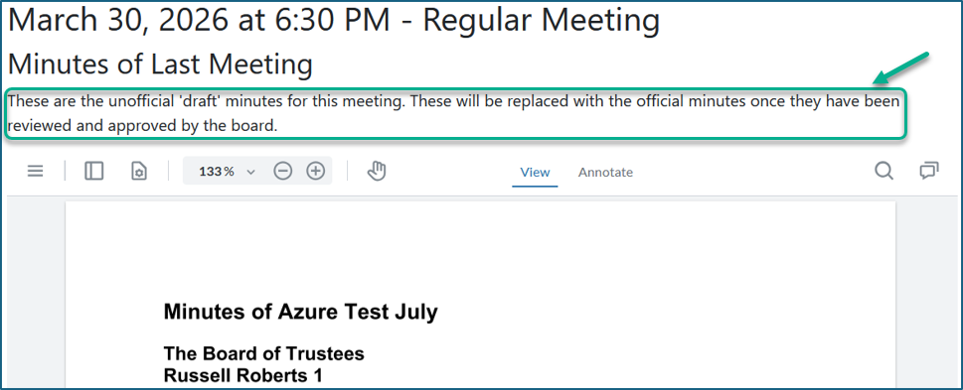

Watermark:
A watermark, of text of your choosing will be shown on the PDF view of the minutes. The watermark appears only on the first page. Settings control the font size, text color, opacity, and rotation.

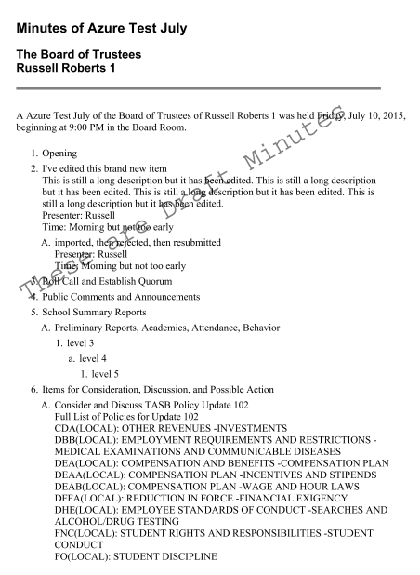

Controlling the options:

If you do not feel comfortable making the changes yourself, please see the final page of this document which identifies what you need in order to ask us to make the changes for your organization.

In the gray menu bar select Settings, then Minutes Options.

The first option is to add the supporting text.

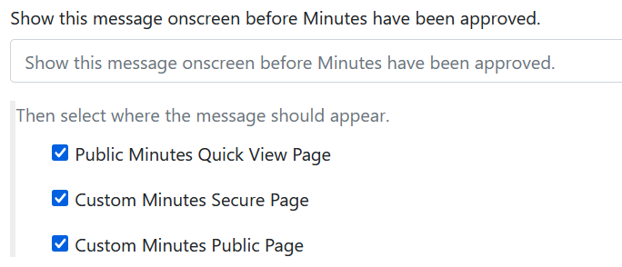

You can enter the text you wish to appear and identify on which page or pages where this text should appear.

The second option is the watermark.

You add the text you wish to appear in the watermark.
There are options for font size, text color, opacity, and rotation.

Note that in my sample earlier in this document I used the following settings:
Font Size 32
Text Color 000
Opacity .5
Rotation 30

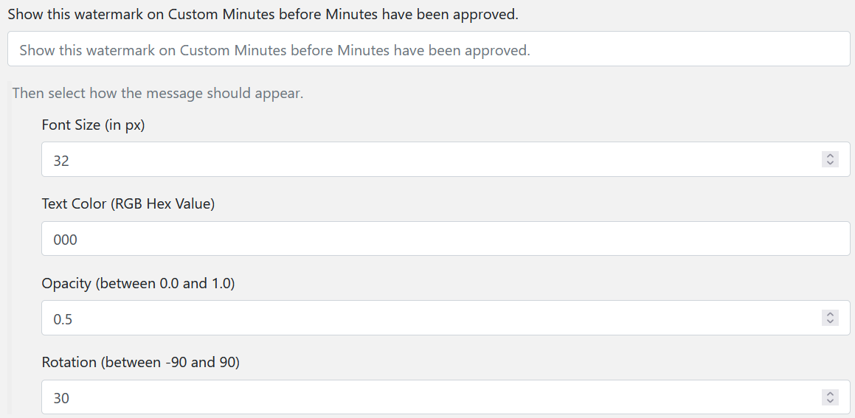

Settings change request
If you do not feel comfortable making changes to your account settings please contact us and we will be happy to make those changes for you. When you contact us please provide the following information:

What specific option, or options would you like changed.

In order to prevent confusion, please refer to the title of the document covering the change(s) you are requesting.

To add or change the supplemental text on draft/unapproved minutes please provide the following information:

What text do you wish to appear?

Should the text appear for your public, your users, or both?

To add or change a watermark for your draft/unapproved minutes please provide the following information:

What text do you want to appear?

What font size?
What text color?
What should the opacity be (between .0 and 1)
Should the text be rotated?
If so by how many degrees between -90 and 90?

Signature option for either of the previously described minutes processes:
The ‘Minutes Report’ within BoardBook can be configured to add up to two different stored signatures to a Minutes Report once the minutes are marked as approved.

Note that because this process uses the minutes report to create the ‘signed’ minutes, this process is only appropriate for users who are using the minutes manager tools to document their minutes.

Note that the Minutes Report Template is a Report Template similar to the Agenda Report Template. On our support page we have both a video and document which discuss managing report templates.

This documentation is broken down into the following sections:

Requirements
What the process looks like in use and time line
Setting up the signatures and minutes report template(s)

Requirements:

As this process uses the minutes report, any changes from the original ‘draft’ minutes report must be either made in the system using the minutes manager tools, or made to the report itself after downloading but before uploading as the Custom Minutes.

Minutes must be marked as approved within the system. The process for marking the minutes approved is covered under the processes documented earlier in this document. Any minutes report run prior to the minutes being approved within the system will not contain the signatures.

Signatures must be configured in the system. The details regarding setting up the signatures are described later in this document in the ‘Setting up the signatures and minutes templates’ section. Note that this requires either the Organizational Administrator role, or the User Manager permission..

The minutes report template must be configured to include the signatures. The details regarding the signature placeholder(s) for the report template are described later in this document in the ‘Setting up the signatures and minutes templates’ section. Note that this requires the Minutes Manager permission.

The minutes report must be run, or run again following the minutes being approved in the system. A timeframe describing this process is described the ‘What the process looks like in use and time line’ section.

What the process looks like in use and time line

Update minutes information if needed (discussion, take action, attendance)
Mark minutes approved in the system

Run the minutes report being sure to select your signature equipped report template
download, double check and make any needed updates

Unlock the meeting if needed

Upload as the Custom Minutes
Note if the draft minutes were previously uploaded, they will need to be deleted, and you will need to return to the meeting date time title menu and reselect Custom Minutes to perform the upload.

Setting up the signatures and minutes report template(s)

Setting up the signatures:

Setting up the signatures requires a user with either the Organizational Administrator role, or the User Manager permission.

In the gray menu bar choose Users & Committees, which may be listed as Users & Units, and choose ‘Manage Signer Information. If you do not see this option, you do not have the required permission to perform this task.

Here you will see the option to setup signers for your regular board as well as any committees which are setup in the program. In the screenshot below only the option for the Regular Board is shown.

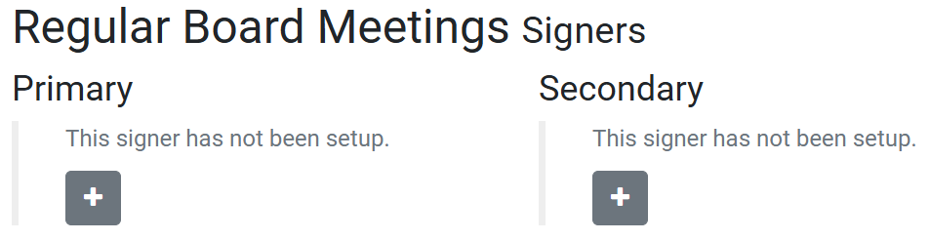

Click the gray box with the plus sign for the primary, use the drop down to identify which user you will be setting up a signature for.

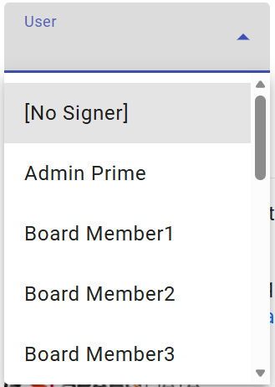

Once the user has been chosen there are three options which are seen in this screenshot:

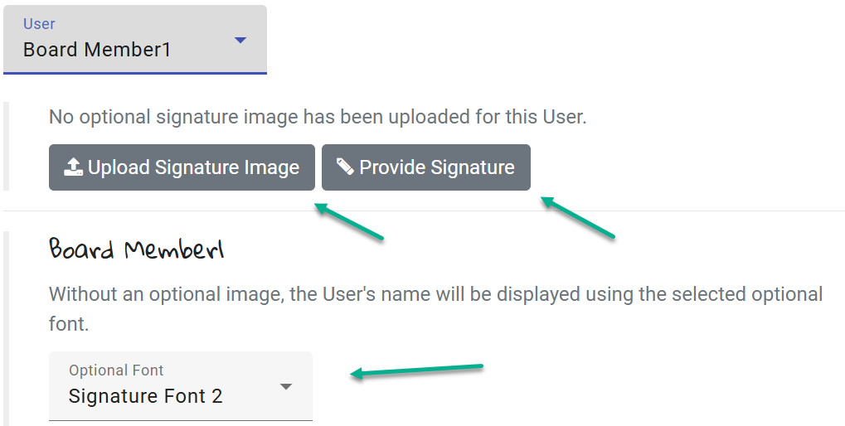

Upload Signature Image: An image of a signature can be uploaded. This can be a PNG, JPEG, JPG, or other basic image file type.

Provide Signature: A basic interface is provided where someone can provide a signature using a mouse or other input device.

User name in signature font: The user’s name can be displayed using a selection of signature font options.

In the case of the first two options, once the signature, or signature image is provided, the image can be cropped.

Signatures for up to two users can be provided for the main board, and each committee.

The image for signatures can be removed, or a different user can be chosen from this screen when needed.

Setting up the Minutes Report Template:

Note that this section will only discuss the use of the placeholders for placing up to two signatures in a minutes report template. The specifics of working with report templates are covered in both a document and video on our support page.

The placeholders:

The placeholders {{Signer0}}, and {{Signer1}} are used to place the configured signatures in the created meeting template. {{Signer0}} simply inserts the signature for the primary signer with {{Signer1}} adding the signature for a second signer if used.

Here is an example of what that might look like in the template itself.

