New Options for the Subscribe Button and Public Projector
New options for selecting the location of the Subscribe Button and the sending of subscriber email are available. We also have some new capability for the Public Projector which will allow you to stream your meeting along with displaying your agenda.

Background
The Public Page Subscribe Button Page 1
The Public Projector Split Screen Page 3

The Public Page Subscribe Button
A button allowing your public to subscribe to email notifications concerning your public meetings has been part of the BoardBook public page for quite some time. This update allows you to control where that button is shown as well as what time those emails are sent. Making changes to the placement of the subscriber button, or to the behavior of subscriber emails requires the Settings Manager permission.

Background
Members of the public who subscribe to your public page will receive notifications when a public meeting is published, shortly before the start of a publicly posted meeting, when the approved minutes are made available to the public, and when a previously published meeting is either cancelled or postponed.

Options
A subscribe button, similar to that shown below, can be placed at the top, and or the bottom, of your list of meetings on your public page.

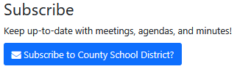

Note that the button will be labeled with the name of your organization as seen in BoardBook.
Members of the public who click on the subscribe button will be asked to provide, then confirm their email address. Members may unsubscribe at any time using the unsubscribe link on the subscriber emails themselves.

Available options
The subscriber capability can be enabled or disabled. For most public organizations it was enabled by default when the account was created.
The subscribe button can appear at the top or bottom of the list meetings on the public page, or in both locations.
A setting lets you specify whether the emails should be sent right away, or at specific time(s).

Making changes
NOTE: Changing system settings incorrectly can cause issues which may be very difficult to recover from. Many of the settings are not intuitive. Please only change or update settings as specifically described in this or other specific BoardBook supplied instructions. If you have questions about other settings, please contact us before making any changes.

In the gray menu bar choose Settings, then Public Page Options. Near the top of this section, you will find the following settings related to the subscribe capability.

Show the Subscribe Section on Your Public Page?
Checking this setting enables the subscribe capability, unclicking disables this capability.

Where should the Subscribe Section on Your Public Page appear?
The options are ‘Bottom (below the Meetings), Top (above the Meetings), and Both (Bottom and Top)

How often would you like your Subscription Emails sent out?
Note: We are expecting this title to be changed to ‘What time(s) would you like your Subscription Emails sent?’ or something similar for clarity, however this may not be done in time for the update.
Options here are as follows:

‘Right Away’, which would send the emails when the triggering event occurs (meeting moved to published status etc.).

‘Specify Time(s)’, which allows you to specify one or two specific times a day when the emails will be sent.

The Public Projector Split Screen
The Public Projector is designed to be used during a meeting as a way for the public to follow along in your meeting place. It works in conjunction with the Meeting Leader function following along as the Meeting Leader moves through the agenda. Note that the projector automatically filters to only show content that was designated for the public. Our new option allows you to stream your meeting along with the agenda.

What it looks like
Below is what the public page meeting information looks like when the projector split screen is used. A link for the projector is shown as well as a link for projector split screen. Note that if the video link is not provided the Projector Split Screen link will not be shown. Also shown are screenshots comparing the projector screen as seen with no video, and the projector screen seen displaying video.

Public Page Meeting Information:

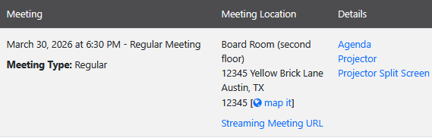

Note, if a link has not been added to the meeting information the ‘Projectors Split Screen’ option will not be displayed.

Projector Screen:

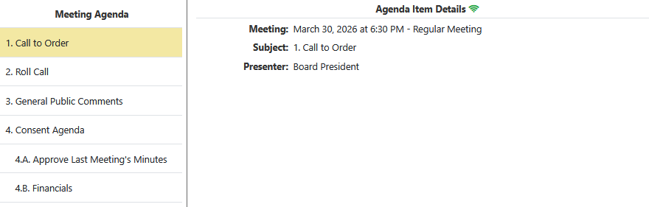

Projector Split Screen:

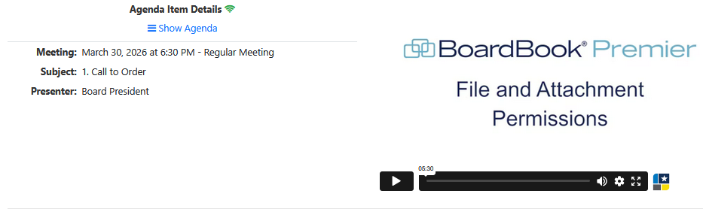

Note that when the split screen is shown the list of agenda items is not shown but a link to Show Agenda is available.

Options
The split screen can show videos based on links placed either in the ‘Streaming Video URL’, or ‘Recorded Video URL’ fields which are found on the Create Meeting or Edit Meeting screens. Links such as Facebook live streaming (note that Facebook may remove live streams after some period), Vimeo, Google Drive, and Zoom have been tested. Note that the content will need to be available to the public on whichever service is used.

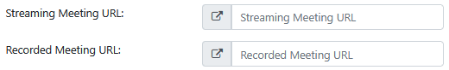

Enabling or Making changes
NOTE: Changing system settings incorrectly can cause issues which may be very difficult to recover from. Many of the settings are not intuitive. Please only change or update settings as specifically described in this or other specific BoardBook supplied instructions. If you have questions about other settings, please contact us before making any changes.

In the gray menu bar choose Settings, then Public Page Options. Scroll down until you see the option to Enable Your Public Projector Page.

Place a check in the box to enable the projector page

Find the setting ‘Show your Public Projector Page via a Split Screen?’ and choose the appropriate choice for your organization in the drop down menu to enable the split screen and identify which field will be used to provide the URL.

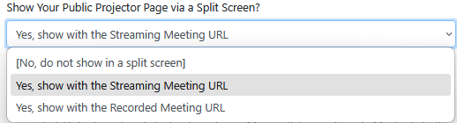

If you would prefer, we are happy to enable this option for you. Please contact support and let us know that you would like the Projector Split Screen enabled and whether you would like it to use the Streaming Meeting URL, or the Recorded Meeting URL. Our support contact information is in the footer of this document.

