The User Homepage
The user homepage in BoardBook was designed to be a dashboard, if you will, of useful and timely information. As originally designed it contains a limited list of the most recent meetings, a calendar showing meeting dates, links customized by the organization, and potentially more depending on which features are in use. The locations on the page for each of these options were fixed and unchangeable.

Customizable Homepage
With this update we have added options to customize what information is shown on the home page as well as how it is organized.

The Options
Essentially, the new options can be summarized as follows:

The ability to remove or rearrange existing homepage content.
The ability to add a custom HTML field which can be customized by your organization.

The default homepage:
The default homepage has the following layout:

Left column: A limited list of the newest meetings.

A limited list of recent changes. This will not be seen if the number of recent changes is set to zero. This is the default setting for newer accounts.

Center column: The BoardBook calendar.

Right column: Links. This will not be seen if no links have been configured.

Documents. This shows the For Users information if enabled. This is controlled under Online Documents.

The interface for changes
Note: Making any of these changes requires the Settings Manager permission.
The Settings page now has a Home Page Options section with a drag and drop interface for customizing your home page. The screenshot below shows the basic, default layout.

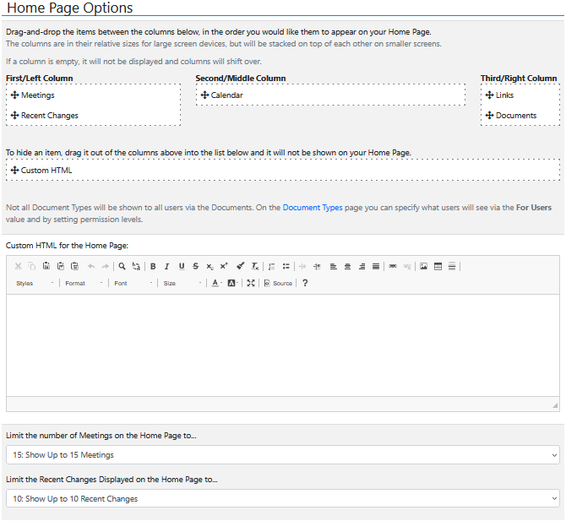

On this page we have six fields as described below:

Meetings: This displays a limited list of the newest meetings. Whether a specific meeting is displayed is controlled by the interaction between the user’s permissions and the status of the meeting. The specific number of meetings to be displayed is controlled using the ‘Limit the number of Meetings on the Home Page to:’ dropdown.

Recent Changes: This displays a limited list of the recent changes. The specific number of recent changes to be displayed is controlled using the ‘Limit the number of Recent Changes on the Home Page to:’ dropdown.

Calendar: The BoardBook calendar which by default displays a month at a time. Meetings that the user has permission to see will be displayed. The permission Calendar Manager allows a user to add or update events on the calendar.

Links: Links, if any are configured, are displayed. A user with the permission Link Manager can add and manage links.

Documents: Documents or rather links to documents can be displayed as part of the Online Documents capability. A user with the Document Manager permission can configure this.

Custom HTML: This represents the HTML which can be added in the ‘Custom HTML for the Home Page’ field.

Arranging the fields
Fields can be dragged and dropped either into different columns, in a different order, or into the field below the columns labeled ‘To hide an item’, if you do not want it to be displayed at all. Note that when dragging and dropping you must drag the item into the white area of the respective column, or the hide item field.

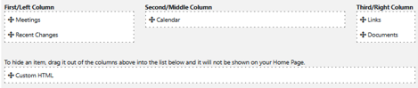

Custom HTML
In the Custom HTML field, you can type and format text, insert links, pictures, or tables using the various tool buttons. For users wanting to do something more complex than that, for example inserting a Google calendar, you’ll want to do this using HTML. To add HTML click the ‘Source’ button and HTML code can be manually added or pasted into the space. Note that we can only offer limited support for working with HTML you may wish to have someone at your organization who is familiar with HTML assist you with this. In the last section of this document we have an example of how this field could be used to add a Google Calendar.

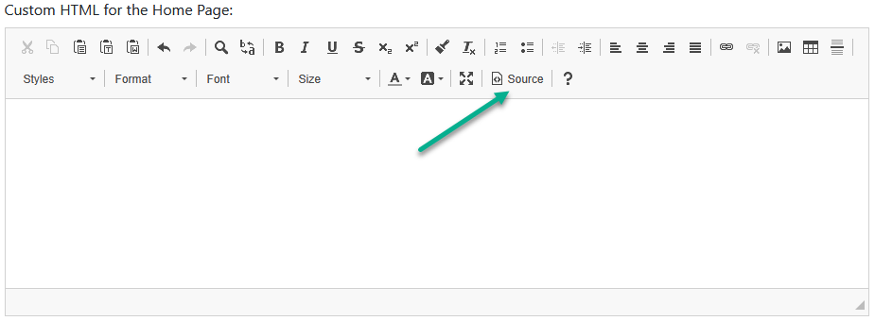

Adjusting the number of recent meetings, or recent changes being displayed.
Below the Custom HTML field, you will find two dropdowns that will allow you to specify how many meetings, or recent changes to be displayed on the user home page. If recent changes is set to ‘Do Not Show’ none will be displayed even if the field is positioned in one of the columns.

HTML Example
Note that we are providing the example below strictly as example of how you might use this capability. We do not guarantee that the example below will produce the result or exact result you are looking for. We recommend this be done by or with the assistance of someone at your organization who is familiar with HTML.

Example of HTML to add a Google Calendar, or webpage as an iframe.
<iframe src="Add the URL for your Google Calendar or webpage between here between these quotes" title="Add how you want this identified between these quotes"></iframe>

